Declared Animal Policy

under the Natural Resources Management Act 2004

Feral deer

Draft policy for public consultation

Preamble
Feral deer impact on agriculture, the environment and road safety. In South Australia, small numbers of deer were first released in 1880, for hunting and for their aesthetic value. Deer are declared for control under the Natural Resources Management Act 2004 (hereafter NRM Act 2004) and the associated Natural Resource Management Regulations 2005 (hereafter NRM Regulations). The first policy on feral deer (released in 2006) aimed to reduce feral deer numbers, prevent deer escaping from farms and being illegally released.
Feral deer have almost been eradicated from Kangaroo Island (in 2017). However, despite the policy and subsequent culling efforts, particularly by landholders and aerial control programs, feral deer numbers in the rest of the state are at their highest level since introduction, and their distributions have expanded across the state.
This policy stipulates the amount of control required to reduce the number of feral deer, and the fencing standards required to stop farmed deer from escaping.
This policy applies to all species of deer in the Family Cervidae.
Definitions
Feral deer are deer that are not confined by fences and that do not belong to a registered herd under the Livestock Regulations 2013.
Farmed deer are any deer that are confined on land that is registered to keep deer under the Livestock Regulations 2013, and which have visible ear tags (for those over 10 months of age). Farmed deer include those kept for commercial, game or hobby purposes. Deer keepers must hold a permit to keep deer. Farmed deer are confined by fences, which comply with the Natural Resource Management Regulations 2005 and fencing standards specified in Appendix 2 of this policy.
Deer keepers confine deer on a property that is registered under the Livestock Regulations 2013.
Declared for control means destroy the animals, or reduce the extent to which land is inhabited or subject to infestation by the animals, or undertake any other prescribed action.
Declared to be destroyed means destroy the animals. The purpose is to achieve ongoing reductions in their numbers. Farmed deer are exempt if deer keepers hold a permit.

Outcomes
To reduce the environmental, economic, and social impacts of feral deer.

Objectives
- Reduce numbers of feral deer by removing at least 40 per cent of female feral deer from all subpopulations each year
- Ensure boundary fences of deer farms meet appropriate construction and maintenance standards
- Prevent the release of deer
Feral deer risk
Invasiveness
Subpopulations of several species of feral deer have spread across mainland South Australia (Appendix 1). These deer include chital deer (Axis axis), hog deer (Axis porcinus), wapiti (Axis canadensis), red deer (Cervus elaphus), rusa deer (Cervus elaphus), sambar (Cervus unicolor) and fallow deer (Dama dama). The numbers of feral deer that have been culled since 2006 have been inadequate to stop populations spreading. There is a small number of feral White-tailed deer Odocoileus virginianus in northern Australia, but none in South Australia.
Impacts
Feral deer impact agriculture, the environment and public safety by
- eating pasture for stock,
- eating crops,
- eating native plants,
- spreading plant diseases,
- damaging fences,
- causing traffic hazards
Local impacts of deer vary and they can be severe where populations are large.
Trends
Numbers of feral deer across South Australia have increased since the first policy on feral deer was released in 2006. Fallow and red deer populations have increased by 30% and 16% per year respectively in the South East NRM region (Lethbridge and Andrews 2016).
The number of properties registered to keep deer increased from 49 to 107 since 2006. Over this time period, 22 properties have either been destocked or changed ownership.
The number of deer that has escaped from farms is unknown. Because many farmed deer are not tagged with visible ear tags they cannot be counted as escapes.
There was one prosecution for the illegal release of deer between 1986 and 2016.

Feasibility of Containment
It will be more cost effective to reduce current populations, than to reduce larger populations in the future. Aerial and ground culling are effective methods to reduce feral deer populations if more females are culled each year than the number of fawns born.

State Level Risk Assessment
Assessment using the SA Pest Animal Management Guide decision tool recommended that the spread of feral deer populations should be contained and reduced, by reducing the number of feral deer each year. The current level of control has not been effective at containing the spread or reducing the number of feral deer since 2006.
Policy statement
Feral deer impact the environment, economy and society. Effective implementation of the management strategies will reduce the number and distribution of feral deer, prevent farmed deer from escaping and prevent deer from being released.

Management plan for feral deer

Proposed implementation at the State level
Ongoing decline in the numbers of feral deer
To reduce numbers of feral deer, the culling of females is a much higher priority than males. Each year, at least 40 per cent of females need to be culled from each subpopulation to achieve an ongoing decline (Hone et al. 2010) (proposed change to policy). Males will be culled as a secondary priority but they are not included in the required culling target.
Landholders are responsible for destroying feral deer on their land under section 182(1) of the NRM Act 2004 (proposed change to declaration). NRM boards will inform landholders about the importance of culling female deer.
NRM boards will prioritise and try to source external funding to assist the community in coordinated culling programs to target female feral deer, in the areas of greatest impacts. The effectiveness of culling programs will be regularly reported.
Methods used to cull deer must adhere to the National Animal Welfare Codes of Practice (Feral Livestock Animals) and the Animal Welfare Act 1985.
Prevent farmed deer from escaping
Across the State, deer cannot be kept, moved or sold without a permit subject to section 188 of the NRM Act 2004 (proposed change to declaration). The Kangaroo Island NRM Board may issue 12 month permits in accordance with permit conditions relating to the Kangaroo Island Management Plan (existing declaration). Elsewhere, NRM Boards, with assistance from Biosecurity SA, may issue 3 year permits to keep, move and sell deer under specified conditions (proposed change to policy).
South Australia has a productive deer farming industry. Farmed deer must be contained and identified in accordance with minimum permit requirements in the following way:
- All boundary fences of deer enclosure must be constructed, maintained and repaired to a minimum standard in accordance with specifications in Appendix 1 (proposed permit requirements), and,
- Fences must be effective at confining all deer on an on-going basis, and preventing feral deer or other animals from breeching the fence from the outside; and
- Where there is a risk of farmed deer escaping (existing determination), or the fence being breeched from the outside (proposed permit requirements) due to:
  - high ground within 5 metres either side of the boundary fence, that effectively reduces the height of the fence below 2 metres;
  - deeply undulating land; and/or,
  - holes under boundary fences,
then additional measures must be taken to stop deer escaping, outlined in Appendix 1; and
- audits of deer farm fences will be conducted at least every 2 years by Authorised Officers (proposed amendment to policy); and
- all properties will keep log books, which are available to Authorised Officers at all times, which will document faults and maintenance carried out on boundary fencing (proposed amendment to policy).
Natural Resource Management boards may:
- Impose conditions on deer keepers who, after sufficient warning, do not have adequate fencing and allow domestic deer to stray, e.g. require fences to be upgraded to a standard that will ensure deer do not escape (existing policy).
- Recover from the deer keeper the cost of recapturing or destroying released or escaped deer, when the deer keeper has done nothing to prevent these escapes and it can be demonstrated that the release is the result of a deliberate or negligent act (existing declaration, s179(5)).
Local councils may:
- Make orders, under section 254 of the Local Government Act, to require a farmer to fence land to prevent the escape of deer if they may become a traffic hazard (existing policy).
Deer cannot be released into the wild under the NRM Act 2004 (existing declaration).
On offshore islands, including Kangaroo Island, any sightings of feral deer must be reported to the local NRM Group or Board. White-tailed deer must be reported anywhere in South Australia (existing declaration).

Reduce the number of deer escaping farms due to unforeseen circumstances
Farm escapees should be recaptured or destroyed, based on the responsibilities outlined in Regulation 28(1) of the NRM (General) Regulations 2005 (existing regulations). These are summarised below:
- The deer keeper must immediately advise adjacent landholders.
- The deer keeper has 48 hours to recapture the deer.
- Landholders who have been notified must not capture or destroy any deer carrying a visible ear tag (at least 6 x 5cm) for 48 hours.
- Landholders who have not been notified should continue to destroy feral deer (deer that are not tagged) on their land.

Deer keepers are required to tag their deer (that are 10 months of age or more) with at least a 6 x 5cm visible tag with an identification that is linked to the property identification code recorded on it so as to assist the recovery of escaped deer (proposed permit requirement).
Prevent deer from being released
Deer must not be released into the wild under the NRM Act 2004 (existing declaration).
The movement of feral deer is prohibited in South Australia under the NRM Act 2004 (proposed change to declaration). Farmed deer may be transported if they are tagged (section 73 of the Livestock Regulations 2013) and if the deer keeper has a permit (existing Livestock Regulations).
Registered farm deer may be moved for emergency veterinary care or on a short-term temporary basis as may be required by the Animal Welfare Act 1985 and due to any welfare emergency such as a bushfire emergency. Farmed deer must be confined and supervised by a responsible person at all times while outside of the registered farm (proposed change to policy).
Regional Implementation
Refer to regional management plans for further details.
NRM Region | Actions
Adelaide and Mount Lofty Ranges | Reduce and contain populations
Alinytjara Wilurara | Limited action
Eyre Peninsula | Reduce populations. Manage populations in native vegetation, contain populations and protect sites in pasture areas
Kangaroo Island | Eradication
Northern and Yorke | Reduce and contain populations,
South Australian Arid Lands | Monitor
South Australian Murray Darling Basin | Reduce populations, eradication in local areas
South East | Destroy populations in crop/pasture/irrigated areas. Protect forestry areas, manage populations in native vegetation.

Compliance
Effective compliance is required to reduce the numbers of feral deer.
Effective implementation of the management plan will reduce the numbers of feral deer because:
- Landholders will destroy feral deer on their land
- NRM boards will encourage landholders to cull more than 40 per cent of female feral deer each year.
- NRM boards will prioritise and try to source external funding to assist the community in coordinated culling programs to target female feral deer, in the areas of greatest impacts.
- Farm fences will be constructed and maintained to contain deer.
- Farmed deer will be tagged and those that escape will be recaptured or destroyed.
- Neither farmed nor feral deer will be released.
Exclusions
This policy does not seek to address the issue of hunting feral deer apart from its application as a management strategy.

Declaration
To implement this policy, feral deer are declared under the Natural Resources Management Act, 2004 in SA. For description of relevant categories, refer to Natural Resources Management (General) Regulations 2005.

This policy proposes that following sections of the NRM Act 2004 apply to Chital deer (Axis axis), Hog deer (Axis porcinus), Wapiti (Axis Canadensis), Red deer (Cervus elaphus), Javan Rusa deer (Cervus elaphus), Sambar (Cervus unicolor), Fallow deer (Dama dama) (all category 3) in each of the areas shaded below (proposed changes to declarations marked with *):
areas  Sections of Act | AMLR NRM region | AW NRM region | EP NRM region | SE NRM region | NY NRM region | SAAL NRM region | SAMD NRM region | KI NRM region | All offshore islands
175(1) Prohibiting entry of deer to area (except by permit) | * | * | * | * | * | * | *
175(3) Prohibiting movement of deer within area (except by permit) | * | * | * | * | * | * | *
176(1) Prohibiting possession of deer in area (except by permit) | * | * | * | * | * | * | *
177(1) Prohibiting sale of deer (except by permit) | * | * | * | * | * | * | *
179 Prohibiting release of deer
180 Requiring notification of feral deer
181(1) Deer keepers to comply with instructions of authorised officers
182(1) Landowners to destroy deer on their properties (except by permit) | * | * | * | * | * | * | *
182(3) Landowners to control deer on their properties as per Regulation 28(1) - protection of escaped farm deer for 48 hours. Note: Proposed amendment to omit deer from Regulation 26 and 27 (which relate to s182(3)).
The following sections of the NRM Act apply to White-tailed deer (Odocoileus virginianus) (Category 2) across the whole of the State, below (existing declaration):
Sections of Act | Whole of the State
175(1) Prohibiting entry of deer to area (except by permit)
175(3) Prohibiting movement of deer within area (except by permit)
176(1) Prohibiting possession of deer in area (except by permit)
177 Prohibiting sale of deer (except by permit)
179 Prohibiting release of deer
180 Requiring notification of feral deer
181(1) Deer keepers to comply with instructions of authorised officers
182(1) Landowners to destroy deer on their properties (except by permit)

Review
The effectiveness of this policy will be reviewed by 2022 (proposed change to policy). The review will evaluate:
- Whether the management plan was effectively implemented
- Whether the numbers and distributions of feral deer decreased between 2017 and 2022.
References
Australian Deer Association (2009). Australian Deer: Forty years of ADA, 34, pp 80.
Australian Deer Industry Manual, Number 2, Fencing and Handling Yards, RIRDC Report 98/13 (as amended from time to time) https://rirdc.infoservices.com.au/items/98-13
Davis, N., Bennett, A., Forsyth, D., Bowman, D., Lefroy, E., Wood, S., Woolnough, A., West, P., Hampton, J., and Johnson, C. (2016). A systematic review of the impacts and management of introduced deer (family Cervidae) in Australia. Wildlife Research 43: 515–532.
Harper, M (2017). Fleurieu feral deer aerial control program 2017. Report for Natural Resources Adelaide and Mount Lofty Ranges. 1-2.
Hone, J., Duncan, R. and Forsyth, D. (2010). ‘Estimates of maximum annual population growth rates of mammals and their application in wildlife management’. Journal of Applied Ecology 47, 507-514.
Lethbridge MR and Andrews LM, 2016, Feral Deer Aerial Survey of Gum Lagoon Conservation Park and surrounds, 2016. EcoKnowledge report to Natural Resources South-East, Department of Environment, Water and Natural Resources, South Australia.

APPENDIX 1
The distribution of feral deer in South Australia.
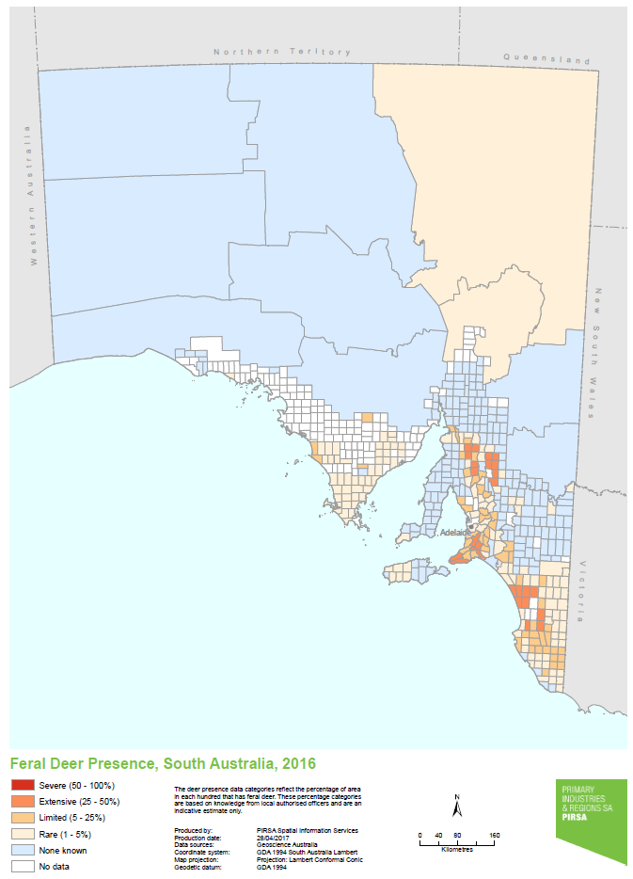
APPENDIX 2. Proposed conditions of permit under section 188 of the NRM Act 2004

Deer on land owned or occupied by the owner of the deer, or on land with the consent of the owner, must be secured or confined and identified in the following manner:

- All boundary fences of deer enclosure must be constructed so that fences are a minimum of 2.4m in height from the ground and

- All boundary fences of deer enclosure must be constructed using deer mesh (size 17/190/15), and

- All boundary fences of deer enclosure must be fitted with electric wire outriggers to protect wire mesh from damage by deer and other grazing animals in paddocks either side of fence, and

- Where there is high ground either side of the enclosure that increases the risk of deer escaping, or of deer breaching the fence from the outside, sections of boundary fences must be increased to a height of 3 metres, where in the opinion of an authorised officer under the Natural Resources Management Act 2004 this action is required to stop deer from jumping over the fence; and

- All holes under boundary fences and gates of deer enclosure must be repaired or blocked with additional deer mesh (or equivalent material) in accordance with the minimum standard for size and strength and the fence must be pegged down so that the bottom horizontal wire in the fence or the bottom of the gate is not greater than 50mm distance in a vertical direction down to the ground level at any point; and

- Where contour of the land following the boundary fence line is deeply undulating, where the soil is sandy or rocky, sections of the boundary fence post spacing must be less than 10 metres, where in the opinion of an authorised officer under the Natural Resources Management Act 2004 action is required to stop deer escaping under the fence, and

- All boundary fences of deer enclosure must be maintained and repaired so that they are effective at confining deer on an ongoing basis; and

- All boundary fences of deer enclosure must be kept clear of fallen trees or timber, which are lying over or have damaged the fence.
- All deer over 10 months of age must carry a permanent, visible, identifiable tag (6 x 5cm) which has an identification that is linked to the deer keeper’s Property Identification Code (PIC) recorded on it.

Previous declaration, gazetted in 2006:

Feral deer are currently declared under the Natural Resources Management Act, 2004 with the following sections applying:

The policy (released in 2006) requires that the following sections of the NRM Act apply to deer across the State (excluding off-shore islands and Kangaroo Island)

- 179 Prohibiting release of deer
- 181(1) Deer keepers to comply with instructions of authorised officers to keep deer confined
- 182(3) Landowners to control deer on their properties as per Regulation 26(2) - a farmed deer must be confined according to determinations by Chief Officer, and if deer are on a property without consent they must be captured and removed, or destroyed; and as per Regulation 28 -A deer must not be destroyed or removed if it bears a visible ear tag and notification has been received from a deer keeper about an escape and less than 48 hours has elapsed since notification was received.

The policy (released in 2006) requires that the following sections of the NRM Act apply to deer on off-shore islands and Kangaroo Island:
- 175(1) (3) Prohibiting movement within and onto an island
- 176(1) Prohibiting possession of deer
- 177 Prohibiting sale of deer
- 179 Prohibiting release of deer
- 180 Landowner must notify the NRM Board or Group of the presence of deer
- 181(1) Deer keepers to comply with instructions of authorised officers to keep deer confined
- 182(1) Landowners must destroy any feral deer on their land
- 188 enables the Board to issue a Permit to keep deer and to outline Permit Conditions that must be met prior to issuing a Permit.

The declarations (released in 2004) requires that the following sections of the NRM Act apply to white tailed deer (Odocoileus virginianus) across the state:
- 175(1) (3) Prohibiting movement within and onto an island
- 176(1) Prohibiting possession of deer
- 177 Prohibiting sale of deer
- 179 Prohibiting release of deer
- 180 Landowner must notify the NRM Board or Group of the presence of deer
- 181(1) Deer keepers to comply with instructions of authorised officers to keep deer confined
- 182(1) Landowners must destroy any feral deer on their land

