COMMENTS ON KANGAROO ISLAND REGIONAL PLAN (KIRP) Draft March 2024
Introduction
- These notes are written by way of comment on the subject document, concentrating on Penneshaw but with consideration of other trends which may impact the proposed plan as they relate to Penneshaw.
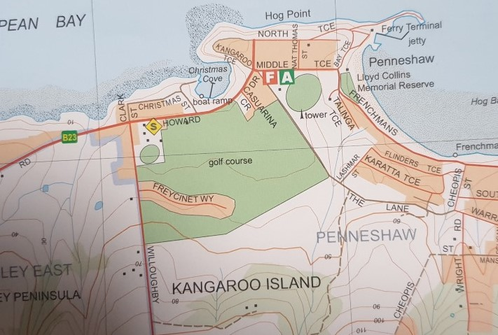
- In particular, the proposal to convert the golf course to housing and tourist use is strongly opposed. The picture shows the golf course area marked for housing in green but excludes the oval. Note that the land along Howard Drive from the KI Information Centre to Casuarina Ct. is also included in the proposition. If adopted, this would remove open space from the town area when other options for housing etc are available. For example, the town and golf course are ringed by hills on the eastern, southern and western flanks. Parts of the southern and eastern areas are already allocated or marked for housing. On the southern side Allambie was set aside for housing blocks some years ago. Where this development currently sits in terms of sales is not known. The eastern flank along Binney’s Track and Trethewey Terrace is already divided, and part has been sold for housing. This area contains a significant number of housing blocks still for sale. Exact numbers are not contained in the draft proposal but given the predictions covered below, the expected demand is covered.
Golf course area, (900mx500m) is indicated in green less the oval
Housing and Population

- The KIRP identifies there is currently a 15-year supply of appropriately zoned land in Penneshaw to cater for the projected 0–15-year housing demand. According to the KIRP, the population on Kangaroo Island is projected to grow by 1792 permanent residents over a 30-year period. The population of Penneshaw in the 2016 census was 275. This figure according to the KIRP is expected to rise to 330 by 2041, an increase of 55, or 20%. This may result in about 18 families of 3 persons becoming residents. This predicted permanent population growth is not significant and will not overstretch housing construction capabilities or supply. The predicted population rise can be catered for by the existing zoned land to the east and south of the town centre. There is no requirement to occupy open space (golf course) with housing and non-specified tourist attractions as this would change the very character of the town.

- Recent pressure on housing availability in SA is well known with the government providing funding for a number of significant housing estates on the mainland. These estates have risen with what appears to be an objective to fit the largest number of houses into a specified land area, resulting in tomorrow’s slums. The developments have built houses which are far too close to each other, making the establishment of green areas and gardens impossible. This is to be studiously avoided on the island.

- The population age of Penneshaw between 65 and 84 years is 31.8% compared with SA which is 15.5%. This means that the death rate over the next 10 years will be significant, freeing up housing. This will assist by suppling additional housing, a figure not quantified.

2
Tourism

- Kangaroo Island is a popular tourist destination located 16 km to the southwest of Cape Jarvis across Backstairs Passage. With a seasonal arrival of cruise boats and tourists, the island hosts up to 205,000 annual visitors. These numbers may increase and put pressure on accommodation although the cruise boat influx does not contribute to this problem. It is anticipated that this pressure will continue as predicted. This demand is being addressed by commercial interests and is not part of the problem faced by permanent residents.
Conclusion
- There is a requirement for planning for the future in all areas in SA. KI is an important element in this exercise because of the growing interest shown by the tourist industry. However, it is also important to maintain the quirky nature of the island as a largely undeveloped, beautiful natural island. Reports of developing interest in the island, drawing potential comparisons with Byron Bay in NSW, are frankly ludicrous. The unspoilt beauty of the island, certainly Penneshaw, will be destroyed by the adoption of this quote from the study,

“Penneshaw KI Council Undertake a Code Amendment to 0-5 years apply the Golf Course Estate Zone to the Penneshaw Golf Course and a portion of the adjoining Neighbourhood Zone to facilitate housing and tourism development integrated with open space.”

- A growing population requires not just more housing, but a greater choice in housing to accommodate older people, smaller households, seasonal and temporary workers, and tourists. That does not require the Penneshaw golf course to be destroyed to accommodate that need.

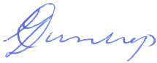

Moose Dunlop OAM, AIMM
23 Freycinet Way
Penneshaw
18 April 2024

Following taken from The Kangaroo Island Regional Plan Draft 2024

YourSAy page:

yoursay.sa.gov.au/kangaroo-island-regional-plan
The PlanSA online submission form:

plan.sa.gov.au/regional-planning-program/how-to-get-involved/ public-feedback-form
Email:

plansasubmissions@sa.gov.au
(Subject: Submission – Kangaroo Island Regional Plan)

Post:
Attention: Strategic Planning Team, Planning and Land Use Services
Department for Trade and Investment
GPO Box 1815, Adelaide SA 5001
.

