Heritage Standard
Burra State Heritage Area

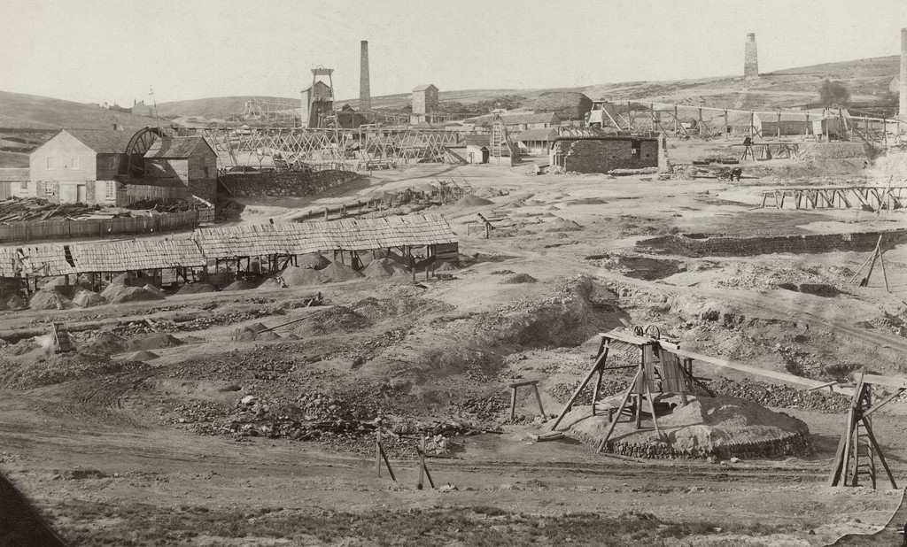

Contents

1. Background 3
1.1. Burra State Heritage Area 3
1.2. Purpose of Heritage Standard 3
1.3. History – Burra 3
2. Heritage Value 8
2.1 Statement of Significance (Burra State Heritage Area) 8
2.2 What is of heritage significance? 8
3. Heritage Standards for Development (Burra State Heritage Area) 19
3.1. Purpose of Heritage Standards for Development 19
3.2. Land use 21
3.3 New buildings 22
3.4 Alterations and additions 25
3.5 Ancillary development 29
3.6 Land division 34
3.7 Landscape context and streetscape amenity 35
3.8 Demolition 37
3.9 Conservation works 38

Version 1 – 13 June 2023
Heritage South Australia
Department for Environment and Water

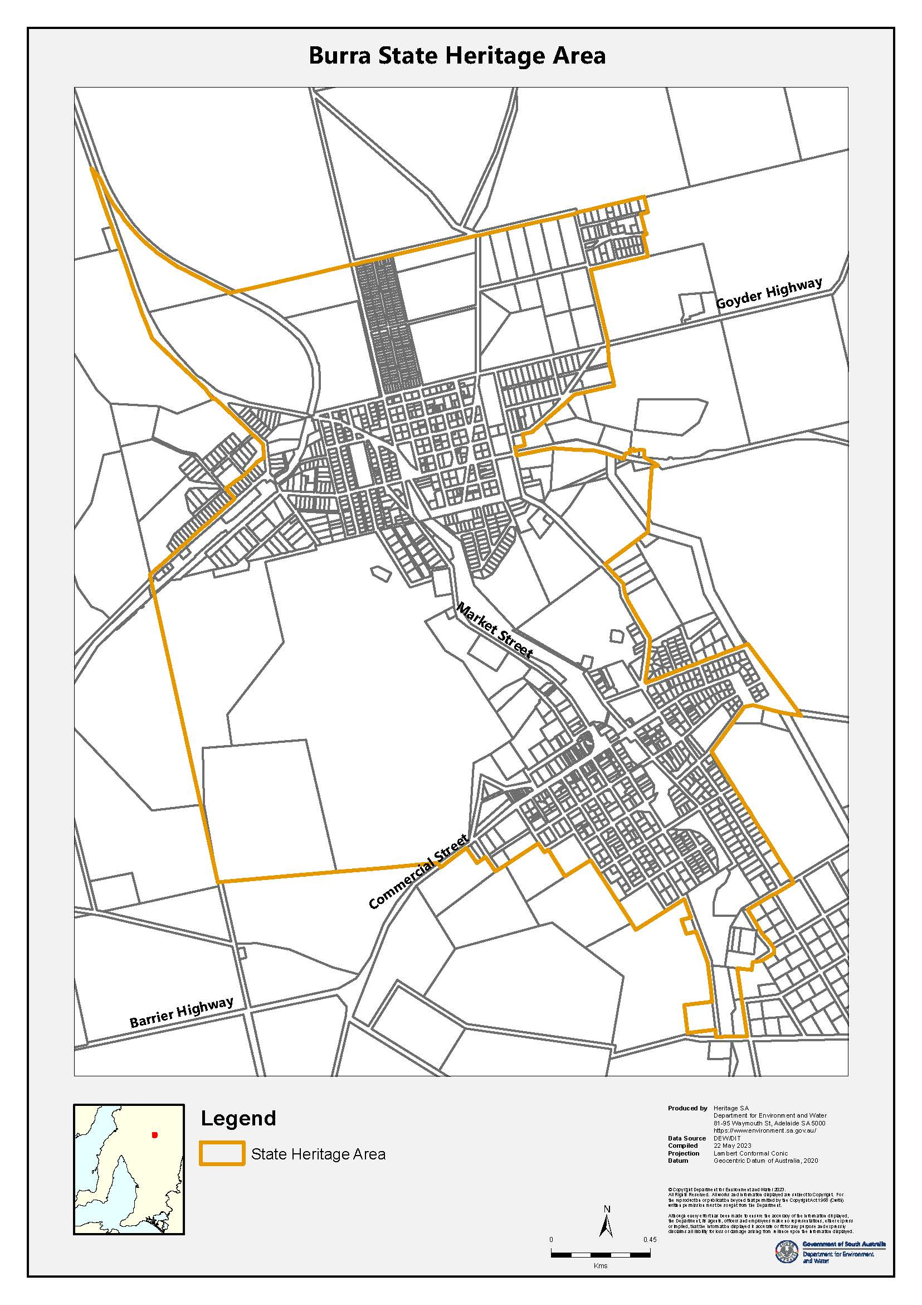

Background

Burra State Heritage Area
South Australia’s State Heritage Areas represent significant aspects of the State’s rich natural and cultural heritage. Burra was designated as a State Heritage Area under the Heritage Places Act 1993 in 1993. The designation ensures that future development of properties within Burra is managed in a way that maintains the Area’s heritage value.
On 9 May 2017, the ‘Australian Cornish Mining Sites: Burra and Moonta’ were included on the National Heritage list, in recognition that Burra is one of Australia’s earliest, largest and best-preserved 19th century mining towns where Cornish mining technology, skills and culture is demonstrated to a high degree. ^{CMPp.47}
Recognised as being a nationally significant area as it is only one of two areas in Australia that reflect the successful transplantation of Cornish mining systems to Australia, and the development of mining settlements, that are an important expression of Australian identity and experience. ^{The Barossa Leader 17/8/22}
The Burra State Heritage Area includes seventy places and one object in the State Heritage Register, including the Burra mines historic site and structures, private dwellings, religious buildings bridges and stone walls.

Purpose of Heritage Standard
The Heritage Standard is published in accordance with the Planning, Development and Infrastructure Act 2016 and the Planning and Design Code (Code). It is a supplementary tool of the Code and is referenced in the State Heritage Area Overlay.
Any proposals to undertake development within a State Heritage Area will be referred to the Minister responsible for administering the Heritage Places Act 1993, for heritage advice.. Heritage South Australia (Heritage SA) in the Department for Environment and Water is the Minister’s delegate for decisions on referred development applications. Heritage SA also has the ability to direct conditions, should the development be approved, or to direct refusal if heritage values are compromised. The Heritage Standard forms a key part of Heritage SA’s assessment of development proposals.
The Heritage Standard is presented in three parts:
- Background - the historical development of Burra and the principles that underpin the State Heritage Area listing
- Statement of Significance –the South Australian Heritage Register listing and the context and description of the heritage values
- Heritage Standards for Development - Principles and Acceptable Standards for development

History – Burra
Ngadjuri ownership and dispossession
The Ngadjuri people are traditional owners of South Australia’s Mid North region, including Burra, and were among the first Aboriginal groups ‘to suffer the full impact of European intrusion’ following the introduction of pastoralism into South Australia from the late 1830s.
The growth of European mining, pastoral and agricultural activities around Burra had ‘cumulative and irreversible’ consequences for the Ngadjuri people. Timber taken to feed the mining industry denuded the landscape of trees; sheep polluted the waterways, further degraded the landscape and competed with local fauna; and the expansion of agricultural settlement east of Burra from the mid-1870s caused Ngadjuri people to be ‘fenced out of their own land.’
After 1911 many Ngadjuri people were removed and confined to missions and reserves under ‘restrictive and repressive’ legislation. Nevertheless, Ngadjuri people and culture ‘have endured and continue to thrive.’ In recent decades Ngadjuri people have returned to country and are engaged in a process of rediscovering lost places and cultural knowledge.
Copper mining in Cornwall
Cornwall in South West England once possessed rich mineral resources including tin and copper. From the Bronze Age tin mining was Cornwall’s dominant industry. The exhaustion of surface deposits catalysed the development of deep mining in the sixteenth and seventeenth centuries. Copper mining supplanted tin in the eighteenth century and saw the rapid emergence of an industrialised mining landscape, characterised by ‘deep underground mines, engine houses, foundries, new towns, smallholdings, ports and harbours, and their ancillary industries.’
Mining was accomplished under the ‘traditional leadership’ of the Cornish mine ‘Captain’ (superintendent) and employed the Cornish system of ‘tribute’ and ‘tutwork’. Miners engaged in tutwork sunk shafts, excavated levels and were paid a low but reliable rate per fathom, while teams of tribute workers bid for the right to mine lodes made accessible by tutwork and were paid according to the value of ore mined. This system promised flexibility and independence for miners with little risk to investors, and played an important role in the success of Cornish mining.
The early development of the steam engine occurred in Cornwall and was driven by the mining industry and its need to efficiently dewater deep mines, allowing work below groundwater level. The first practical steam engine, with motion transmitted from steam cylinder to water pump through a pivoting beam or bob, was devised by Thomas Newcomen in 1712. Improvements by James Watt, commercialised by 1776, were protected by patents, and with their expiry in 1800 the steam engine developed rapidly. The ‘Cornish’ engine evolved from Watt’s engine and reached its zenith around 1850, coinciding with peak production at the Burra Burra Mines.
Steam power revolutionised the mining industry. Cornish engineers developed two main varieties of the Cornish engine, namely the beam pumping engine, in which the reciprocating see-saw motion of the bob powered subterranean pumping apparatus known as pitwork, and the beam rotative engine, which translated the motion of the bob into rotary motion, allowing the engine to drive machinery including crusher rolls, dressing machinery and winches. Tall masonry enginehouses and the tapered cylindrical chimneys of their associated boiler houses were defining characteristics of the Cornish mining landscape transposed into South Australia.
Cornish engines were manufactured by firms such as Williams’ Perran Foundry and Harvey’s Hayle Foundry. Both exported all over the world and supplied large Cornish pumping engines brought to South Australia.
Economic depression and famine in the 1840s and the decline of Cornish copper mining in the 1850s coincided with the discovery and exploitation of copper in places such as South Australia, Chile and the United States, providing impetus for Cornish miners and their families to emigrate in large numbers. They took with them hard-rock mining expertise as well as their vernacular building traditions, social and cultural customs, religious beliefs and identity.
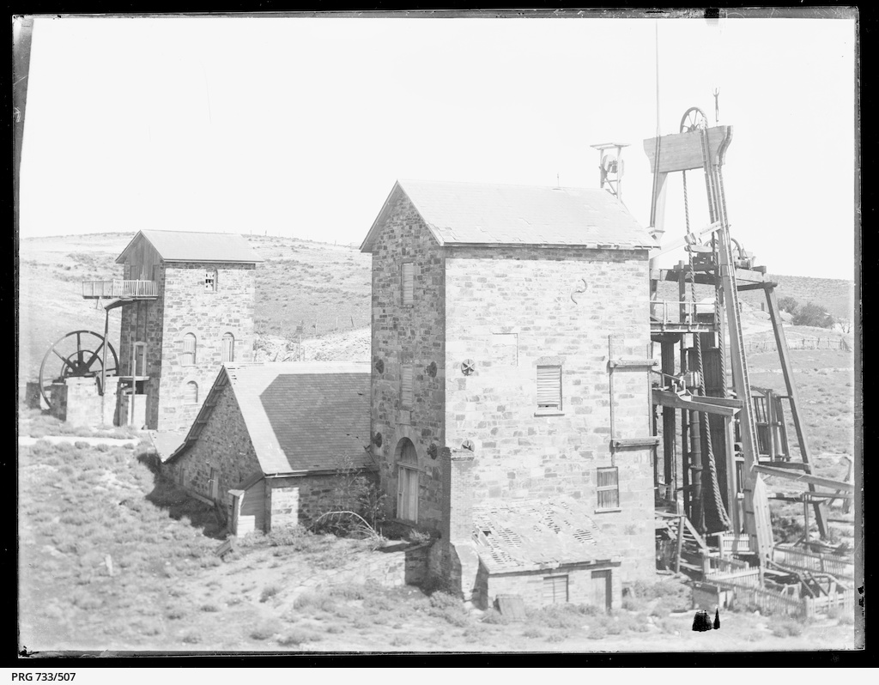
(SLSA PRG-733-507 1915-30 Morphett’s Pumping House)

The Burra Burra Mine
Following the discovery of copper at Kapunda in 1842, shepherds learned to recognise the colours of copper ore, sometimes with instruction from their pastoralist employers. In 1845, shepherds Thomas Pickett and William Streair independently discovered copper outcrops at two locations on the Burra Creek.
Under regulations of the Waste Lands Act 1842, mineral rights could only be acquired outside of Counties by purchasing a Special Survey of 20,000 acres in one contiguous block, at a cost of £1 per acre. Two parties, namely the South Australian Mining Association (SAMA) and the Princess Royal Mining Company (PRMC), jointly purchased the Burra Creek Special Survey in July 1845 then drew lots to determine ownership of the outcrops. SAMA acquired Pickett’s northern outcrop, which became the ‘lucrative’ Burra Burra Mine, while Streair’s southern outcrops proved unproductive, leading the Princess Royal Mine to close in 1851.
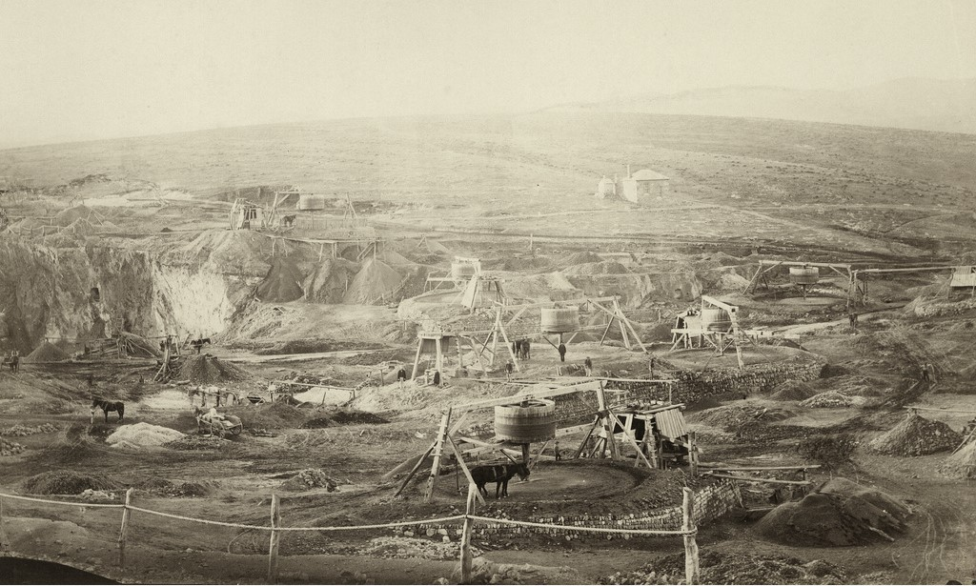
(SLSA B-4149 1870, Horses pulling kibble baskets of ore to surface, Burra Mine)
SAMA commenced mining at Burra on 29 September 1845. Production of copper ore soon eclipsed the Kapunda mines, and in 1847 the Burra Burra mine produced more copper than all 94 copper mines in Cornwall. Burra Burra emerged as the largest mine in Australia, a title it held for a decade from 1845. Copper mining reputedly saved the colony from bankruptcy, and by 1850 South Australia was the third-largest producer of copper in the world, with the value of mineral exports exceeding that of wool and grain.
Burra was home to the first large population of Cornish people in South Australia. Henry Ayres, secretary and later managing director of the Burra Burra Mines, conducted an ‘intensive recruiting drive’ through agents in Cornwall. Unemployment and overpopulation at home and the promise of work and higher wages abroad meant mining families readily accepted assisted passage to South Australia. By 1851 the Burra Burra mine employed over 1,000 men and boys, most of them Cornish. The influx of Cornish families made Burra Australia’s largest inland town.
Mining at Burra followed traditional Cornish practice with little adaptation and all positions of responsibility were held by Cornishmen. SAMA also imported six Cornish engines from foundries in Cornwall. Large components were transported from Port Adelaide on purpose-built, bullock-drawn jinkers (of which the Burra Jinker SHO 10051 survives), a two-month return trip, supported by up to forty drays carrying smaller parts. Upon arrival, Cornish engines were installed in large stone engine houses built to standardised Cornish designs. Successful mining in South Australia would not have been possible without Cornish engines. Their introduction and subsequent use marked the beginning of the industrialisation of South Australia.
The Burra Smelts
Smelting is a process of extracting metal from ore through the application of heat. During the 1840s the ‘vast majority’ of the world’s copper, including copper from Burra, was smelted in the Welsh town of Swansea, close to the coalfields that supplied fuel for the smelters. The smelting industry was secretive with knowledge of the ‘Welsh Process’ guarded within Welsh families. Export costs led South Australian colonists to establish local smelters, however early attempts by SAMA to smelt copper at Burra in 1846-1847 failed due to the absence of local smelting expertise.
In 1848 SAMA leased land on the east side of Burra Creek to the Patent Copper Company (PCC) which opened the Burra Smelts (Burra Smelts Historic Site SHP 10989) in April 1848. Notably, the Smelts brought experienced Welsh smelters and their families to Burra and was the largest smelter outside Swansea until 1861.
Initially the Burra Smelts were fired by timber cut from crown land. When this practice was prohibited, the PCC imported over 400 mules and 20 muleteers (drivers) from Chile to cart coal from Port Wakefield. After 1861 most of the Burra ore was smelted in Port Adelaide and the Burra Smelts closed in 1869.
The Burra townships
Numerous townships developed in the vicinity of the Burra Burra Mine, satisfying the critical demand for housing while also providing ‘ecclesiastical, civic and commercial amenities.’ From 1845 SAMA’s private company town of Kooringa, the first such town in Australia, was established on the Burra Creek. Kooringa is likely a Ngadjuri word, which may mean ‘place of she-oaks’ or may derive from the word ‘kuri-ngga’ meaning ‘in the circle,’ referring to ceremony. Kooringa was planned by George Strickland Kingston, surveyor, architect and a director of SAMA. SAMA provided some of Australia’s first company housing at Kooringa, including Paxton Square Cottages (SHP 10519).
Rents at Kooringa were high and allotments could be leased but not purchased freehold, leading many miners and their families to excavate dugouts on the Burra Creek. “Creek Street” boasted a population of up to 2,600 by 1851. Floods devastated the creek community that year discouraging future habitation, however some families remained until 1860.
In response to the SAMA monopoly at Kooringa, in 1849 the South Australian Government laid out its own township on the northern boundary of the Burra Creek Special Survey, named Redruth. However, Henry Ayres and George Kingston attended the auction and acquired 77 of 120 allotments for SAMA, undermining the government’s attempt to provide affordable housing for mining families.
Several private townships were also established in the vicinity of the mines. In 1846 Scottish speculators opened the Bon Accord Mine adjoining SAMA land. This venture was a failure and Bon Accord Mining Company surveyed the town of Aberdeen (1849) to recoup their investment. From 1855 the English and Australian Copper Company established the village of Llwchwr, east of Redruth, to house Welsh smelters. Kooringa landowner Thomas William Powell surveyed Hampton in 1857, north-east of Llwchwr. In 1872 the Scottish Association established New Aberdeen on the site of the Bon Accord Mine. Finally a proposed rail connection with Adelaide encouraged the establishment of the outlying townships of Copperhouse and Lostwithiel in 1858-1859.
The railway from Adelaide finally reached Burra in 1870. In 1876 the townships amalgamated to form the Corporation of the Town of Burra, however retained their individual identities until 1940, when the name Burra was adopted.
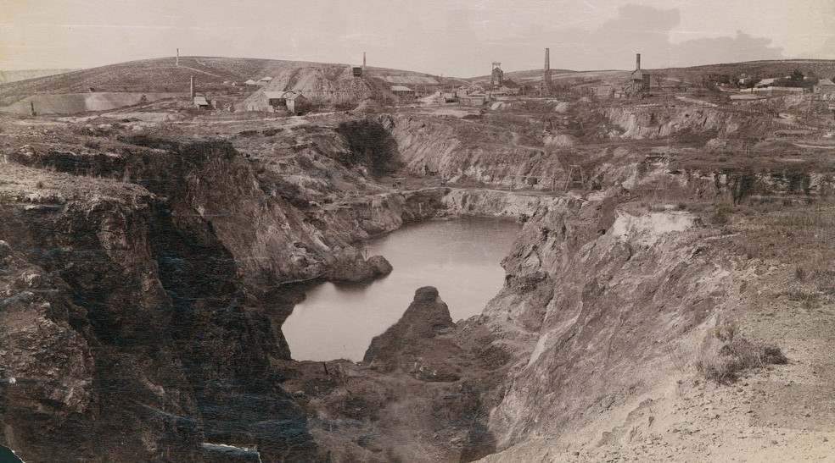
(SLSA B-12538 1880, Burra Open-Cut Mine)
Decline and closure of the Burra Burra Mine
The Victorian gold rush caused the working population of Burra to collapse, and the mine closed from October 1852 until January 1855. After reopening, ore production declined from 1861 and in 1864 SAMA recorded its first losses. Overshadowed by newer mines at Moonta (Moonta Mines State Heritage Area SHA 13975) and Kadina, the Burra Burra Mine closed in 1867 before reopening as an open cut in 1870, on the recommendation of English mining engineer John Darlington. This open cut mine closed in 1877 due to falling world copper prices.
Subsequently Burra prospered as an agricultural, pastoral, and supply centre for the region, resulting in construction of large public buildings such as the Town Hall (SHP 10403), Model School (SHP 10025), and churches.
In 1971, the open cut mine was reopened, resulting in the loss of some mine structures, and worked to a depth of 100 metres before finally closing in 1981. Today the mine site is dominated by the flooded open cut. Three engine houses stand on its perimeter, while complex structures remain underground including shafts connected by horizontal levels.
Rising car ownership and road improvements after the Second World War brought more visitors to country South Australia, and tourism contributed to an emerging awareness of Burra’s cultural heritage significance. The efforts of a ‘caring community’ and National Trust have allowed the Burra mines and townships to remain highly intact. Burra was designated a State Heritage Area on 28 January 1993 and with Moonta, received National Heritage Listing on 9 May 2017. Burra continues to be a pastoral and agricultural centre, with a focus on cultural heritage tourism.

Heritage Value

2.1 Statement of Significance (Burra State Heritage Area)
Burra is of heritage value for the following reasons:
The Burra State Heritage Area is of significance to the economic and social history of South Australia and is a testament to the success of copper mining in the area. In the late 1840s, the Burra Mine made South Australia the most prosperous colony in Australia. At one stage the mine was the second largest producer of copper in the world. Comprising the mining area and a complex of what were originally separate townships which are now merged into one, the area provides evidence of early mining, industrial and urban functions with Welsh and Cornish influences.
Heritage SA, Heritage Places database, Statement of Significance

2.2 What is of heritage significance?
Burra’s built environment derives from two historic phases of development. The State Heritage area retains many mid-nineteenth century structures dating back from its 1845-1877 mining activities. Later Victorian buildings reflect the town's role as a regional centre for agriculture, pastoralism and local government into the early twentieth century.
Burra is one of only two areas in Australia where Cornish mining technology, skills and culture is demonstrated to a high degree. Whilst many of Burra’s individual buildings and places have historic merit, it is the town’s purpose, location, layout and building type that contribute to its heritage character and significance. ^{CMP}
Features within the State Heritage Area which contribute to the heritage value of the State Heritage Area include:

- Burra’s rural setting, derived from its valley location along Burra Creek, surrounded by hills cleared for fuel and agricultural activity. | 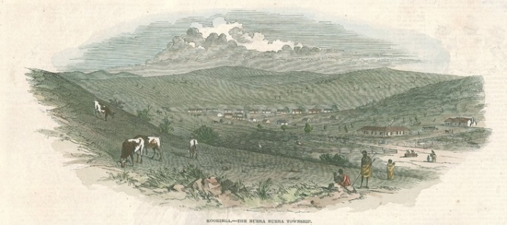  (SLSA B-69728-1) 1848, Kooringa Township, S.T.Gill
- A strong sense of containment within neatly defined boundaries reflecting the original settlement pattern. The clear distinction between town and countryside. | 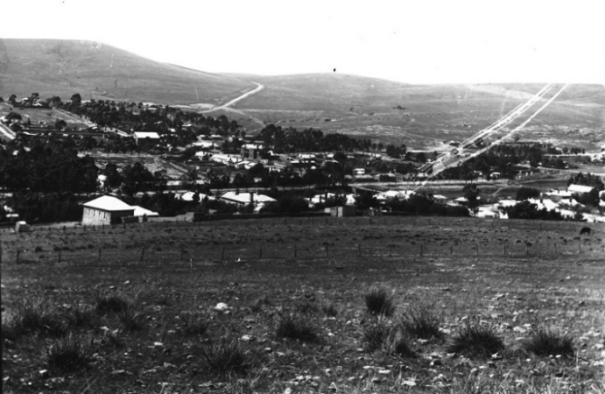  (SLSA B-68635) 1885, Kooringa from Lookout Hill
- Historic settlement pattern, defined by two townships separated by the open area of former mine sites: SAMA town of Kooringa (now ‘Burra’) to the south, and ‘Burra North’, a loose grouping of privately surveyed villages developed outside the company boundary. | 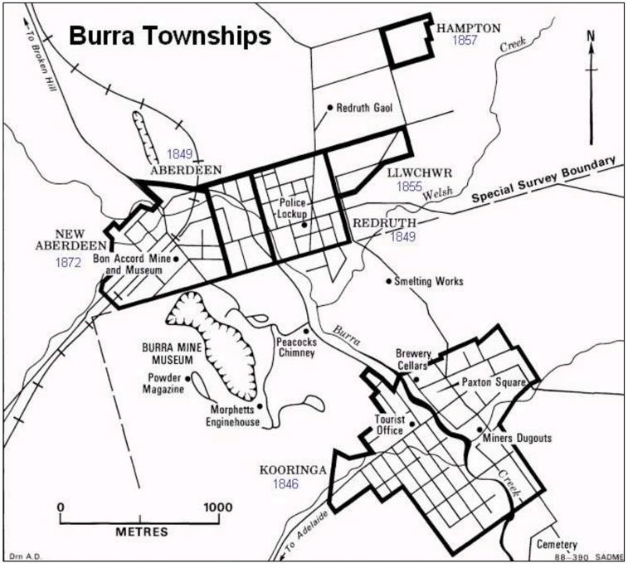  Burra Townships, Primary Industries & Resources SA
- Planned development of company, government and private townships, evidenced in gridded subdivisions and road networks. | 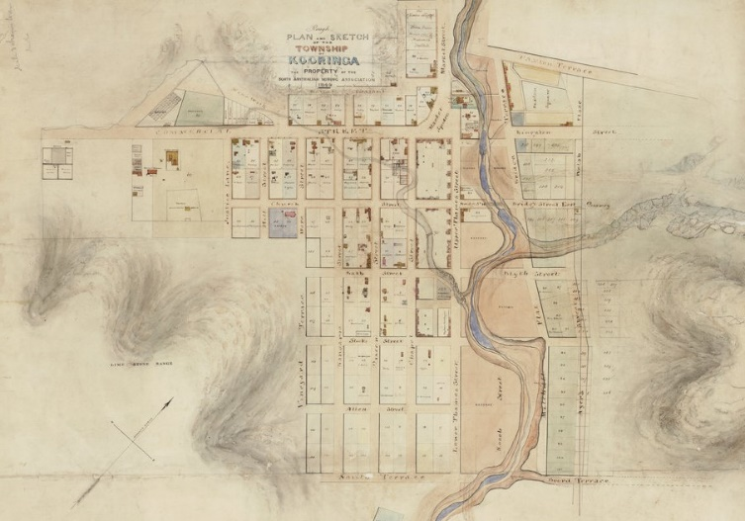  (SLSA) 849, SAMA subdivision of Kooringa company township
- Many examples of early colonial, rural building styles demonstrating a high degree of architectural integrity. Surviving residential, commercial, public and ecclesiastical buildings evidence imported culture and living conditions of early settlers. Burra’s transformation from a mining to pastoral/agricultural centre is evidenced in its Town Hall, schools and late Victorian era hillside houses with generous verandahs. | 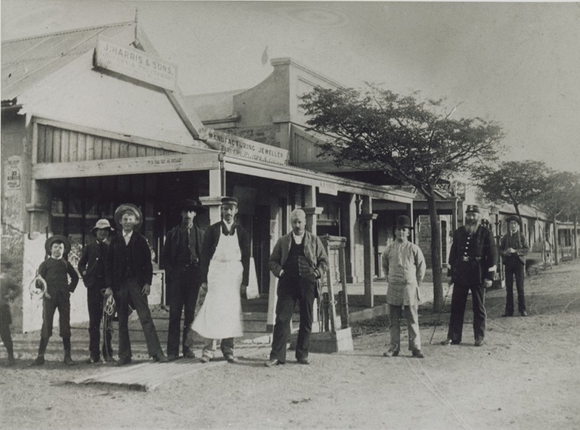  (SLSA B-27701) 1908, Burra Street, Town Centre
- Civic buildings: symbols of frontier law and order (Police Station, Gaol, Courthouse, Town Hall, Telegraph Office) and evidence the social structure of the community and economic success of the mine. | 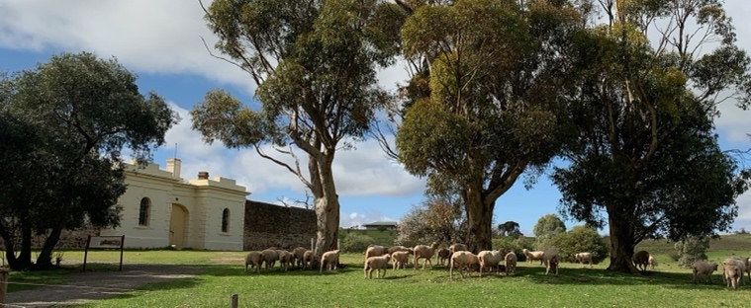  Rural setting of Redruth Gaol
- Number and scale of Burra’s ecclesiastical buildings, as evidence the importance of religion, in the social structure of the Cornish community. | 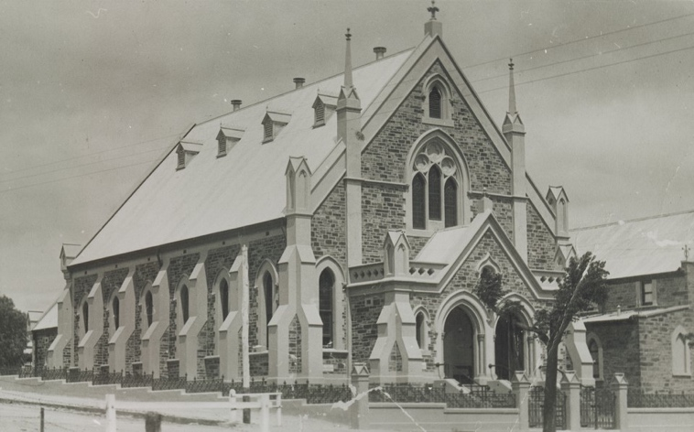  (SLSA B-27708) 1914 Methodist Church
- Commercial buildings: Burra’s earliest shops and banks demonstrate a community’s way of life and the economic importance of the mine. Former hotels stand alongside Methodist Chapels, evidencing social divisions in the Cornish mining community. | 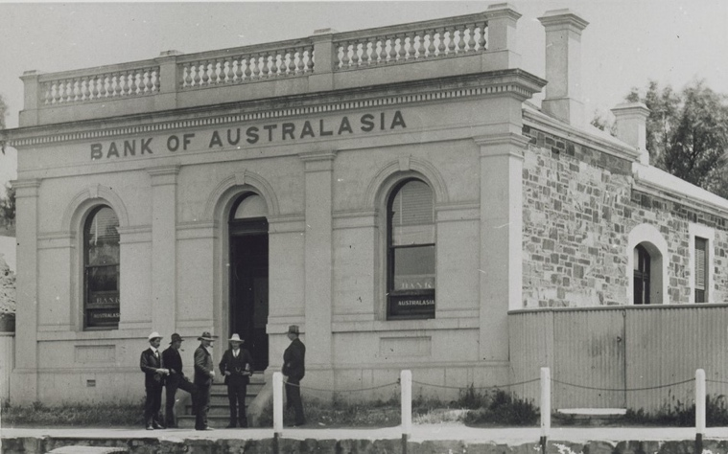  (SLSA B_27694) 1910, Bank of Australasia
- Kooringa’s Commercial Street and Market Square demonstrates Burra’s post-mining, pastoral prosperity of the 1877–1915 period | 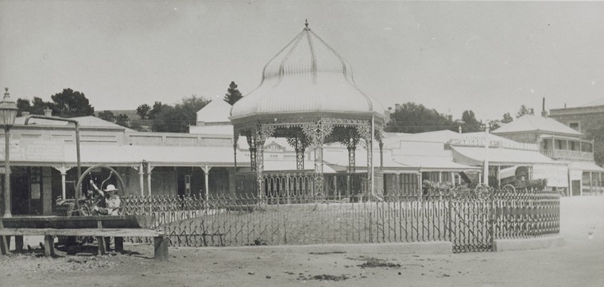  (SLSA B-27700) 1911, Market Square Kooringa
- Some of the earliest company housing in Australia survives in Kooringa. | 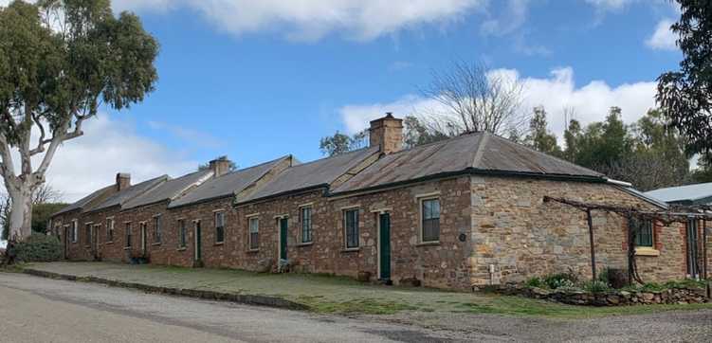  Redruth’s attached row cottages by James Tiver
- Dwellings constructed of locally quarried stone by Cornish masons, demonstrating traditional Cornish building methods and styles. (e.g. originally without verandahs). | 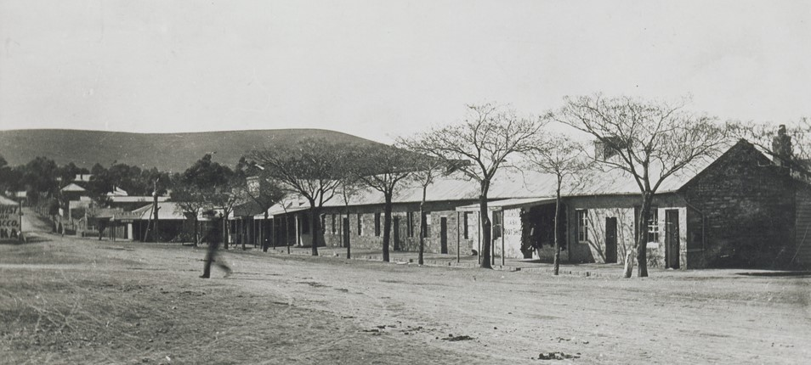(SLSA B-27707) 1890, Mining Corp. cottages
- Dwellings, principally single storey and consistent in architectural form, scale and material, with substantial chimneys. | 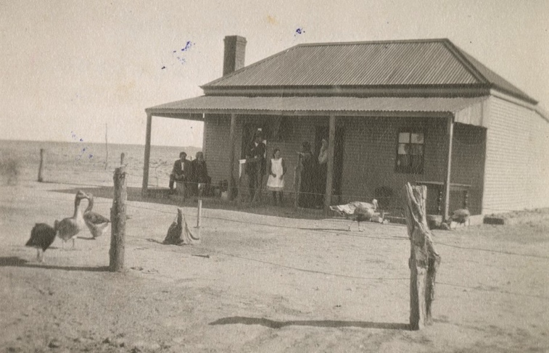  (SLSA B-78586) 1920, Eurovale Homestead
- Remaining, early timber-framed cottages constructed of ‘paling’, ‘wattle and daub’, ‘board’, ‘pug’, and ‘brick’, clad in corrugated steel or timber siding, with timber shingle roofs. | 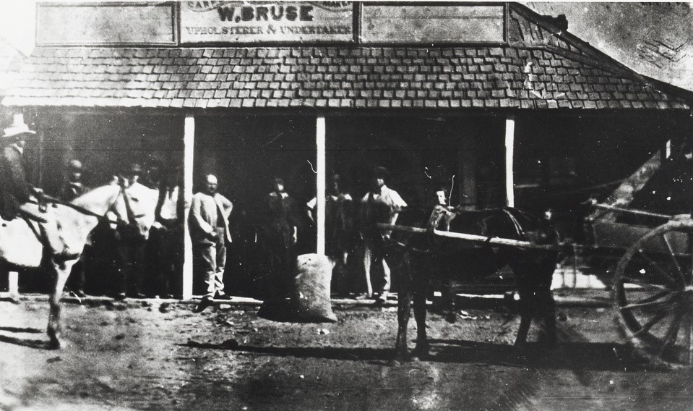(SLSA B-32117) 1890, shingle roofs now replaced with corrugated steel sheet
- Former miners’ dug-outs and dug-out sites along the banks of Burra Creek and its tributaries demonstrate the rent-free living conditions of the earliest settlers. | 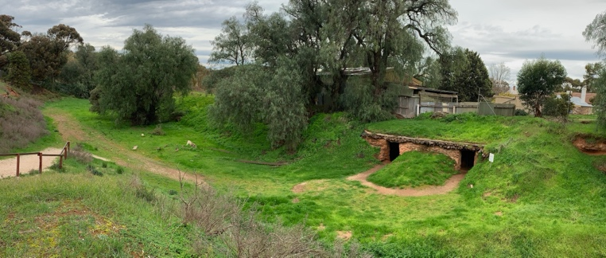  Restored examples of miners’ dug-outs along ‘Creek Street’
- The natural character of the Burra Creek line, with indigenous plantings and historic bridges: a green ‘recreation’ corridor, linking Burra with Burra North. | 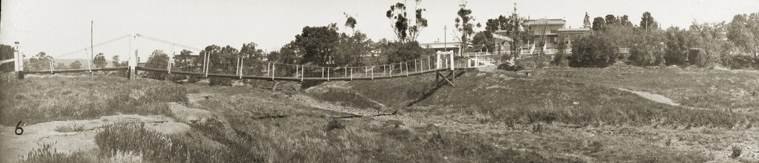(SLSA B-3151) 1925, swing footbridge over Burra Creek
- Historic transport routes through Burra evidenced in street layouts. Town entrances framed by formal planting within rural setting. | 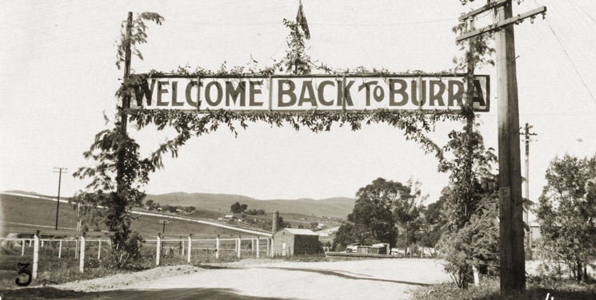  (SLSA b-3149) 1925 Rural setting to town entrance
- Hierarchy of residential development. Smaller cottages located closer to the street and larger residences situated on higher ground. | 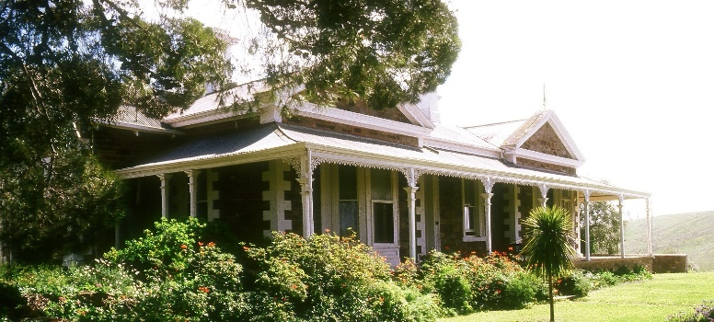  Substantial Victorian era villas illustrate post mining pastoral wealth
- A density of mature, planted and natural vegetation contrasting with a backdrop of bare hills. Contributing to individual character areas are Red Gums in Burra Creek; Aloe in Redruth; Pines in Bon Accord and Bridge Terrace; formal street plantings of White Cedar, Carob and Plane trees. | 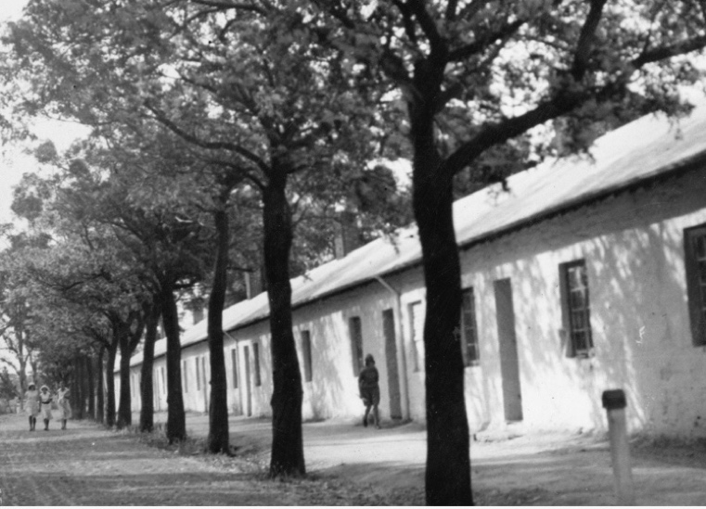  (SLSA B-8630) 1933, Paxton Square Cottages, Kingston Street
- Informal public realm streetscapes including absence of parking bays, and repetitive lighting. Historic stone kerbs and drains survive in areas. Although many roads are sealed, outlying streets remain gravelled. | 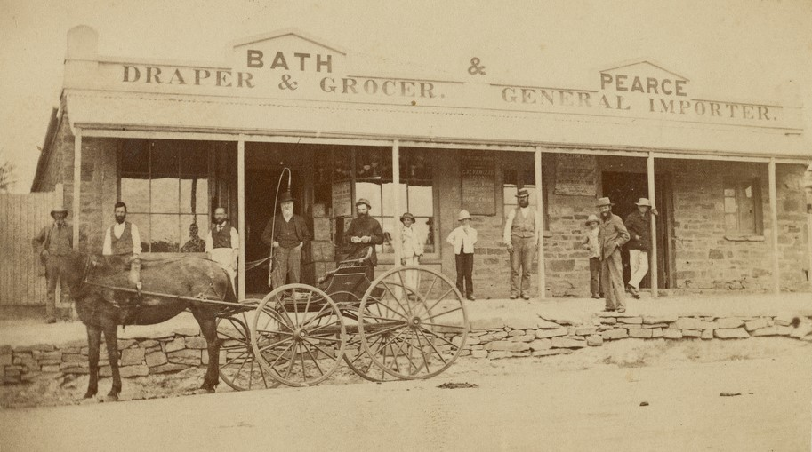(SLSA B-73361) 1880, stone retaining walls, kerbs and drains
- Burra Creek bridge crossings. Redruth and Kooringa linked by the stone ‘Mine Bridge’. | 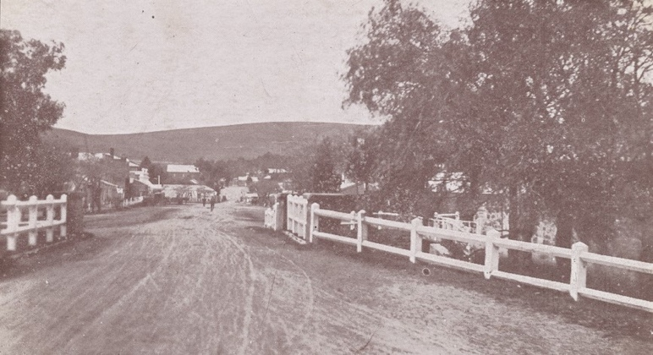  (SLSA B-47938) 1906 Commercial Street Kooringa
- Minimal advertising, way-finding and interpretation signage. Traditional commercial/retail signage in town centre. | 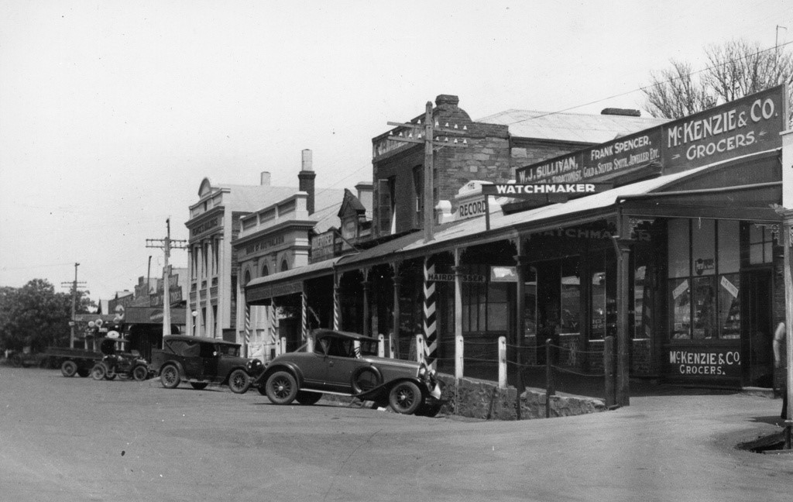(SLSA B-8633) 1933, Traditional retail signage style and location
- Abandoned Hampton Township evidences the population exodus following the 1877 mine closure. Features of significance include Jacka House (reconstructed), street and allotment layout, remnant fences, walls, stone dwellings, quarries and introduced trees of almond, pine, olive and pepper within a rural setting. | 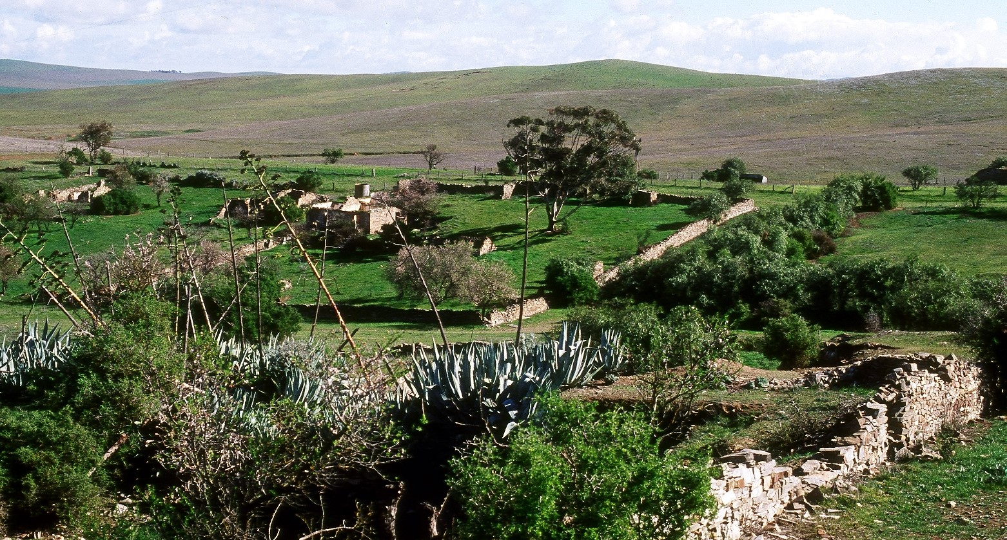
- Burra Cemetery retains a valuable genealogical and religious record of the Burra community. | 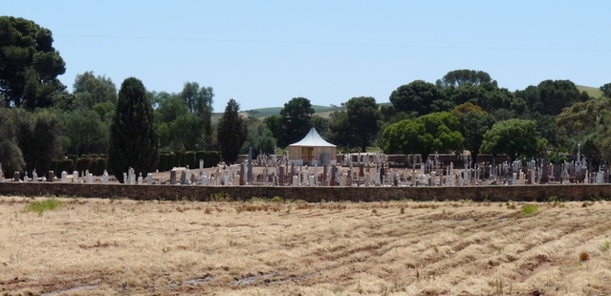
- Burra Mine Site landscape – barren hillscape scarred by mine cuttings, former roadways and ruined structures, visually dominated by the 1970’s open-cut mine and overburden. | 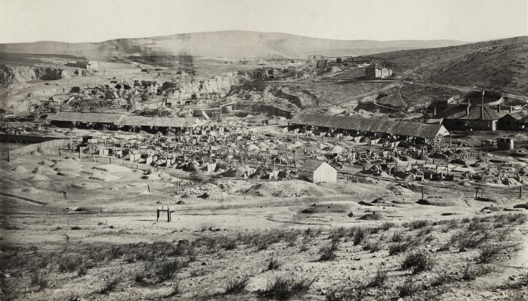  (SLSA 4147) 1870_Burra Panorama
- Physical evidence and layout of mine site’s industrial architecture, including ruins of mining shafts, engine houses, crushing plant, ore sorting floors, mine stores, mine offices and company dwellings, demonstrating the complete Cornish mining system and its associated infrastructure. | 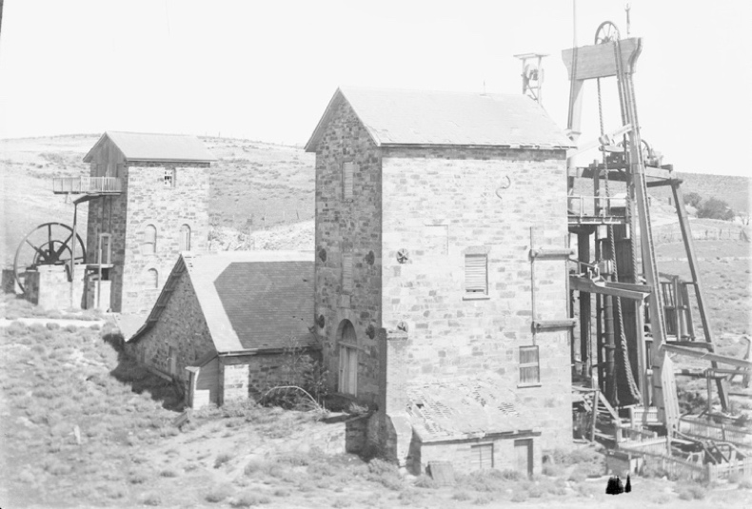  (SLSA RG-733-507) 1915-30, Morphett’s Pumping House
- Inaccessible, abandoned underground workings evidence transplanted Cornish mining practices of tut and tribute work. Remnant shafts reflected in the arrangement of surface mining structures. | 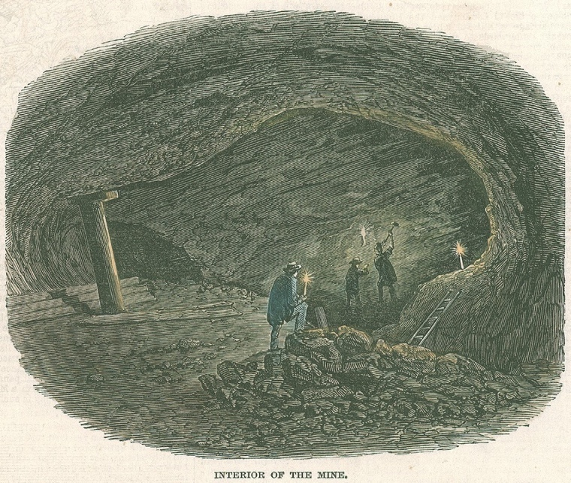  (SLSA B-69728-3) 1848, Mine Interior, S.T Gill
- The 1870 open-cut mine extended mining operations for seven years, destroying all but two of twelve major shafts. Modern (1970s) open-cut operations buried much of the remaining archaeology beneath overburden, dramatically altering the setting and legibility of earlier mining operations. | 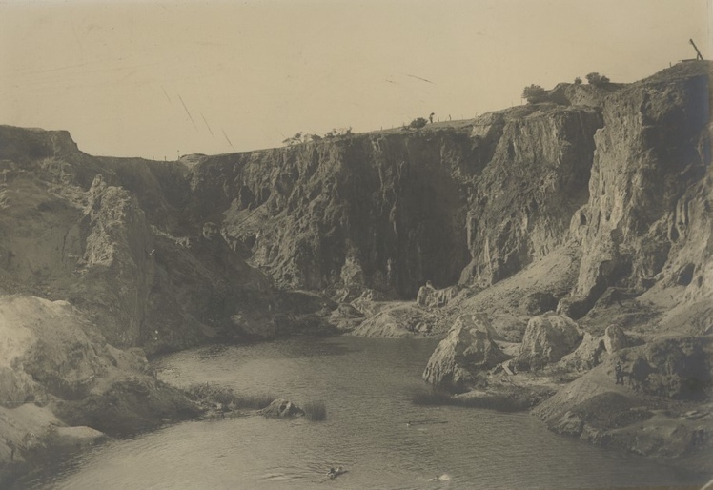  (SLSA B-47670) 1904, Burra Mine Pool
- Subsurface archaeological remains, including those, as yet, undiscovered, form part of the record of Cornish mining practices, technology and settlement.

- Moveable heritage items form part of the visual setting and heritage value of Burra, contributing to the understanding of Cornish mining influence and technology. | 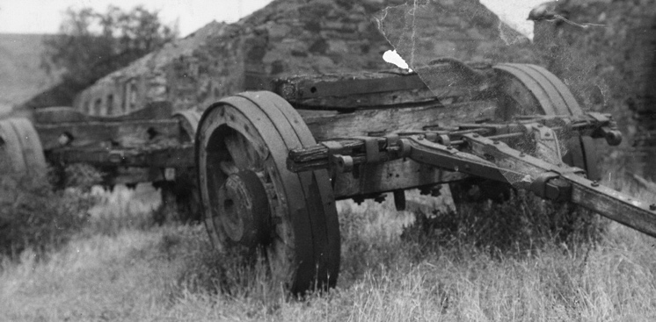  (SLSA B-8637) Burra Jinker demonstrates a remote community’s dependence on animal transport
- The former Bon Accord Mine Buildings demonstrate speculative mining operations in Burra. | 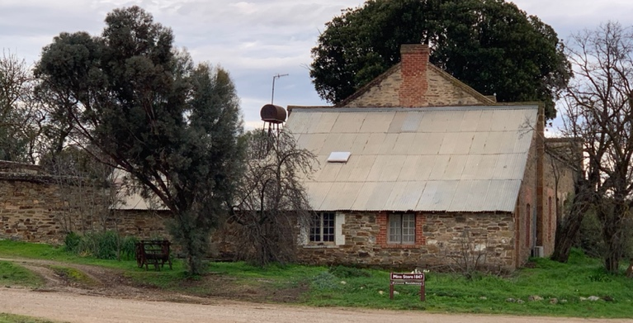
- Scattered ruins and surviving buildings of former Burra Smelts historic site, evidence the introduction of Welsh smelting technology and practices to improve economic viability. | 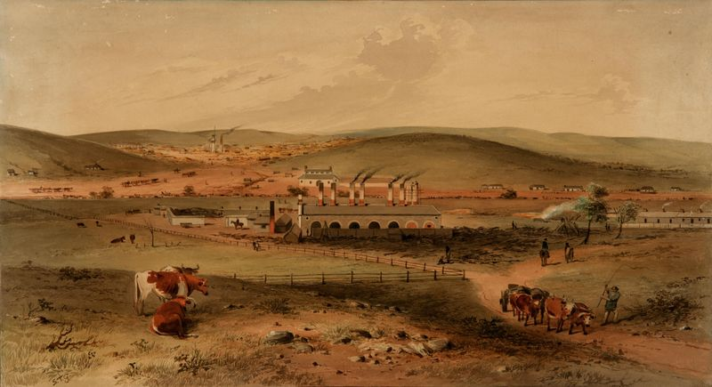  (AGSA) 1850, Patent Copper Company’s Smelting Works and the Burra Burra Mine, S.T.Gill, watercolour on paper
- Key vistas and views: Maintaining visual connections and sightlines between, towards and from historically significant areas. e.g. Hampton Village towards Burra and the Historic Mine site; Burra Creek between the Mine and Smelts sites. | 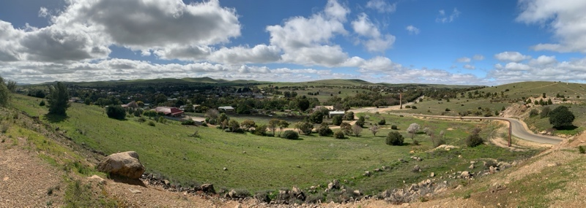  View from mine site towards two settlements separated by Burra Smelts.
Architectural features of heritage value include:
- Extensive use of local bluestone (Hampton Quarry) provides a unifying element in the built environment. Construction techniques include random rubble stone with lined pointing; coursed stone walls to civic buildings; rendered or red brick quoins and surrounds; rendered walls and details typically limewashed. | 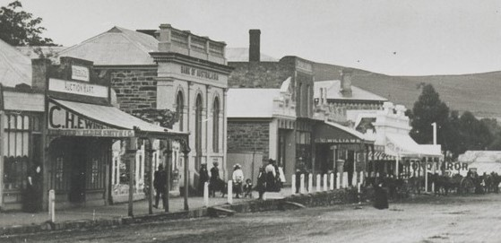  (SLSA B-27684) 1900 Commercial Street Kooringa
- Consistent building scale of mid-Victorian era, including wall-to-roof proportions; ridge-to-eaves length; street frontage length. | 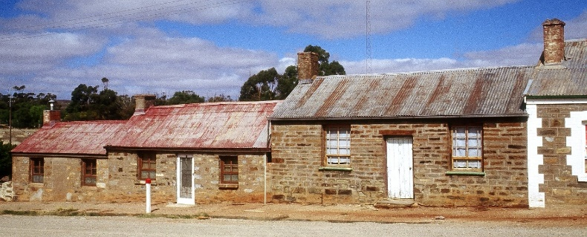
- Consistent development patterns contributing to the streetscape character of localities, including building set-backs and spacings, scale and mass, vertical heights and horizontal lines. | 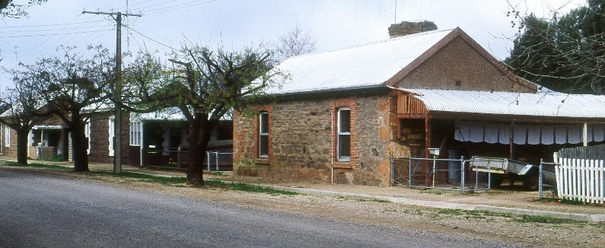
- Steeply pitched (30-40 degrees) gable/ hipped roofs, clad with painted or galvanised, corrugated steel sheeting. Consistent (barge/eaves) edge detailing. | 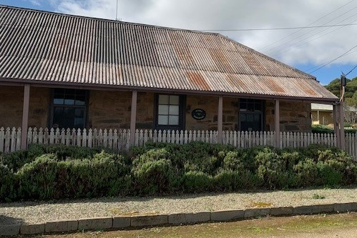
- Simple, timber-framed, open verandahs with straight-pitched or concave roofs, supported on plain timber posts. Absence of decorative features. Some later Victorian verandahs were bullnose with decorative iron brackets and balustrades. Earlier housing typically built without verandahs in the Cornish style. | 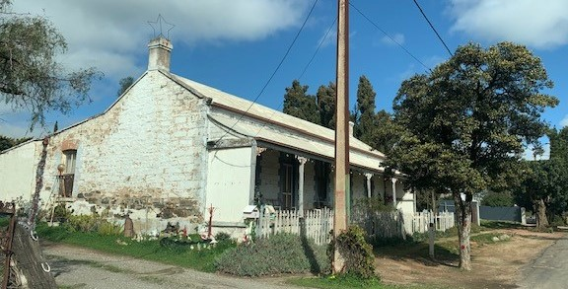
- Modestly scaled, vertically proportioned timber doors and sash/casement windows (earlier multi-paned). | 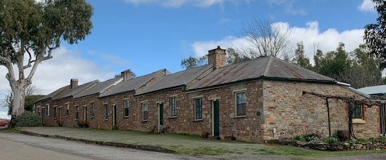
- Traditional lean-to additions to rear of buildings, clad in corrugated steel sheet or weatherboard. | 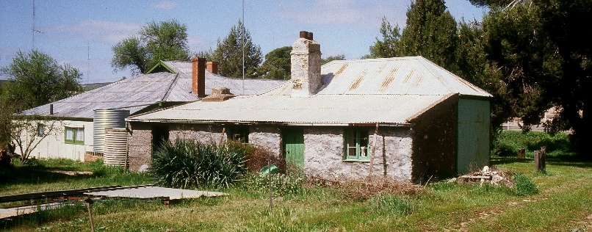
- Small circular corrugated steel water tanks. | 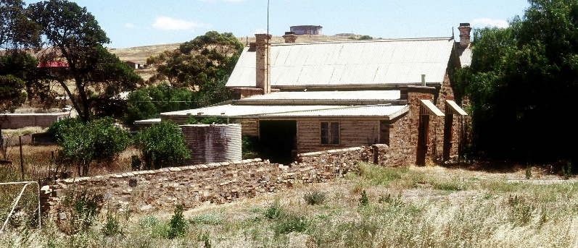
- Freestanding outbuildings of small scale and traditional form, constructed in stone or clad in galvanised, corrugated steel sheeting or timber siding. | 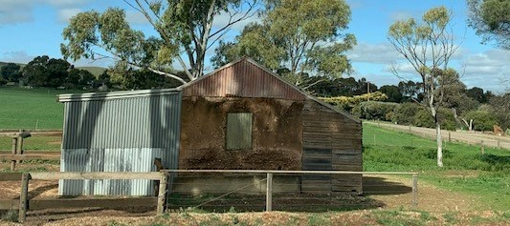
- Fencing: low stone walls; low, open post & wire / post & rail, timber pickets of simple profile. Galvanized, corrugated steel fencing to side and rear boundaries of dwellings typical of more recent development. | 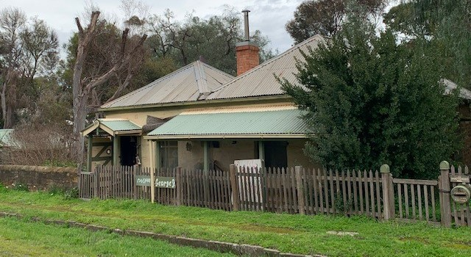

Heritage Standards for Development (Burra State Heritage Area)

Purpose of Heritage Standards for Development
Any proposals to undertake development within a State Heritage Area will be referred to the Minister responsible for administering the Heritage Places Act 1993, for heritage advice. Heritage South Australia (Heritage SA) in the Department for Environment and Water is the Minister’s delegate for decisions on referred development applications. Heritage SA also has the ability to direct conditions, should the development be approved, or to direct refusal if heritage values are compromised. The Heritage Standard forms a key part of Heritage SA’s assessment of development proposals.
Heritage Standards:
- provide a basis for assessment regarding management of heritage impact of development by Heritage SA Heritage Officers.
- include heritage principles and location specific detail on how development can be undertaken to ensure heritage values are protected
- propose a minimum acceptable standard for development related solutions within the State Heritage Area
A State Heritage Area includes both private and public spaces (including streets) and a Heritage Standard is applicable to development across the entire area.
Development associated with a State Heritage Place and also within a State Heritage Area is defined in the Planning, Development and Infrastructure Act 2016 Part 1, 3 (1). Additional definition specific to a State Heritage Place or Area includes:
“ (e) …….—the demolition, removal, conversion, alteration or painting of, or addition to, the place, or any other work that could materially affect the heritage value of the place”.
The State Heritage Area Overlay ‘Procedural Matters (PM) Referrals’ – identifies the types of development to be referred to the Minister responsible for the Heritage Places Act 1993 - Heritage SA, for assessment and direction.
Exemptions to the definition of Development within a State Heritage Area are scheduled in the Planning, Development and Infrastructure (General) Regulations 2017 – Schedule 5
Development of a State Heritage Place, located within in a State Heritage Area, is governed by the State Heritage Place (SAPPA) Overlay. This Overlay requires approval for development of the interior and exterior of a State Heritage Place.
The Burra State Heritage Area is to be conserved and interpreted as a place of historic and archaeological significance, demonstrating Cornish mining history in South Australia. Conservation and development is to be undertaken in order to preserve the character of the place and uphold its heritage values through:
- Retention of the original land subdivision pattern.
- Reinforcement of the mining village character with minimal infrastructure.
- Retention of significant views across the historic mining site and out towards to agricultural land.
- Retention and conservation of the buildings, structures and ruins of heritage value.
- Adaptation of existing buildings and structures to ensure their long-term conservation and viability.
- Unity of built form, with new buildings compatible in design and form to existing buildings of heritage value.
- Retention of the town’s landscape character.
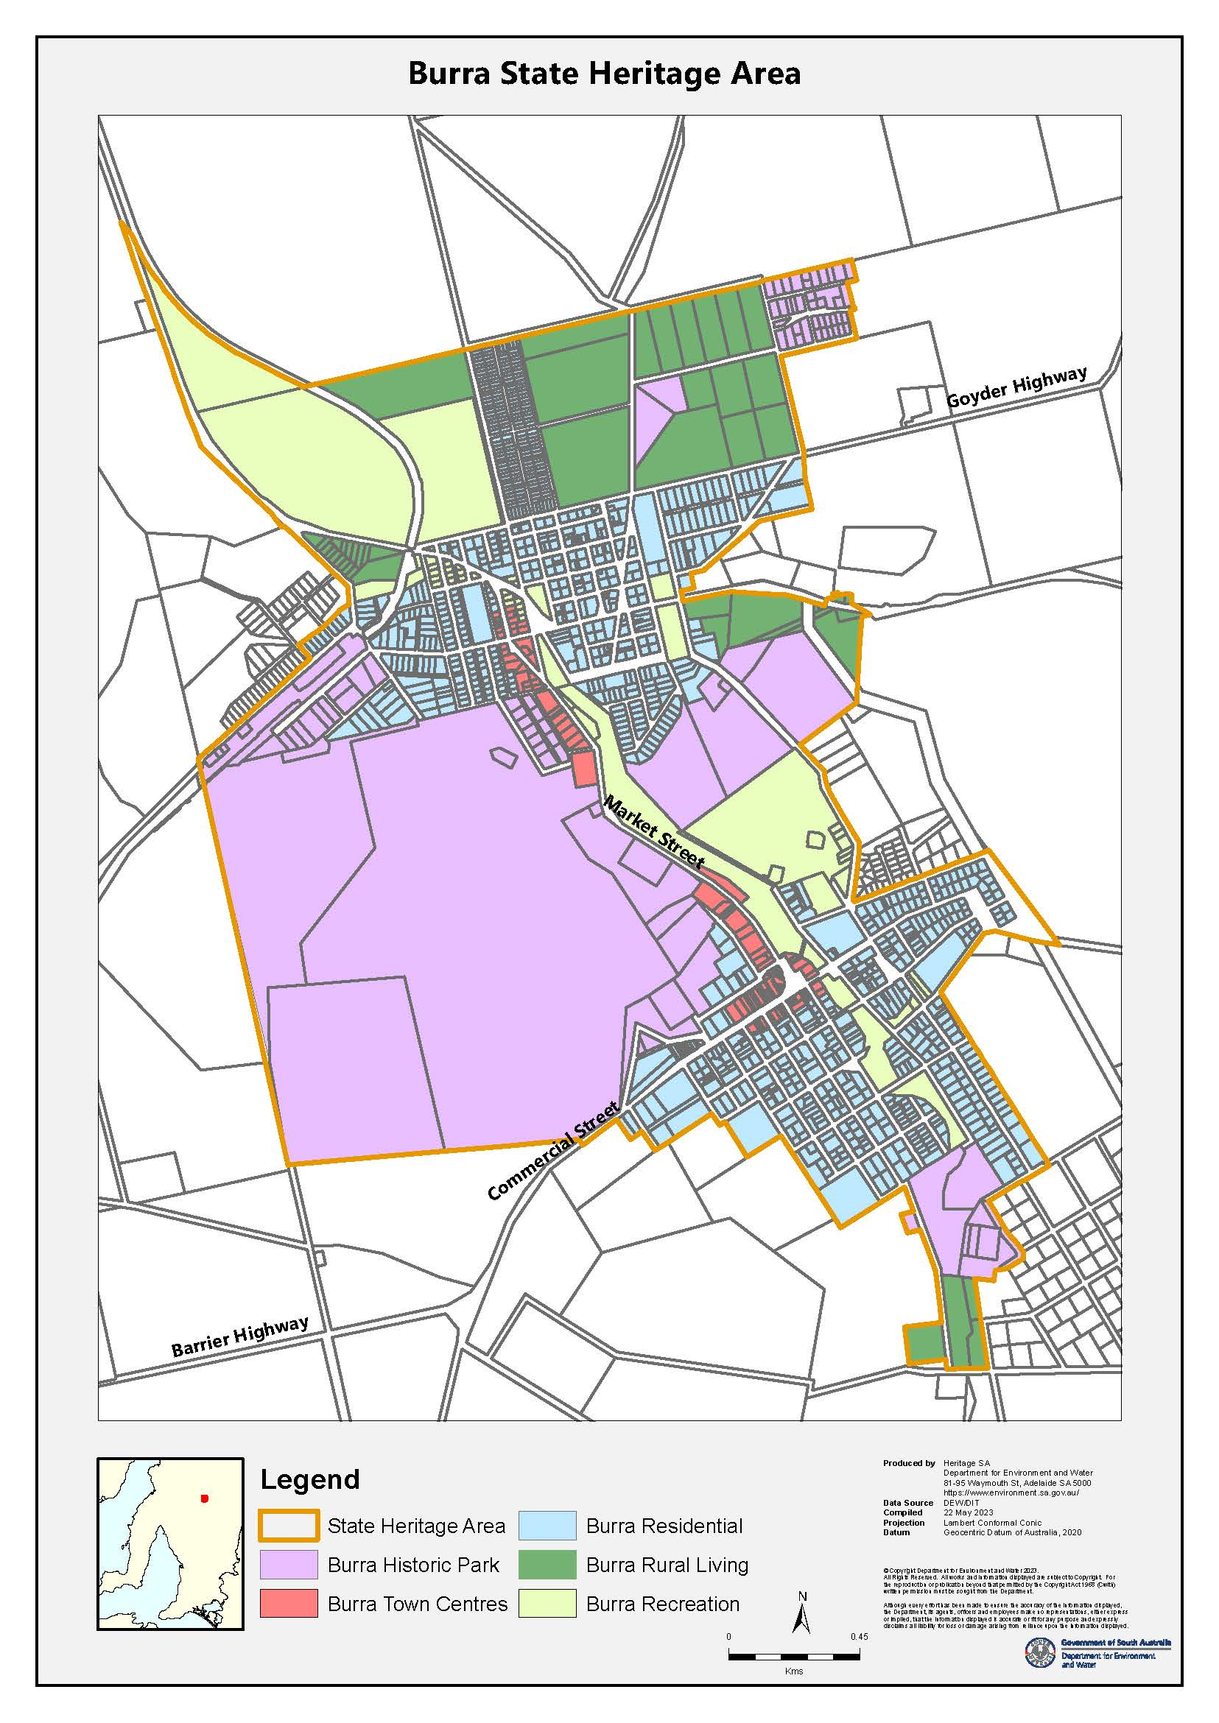

Land use
(refer: State Heritage Area Overlay – Alterations and Additions PO 2.2)
Burra’s land use arrangement derives from its historic development within original survey sections. The southern (Section 1), acquired by SAMA, was dedicated to exploiting and protecting the company’s mining interests. Government and private development took place incrementally north of the company border, resulting in a north/south disbursement of settlements separated by mining activities. Ecclesiastical, civic and commercial amenities were established as townships grew, with Redruth becoming the focus of Colonial government institutions, as two distinct residential areas set within the topography of a pastoral valley.

Principles | Acceptable Standard

3.2.1. Land Use
The land use plan intent associated with the State Heritage Area is important to understanding Burra’s mining and settlement history. Original land use is evidenced in Burra’s informal grouping of settlements established to support mining operations. Subsequent changes record the decline of the mining industry and its replacement with the agricultural and tourism industries.
Development is to have regard to the following:
3.2.2. Land use planning | Spatial distribution of the functional land use areas is to be retained in future planning. Shops, offices, civic, community, religious and similar non-residential development is to occur within existing sites either currently used for that purpose, or existing buildings originally intended for that purpose.  Development to have regard to the open, rural setting of Burra.  Development within Historic Park areas is restricted to conservation, interpretation and the sensitive adaptation of existing buildings and structures supporting tourism use. Adaptive reuse of existing shops or community facilities is possible, but the external appearance of existing buildings is to continue to reflect land use plan intent during the period of heritage value associated with the State Heritage Area.  Original shop and commercial buildings located at Market Square and Morehead Street to be retained, restored and reused, having regard for their original purpose. Reactivation of Bests Place as a second Town Centre, providing a focus for commercial and retail activities in North Burra, is appropriate.  Development along Burra Creek to be limited to landscaping, supporting civic / recreational use.

3.3 New buildings
(refer: State Heritage Area Overlay - Built Form PO1.1 to 1.5)
New buildings within the State Heritage Area are to reflect and contribute to the historic character and setting of the area. Where existing structures do not contribute to the heritage value of the place they may be replaced.
Existing incompatible development within the State Heritage Area cannot be referenced to justify design variation from this Heritage Standard.

Principles | Acceptable Standard

3.3.1 Siting of new buildings
Burra’s townships contain some of South Australia’s earliest miners’ housing. Attached row cottages and detached dwellings retain their original character. Commercial and public buildings associated with the former mining community line the main streets, all contribute to the village feel of ‘Little Cornwall’.
The built form character of Burra is homogenous in era, scale, form and use of materials, demonstrating Cornish building techniques and way of life.
New buildings are to have regard to the following:
- Street and side boundary setbacks  New development reinforces the continuity of existing streetscapes, maintaining the historic allotment layouts characteristic of the area.  Building setbacks and spacings reference existing adjacent development, reflecting the original pattern of development in the area.  New buildings are sited to match the prevailing built form spatial character of the surrounding street/landscape, adopting typical setbacks and alignments. The visual dominance of existing buildings of heritage value is maintained. Key views/vistas are protected. | Dwellings: Front and side setbacks are to repeat existing on the allotment or within the locality. Street edges and typical spacings between buildings are maintained.  No new construction should take place between the street boundary and front or side facades of existing buildings.  Non-residential buildings: Development to adopt street and site setbacks common to existing surrounding buildings.  In areas where buildings post-date 1939, front and side setbacks are to repeat existing setbacks on the allotment or in the surrounding street.
- Earthworks  Retention of the natural topography of the surrounding landscape within Burra. | New buildings are designed and sited to minimise land cut and fill and benched into sloping sites where necessary, to visually minimise built form scale and bulk. Excavation of sites for ramps, undercroft or subterranean garages is not acceptable.

3.3.2 Form and design of new buildings
The form, scale and architectural features of existing mid-Victorian (1845-1877) buildings in Burra are of heritage value, demonstrating Cornish mining practices, construction techniques and culture.
New buildings are to have regard to the following:
- Scale  The prevailing scale of established residential and retail development is single storey and modestly sized. Community and company buildings are larger in scale, with higher ceilings and steeper roofs, reflecting their landmark importance.  New development to reflect scale of established built form. The scale and bulk of new work should not dominate the established. | Dwellings: New buildings to be single storey in height, modest in scale, adopting small, rectangular floorplans (traditionally 2-4 interconnecting rooms without corridors, arranged beneath principal roof and lean-to). Wall, eaves and ridge heights are to match those in the locality, façade heights typically measuring 3-4m from ground to roof gutter, and 2-2.4m from ground to verandah gutter.  For larger building footprints, a grouped arrangement of small building elements reduces visual bulk by maintaining the short roof spans characteristic of the area.  Non-residential buildings: Scale and bulk of new development is to reflect the height and footprint of existing buildings in the area. New development should not visually dominate existing structures of heritage value.  In areas where dwellings post-date 1939, the scale of new buildings is to match those typical in the surrounding street. The scale of new community buildings is to reflect the height and footprint of existing community buildings within the suburb.
- Roof form and pitch  Roofs in Burra are steeply-pitched (35-40⁰), typically simple / parapet gable-ended, or slightly lower-pitched, simple hipped without eaves. Early row cottages followed Cornish tradition, constructed without street-front verandahs. Chimneys are large, sometimes set diagonally, servicing more than one room.  Outbuildings are generally smaller versions of these basic forms, or have simple, low, mono-pitched roofs. | Dwellings: Roof forms and eaves profiles are to match traditional styles characteristic in the locality. New roofs to reflect the traditional, incremental extension of local houses - adopting a grouping of smaller, steeply pitched gables or hipped roofs to reduce building mass, and incorporating simple verandahs to front facades and lean-tos to rear.  Non-residential buildings: New development to reflect roof form and pitch in the area, without dominating existing buildings of heritage value.
- Façade proportions and openings  Design of buildings is consistent and horizontally proportioned in style, with double-fronted facades punctuated by small, vertical openings (1:2 window proportions typical). Windows traditionally multi-paned double-hung sash or casement with substantial frame profiles. | New buildings to complement the proportions and architectural features of surrounding buildings of heritage value. Window and door openings viewed from the public realm to be traditional in construction, scale and proportion.
- Verandahs and Lean-to additions  Early ‘Cornish’ style dwellings retain front facades without verandahs, or later verandah additions of simple style (e.g. Upper Thames Street; Paxton Square). Late Victorian era verandahs and balconies, on commercial buildings (eg. pubs), were more elaborately decorated.  Verandahs and lean-tos are simple, straight-sloped or concave (bull-nose less common), supported on plain timber posts, clad in corrugated steel sheet. Lean-to extensions are smaller in scale to the main building structure, clad in corrugated steel sheet and weatherboard. | Verandahs and lean-tos to be modest in scale and simple in design - straight pitched or concave roofs. Spacing of verandah posts to match existing examples.  Elaborately decorated verandahs are typically not in keeping with the character of Burra State Heritage Area. Where removed or altered, verandahs are to be reinstated to original, or otherwise appropriate, form and detailing.
3.3.3 Materials, finishes and colours  The architectural features of Burra’s mid-Victorian era (1845-1877) buildings are of heritage value, demonstrating Cornish mining practices, construction techniques and way of life.  Existing buildings are consistent in design and material, constructed of local bluestone, with dressed stone or brick quoins, chimneys and window surrounds.  Originally constructed in large numbers on the hillsides around the mine, few of Burra’s early‘timber paling’, ‘wattle and dab’, ‘board’, ‘pug’, and ‘brick’ houses survive. Early timber shingle roofs were over-clad with corrugated steel sheet. | New development is to have regard to Accepted Materials, Finishes and Colours as scheduled in: (Alterations and Additions) 3.4.3 Materials, finishes and colours, incorporating those common to the era of heritage value of the State Heritage Area.

3.4 Alterations and additions
(refer: State Heritage Area Overlay - PO 2.1)
Additions and alterations are acceptable, provided they do not visually dominate existing buildings or the surrounding street/landscape of heritage value. Any addition or alteration is to complement the established building, without attempting to imitate architectural features, maintaining a clearly legible pattern of development.

Principles | Acceptable Standard

3.4.1 Site and location of additions
Development is to reflect the established setback, scale and subdivision layout of the locality. Key views/vistas are to be protected.
Development is to have regard to the following:
- Street and side boundary setbacks  Development is to repeat site setbacks common to existing surrounding development of heritage value. Additions and alterations maintain the historic allotment layouts characteristic of the area. | Dwellings: Additions are to be located to the rear of existing dwellings, matching building width, or to one side of existing dwellings (unless on a secondary street boundary).  Additions to the side of existing buildings are only acceptable where the shape and space available on an irregular allotment precludes rear additions. In these cases, additions to the side are to be set back from the existing front façade by at least 4 metres, and set back a minimum of 1.5 metres from any point along a side boundary. If the existing building is located less than 1.5 metres off the side boundary, additions can match this alignment, subject to approval.  Non Residential Development: Development: is to repeat the site setbacks common to existing surrounding development.

3.4.2 Design of additions
The form, scale and architectural features of existing mid-Victorian era (1845-1877) buildings in Burra are of heritage value, demonstrating Cornish mining practices, construction techniques and way of life.
Additions may be acceptable where they support ongoing use, are visually recessive, are distinguishable from the original built form.
New buildings are to have regard to the following:
- Scale  Burra retains a consistently single storey scale of established residential and retail development, with some two-storey exceptions in the town centre. Community buildings, such as schools and churches, are larger, reflecting their landmark importance.  The scale and bulk of new work should not visually dominate the existing building. | Dwellings: Residential development, developed to reflect the typical site coverage on existing allotments. Additions should not have a floor area greater in area than the existing building footprint.  Additions to be designed so that the scale, plan and roof form of the original dwelling is clearly legible. A break in the roof line between dwelling and addition is required.  Additions to be single storey, matching the eaves height of the original dwelling. Two storey additions, in the form of an attic or mezzanine room are limited in height to that of the original ridge line of the roof.  To complement existing built form and composition, larger additions can be designed as a group of smaller units, referencing the historic, incremental expansion of original, modestly scaled cottages. Where possible, the natural slope of the ground can be used to add ceiling height.  Non-residential development: The scale of additions is to respect existing mass and height without dominating the established. Additions to existing retail buildings are to be single storey.
- Roof form and pitch  Established dwellings maintain an overall consistency in roof form (typically a grouping of gable or hipped roofs reflecting the incremental expansion of original cottages), are steeply pitched (35-45 degrees), without eaves. Lean-to additions and verandahs are a lesser pitch. | Dwellings & non-residential buildings: Roof form, pitch, span and ridge height of additions is to match the existing building of heritage value, repeating eaves, barge and verandah details.  Roofs are to be designed so that the original building form remains legible. A break in the roofline between existing building and addition is required. Lean-to additions to be set out below the gutter line of existing roofs. Verandahs to be simple-sloped structures supported by timber posts.  Chimneys to existing roofs are to remain and not be removed when roof cladding is updated.
- Façade proportions  Single room terrace fronts and symmetrical cottage facades demonstrate the Cornish building tradition of 1845-1877 era miners housing in Burra. Building proportions are consistently 2/3 wall to 1/3 roof, with lean-to additions and small, vertically proportioned doors and windows. | Dwellings: Where visible from the public realm, additions to dwellings are to complement the proportions of existing buildings of heritage value.  New window and door openings should not dominate front or /side facades. Openings to be similar in scale, proportion and extent of original building. Plate glass walls and ‘patio’ doors are not acceptable where visible from the street.  Non-residential development should respect the proportions of existing built form of heritage value.
- Alterations to original building features  The overall consistency in architectural features to buildings associated with the 1845-1915 period buildings is of heritage value in Burra. | Refer [3.10 Conservation Works] for further details  Dwellings and non-residential buildings: Exposed external masonry walls are to be retained and not painted or render finished.  Façade features, including windows and doors, are to be retained in their original configuration and material where visible from the public realm. The original detailing of verandahs and lean-tos is to be retained. Front verandahs are to remain unenclosed.  Where inappropriate alterations have been undertaken in the past, reconstruction of the original known form is acceptable. Where evidence of removed or altered original features is not clear, reinstatement using architectural detailing referencing nearby buildings of similar style is acceptable.  Façade features to shops and community buildings are to be retained in their original configuration and material where visible from the public realm.

3.4.3 Materials, finishes and colours
The architectural features of existing 1845-1877 era buildings within Burra are of heritage value, demonstrating Cornish mining practices, construction techniques and way of life. Buildings are consistent in design and material, using locally-quarried stone, with dressed stone or brick quoins, chimneys and window/door surrounds.
Alterations/ additions to be undertaken using materials which complement those used in adjacent buildings of heritage value.

The design of alterations and additions is to have regard to the following: | Acceptable | Not supported (where visible from the Public realm)
- Roofing and rainwater goods (new)  Roof cladding, gutter and downpipe profiles are to match original, traditional profile. Where evidence of an original gutter profile exists this should be reinstated. | - deep profile, corrugated, galvanised or Colorbond metal sheet (traditional red or mid grey tones to match galv.iron)  - Galvanised or Colorbond (mid grey) ‘ogee’, & ‘half round’ profile gutters; round galvanised or Colorbond (mid grey) downpipes.  - scribed roof cappings  - ‘colonial’ rainwater heads, unless originals remain. | - metal sheeting profiles, other than traditional corrugated.  - Zincalume finish; Colorbond colours incompatible with the traditional galv./red-painted roof tones (incl. very dark or very light Colorbond)  - PVC or square profile metal gutters & downpipes.  - roof tiles.
- Exterior walls (new)  Dwellings and outbuildings are typically constructed of local random rubble bluestone with dressed stone or brick quoins and surrounds. Additions and outbuildings are clad in corrugated iron or timber weatherboard. Public / commercial buildings have stone or rendered quoins.  Stone construction to follow traditional construction methods and style – laid in the direction of the stone bed, roughly coursed and pointed in a traditional style with lime mortar.  Note: Existing face stone and brick to original dwellings to not be rendered or painted. | - random rubble bluestone with dressed, rendered or brick quoins and surrounds to match existing material/detailing.  - deep profile, corrugated, galvanised metal sheet Colorbond metal sheet (mid stone/ grey tones)  - painted timber weatherboard, (19mm min. thickness, profile to match traditional). | - square profile steel sheeting.  - zincalume or Colorbond metal sheet in colours other than historic examples, incl. very light or very dark greys  - brick walling  - concrete blocks  - fibre cement sheeting  - cement render  - stone construction not in keeping with style or materials used in buildings of heritage value incl. stone veneer facing  - painting of unpainted masonry.  - Unpainted/exposed timber  - vertical weatherboard
- Proposed external doors and windows in view of the public realm  Timber doors and double-hung sash or casement windows,vertically proportioned with substantial timber frame profiles. | - simple, timber framed, recessed panel doors appropriate to the period.  - timber (woven) flywire screen doors.  - timber-framed windows, matching traditional cross-sectional details; vertically proportioned double-hung sash or casement, four-pane casement (square format); timber-framed, metal clad window hoods to match traditional details.  - dressed stone or rendered sills.  - expressed timber lintels. | - sliding doors/windows.  - decorative aluminium screen/security doors.  - aluminium-framed doors and windows.  - horizontally proportioned and/or large windows.
- Exterior painting  Colour schemes to be appropriate to the historic period of construction.  Stripping of historically painted timber and painting of unpainted external surfaces to existing buildings is not supported. | - Painting of additions is not deemed development, but compatible colours are encouraged.
- Verandahs (new)  Where altered, verandahs should be reinstated to original or appropriate form and detailing. Introduction of decorative elements (e.g. cast iron lacework and turned posts) is inappropriate where it was not part of the original construction. | - Simple, dressed, timber posts (110-120mm square).  - Spandrel ends clad with vertical boards, timber barge trim or metal-flashed top & un-trimmed bottom edges.  - simple timber or iron brackets where evidence of existing original.  - flagstone, timber board, natural ground verandah floors. | - decorative timber posts.  - steel or concrete posts.  - post shoes.  - tiled verandah floors to pre 1870s dwellings.
- Fencing | - refer 3.5.2 Fences and Gates
- Ancillary Development | - Refer 3.5 Ancillary development

3.5 Ancillary development
(refer: State Heritage Area Overlay - PO3.1-3.3) – garages, carports, sheds, verandahs, solar panels, signage, fences
Ancillary development in Burra includes: carports, garages and sheds; studios, offices and dependent accommodation; fences and gates; signage; solar panels and skylights, rainwater tanks and other ancillary services. While such development is of a secondary nature, it may still have an adverse impact on the heritage value of the State Heritage Area if not managed appropriately.

Principles |  | Acceptable Standard

3.5.1 Outbuildings including carports, garages and sheds; studios, offices and dependent accommodation
Outbuildings contribute to the built form heritage values of Burra.
Existing outbuildings in Burra are typically smaller freestanding versions of 1845-1877 buildings common to the town: rectilinear in plan, with short-span, steeply-pitched, gabled, hipped or low-pitch skillion (mono-pitched) roof forms Materials used are stone or galvanised corrugated steel wall and roof cladding.
Development is to have regard to the following:
- Outbuildings (garages and sheds; studios, offices and dependent accommodation)  New outbuildings complement the architectural language of existing buildings of heritage value. The scale and bulk of these structures do not dominate existing buildings.  Outbuildings are located to avoid adverse visual impact on the setting of buildings of heritage value.  Outbuildings are free-standing and located to the rear of existing buildings, well set back from the street, to maintain the character of streetscapes in Burra. Key views and vistas are to be protected (refer 3.7.1 (c)). | Enclosed outbuildings are to be free standing and sited behind existing buildings, located a minimum distance of 900mm off rear boundaries and 1.5 metres off side boundaries.  Outbuildings are to be to be rectilinear in floor plan and constructed of stone, stone-coloured render, weatherboard or corrugated steel sheeting, in galvanised finish or Colorbond mid stone/grey tones.  Roofs to be steeply pitched (35-45 degrees), gabled or hipped, of modest ridge-eaves length (max. 2m). Small-scale skillion roofs are acceptable where out of view of the public realm.  Sheds greater than 80m2 are acceptable outside residential / township areas if roof spans are reduced by incorporation of several gable/lean-to forms, reducing bulk. The roof pitch of larger sheds (>2m ridge-to-eaves length) is acceptable at 25 degrees, provided the outbuilding is not located in visual proximity to a historic building of smaller proportions, the development does not impact on key views or vistas, or otherwise negatively impacts on the public realm.
- Outbuildings (carports)  Open carports, with no walls or doors, attached to the side of dwellings are only acceptable where they do not detract from the appearance of buildings on the site, neighbouring buildings, or adversely impact on the public realm. | Open, attached carports have no walls or doors, are sited a minimum of four metres behind the front wall of the dwelling and any secondary street boundary, and set back a minimum of 900mm from a side boundary with no part of the structure (eaves or fascia) to be closer than 450mm to the side boundary. Lean-to carports attached to dwellings should be oriented to project out from the existing side walls and match details of front verandah. Timber carport posts are to be 120x120mm in dimension.  Freestanding carports have steeply pitched (35-45 degrees) gabled or hipped roof forms of modest ridge-eaves lengths (max. 2m), similar to associated dwellings. Skillion roofs are acceptable where out of view of the public realm.  Carports are not to be greater than 40 square metres in area.  Carports greater than 40m² are acceptable outside residential and township areas if roof spans are reduced by incorporation of several gable/lean-to forms, reducing bulk. A 25-degree roof pitch is acceptable for larger carports (>2m ridge-to-eaves span), provided the outbuilding is not located in visual proximity to a historic building of smaller proportions, does not impact on key views or vistas, or otherwise negatively impact on the public realm.
- Pergolas and garden structures | Freestanding or attached pergolas to be located to the rear of existing buildings, to avoid adversely impacting on views from the public realm.
3.5.2 Fences and gates  Early miner row houses and cottages followed the Cornish village tradition of house fronts constructed on street boundaries. Fencing was typically low, open and minimal in style. Simple timber-framed picket or paling, timber post & rail / post & wire fencing reflects Burra’s rural setting. Extensive stone walling survives in some areas. Later corrugated steel sheet fencing to side and rear boundaries is not in keeping with the period of heritage significance. | New fencing to match palette of materials typical to locality, as evidenced in historic photographs. Fencing styles to reflect informality of traditional post & wire / post & rail or timber picket fencing, reinforcing Burra’s rural setting. Fence posts to be hardwood where in view of the streetscape.  Existing stone walls to be retained and, where appropriate, restored and extended.  Corrugated, galvanised steel sheet fencing to secondary boundaries is acceptable, as the material is common to the period of significance.  Replacement of inappropriate fencing materials is supported.
- Fences and gates (replacement or new) | Location |  | Accepted
 | - Town Centre |  | Low stone walls post and wire/post and rail; simple timber picket fence & gate.
 | - Residential
 | - Boundary A shown below |  | No higher than 1.2m: simple timber picket fence & gate, post & rail / post & wire fence; stone walls based on historic evidence; planted hedge.
 | - Boundary B shown below |  | No higher than 1.2m: simple timber picket, post & rail / post & wire fence; not higher than 1.5m: deep profile corrugated galvanised iron sheet / timber paling (vertical orientation) on timber frame.  Taper height to Boundary A fence.
 | - Boundary C as shown below, and other adjoining property boundaries |  | No higher than 1.2m: simple timber picket, post & rail / post & wire fence; not higher than 1.5m: deep profile corrugated galvanised iron sheet / timber paling (vertical orientation) on timber frame. Planted hedge.  Taper height to Boundary A fence.
 | 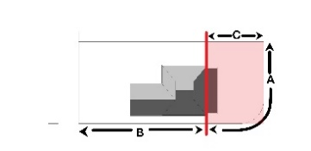
 | - Rural |  | Simple post & rail; post & wire fence.
 | - Public Buildings |  | Unfenced, or reinstatement of historic fencing based on evidence.
 | - Former Mine Sites |  | Unfenced, or security / safety fencing (e.g. around mine shafts) open in style and consistent across site (designed as part of overall site re-presentation).
 | - Public Recreational |  | Open rural-type fencing of post & wire or post and rail.
3.5.3 Signage  Signage to be minimal, small and of a low profile within the town/landscape, sited to avoid negatively impacting on views, vistas and visual amenity of the place. | All external signs in the Burra State Heritage Area require development approval.
- Advertising signage  New signs should be compatible with the setting, scale and character of the immediate area. | Signage to not conceal or obstruct historic detailing, project beyond the building silhouette or skyline, or otherwise form the dominant visual element of a place.  Signs are not to be more than 1m² in area; contain internal illumination or neon lighting. Permanent LED screen type signs are not acceptable. Sign design to be based on a heritage range of external colours appropriate to the era. Corporate colour signage is not acceptable.  Commercial (office / retail) signage is to be restricted to traditional signage panel locations below roof level, such as parapet walls above verandahs, verandah fascias and infill end panels, hung from below verandah fascias and painted on shop windows.  Community Buildings: Signs for public, school and religious buildings to be small and free-standing, sited so as not to intrude on the setting of the place.
- Directional & Interpretive signage  Interpretative and directional signage to be informed by a site-wide signage strategy, facilitating design consistency and dual-purpose functionality. | Interpretation should not negatively impact on the setting and experience of the place.  Historic Park: External, free-standing signs are acceptable where visual impact on the setting and views is minimal, or when signage references the landscape (e.g. historic photographic angles).  Heritage listed places: Maintaining the existing, minimal ‘blue plaque’ approach, supplemented by more ephemeral interpretation (brochures, guidebooks, personal phones, tours etc.) is appropriate.

3.5.4 Services
- Solar Panels  Solar panels provide environmental benefits. Adverse visual impact of solar panels is negated if panels are placed out of view of the public realm. Key views/vistas are also a consideration. | Solar panels are to be:  - located on roof planes not visible from the public realm and sited below the ridge  - black-framed solar panels  - installed to ensure sundry cabling, conduits, batteries and inverters are not visible from the public realm.  - ground mounted or located on sheds, carports, garages, rear verandahs provided they are not visible from the public realm.  If no other mounting location is possible, side roof-mounted solar panels must be:  - located at least 4 metres behind the front of the roof (but not on a corner site)  - located as far as practical on the lower part of the roof, arranged in a symmetrical group (not staggered) with a margin of visible roof edge around the group.
- Skylights | New or replacement skylights are to be low profile and located out of view of the public realm. Skylights on street facades are not acceptable.
- Rainwater tanks  Traditionally, rainwater tanks in Burra were circular in plan, small in size and fabricated from corrugated galvanised iron. | Rainwater tanks are to be located underground or to the rear of properties to avoid adverse visual impact on the public realm.  Above-ground tanks to be corrugated, circular, metal tanks of modest size in galvanised or Colorbond finish (mid grey tones). Where required, clusters of small tanks to be used rather than a single large tank.  In rural-living areas, large, galvanised, corrugated steel tanks are acceptable where capacity is required for fire fighting purposes. Modern plastic tanks of the same form, profile and colour to be screened from public view.
- Plant and ancillary equipment | Hot water units, water pumps and effluent systems are to be located to the rear of properties, underground or otherwise concealed by vegetation or small sheds.  Air conditioners are not located on street façades and external air handing units are screened from view of the public realm. Roof-mounted evaporative units are located on rear roof planes and coloured to match roof sheeting.  Use of through-wall or window-mounted units on historic properties is not appropriate. Service runs to be concealed internally or run externally in circular, painted metal conduits along the most efficient route.
- Antennae, satellite dishes | Antennae and satellite equipment to be located out of view of the public realm.

3.6 Land division
(refer: State Heritage Area Overlay - PO4.1)
Land division refers to boundary adjustments and sub-division of allotments within the State Heritage Area. The division of land is to reinstate or maintain the original subdivision layout of the Burra State Heritage Area.
Burra’s settlement pattern derives from the original land division of 20,000 acres in 1845. Two groups of investors drew straws for the two sections. Subsequent development is reflected in a dispersed group of gridded subdivisions north and south of the Burra mine. Kooringa (south) and Burra’s northern townships collectively developed as a pastoral and agricultural centre following the mine’s closure in 1877.

Principles | Acceptable Standard
3.6.1 Land division characteristics  Burra’s original settlement pattern remains largely intact. A group of gridded subdivisions north and south of the mining operations, Burra’s allotment sizes, street layout and open space survive as one of South Australia’s best conserved examples of 19thcentury imported mining and settlement operations.  Development is to have regard to the following: | 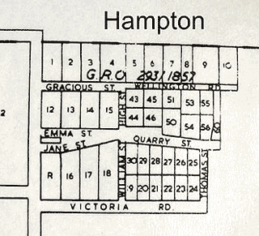
- Land division  The established pattern of allotment size and orientation should be maintained. | Any division of land or adjustment of boundaries should only reinstate or maintain the original historic land division layouts of the 1845-1877 Burra State Heritage area.  Subdivision and amalgamation of land is inappropriate unless it supports the conservation of historic sites and structures.  Subdivision of existing allotments to create additional allotments is not acceptable unless it can be established that the boundary alignment previously existed, and that the proposed development will not interfere with archaeological remains.

3.7 Landscape context and streetscape amenity
(refer: State Heritage Area Overlay - PO5.1)
The landscape character of Burra State is a key part of its heritage value, defined as much by its natural topography, water courses and vegetation as by its remnant historic mining activity and settlement pattern. Prior to European settlement, the landscape was most likely a River Red Gum open woodland with a mix of grass and shrub understorey, little of which remains. Despite this, Burra’s introduced and regenerated vegetation plays an important role in defining the character of the town, presenting a density of planting in contrast to the surrounding open, rural countryside.

Principles | Acceptable Standard
3.7.1 Landscape character  Set within a valley surrounded by cleared hills, Burra’s built heritage remains contained within its original boundaries. Introduced planting reinforces the contrast between townscape and rural countryside.  The public realm is distinguished by established trees and the absence of developed street amenities. Increasing planting and maintaining minimal infrastructure on public land reinforces the historic rural settlement character of Burra.  Development is to have regard to the following: | Actions involving the replacement or upgrade of public realm features by a local council are typically not defined as development in the PDI Act 2016. These actions are, nevertheless, not exempt from the definition of development in the case of a State Heritage Area Early discussion between Heritage South Australia and Goyder Regional Council is required to confirm if works materially affect heritage values. Where they do affect heritage values, development approval is required.  Other non-statutory documentation such as Conservation Management Plans and Master Plans may provide guidance.  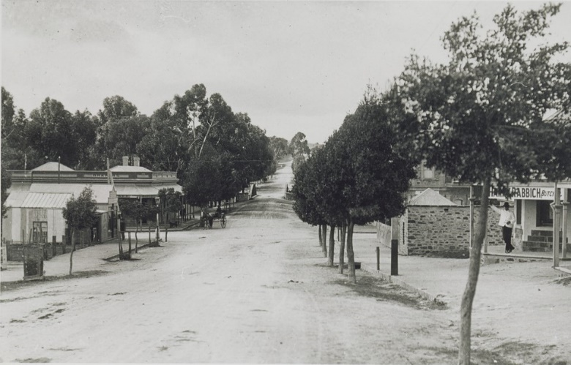 (SLSA B-27698) 1908 Morehead Street Aberdeen
- Visual Setting | The visual setting of Burra to be protected - two settlements straddling Burra Creek, separated by former mine sites, contained within an open pastoral landscape, remains central to the area’s heritage values.
- Historic Routes | Historic Park: Priority should be given to reinstatement of historic routes where possible.  Pre-1877 roads, pathways and boundaries are to be conserved or restored. Walking and cycling routes to be developed following historic movement patterns. Visitor facilities and infrastructure (roads, carparks) are to be appropriately sited to avoid compromising the heritage values of the area.

Principles | Acceptable Standard
- Views and Vistas | Significant views and vistas are to be protected. New development is to consider the impact of associated traffic, car parking and fencing on site setting, views and vistas.  Historic Park: New development to be sited to avoid compromising the legibility of visual connections associated with historic mining activity. Use of fencing and vegetation to screen existing intrusive development is supported.
- Services and Infrastructure | Historic Park: services, pathways, visitor facilities and infrastructure (e.g. roads and carparks) to be sited and designed to protect the setting of individual places, the legibility of historically significant visual connections, underground features and archaeological remains. Stormwater to be diverted away from significant fabric, including sites of potential archaeological importance. New roads and fencing to be avoided except where required for safety and conservation or designed to interpret historically fenced boundaries.
- Kerbing | Where required, kerbing and guttering to be bluestone.
- Street Furniture | Simple, unobtrusive street lighting to be restricted to Town Centres and Burra Creek
- Vegetation  Pockets of vegetation define areas of character: low scrub on the outer plains; River Red Gums in Burra Creek; aloe plantations in Redruth; almond, pine, olive and pepper trees in Hampton Township; pines in Bon Accord and Bridge Terrace; heavy pine plantings along Burra’s northern entrance and a series of pine ‘portals’ along south. | Where appropriate, retain and reinforce established planting, a mix of indigenous and introduced species in township settlements and along Burra Creek. (except Kooringa Market Square and Commercial Street).  Historic Park: Regenerated vegetation is not characteristic of the historic mining landscape and obscures views from designated vantage points. Selective clearance of vegetation is appropriate where it compromises public safety, preservation of surviving mining infrastructure, views or legibility of historic site connections.
- Burra Creek | From Cemetery to Station, Burra Creek retains its historical function as a link, connecting north and south townships with a corridor of open space.  Existing walking and cycling trails provide opportunities for developing site-wide interpretation, improving links between sites and improving permeability across Burra Creek.

3.8 Demolition
(refer: State Heritage Area Overlay - PO6.1)
Demolition of original buildings, structures, public realm elements and other features of identified heritage value is not acceptable.

Principles | Acceptable Standard

3.8.1 Demolition
The form, scale and architectural features of existing buildings, structures and landscape features are of heritage value.
Burra’s surviving significant building fabric provides important evidence of a once thriving mining enterprise and its associated settlements.
Development is to have regard to the following:
- Demolition of complete buildings / structures | Demolition of buildings or structures erected before 1915 is not acceptable
- Demolition of out buildings, dwelling additions and limited building fabric as part of development proposals | Demolition of dwelling lean-tos, building additions, garages and sheds is acceptable, subject to confirmation that removal does not adversely impact on the heritage values of the State Heritage Area
- Demolition of public realm infrastructure | Demolition and replacement of public realm infrastructure is acceptable where heritage values are not compromised.
- Demolition of mining remains | Demolition of ruins / remains of mining activities is not acceptable.

3.9 Conservation works
(refer: State Heritage Area Overlay - PO7.1)
Ruins, underground workings and archaeology form an important part of the mine site’s character, evidencing its history after the closure of the mine. Stabilisation and/or exclusion, required to mitigate risk to public and built fabric, is included under Conservation.
Conservation work to repair and maintain building fabric is considered a development matter getting the right advice is important, to save time, cost and to ensure the ongoing and appropriate management of buildings and sites.

Principles | Acceptable Standard

3.9.1 Conservation approach, Built Fabric
Significant building fabric of existing buildings and structures of heritage value within the Burra State Heritage Area is to be conserved and maintained.
Correct repair methods ensure the ongoing preservation of built fabric. The aim is to only repair as much as needed, avoiding conjectural reinstatement. Conservation works are to respect the historic layering of individual buildings, structures, and ruins. ^{Policy 15 p.190 CMP}
The ruins contained within Burra State Heritage Area are to be retained and conserved. New structures designed to protect ruins are not to adversely impact on the heritage values. Reconstruction of ruinous structures is not supported as it compromises the authenticity of the place.
The following conservation works are deemed ‘development’:
- Roof, guttering and verandah repairs  - Chimney repairs – stabilisation, repointing  - Structural stabilisation  - External wall repairs and repointing / rendering  - External timber repairs  - Rising / falling / penetrating damp repairs  - Removal of paint finishes from external masonry surfaces and original timber/metal surfaces.  - Repairs to historic fences  - Repair/stabilisation of ruins and underground workings | Seek the advice of a Heritage South Australia heritage officer before undertaking conservation repairs to dilapidated building fabric. Works that could materially affect the heritage values of a place within a State Heritage Area require Development Approval (PDI Act). Works exempt from approval are listed as exclusions in PDI Regulations, Schedule 5. The Relevant Authority (Goyder Regional Council) in conjunction with Heritage SA, can provide advice confirming if works require Development Approval.

Appendix A: Definitions taken from the Australia ICOMOS Charter for the Conservation of Places of Cultural Significance 2013 (Burra Charter)

Place means the site, area, land, landscape, building or other work, group of buildings or other works, and may include components, contents, spaces and views.
Fabric means all the physical material of the place including components, fixtures, contents and objects.
Conservation means all the processes of looking after a place to retain its cultural significance. It may include a number or combination of maintenance, preservation, restoration, reconstruction and adaptation.
Maintenance means to continuous protective care of the fabric and setting of a place and is distinguished from repair which involves restoration and reconstruction.
Preservation means maintaining the fabric of the place in its existing state and retarding its deterioration.
Restoration means returning the existing fabric of a place to a known earlier state by removing accretions or by reassembling existing components without the introduction of new material.
Reconstruction means returning a place to a known earlier state and is distinguished from restoration by the introduction of new materials into the fabric. This should not be confused with either re-creation or conjectural reconstructions which are outside the scope of this charter.
Adaptation means modifying a place to suit proposed compatible uses.
Compatible use means a use which involves no change to the culturally significant fabric, changes which are substantially reversible or changes which require minimal impact.

Ngadjuri Nation, About Us http://www.ngadjuri.com.au/aboutus.html accessed 6 December 2021
Peter Birt and Vincent Copley, “Coming back to country: a conversation at Firewood Creek” in Claire Smith and H. Martin Wobst (eds) Indigenous archaeologies: decolonizing theory and practice (2005) London/New York: Routledge p. 250
Ngadjuri Nation, About Us
Tom Gara, “The Aboriginal Presence in Adelaide, 1860s-1960s: From exclusion to assimilation” in Peggy Brock and Tom Gara, Colonialism and its Aftermath: a history of Aboriginal South Australia (2017) Mile End SA: Wakefield Press p. 97
Ngadjuri Nation, About Us
Swanbury Penglase, Australian Cornish Mining Sites: Burra p. 22
Swanbury Penglase, Australian Cornish Mining Sites: Moonta Conservation Management Plan (May 2020 ref 19127) p. 15
Swanbury Penglase, Australian Cornish Mining Sites: Burra p. 16
Swanbury Penglase, Australian Cornish Mining Sites: Moonta p. 21
Masao Yamanaka, “Tribute System and Cost Book Principle: South Australian Copper Mining Business in the Mid-Nineteenth Century” in Otemon Economic Studies, 18 (1985) pp. 8-9
Masao Yamanaka, “Tribute System and Cost Book Principle” p. 9
G. J. Drew and J. E. Connell, Cornish Beam Engines in South Australian mines (Special Publication No. 9) (1993) Adelaide SA: Department of Mines and Energy of South Australia pp. 13-15
G. J. Drew and J. E. Connell, Cornish Beam Engines pp. 21-27, 37-51
Sean M. Gohman, Cornish-Periphery Analysis p. 7
Swanbury Penglase, Australian Cornish Mining Sites: Moonta p. 16
Jim Faull, “The Cornish miner in South Australia” in Jonathan Shelby (ed) South Australia’s Mining Heritage (Special Publication No. 7) (1987) Adelaide SA: Department of Mines and Energy South Australia/Australian Institute of Mining and Metallurgy p. 139
Sean M. Gohman, Cornish-Periphery Analysis p. 7
Swanbury Penglase, Australian Cornish Mining Sites: Burra p. 45
Bernard O’Neil, “Mines and Mining” in Wilfrid Prest (ed), The Wakefield Companion to South Australian History (2001) Adelaide SA: Wakefield Press p. 356
Ian Auhl, The Story of the ‘Monster Mine’: The Burra Burra Mine and its Townships 1845-1877 (1986) Burra SA: District Council of Burra Burra p. 31
Douglas Pike, Paradise of Dissent: South Australia 1827-1857 (1957/1967) London: Longmans, Green and Co Ltd/Melbourne VIC: Melbourne University Press p. 306
Ian Auhl, The Story of the ‘Monster Mine’ p. 23
Swanbury Penglase, Australian Cornish Mining Sites: Burra p. 20
Swanbury Penglase, Australian Cornish Mining Sites: Burra p. 21
Jennifer M. T. Carter and Roger Cross, “Success and Failure: Earliest Attempts at the Commercial Smelting of the ‘Monster Mine’s’ Copper Ore in the Province of South Australia” in Journal of the Historical Society of South Australia (1998) p. 20
Jennifer M. T. Carter and Roger Cross, “Success and Failure” p. 20
Swanbury Penglase, Australian Cornish Mining Sites: Burra p. 21
Swanbury Penglase, Australian Cornish Mining Sites: Burra p. 45
G. J. Drew and J. E. Connell, Cornish Beam Engines p. 75
R. Keith Johns, “The Cornish at Burra, South Australia” in Journal of Australian Mining History, Vol. 4 September 2006 p. 170
G. J. Drew and J. E. Connell, Cornish Beam Engines p. 75
Jim Faull, “The Cornish Miner in South Australia” p. 141
Roslyn Paterson, “The Cornish Heritage on Northern Yorke Peninsula: the Cousin Jenny contribution” in Journal of the Historical Society of South Australia DATE p. 137
Jim Faull, “The Cornish Miner in South Australia” p. 139
G. J. Drew and J. E. Connell, Cornish Beam Engines p. 75
Swanbury Penglase, Australian Cornish Mining Sites: Burra p. 32
Swanbury Penglase, Australian Cornish Mining Sites: Burra p. 45
G. J. Drew and J. E. Connell, Cornish Beam Engines p. 75
Ian Auhl, The Story of the ‘Monster Mine’ p. 202
Swanbury Penglase, Australian Cornish Mining Sites: Burra p. 46
R. Keith Johns, “The Cornish at Burra, South Australia” p. 172
Swanbury Penglase, Australian Cornish Mining Sites: Burra p. 26
G. J. Drew and J. E. Connell, Cornish Beam Engines pp. 9-10
Swanbury Penglase, Australian Cornish Mining Sites: Burra p. 46
Jennifer M. T. Carter and Roger Cross, “Success and Failure” p. 18
https://web.archive.org/web/20170518180012/http://www.historic-cornwall.org.uk:80/flyingpast/age.html
Swanbury Penglase, Australian Cornish Mining Sites: Burra p. 62
Swansea-based Schneider and Company traded as the Patent Copper Company, “Smelting.” in South Australian 24 November 1848 p. 2 http://nla.gov.au/nla.news-article71613011 accessed 9 December 2021
Swanbury Penglase, Australian Cornish Mining Sites: Burra p. 31
Swanbury Penglase, Australian Cornish Mining Sites: Burra p. 64
Swanbury Penglase, Australian Cornish Mining Sites: Burra p. 62
Swanbury Penglase, Australian Cornish Mining Sites: Burra p. 31
Swanbury Penglase, Australian Cornish Mining Sites: Burra p. 66
Swanbury Penglase, Australian Cornish Mining Sites: Burra p. 66
Ian Auhl and Perry Finch, Burra in Colour (1973) Adelaide: Rigby Ltd, cited in Swanbury Penglase, Australian Cornish Mining Sites: Burra p. 33
Geoffrey H. Manning, Manning’s Place Names of South Australia (1990) Adelaide SA: Geoffrey H. Manning p. 173
Swanbury Penglase, Australian Cornish Mining Sites: Burra p. 34
Swanbury Penglase, Australian Cornish Mining Sites: Burra p. 35
Swanbury Penglase, Australian Cornish Mining Sites: Burra p. 34
Swanbury Penglase, Australian Cornish Mining Sites: Burra p. 32
Swanbury Penglase, Australian Cornish Mining Sites: Burra p. 33
Swanbury Penglase, Australian Cornish Mining Sites: Burra p. 66
Swanbury Penglase, Australian Cornish Mining Sites: Burra p. 71
Swanbury Penglase, Australian Cornish Mining Sites: Burra p. 36
Swanbury Penglase, Australian Cornish Mining Sites: Burra p. 37
Swanbury Penglase, Australian Cornish Mining Sites: Burra p. 38
Swanbury Penglase, Australian Cornish Mining Sites: Burra p. 82
Swanbury Penglase, Australian Cornish Mining Sites: Burra p. 27
Jennifer M. T. Carter and Roger Cross, “Success and Failure” p. 32
Swanbury Penglase, Australian Cornish Mining Sites: Burra p. 47
G. J. Drew and J. E. Connell, Cornish Beam Engines p. 75
G. J. Drew and J. E. Connell, Cornish Beam Engines in South Australian mines (Special Publication No. 9) (1993) Adelaide SA: Department of Mines and Energy of South Australia p. 75
Swanbury Penglase, Australian Cornish Mining Sites: Burra p. 47
Historical Consultants Pty Ltd and Hames Sharley Australia, “Survey of the Heritage of Eight Lower North Towns” p. 25
Swanbury Penglase, Australian Cornish Mining Sites: Burra p. 40
Swanbury Penglase, Australian Cornish Mining Sites: Burra p. 47
Swanbury Penglase, Australian Cornish Mining Sites: Burra p. 47

