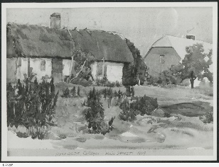
Hahndorf Cottages Main Street 1909, SLSA B 71237
Heritage Standard
Hahndorf
State Heritage Area

Contents

1. Background 4
1.1. Hahndorf State Heritage Area 4
1.2. Purpose of Heritage Standards 4
1.3. History – Hahndorf 4
1.4. Reference documents 10
1.5. Supporting Reference documents 10
2. Heritage Value 11
2.1. Statement of Significance (Hahndorf State Heritage Area) 11
2.2. What is of heritage significance? 11
3. Heritage Standards for Development (Hahndorf State Heritage Area) 17
3.1. Purpose of Heritage Standards for Development 17
3.2. Land use 19
3.3. New buildings 20
3.4. Alterations and additions 23
3.5. Ancillary development 28
3.6. Land division 33
3.7. Landscape context and streetscape amenity 34
3.8. Demolition 35
3.9. Conservation works 36

Version 1 – 13 June 2023

Heritage South Australia
Department for Environment and Water

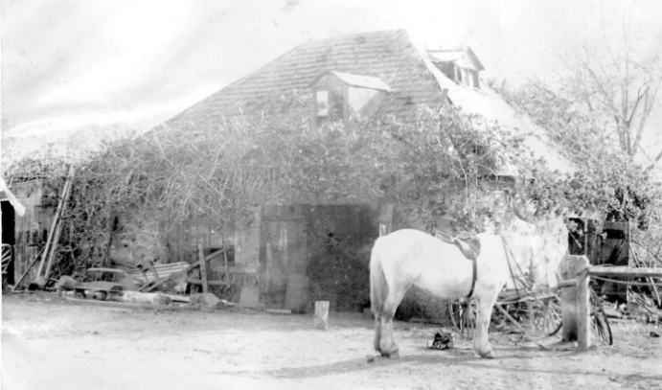
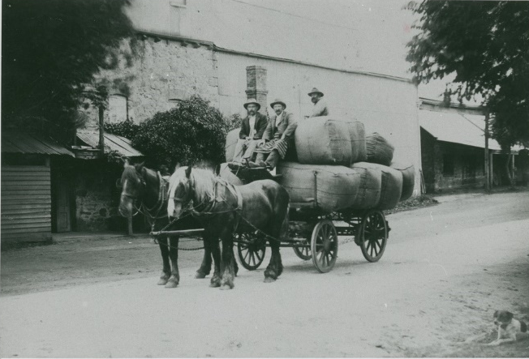
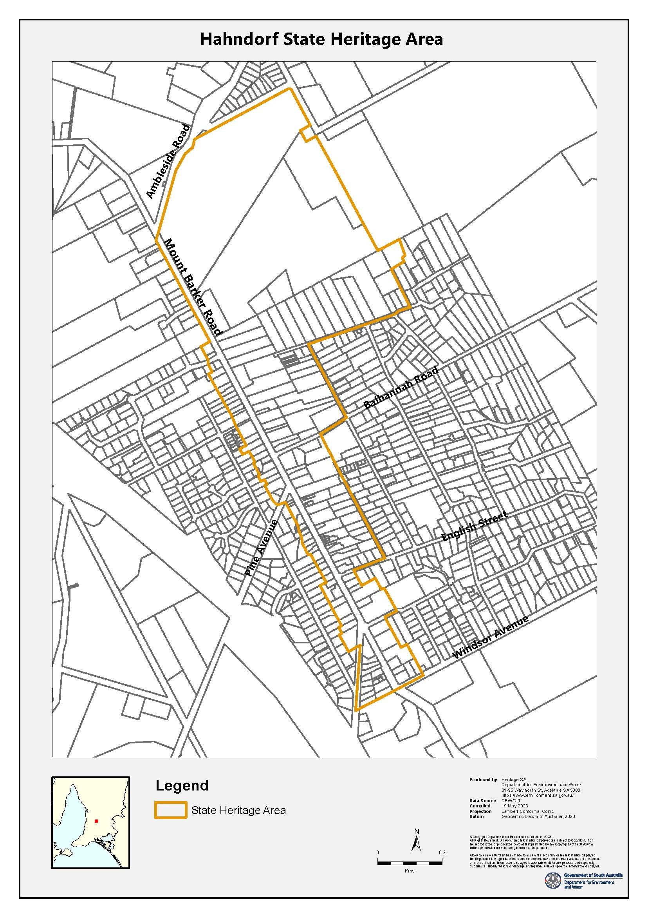
Blacksmith shop in Hahndorf, 1899, SLSA PRG 280/1/5/66
Old Mill, Hahndorf, B-18243 circa 1901. Bringing a load of wool to the mill, Heinrich Thiele, Gottlieb Jaensch and Bill Jaensch

Background

Hahndorf State Heritage Area
South Australia’s State Heritage Areas represent significant aspects of the State’s rich natural and cultural heritage. Hahndorf was designated as a State Heritage Area under the South Australian Heritage Act 1978-1980 in 1988. The designation ensures that future development of properties and open spaces within Hahndorf is managed in a way that maintains the Area’s heritage value.
Development of a place listed in the South Australian Heritage Register that is located within a State Heritage Area is covered by the State Heritage Place overlay which, in this instance, will take precedence over the State Heritage Area overlay.

Purpose of Heritage Standards
The Heritage Standard is published in accordance with the Planning, Development and Infrastructure Act 2016 and the Planning and Design Code (Code). It is a supplementary tool of the Code and is referenced in the State Heritage Area Overlay.
Any proposals to undertake development within a State Heritage Area will be referred to the Minister responsible for administering the Heritage Places Act 1993, for heritage advice. Heritage South Australia (Heritage SA) in the Department for Environment and Water is the Minister’s delegate for decisions on referred development applications. Heritage SA also has the ability to direct conditions, should the development be approved, or to direct refusal if heritage values are compromised. The Heritage Standard forms a key part of Heritage SA’s assessment of development proposals.
The Heritage Standard is presented in three parts:
- Background - the historical development of Hahndorf and the principles that underpin the State Heritage Area listing
- Statement of Significance –the South Australian Heritage Register listing and the context and description of the heritage values
- Heritage Standards for Development - Principles and Acceptable Standards for development

History – Hahndorf
Peramangk Country
The Peramangk are traditional custodians of country including the district now known as Mount Barker, much of the Adelaide Hills, and land east of the Murray River and south towards Myponga. The area where the town of Hahndorf was laid out in 1839 was an important camping place with reliable water, food sources and swimming holes. The Peramangk moved seasonally through the area and managed natural resources using techniques including controlled burning to maintain a healthy and productive ecosystem. After colonists arrived in 1837 this landscape was attractive to pastoralists and farmers who began grazing in the area as early as 1838.
A group of emigrants from Prussia began building a small rural settlement on the eastern slopes of the Adelaide Hills in a place known by the Peramangk, as Berkatilla, referencing local waterholes. They shared local knowledge with the new comers showing them how to catch possums for food and skins, and which native vegetables could be harvested to supplement their diets before crops could be established. Relations faltered when the settlers began clearing the land for farming and restricting Peramangk access to traditional water sources. Pressures increased due to a growing immigrant population throughout the greater Adelaide region and reports suggest that by the 1850s surviving Peramangk families had relocated, some merging with other regional groups living along the River Murray.
Colonial migration and settlement
Lutheran pastor, August Kavel met with George Fife Angas Director of South Australian Company in London in 1834, to discuss possible German migration to the Colony of South Australia. Kavel was pastor for congregations in Klemzig, in the Provence of Brandenburg, and Posnan in the Province of Posen in the East German State of Prussia. At this time, the King of Prussia, Frederick William III, was unifying the many branches of the Protestant faith in Prussia by enforcing a single liturgy. As members of the Church of the ‘Old Lutheran’ belief, Kavel and his congregations were being increasingly persecuted. The Colony of South Australia was to be founded on a tenant of religious freedom, and Angas, a religious man and fellow dissenter, was sympathetic to the situation of ‘Old Lutherans’ and was also keen to encourage the migration of skilled agricultural workers to the colony. In 1836 an agreement was reached between Kavel and Angas and preparation began to for over 250 Germans from the eastern provinces of Germany to migrate to South Australia. It took the group almost two years to secure permission from the King to leave their country, by which time the South Australian Company was financially stressed and could no longer support their passage. Angas was however determined to follow through and used his own resources to secure the venture.
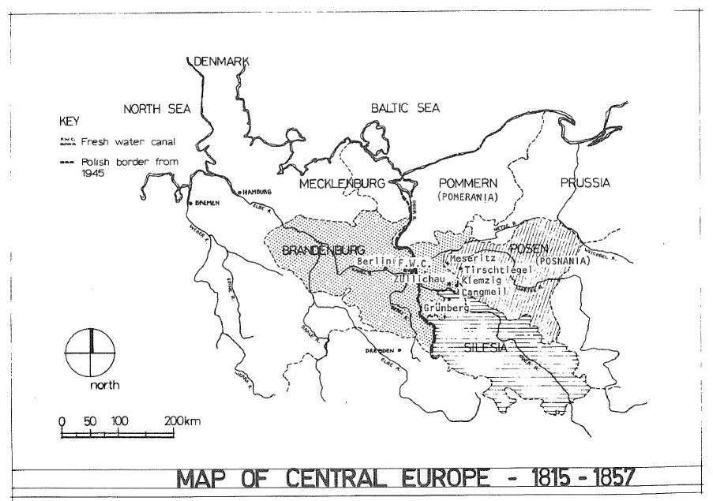

Eastern Germany showing provinces where many of the early Hahndorf settlers originated. Source: Young et. al., Hahndorf Volume 1, 1981, p 15

Four ships travelled from Germany to South Australia in 1838. The first, The Prince George arrived in Adelaide in November 1838 with migrants including Paster Kavel. Three more ships followed, the Bengalee, the Zebra, and the Catharina arriving in Adelaide between December 1838 and February 1839. These emigrants were primarily from the provinces of Brandenburg, Posen and Silesia. Passengers from the Prince George and Bengalee settled on land owned by Angas in the Torrens Valley and named their first township Klemzig. The Zebra, commanded by Danish Captain Dirk Meinertz Hahn, arrived in December 1838 and during the voyage a strong bond formed between the Captain and his passengers. These new arrivals looked to Hahn rather than Kavel for guidance and the Danish captain agreed to act as their agent negotiating a land deal which he believed offered better prospects than Klemzig.
Special surveys were a new provision of land procurement in the colony allowing speculators to request, at cost, a survey of 15,000 acres of which the applicant could select 4000 acres. The first survey of this kind, purchased by William Dutton, John Finnis and Duncan Macfarlane included prime grazing country in the area around Mount Barker in the Adelaide Hills area. Hahn negotiated the transfer of one hundred and fifty contiguous acres from sections 4002, 4003, and 4004, rent free for twelve months for the passengers of the Zebra on the basis the settlers would buy the land once established. The deal included seed, six cows on loan, fowls, pigs and building materials for a church.
Emigrants who had arrived on the Zebra set out for their new home in February 1839 walking from Port Adelaide and arrived in March 1839. In recognition of Hahn’s role in their safe passage to the colony and his guidance and skill in negotiating land, the community named their new settlement Hahndorf. In May of that year fourteen families relocated from Klemzig bringing the total number of original Hahndorf families to 52.
Settlement
Hahndorf settlers initially practiced semi-subsistence farming, growing cereals, vegetables, orchard trees and raising livestock. Women from Hahndorf walked surplus produce to market in Adelaide, supplying fresh fruit and vegetables to Adelaide during the early years of settlement. In these early years the physical isolation of the town and singular religious focus reinforced the community’s identity and culture with social and farming practices continuing much as they would have done in their country of origin. As the decades passed Hahndorf supported an increasing diversity of trades and professions, reflecting the growth of viable industries in the town.
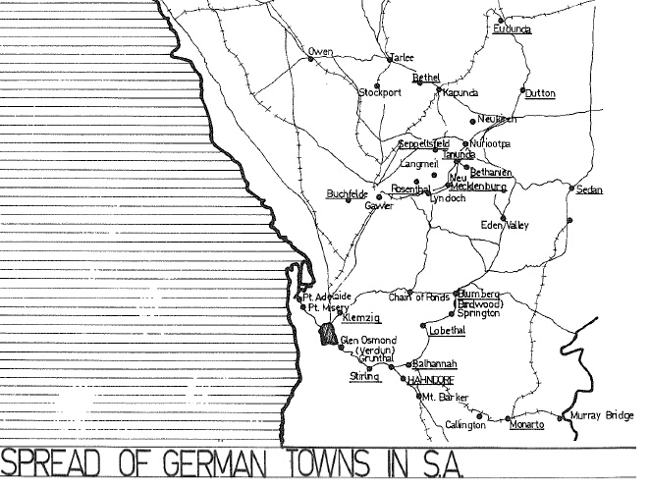
The arrival of a separate group of ‘Old Lutheran’ immigrants from Hamburg with itinerant Pastor Gotthard Daniel Fritzsche in October 1841 led to internal conflict, and in 1846 the church was split over theological differences between Fritzsche and Kavel. Supreme Court action between the factions was resolved in 1857 and granted Fritzsche’s followers the original Hahndorf church, while Kavel’s followers built a second church at the southern end of the settlement. Religious persecution of Old Lutherans ended in 1840 with the death of Friedrich Wilhelm III, however the success of German and Prussian/German settlements in South Australia set up a ‘chain’ of migration which continued through the nineteenth century.

German settlements in South Australia. Source: Young et al. 1981. p.66

Hahndorf: subdivision and main street development
Early subdivisions and land use in Hahndorf reflect German rural settlement patterns dating back as early as the 12th century. These settlement patterns were used successfully during colonial expansions east of the Oder River into what would become Germany’s Eastern Provinces including Brandenburg, Silesia and Posen, where German farming communities were established and from where many of Hahndorf’s settlers originated. When ‘Old Lutheran’ migrants arrived in South Australia they brought their farming practices and settlement patterns with them.
Herman Friedrich Koch (or Kook) arrived aboard the Zebra with experience in both agriculture and surveying. Land owner William Dutton, appointed Koch the new settlement’s supervisor and it is believed he laid out a plan comprising 54 narrow blocks of approximately equal area. These blocks provided each family with farmland and access to pasture. The U-shaped plan is considered to be an adaptation of the traditional German Hufendorf rural village form (although it has been identified alternatively as and Angerdorf layout), articulated to suit the topography and aligned with the existing road to Mount Barker. Contained within the U-shaped village was the original church, later known as St Michael’s, which was the religious and cultural centre of the new settlement. Land around the church was used as common pasture for early residents.
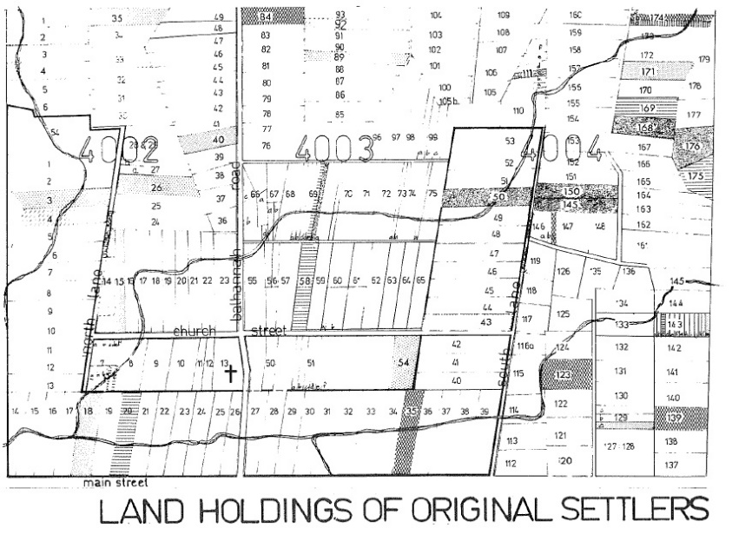

Land holdings of original settlers Source: Young et al. 1981. p.89

Settlers later purchased an additional 240 acres, including fertile land inside the Hahndorf “U” and less-fertile land on slopes to the east. This additional land was subdivided into a complex patchwork of narrow farm blocks, each typically smaller than an acre (0.4 ha), to suit the three-field system of crop rotation. Each family was allotted three or four blocks of land, of varying size and quality, adding up to roughly an equitable share of the total available farmland. This pattern of strip farming and fragmentation distinguished Hahndorf from the more typical British patterns of settlement adopted elsewhere in the colony of South Australia, where agriculture was based on larger, eighty-acre (32 ha) modules.
After 1840 religious persecution in Germany’s eastern regions abated and there was a lull in migration from these parts to South Australia. From 1846, socio-economic migrants began arriving from Germany in search of improved lifestyles. Two new subdivisions in 1849, on the opposite side of the road to Mount Barker, extended the settlement and changed the dominant form of Hahndorf. F. W. Wittwer subdivided section 4235 into long, narrow hufe or farmlet blocks, while Joseph Remfrey subdivided sections 4233 and 4234 into shorter, conventional blocks between Mount Barker and Echunga Roads. With subdivisions on either side of a main road, Hahndorf now resembled a German linear street-village or Strassendorf. The shift in spatial focus towards Mount Barker Road accompanied the township’s broader transition from a subsistence-farming village to a local service centre and commercial town.
Hahndorf’s vernacular architectural tradition
‘From humble beginnings in 1839 to its architectural peak in the eighteen fifties, a true Hahndorf style emerged which remained unequalled anywhere in Australia.’ Hahndorf’s colonial settlers brought with them distinctive vernacular building practices. Initially buildings were constructed with whatever materials were available and structures were simple and utilitarian often serving as both barn and house until purpose built residences could be constructed. As the village developed buildings were constructed using stone, brick, timber, wattle-and-daub, or a combination of these materials. Early stone buildings were primarily undressed sandstones quarried in the district and early bricks were locally made fired clay.
Half-timbered or box-frame construction or Fachwerk, was popular and required a high degree of skill and artisanship. The technique employed a timber frame comprised of vertical load-bearing members, mortised into horizontal rails and stiffened with horizontal noggings and diagonal bracing. Red gums, felled during land clearing provided much of the hardwood timber for framing and ranged from split logs, roughly adzed to shape, to dimensionally perfect members. Walls were sealed with infill panels of wattle-and-daub, plastered timber slabs or brick, weatherproofing the structure. Hahndorf’s early buildings included traditional German house forms commonly found in the eastern provinces and in particular Franconian house plans featuring centrally located chimneys, cross-passage, and hall or hearth kitchens. These houses often included steeply pitched gable, or half hipped roofs with attics, which, along with the distinctive fachwerk walls gave Hahndorf its unique visual character.
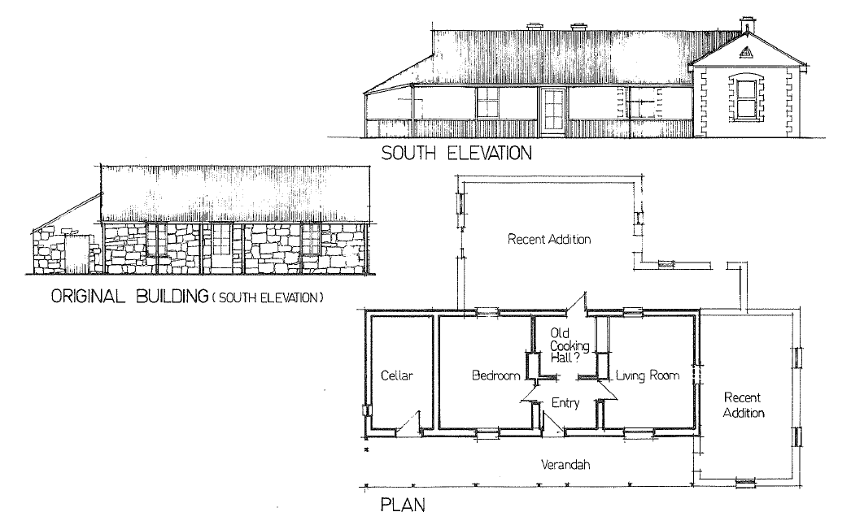
Quoining was not common in Hahndorf until the late 1860s. As a building element it set structures apart from the stone buildings of the town’s early years. Buildings which introduced this more standard ‘Australian’ element into Hahndorf tended to be houses of wealthier residents and public buildings such as the Post Office (1873) and Institute (1893). From the late 19th century Hahndorf’s buildings, both new and existing, began to show a ‘process of acculturation’. New buildings of a more generic Australian country town character began to appear while some existing buildings were materially altered (see below) with additions, embellishments, veneers, render, claddings and add-ons including bull-nosed verandahs and lacework altering, their appearance.

Drawings showing the transition of an original German style house with the addition of a gable ended room, quoining, sash windows and rendering. Source: Young et al., Hahndorf Volume 1, 1981, p 99

Hahndorf into the twentieth century
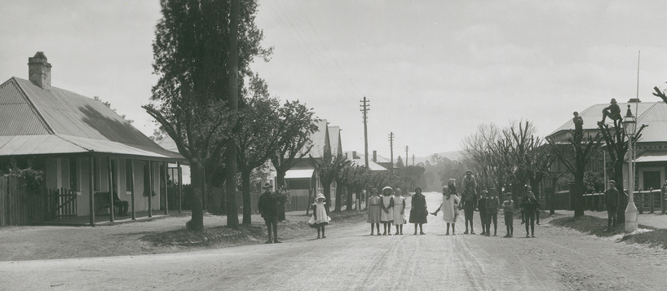

Main Street, Hahndorf circa 1905. SLSA B-16978 Hahndorf’s Main Street lined with trees, recently lopped.

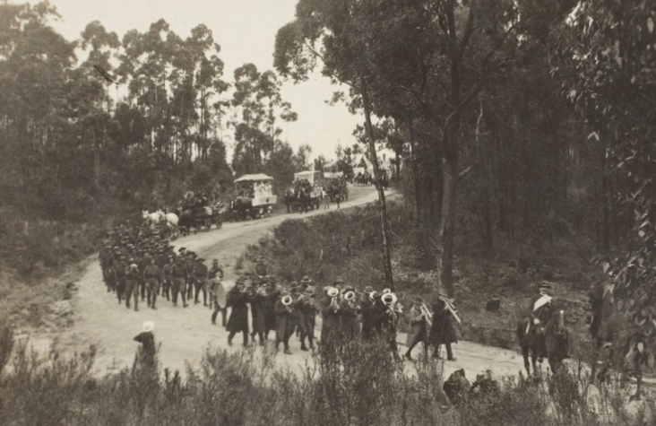
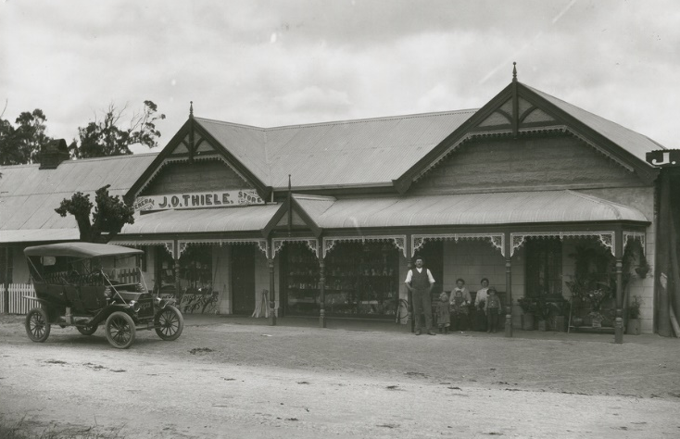
Street trees were first planted in Hahndorf’s main street in 1885, and included 300 chestnut, elm and plane trees. This was the first informal Arbor Day tree-planting programme in the Colony and predated the first official Arbor Day plantings in Adelaide’s south parklands by three years. In all 300 trees were planted, including chestnut, elm, cork and plane trees selected by the director of the Botanic Gardens, Dr Richard Schomburgk. The trees created a sense of ‘enclosure’ and helped to ‘unify’ the streetscape.

Thiele’s store Hahndorf, SLSA B-16975, circa 1920.
Hahndorf Main Street, store with motor car outside.

Parade at Hahndorf, SLSA B-78569, circa 1918.
Parade honouring service men and women during WW1

At the time of the Second Boer War (1899-1902), and during the lead-up to and outbreak of the First World War in 1914, German South Australians were viewed as holding ‘ambiguous’ loyalties. In 1918 many South Australian place names of Germanic origin were anglicised and Hahndorf was renamed ‘Ambleside’ after the local railway station. The name Hahndorf was restored in 1935, in preparation for commemoration of the State’s Centenary the following year.
During the first half of the twentieth century the character of Hahndorf’s main street began to change as industries requiring larger premises located in town, breaking up the continuity of scale in parts of the streetscape and more standardised ‘Australian’ style houses replaced some of the original dwellings. Private ownership and use of motor cars increased and new businesses opened in Hahndorf reinforcing its position as a layover for those travelling east from Adelaide. In the 1930s the impact of the Depression was devastating to large primary businesses but was less so in Hahndorf where smaller scale primary production such as orchards and market gardens continued to supply produce to the domestic market.
By the 1960s the influence of the original settler families in Hahndorf began to decrease. Hahndorf grew as an attractive location particularly for tourist-oriented business. Interest in Hahndorf’s heritage and customs grew at this time while Prussian/German customs and material heritage declined. It was at this time that Hahndorf’s economy which had primarily relied on productive and service industries became increasingly service oriented.
Hahndorf’s growth as a tourist destination accelerated in the 1960s with the opening of the Museum and Art Gallery, and the Hofbräuhaus if the former mill complex in 1970 as well as the restoration of the Hahndorf Inn in 1972. Other businesses opened in the 1970s selling food, crafts and tourist merchandise. The town’s appeal for visitors was greatly enhanced by its surviving buildings, picturesque setting and cultural practices. The adoption of some Bavarian cultural traditions and their manifestations in the built environment led to the emergence of ‘pastiche’ elements in the townscape which by the late 1970s threatened to overwhelm Hahndorf’s historic character. An extensive heritage survey, carried out in the early 1980s for the Australian Heritage Commission, was the first major historical study of Hahndorf and laid the foundations for the designation of the Hahndorf State Heritage Area under the South Australian Heritage Act 1978 on 25 August 1988.

Reference documents
Altman, David Hahndorf Historic Main Street: the management of change, Adelaide SA: School of the Built Environment, University of South Australia, 1991
Arnold, Bernard ‘German settlers' accounts of the Australian Aborigines’, Torrens Valley History Journal, No. 33. 1988
Brasse, Lothar ‘The German Contribution’, Historic Environment, VI, 2, 1988, p. 46
Clarke, Philip A., ‘Report on the Bird-in-Hand Heritage Assessment for a mining lease application’, Terramin Australia Limited, Adelaide SA, 2016
Copley, Ivan-Tiwu Indigenous Heritage – Hahndorf: Sites of Aboriginal Cultural Significance In and Around Hahndorf, South Australia, 2019. Available online at: https://storymaps.arcgis.com/stories/16251441de5e48feb4c3dd55be82bce7, accessed October 2022
Harmstorf, Ian A. (ed), Insights into South Australian History Volume 2: South Australia’s German History and Heritage Adelaide SA: Historical Society of South Australia Inc., 1994
LeMesssurier Architects, Hahndorf Conservation Policy, Adelaide 1991
Lohe, M. ‘Lutheran Pioneers in Australia The Emigration, Landing, and Establishment (31 December 1963)’, in The Australian Lutheran almanac for the year, 1964
D. W. Meinig, On the Margins of the Good Earth: the South Australian Wheat Frontier 1869-1884, Rigby, Adelaide SA, 1962
Young, Gordon, ‘Pioneer settlement patterns in the Onkaparinga District Council of South Australia’, Antiquity, Vol. 61, ISS 232, 287-310, 1987
Young, Gordon, Ian Harmstorf, Lothar Brasse and Alexandra Marsden, Hahndorf Volume 1: A survey carried out for the Australian Heritage Commission, Techsearch Inc., Adelaide SA, 1981

Supporting Reference documents
Dickinson, Robert E., Germany: A General and Regional Geography, Methuen & Co., London, 1961
Young, Gordon, Ian Harmstorf, Lothar Brasse and Alexandra Marsden, Hahndorf Volume 2: A survey carried out for the Australian Heritage Commission Techsearch Inc., 1981
Young, G., Pioneer settlement patterns in the Onkaparinga District Council of South Australia, 1987, 301

Heritage Value

Statement of Significance (Hahndorf State Heritage Area)
Hahndorf is of heritage value for the following reasons:
Hahndorf State Heritage Area acknowledges the status of Hahndorf as the oldest (1839) surviving German settlement in Australia. It is one of the few Australian towns with a significant number of buildings which reflect a distinctive German character. 'The township of Hahndorf lies within a gentle and undulating landscape, drained by a network of five creeks, the confluence of which is at the main approaches to the township are through open rural landscapes into the very long Main Street with its large two storey landmark buildings and the open spaces of unbuilt-upon allotments and building setbacks, unified by an avenue of mature trees. Its layout is unique in Australia, for unlike Klemzig's (1838) Strassendorf form and Bethany's (1842) Hufendorf layout, Hahndorf is a combination of both archetypes. It is the oldest surviving German settlement in Australia (Klemzig was the first) and as such presents important facets of the pioneer German way of life. Its historic character, centred upon Main Street and Victoria Street, arises from its unique plan form and is strengthened by the many surviving 19th century buildings constructed originally in German and then through generations of assimilation, Australian styles, the rhythm of its buildings and open spaces, small rural scale and avenue of trees'. (Extracted from 'Hahndorf Conservation Policy' 1991, p9) (As entered on the South Australian Register, 25 August 1988)

What is of heritage significance?
Background
The portion of Mount Barker Road which runs through Hahndorf is generally known as Main Street, this document will use Main Street in reference to this section of road.
The majority of Hahndorf’s early 19th century settlers came from the Provinces of Brandenburg, Posen and Silesia, in Prussia which was at that time, the eastern kingdom in the German Empire. Much of Prussia became part of Poland in the mid 20th century. This region had been colonised by the German Empire from the 13th century and shared cultural practices including language, settlement patterns and farming techniques. This document will describe the original architecture and urban layout of Hahndorf as German and use the term Prussian/German or ‘Old Lutherans’ to refer to this group of settlers and to acknowledge their heritage.
Unique German settlement layout in colonial South Australia
The initial wave of Prussian/German migration to South Australia began in 1838 and is an important part of the colonial story of South Australia. Hahndorf was an early example of a non-British community who maintained language, religion, farming, building and other social practices within the colonial project.
Hahndorf’s original town layout was a U-shaped subdivision with St Michael’s Lutheran Church at its centre and the base of the U running along the main road from Adelaide to Mount Barker. These blocks are considered to have followed a Hufendorf settlement pattern and provided each settler family with access to water and enough land to practice a traditional three field system of agriculture. From 1849, new allotments were established along the west side of Main Street. Now known as the Strassendorf subdivision, these blocks shifted the town focus away from the church and bullock track to the main street.
Hahndorf’s State Heritage Area comprises much of the early town layout along Victoria Street and Main Street and contains a portion of the intact original subdivision and early building stock consisting of shops, houses and associated outbuildings. Remnant rural land to the north/west of Victoria Street serves to maintain the visual extent and rural nature of the town and safeguards the original pattern of subdivision and thus its character.
Key factors which illustrate the unique layout of Hahndorf include:
- Contiguous subdivisions dating back to the first years of settlement which remain recognisable today.
- A combination of German colonial settlement patterns in Hahndorf, giving the town a unique layout. Examples of both farmlet blocks (Hufendorf) dating back to 1839 and street facing blocks (Strassendorf) dating back to 1849 remain recognisable.
- Main Street as a mixed-use area containing housing and businesses on original allotments
Historic townscape character and architecture
The assimilation of Australian building practices and Hahndorf’s transition from German rural village to South Australian country town is evident in the housing stock as well as its community and significant buildings. Over 20 buildings in the State Heritage Area are also listed as State Heritage Places. Most of these buildings date from 1840 to 1880 and are fundamental to the cultural and visual character of Hahndorf.
Extant building stock in Hahndorf dating from 1839 to 1918 includes vernacular German, German-Australian, and Australian architectural styles and tells the story of its beginnings as a German colonial settlement and transition to a hybrid South Australian country town. Architectural features of particular note include: half-timbered (fachwerk) buildings with wattle and daube or brick infill, timber slab buildings, and undressed stone, brick, and stone and brick buildings, all built in a German vernacular style with steeply pitched gable or half hipped roofs. These features reflect the cultural construction practices of the transplanted Prussian/German community and local available materials. Hipped roofs, quoining, dressed stone and projecting gable architectural features are also part of Hahndorf’s story.
Tree planting along Main Street, which began in 1885, is a significant part of the historic development of Main Street and is a unifying element in the streetscape.
Features within the State Heritage Area which contribute to the heritage value of the State Heritage Area include:
The Academy Hahndorf showing established street trees along Main Street. Source: SLSA B-16979 circa 1913.

- Original subdivisions include both the farmlet-village (Hufendorf) blocks and long narrower blocks of the street village (Strassendorf) pattern.  Early subdivision patterns showing the growth of the village focussed along Main Road. Source: Young et al. 1981. p.90 | 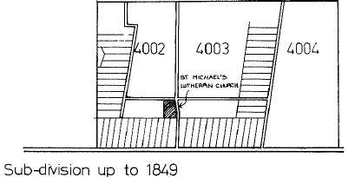  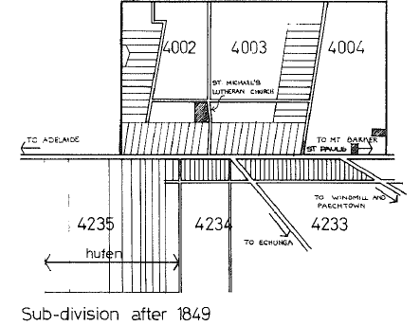
- Historic built form development reflecting the typical functional arrangement of Hufen and Strassen farms dating back to early settlement. | 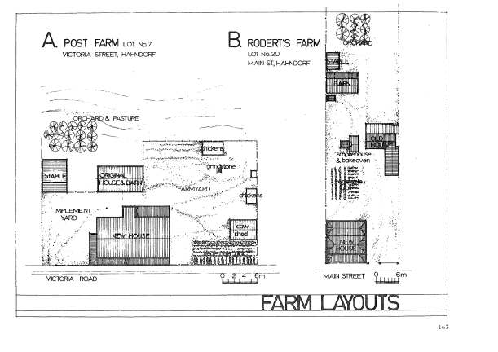  Farm layouts on Victoria Street (Hufendorf) and Main Street (Strassendorf) allotments. Source: Young et al, 1981, p. 163
- Street tree canopy along Main Street originally planted in 1885. | 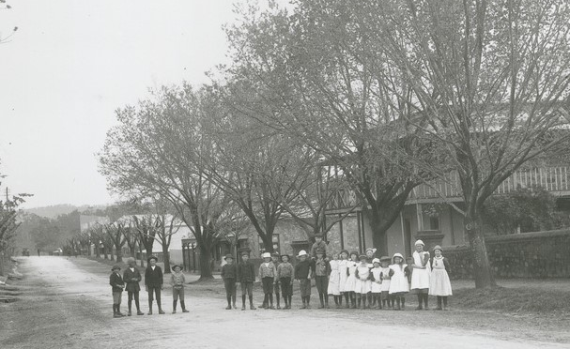
- Areas of collective heritage character recognised within the State Heritage Area.  - Heritage Rural Area (Hahndorf)  - Hufendorf Residential Area  - Main Street Area  These areas reflect the original Hufendorf layout, a subsequent Strassendorf sub-divisions and remnant productive rural land to the north of the town limits. | 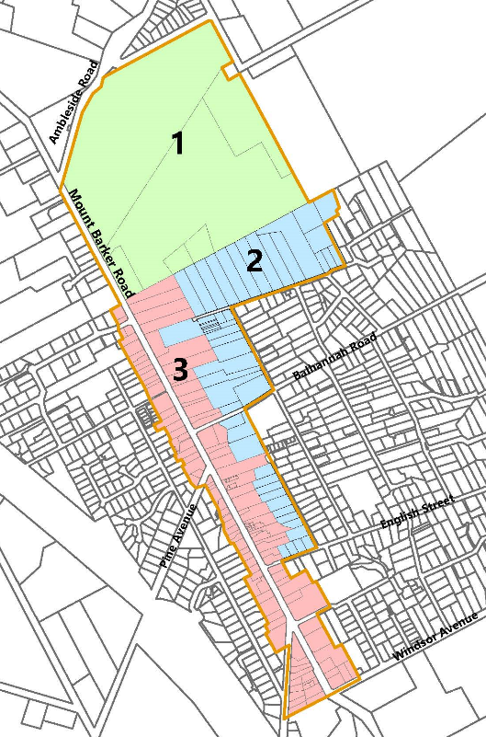  Areas of shared character within Hahndorf State Heritage Area
- The open space nature of the heritage character of Hahndorf includes informal open spaces, small public parks, open space between detached buildings on neighbouring allotments, open rural blocks to the north and a seasonal creek running through hufen allotments on Main Street blocks. | 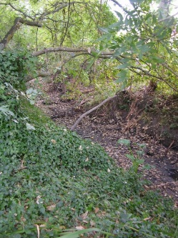  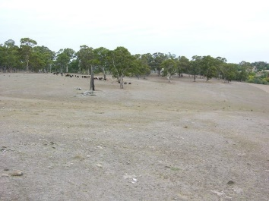  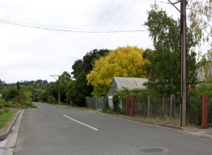  Open productive rural land along the Mount Barker Road entering Hahndorf from the north.
- Low density development includes dwellings, farm buildings, and businesses, primarily single storey. Larger scale non-residential buildings provide historic landmarks and enhance the village character and scale and include churches, the Hahndorf Academy, hotels, mill and Institute building. | 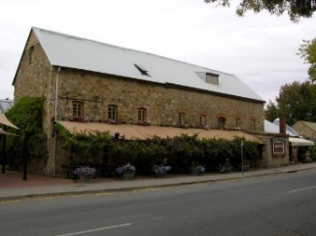  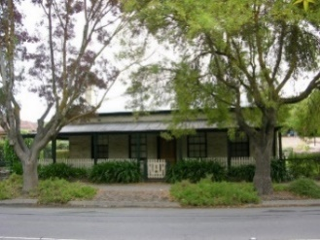
Architectural features of heritage value include: | Colour photos in this section sourced from Heritage SA
- German vernacular style buildings including houses, shops, workshops and outbuildings  - Half-timbered construction with wattle and daube, earth or brick infill  - Gable or half-hipped roof forms of steep pitch (approximately 45 degrees), some with long or gable end facing the street | 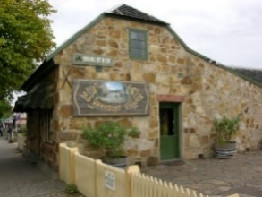  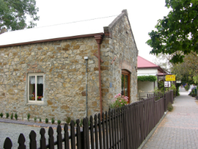  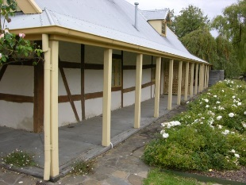  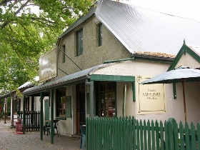  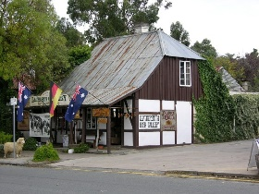
- Pre 1918 stone and brick buildings of German, German/Australian and Australian styling.  - Simple verandahs contemporary with building style and age:  - Verandahs to gable end or long side of early German style buildings.  - Front verandahs some with returns, to Australian style cottages and villas | 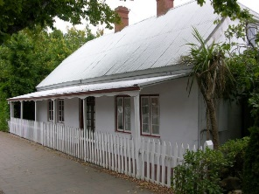  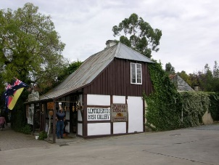  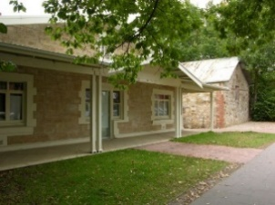  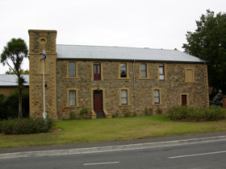  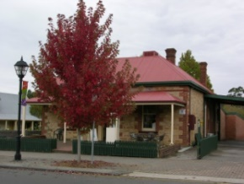  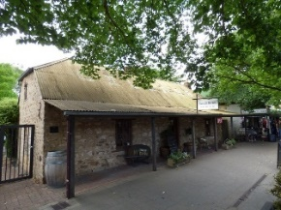
- Timber framed casement and sash windows, vertical proportions, and small glass panes to 1918  - Loft doors/ windows in gable ends | 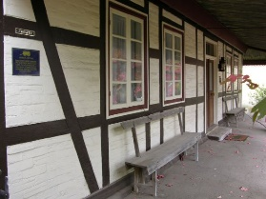  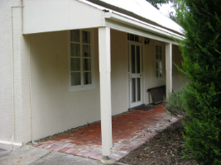  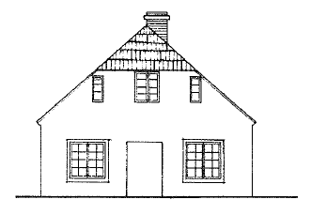
- Traditional building addition forms - either lean-to or repeated form  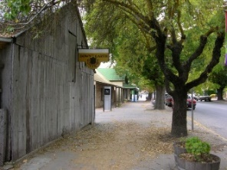  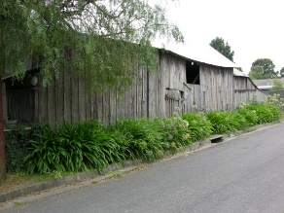  - Timber buildings with no street setback, Main Street and Victoria Street; barns and early accommodation. | 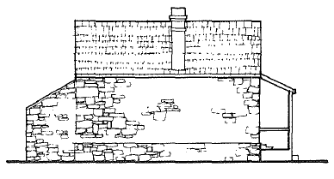  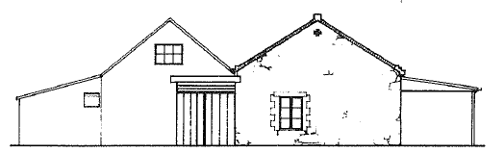
- Early outbuildings of timber, masonry or mixed construction with gable or single pitch roofs mostly in (now) rear yards, some on street. These buildings include sheds, barns, smokehouses and kitchens. | 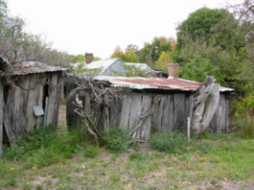
- Front fencing –  - original stone and masonry walls,  - post and rail fencing  - simple picket fencing and gates  - crimped/woven wire with timber post and rail  - crimped/woven wire gates with metal pipe framing  - hedging | 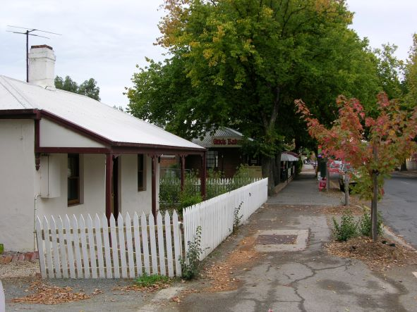

Heritage Standards for Development (Hahndorf State Heritage Area)

Purpose of Heritage Standards for Development
Any proposals to undertake development within a State Heritage Area will be referred to the Minister responsible for administering the Heritage Places Act 1993, for heritage advice. Heritage South Australia (Heritage SA) in the Department for Environment and Water is the Minister’s delegate for decisions on referred development applications. Heritage SA also has the ability to direct conditions, should the development be approved, or to direct refusal if heritage values are compromised. The Heritage Standard forms a key part of Heritage SA’s assessment of development proposals.
Heritage Standards:
- provide a basis for assessment regarding management of heritage impact of development by Heritage SA Heritage Officers.
- include heritage principles and location specific detail on how development can be undertaken to ensure heritage values are protected
- propose a minimum acceptable standard for development related solutions within the State Heritage Area.
A State Heritage Area includes both private and public spaces (including streets) and the Heritage Standard is applicable to development across the entire State Heritage Area.
Development associated with a State Heritage Place and also within a State Heritage Area is defined in the Planning, Development and Infrastructure Act 2016 Part 1, 3 (1). Additional definition specific to a State Heritage Place or Area includes:
“ (e) …….—the demolition, removal, conversion, alteration or painting of, or addition to, the place, or any other work that could materially affect the heritage value of the place”.
The State Heritage Area Overlay ‘Procedural Matters (PM) Referrals’ – identifies the types of development to be referred to the Minister responsible for the Heritage Places Act 1993 - Heritage SA, for assessment and direction.
Exemptions to the definition of Development within a State Heritage Area are scheduled in the Planning, Development and Infrastructure (General) Regulations 2017 – Schedule 5
Development of a State Heritage Place, located within in a State Heritage Area, is governed by the State Heritage Place (SAPPA) Overlay. This Overlay requires approval for development of the interior and exterior of a State Heritage Place.

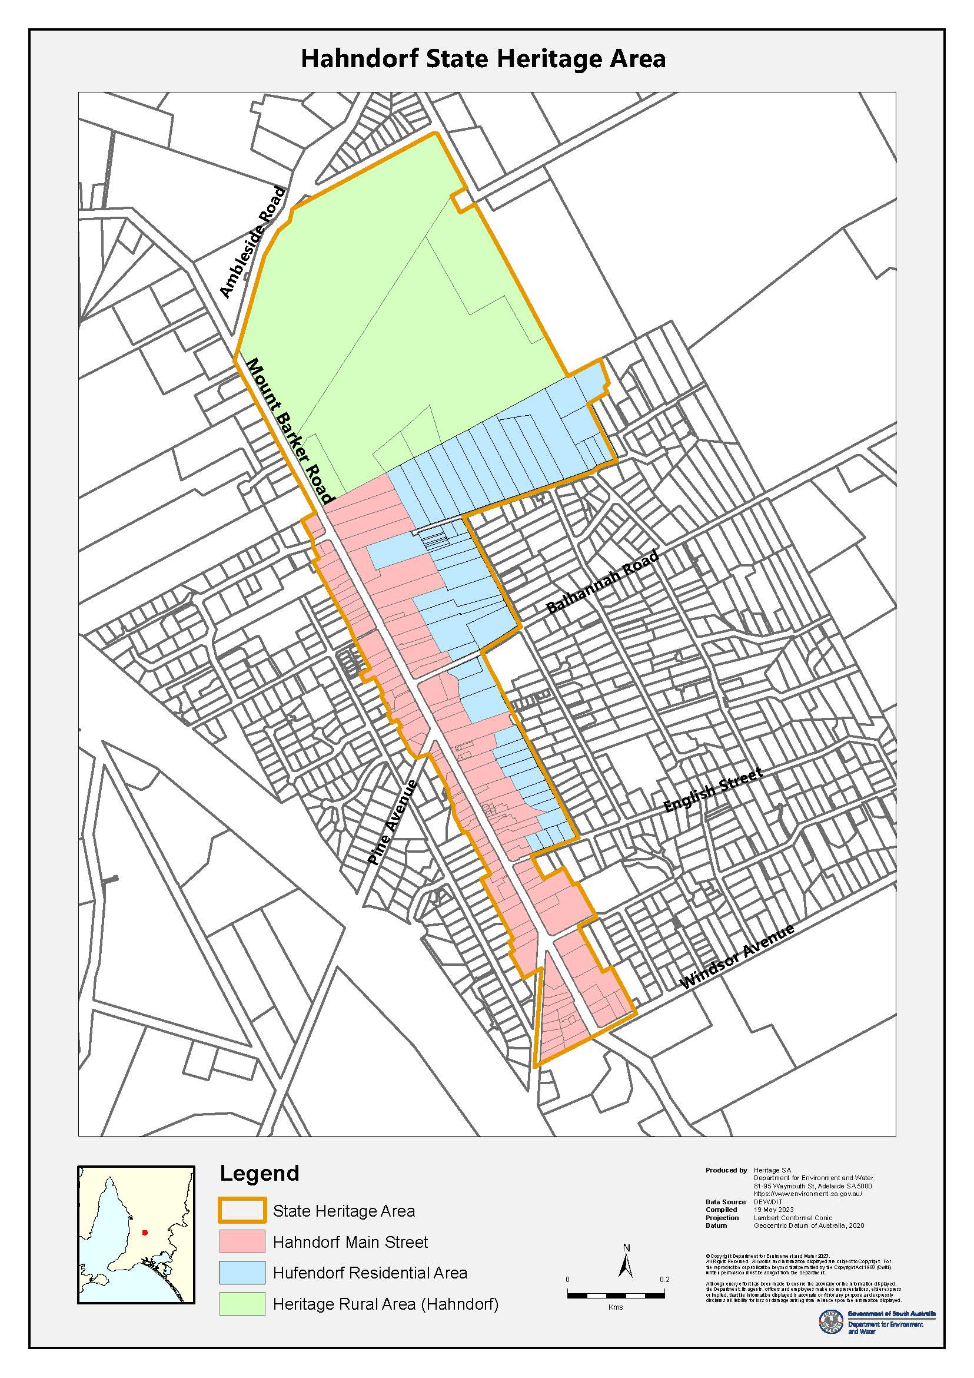

Land use
(refer: State Heritage Area Overlay – Alterations and Additions PO 2.2)
Early subdivision and land use in Hahndorf reflected the historic vernacular rural land settlement patterns already known to initial settlers. The Hufendorf and Strassendorf land division uses enabled established rural and commercial activities to establish as they did at home, adjusted to suit the local landscape.

Principles | Acceptable Standard

Land Use
Evidence of significant vernacular village and rural land uses within the original Hufendorf and Strassendorf subdivision areas of Hahndorf is evident in the arrangement of surviving houses, rural outbuildings, shops and open farmland.
Continuation of the unique combination of two distinct historic settlement patterns, with a rural outlook, is essential to underpin the heritage values of Hahndorf.
Development is to have regard to the following:
Land use planning  Future land uses proposed within the State Heritage Area do not obscure understanding of the remnant and significant 1839-1918 subdivision layout and rural/ village pattern of development within the State Heritage Area. | Hufendorf Residential Area: Future land use in this area is to be residential, with education uses confined to the existing land parcels.  Main Street Area: Early housing and outbuildings have generally been repurposed for retail, interspersed with later, small scale, mixed use development. Public buildings also dominate and continuation of use is acceptable.  Heritage Rural Area (Hahndorf): Development in this area to support primary production and to retain an open rural landscape.

New buildings
(refer: State Heritage Area Overlay - Built Form PO 1.1 to PO 1.5 – note: this section does not refer to Ancillary/Out buildings)
Opportunities for new buildings are rare in Hahndorf. Small scale, stand-alone development is possible if new buildings maintain the established built form character and spatial rhythm of streetscapes within the Area, or where buildings built after 1918 do not contribute to the heritage value of the Area are replaced. New buildings will not adversely impact the heritage values of the State Heritage Area.

Principles | Acceptable Standard

Siting of new buildings
The streetscapes of Hahndorf within the State Heritage Area tell the story of Hahndorf’s history as a German settlement: from subdivision and layout to village and rural town. 1839-1918 buildings have scale, form and situation that reflects early land use and life within in the original pattern of subdivision.
New buildings are to have regard to the following:
- Street and side boundary setbacks  New building setbacks are to reflect historic settlement patterns.  Side setbacks for new buildings are to maintain sufficient open space between buildings, to maintain the rural, open character of the town and ensure significant settlement patterns remain recognisable. | Hufendorf Residential Area: New development to be aligned behind the entire main roof form of adjacent dwellings if identified as State Heritage Places, to not visually dominate heritage buildings. Setbacks for new development in Church Street to match building to be replaced, or match the common street setback alignment  Main Street Area: New building setbacks to align with building being replaced, to reflect and maintain the existing rhythm of historic subdivision and development.  Heritage Rural Area (Hahndorf): Any new buildings in the Heritage Rural Area (Hahndorf) are situated well back from the main road and clustered near existing rural development, to not dominate the landscape.

Form and design of new buildings
The form, scale and architectural features of existing buildings within the Hahndorf State Heritage Area illustrate original German rural settlement patterns, and include buildings forms, and practices, as well as land use and reflect the town’s development from 1839.
New buildings are to have regard to the following:
- Scale  The built form scale of residential and Main Street areas of Hahndorf is typically single storey, with buildings of limited site coverage.  Existing larger non-residential buildings, such as The Academy, Hahndorf Institute, churches, and schools, and including businesses such as hotels and the Old Mill, are landmark in scale and up to two storey, contributing to the visual hierarchy of the heritage streetscape. | Site coverage is limited to 35 per cent.  Dwellings: Residential development will reflect the scale of existing development in the Area with eaves height, roof ridge and wall heights that typically match existing buildings in the vicinity.  Non-residential: The scale of new buildings reflects the height and footprint of existing buildings in the vicinity.  Hufendorf Residential Area:  Dwellings: New residential development is single storey, detached and of a scale to match surrounding dwellings. Second storey acceptable only within roof space.  Non-residential: Not supported in this Area.  Main Street Area:  Dwellings: New dwellings are single storey and reflect the scale and form of existing dwellings of significance in the vicinity.  Non-residential: New buildings are single storey to the street. Two storey development is at least 12 metres from the street boundary on the west side and 12 metres from the street boundary on the east side.  Heritage Rural Area (Hahndorf):  Dwellings: New dwellings are single storey, to not exceed the height of existing dwellings in the vicinity.  Non-residential: New development associated with rural production including outbuildings and sheds to not visually dominate existing buildings or the landscape.
- Roof form and pitch  Early, vernacular roof forms within the Hahndorf State Heritage Area are a significant, consistent part of the built form character of the area. German vernacular style buildings feature steeply pitched roofs, with gable ended or half hipped roofs.  Later buildings of heritage value feature hipped roofs with eaves and typically discontinuous verandah roofs. | Flat roofs are not acceptable in the State Heritage Area.  Hufendorf Residential Area:  Dwellings: Roofs of new dwellings to reflect the scale, form and pitch (at least 30 degrees), of roofs in the immediate vicinity being either gable ended, half-hipped or hipped. Verandahs to match proposed roof form if appropriate.  Main Street Area:  Dwellings: Roofs of new development reflect the scale, form and pitch (at least 30 degrees) of roofs in the immediate vicinity being either gable ended, half-hipped or hipped. Verandahs to match proposed roof form.  Non-residential: Roofs of new development reflect the scale, form and pitch of roofs in the immediate vicinity. Development of a larger scale to have an appropriate roof pitch so as not to dominate the existing streetscape or disrupt the existing visual hierarchy of buildings.  Heritage Rural Area (Hahndorf)  Dwellings: New dwellings have roofs that reflect the scale of surrounding farm buildings, either gable ended, half-hipped or hipped. Verandahs to match proposed roof form.  Non-residential: Rural development has a roof pitch 15-20 degrees and be gable or hipped in form.
- Façade proportions  The 19th century buildings which give Hahndorf its built form character, feature horizontally proportioned façades, with vertically proportioned doors and window openings. | Hufendorf Residential Area:  Dwellings: New dwellings repeat the proportions of existing street facing façades in the vicinity, considering window and door openings and facade proportions.  Main Street Area:  Dwellings: New development repeats the proportions of existing adjacent street facing façades of dwellings, considering façade proportions and window and door openings.  Non-residential: Façade proportions to reflect proportions common to the locality and not visually dominate existing buildings or streetscape.  Heritage Rural Area (Hahndorf):  Dwellings: New development reflects the façade proportions of existing buildings.  Non-residential: Façade proportions to not visually dominate existing buildings or the landscape.
- Verandahs  Verandahs and lean-tos are common to most buildings of heritage value across the Hahndorf State Heritage Area.  Verandahs to early German vernacular buildings are typically an extension of the main roof or added to the gable end at eaves height.  Later hipped roof buildings have either continuous or discontinuous verandahs along street facing façades. | Hufendorf Residential Area:  New dwellings are to incorporate a verandah on street facing façade.  Main Street Area:  New dwellings are to incorporate a verandah on at least the street facing façade.  The scale, form and positioning of the verandah is to complement roof form as well as verandahs common to the existing streetscape.  Heritage Rural Area (Hahndorf):  New buildings to have verandahs which complement the roof form.
Materials, finishes and colours  The building materials of Hahndorf’s early German vernacular style buildings are of heritage value, reflecting construction methods utilised in homeland Prussia. In particular buildings constructed using half-timber/fachwerk or local stone and/or brick with steeply pitched timber framed roofs are of note.  Later, pre 1918 era buildings constructed of stone and brick also contribute to the heritage value of Hahndorf. | New development across Hahndorf’s State Heritage Area is to have regard to Accepted Materials, Finishes and Colours as scheduled in: (Alterations and Additions) 3.4.3 Materials, finishes and colours, incorporating those common to the era of heritage value of the State Heritage Area.

Alterations and additions
(refer: State Heritage Area Overlay – PO 2.1 and PO 2.2)
Alterations and additions to existing buildings in the Hahndorf State Heritage Area are possible, but additions must not visually dominate existing buildings within the heritage streetscape or landscape.

Principles | Acceptable Standard

Site and location of additions
Additions to buildings in Hahndorf will maintain existing rhythm of streetscapes, the visual prominence of significant buildings and complement the original pattern of subdivision or maintain existing rural landscape.
Development is to have regard to the following:
- Street and side boundary setbacks  Additions to existing buildings within Hahndorf are to maintain understanding of the historic subdivision pattern and building footprint layout of properties. Early development practices generally occurred in stages and consisted of buildings of small scale and footprint. | Hufendorf Residential Area:  Dwellings: Additions are located to the rear of existing street facing buildings, to minimise visual impact and ensure the original building is clearly distinguishable in historic footprint from the street. Additions do not extend beyond the width of the existing building footprint.  Main Street Area:  Dwellings & Non-residential: Additions are located to the rear of existing street facing buildings, to minimise visual impact and ensure the original building is clearly distinguishable in historic footprint, from the streetscape. Additions do not extend beyond the width of the existing building footprint.  Heritage Rural Area (Hahndorf):  Dwellings & Non-residential: Additions to existing buildings to be located to minimise visual impact on existing buildings and the open rural landscape.

Design of additions
Beginning as a German settler-colonial village with practices unique to the cultural origins of its inhabitants. Hahndorf grew to incorporate the styles and building practices typical of South Australian country towns.
Development is to have regard to the following:
- Scale  The traditional use of village allotments in Hahndorf is illustrated through buildings of small footprint, built in stages. Subsequent development along Main Street continued this tradition, with long, narrow, allotments and small buildings fronting the street.  Hotels and larger scale community buildings, such as St Michael’s and St Paul’s churches, The Academy and Hahndorf’s Memorial Institute reflect their landmark importance in the life and development of the town. | Development is to be limited in site coverage to 50 percent of the allotment area to maintain the open character of Hahndorf in Hufendorf and Main Street Residential Areas.  Where seen from the street and/or surrounding public realm, the scale of additions must ensure the original building remains obvious.  A break in roof line between original building and addition is required. Additions to existing single storey development to match eaves height of existing building.  Hufendorf Residential Area & Main Street Area:  Dwellings: Single storey additions to not dominate the existing historic scale of development within the existing streetscape. Two storey residential additions are not acceptable.  Main Street Area:  Non-residential: Additions to not dominate the historic scale of development within the existing streetscape. Two storey additions only acceptable where existing development is of a matching height.  Heritage Rural Area (Hahndorf):  Dwellings & Non-residential: The scale of new additions to complement and not dominate the landscape or existing development.
- Roof form and pitch  Roof form and pitch of existing heritage buildings illustrate the vernacular origins of Hahndorf’s heritage buildings and include gable, half-hip, and hipped roofs. Pitch varies with an average of 45 degrees for early German vernacular. | Hufendorf Residential Area & Main Street Area:  Dwellings: The roof form, ridge height and roof pitch of additions to dwellings is to match the existing dwelling, repeating roof form, pitch and eaves. Roof cladding is to match the cladding of the original dwelling.  Chimneys to existing roofs are to remain and not be removed when roof cladding is updated.  The roof form, ridge height and roof pitch of additions to dwellings is to match the existing dwelling, repeating roof form, pitch and eaves. Roof cladding is to match the cladding of the original dwelling.  Main Street Area:  Non-residential: New roof forms to match roof form and pitch of the existing building.  Chimneys to existing roofs remain and are not removed when roof cladding is updated.  Heritage Rural Area (Hahndorf):  Dwellings & Non-residential: Additions to existing development to have a complimentary roof form and not be dominant in the landscape.
- Façade proportions  Horizontal proportions of established buildings, divided by exposed wall framing and vertical proportions of door and window openings in existing façades are common throughout the State Heritage Area. | Hufendorf Residential Area & Main Street Area:  Dwellings: New window and door openings to additions facing the street to not dominate existing front or side façades and be similar in proportion and extent to existing buildings. Plate glass walls and patio doors are not accepted where facing a street.  Main Street Area:  Non-residential: New window and door openings to additions facing the street to not dominate front or side façades and be similar in proportion and extent to existing building.  Heritage Rural Area (Hahndorf):  Dwellings: New windows and door openings to additions visible from the street to be similar in proportion and extent to existing building. Plate glass walls and patio doors are not accepted where facing a street.  Non-residential: New windows and door openings to additions visible from the street to be similar in proportion and extent to existing building.
- Alterations to original building features of heritage value  The consistency of vernacular German architectural features, along with those of other local 19th century buildings (1839-1918), contribute to the heritage values of Hahndorf. | Refer [3.10 Conservation Works] for further details  Hufendorf Residential Area & Main Street Area:  Dwellings: Face brick or stone external walls are retained and not painted or render finished. Exposed wall framing remains exposed.  Façade features including windows and doors are retained in their original configuration and material, where visible from the street.  Original detailing of front/side verandahs is maintained. Verandahs remain unenclosed.  Where original façade features have been removed/altered and evidence of these features is not clear, reinstatement is acceptable using architectural detailing copied from nearby dwellings/buildings of similar style/era.  Main Street Area:  Non-residential: Face brick or stone external walls are retained and not painted or render finished. Exposed wall framing to remain exposed.  Original façade features to commercial and community buildings are to be retained in their original configuration and material.  Where original façade features have been removed/altered and evidence of these features is not clear, reinstatement is acceptable using architectural detailing copied from nearby dwellings/buildings of similar style.  Heritage Rural Area (Hahndorf):  Dwellings: Face brick or stone external walls are retained and not painted or render finished.  Original façade features including windows and doors are retained in their original configuration and material, where visible from the street.  Non-residential: Original façade features of existing rural buildings of heritage value to be retained.

Materials, finishes and colours
The architectural features and materials of existing buildings within Hahndorf illustrate the building traditions of early German/Prussian settlers. Later features of importance illustrate the transition from German settlement to South Australian country town (1839-1918) include:
- Simple timber slab construction
- Half-timber construction
- Face and render brick
- Face and rendered stone
- Corrugated iron roofs
- Tiled roofs
- Evidence of timber roof shingles
- Timber framed doors and windows

The design of alterations and additions is to have regard to the following: | Acceptable | Not supported (where visible from street/public space)
- Roofing and rainwater goods (new)  Roof cladding, guttering and downpipe profiles match original, traditional material profiles. | - deep profile, corrugated galvanised or Colorbond metal sheet –light or mid grey tones  - half round or ogee profile gutters, metal round downpipes to match existing  - galvanised or Colorbond ogee or half round gutter profiles  - metal circular downpipes  - guttering and downpipes to match roof sheeting | - steel sheeting with rectangular/square profiles  - Zincalume finish roof tiles where not on original building  - scribed roof capping  - steel barges and fascias  - colours incompatible with the traditional (grey or galvanised) roofing colours on historic buildings  - roof tiles or other heavy weight materials where not on existing building  - modern quad gutter profile  - rectangular downpipes  - PVC downpipes
- Exterior walls (new)  Early historic buildings in Hahndorf are generally constructed from local undressed sandstone, laid at random, without quoining, half timbered construction, timber, or brick. Later stone buildings, from 1865, began to feature quoining, either brick or plaster.  Stone and masonry construction to follow traditional construction methods and style, pointed to match existing with lime mortar.  Note: existing face stone/ brick external walls to buildings shall not be rendered or painted. | - face stone and/or brick to match original building  - timber cladding – vertical planks  - deep profile corrugated galvanised or Colorbond metal sheet  - rendered masonry | - new replica half-timber construction  - square profile steel sheeting  - concrete blocks  - fibre cement sheeting  - composite wall panels  - stone veneer facing  - Colorbond colours dark grey/black  - exposed concrete block  - masonry construction not in keeping with existing style or materials
- Proposed external doors and windows in view of the street | - timber framed doors – simple timber face without glazing (vertical boards, ledged and braced or recessed panel style)  - timber framed flywire screen doors  - timber framed windows, vertically proportioned (double-hung sash or casement). | - four panel doors  - sliding doors  - decorative aluminium screen/security doors  - aluminium framed doors and windows  - horizontally proportioned and/ or large windows  - leadlight windows
- Exterior painting  Note: the painting of unpainted external surfaces of existing buildings is not supported. | - Painting of additions is not deemed development, but compatible colours are encouraged.
- Verandah posts (new) | - square or square stop chamfered timber posts (120x120mm minimum) | - reproduction finials and cast iron lace work  - decorative timber posts  - steel posts  - post shoes
- Fencing | - refer 3.5.2 Fences and Gates
- Ancillary development | - refer 3.5 Ancillary development

Ancillary development
(refer: State Heritage Area Overlay - PO3.1-3.3) – garages, carports, sheds, verandahs, solar panels, signage, fences
Ancillary development in Hahndorf includes, but is not limited to: carports, garages, studios, ancillary accommodation and sheds; fences and gates; signage; solar panels and rainwater tanks. While such development is of a secondary nature, it may still have an adverse impact on the heritage value of the State Heritage Area if not managed appropriately.

Principles | Acceptable Standard

Outbuildings including carports, garages and sheds, studios, offices, ancillary accommodation and outbuildings supporting business
Outbuildings in Hahndorf are an important part of the built form heritage values. Early outbuildings provided shelter until more substantial residences could be built and/or included barns, stables, smokehouses, kitchens, bakehouses, and workshops, in patterns of use typical of East German rural village life.
New development should complement form, scale and arrangement patterns of such early development.
Development is to have regard to the following:
- Outbuildings (garages, carports, sheds, studios, offices, ancillary accommodation and outbuildings supporting business)  Detached outbuildings located to the rear of dwellings reflect the small scale, incremental, 19th century village character of Hahndorf. | Hufendorf Residential Area & Main Street Area:  New outbuildings are to be detached from existing buildings and located a minimum of three metres behind the rear wall of existing buildings.  Outbuildings are no greater than 40 square metres in area per building, rectilinear in floor plan and constructed of stone, brick, rendered masonry, vertical timber panelling, or corrugated steel sheeting. Roofs have 30-40 degree pitch, with gable, half hipped or hipped with corrugated steel sheet cladding.  Single width garage doors are acceptable when in view of the street, with tilt-up, panel lift mechanism, or double hinged doors clad with corrugated steel or timber planking. Double car width roll-up doors acceptable only where not visible to the street.  Heritage Rural Area (Hahndorf):  New outbuildings are to be detached from existing buildings and located to reduce adverse visual impact from the primary streetscape.  For acceptable external material and finishes refer: Hahndorf Heritage Standard 3.4.3 Materials, Finishes and Colours.
- Pergolas  Garden structures such as arbours and pergolas in front gardens are to complement and not visually distract from existing structures or adjacent streetscape. | Freestanding, or attached pergolas (masonry pillars or timber posts, with flat, open timber roof frames) in front gardens not to exceed 15 square metres in size and match verandah fascia height of adjacent buildings.

Fences and gates
Low fencing or walling allows an appreciation of Hahndorf’s unique land use and settlement pattern of heritage value.
Original fences include stone walls, timber post and wire or rail, timber picket of simple design and hedging. Simple garden gates were often of timber or wrought iron.
- Fences and gates (replacement or new) | Location | Accepted
 | Hufendorf Residential, Main Street  Where new fence required: | Open fence:  - No fence  - Picket or paling fence and gate  - Wire and picket fence and gate  - Open style crimped wire or woven mesh and gate  - Masonry post and metal rail with tensioned wires  Solid fence:  - Timber paling fence and gate, vertical cladding  - Hedge  - Deep profile corrugated iron post and rail fencing (side or rear)
 | - Boundary A shown below | - Open fence no higher than 1.5m  - Solid fence no higher than 1.2m  - On corner allotments taper to side fence height, level with front façade of house.
 | - Boundary B shown below | - No higher than 1.8m.
 | - Boundary C shown below | - No higher than 1.5m. Where there is height change to side fence section taper from front boundary to level with front façade of house.
 | 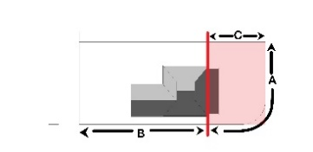
 | Heritage Rural Area (Hahndorf): | - Agricultural fencing, post and wire  - Timber palings, vertical  - Hedges  - Stone walls  - Timber or metal gates to suit fencing
Signage  Commercial signage is a dominant visual element in Hahndorf’s Main Street. The location, scale and proportion, text and colour affect the heritage values of the State Heritage Area. | LED screen, flashing or backlit illuminated signs are not permitted  Corporate signs to conform to the signage guidelines set out in this Heritage Standard.  Main Street:  Signage is of a scale that reflects the pedestrian nature of Hahndorf and does not visually dominate the scale of heritage buildings or other streetscape elements, by adhering to the following requirements.  Businesses along Main Street: two fixed signs only, as follows:  - Signage to be located within the building’s street façade and on one other façade only. Roof signage not supported  - Total fixed signage area will not exceed 10 percent of the affected façade area  - Projected signage will be located below verandah eaves  - Traditional locations such as fascia boards, gable ends, parapet walls or fences are recommended  - Signs to be simple in shape and form – on board, or transparent  - Flat wall signage must not exceed 1500mm wide or 500mm high  - Verandah signage must not exceed 1800mm wide or 300mm high  - Signage materials, finish and colour to be compatible to the building. Corporate colour schemes are not supported, where visually dominant  - Simple and easily legible colour combinations such as black on white or white on black are supported
Skylights  Roof forms are significant to the heritage values of the State Heritage Area. | Skylights are flush with roof cladding and do not impact the roof form.  Dormer windows and roof windows are not supported in the Hahndorf State Heritage Area
Solar panels  Solar panels provide environmental benefits. Panel arrays are to be located out of streetscape view, irrespective of building orientation. | Solar panels are to be:  - Located on roof planes of existing buildings that are not visible from the public realm and sited below the ridge  - Located on sheds, carports, garages or pergolas, that are not visible from the streetscape  - Located on side roof planes, in part view of the streetscape, only where no other mounting locations are possible, and panels are:  - set back at least 4 metres from the front façade edge, (but not on a corner site)  - located as far as practical on the lower part of the roof  - arranged neatly in a symmetrical rectangular group with a margin of visible roof edge around the group  - Black framed solar panels in construction  - Mounted flush with roof plane  - Installed so componentry including cabling, conduits, batteries and inverters are not visible form public streets
Rainwater Tanks | Corrugated metal tanks are to be used within view of the street. Plastic style rainwater tanks are to be located out of view of public streetscapes.  Modern plastic tanks of the same form, profile and colour are to be screened with vegetation, where capacity is required for rural production or firefighting purposes.
Plant and ancillary equipment | Installations such as hot water units and water pumps should be located to the rear of properties to avoid negatively impact the streetscape, concealed by vegetation or small sheds of traditional corrugated steel sheeting or stone.  Air conditioners are not located on the principal façade and external air handling (condenser) units will be screened. Roof mounted evaporative units to be located on rear planes of roofs and coloured to match roof sheeting.  Antennae and satellite dishes and other telecommunications equipment is located out of view from public streetscapes. Ground-mounted options to the rear of buildings, concealed with roof planes or planting are options. Installations such as hot water units and water pumps should be located to the rear of properties to avoid negatively impact the streetscape, concealed by vegetation or small sheds of traditional corrugated steel sheeting or stone.

Land division
(refer: State Heritage Area Overlay - PO4.1)
Land division refers to boundary adjustments and sub-division of allotments within the State Heritage Area. Further subdivision of land in Hahndorf is not supported unless it reinstates or maintains the original subdivision patterns of the town’s earliest subdivision, Hufendorf or Strassendorf patterns, and productive rural blocks.

Principles | Acceptable Standard

Land division characteristics
The early subdivision patterns of Hahndorf including the early Hufendorf and Strassendorf layouts set up the unique and enduring character of the settlement.
Development is to have regard to the following:
- Land division  Subdivision of existing allotments to create additional allotments is not supported. | Any division of land or adjustment of boundaries should only reinstate or maintain the original Hufendorf and Strassendorf subdivision layout.  Hahndorf Rural Area is to not be further subdivided for development.  Existing public reserves, roads and laneways are retained.  Boundary adjustments to remedy boundary anomalies are acceptable where they are of a minor nature.

Landscape context and streetscape amenity
(refer: State Heritage Area Overlay - PO5.1)
The landscape of Hahndorf underpins its identity as a 19th century rural settlement of German/Prussian character in the South Australian landscape. Of particular importance to the landscape and character of the State Heritage Area of Hahndorf is the Heritage Rural Area (Hahndorf) which ensure the town’s visual legibility and historic identity as a productive rural settlement. Street planting along Main Street, dating from 1885, is important to the character and identity of the town and its landscape heritage values.

Principles | Acceptable Standard

Landscape character
The unique layout of Hahndorf underpinned by original Hufendorf and Strassendorf subdivisions which has resulted in a rural village character along Main Street, Victoria Street and elsewhere in the State Heritage Area. Narrow roads and footpaths, buildings close to the front of blocks, spaces between buildings, established street trees and open spaces have established a scale and rhythm to the area which is consistent across public and private realms. The scale and rural character of Hahndorf is safeguarded by rural blocks along the main access road.
Development is to have regard to the following:
- Footpaths and driveways  - Rear laneways  - Kerbing  - Street tree planting and verges  - Open space parks  - Internal reserves (east section)  - Street garden reserves  - Services and infrastructure | Actions involving the replacement or upgrade of public realm kerbing, footpaths, street trees, street furniture and lighting, as well as works in parks and reserves by a local council are typically not defined as development in the PDI Act 2016.  These actions are not exempt from the definition of development in a State Heritage Area where works materially affect the heritage values. As such works vary in scope and early discussion between Heritage South Australia and the City of Mount Barker is required. Where they do affect heritage values, development approval is required.  Other non-statutory documentation such as Conservation Management Plans and Concept Plans may provide guidance as part of Heritage South Australia advice.

Demolition
(refer: State Heritage Area Overlay - PO6.1)
Demolition of significant buildings, structures, public realm elements and other features of identified heritage value is not acceptable.

Principles | Acceptable Standard

Demolition
The built heritage of Hahndorf, located on early town subdivisions, in conjunction with notable street planting encapsulate the character Hahndorf. It is in this composition of extant elements, dating from 1839 -1915 that visually tell the story of Hahndorf’s history from early German settlement to German/Australian country town.
Any demolition work is deemed ‘development’ within the State Heritage Area. Development is to have regard to the following:
- Demolition of buildings | Demolition of any building in a State Heritage Area requires planning approval. Demolition of a building or parts of buildings, erected before 1918 is not supported, unless:  - The building (or part) to be demolished is determined to not contribute to the heritage value of the State Heritage Area, or the structural condition of the building represents an unacceptable risk to public or private safety and results from actions and unforeseen events beyond the control of the owner and is irredeemably beyond repair.  Replacement buildings must have due regard to the Principles and Acceptable Standards of 3.4 New Development.
- Demolition of out buildings and dwelling additions | Demolition of building lean-tos, building additions, garages, sheds or other outbuildings is not supported unless:  - The proposed structure and/or associated building postdates 1918 and removal does not adversely impact on the heritage values of the State Heritage Area.
- Public realm infrastructure | Demolition and replacement of kerbing, footpaths, street furniture or other public realm park and streetscape features of heritage value is acceptable where heritage values are not compromised.

Conservation works
(refer: State Heritage Area Overlay - PO7.1)
Conservation work to repair dilapidated building fabric is considered a development matter where not of minor in nature and getting the right advice is important, to save time, cost and to ensure the ongoing management of buildings.

Principles | Acceptable Standard

Conservation approach
The external building fabric of existing buildings of heritage value within the Hahndorf State Heritage Area is to be conserved and restored.
Correct repair methods and maintenance ensure the longevity of buildings within Hahndorf. The aim is to only repair as much as needed, so that early building fabric is retained where possible, illustrating the 19th century features of the town. Conservation practices must avoid embellishing architectural details and adding features not common to the style and era of the building.
The following conservation works are deemed ‘development’:
- Roof repairs, verandah repairs  - Structural repairs  - Window and door replacement  - Removal of paint finishes from external face brick and stone surfaces, original timber or metal surfaces  - External brick and stone wall repairs and/or repointing  - Chimney repairs – stabilisation, repointing  - Verandah floor repairs  - Gable repairs – stucco infill  - Historic paving repairs  - Rising damp repairs  - Repairs to front fences – rot, subsidence, damp to masonry walls, corrosion to metalwork  - Repair and/or stabilisation of ruins | Dwellings and non-residential buildings:  Seek the advice of a Heritage South Australia heritage officer before undertaking conservation repairs to building fabric.  Works that are more than ‘minor in nature’ require development approval.  The Relevant Authority (District Council of Mount Barker), in conjunction with Heritage SA, can provide advice confirming if works are of a minor nature.

Ivan-Tiwu Copley, Indigenous Heritage – Hahndorf: Sites of Aboriginal Cultural Significance In and Around Hahndorf, South Australia, 2019. Available online at: https://storymaps.arcgis.com/stories/16251441de5e48feb4c3dd55be82bce7
Lothar Brasse, ‘The First Special Survey, W. H. Dutton and the Hahndorf Contract’ in Gordon Young et al, Hahndorf Vol. 1: a survey carried out for the Australian Heritage Commission. Techsearch Inc, Adelaide, 1981, p. 56
Mount Barker District Council, ‘Hahndorf Township Plan March 2018’. Available online at: https://www.mountbarker.sa.gov.au/
E. A. Wittwer, Liebelt Family History, Liebelt Reunion Committee, South Australia, cited in Alexandra Marsden, ‘Development: early difficulties, economic growth with agricultural expansion and service businesses, the milling and wattlebark industries’ in Young et al, 1981, p. 123
Philip A. Clarke for, Report on the Bird-in-Hand Heritage Assessment for a mining lease application, Terramin Australia Limited, (2016), p. 26
Ian Harmstorf, ‘The history of German Migration and the reasons for emigration to South Australia: Economic, Political, Religious’, in Young et al, 1981, P. 50
M. Lohe,‘Lutheran Pioneers in Australia The Emigration, Landing, and Establishment (31 December 1963)’, in The Australian Lutheran almanac for the year, 1964, p 23.
Brasse, ‘The First Special Survey’, in Young et al, 1981, pp 57-60
Brasse, “The First Special Survey’, in Young et al, 1981, p 60
Fay Gale, ‘Hahndorf: an example of cultural transfer’, in Young et al, 1981, p 115
Alexandra Marsden, ‘Development: early difficulties’, in Young et al, 1981, p 129
Brasse, ‘The German Village at Hahndorf’, in Young et al p 85
Harmstorf, ‘The history of German migration’, in Young et al, 1981, p 51
See: Dickinson, Robert E., Germany A General and Regional Geography, Methuen & Co., London, 1961, pp 139-155
Brasse, ‘The German Village at Hahndorf’ in Young et al, 1981, p. 85
Gordon Young, ‘Pioneer settlement patterns in the Onkaparinga District Council of South Australia’, Antiquity, Vol. 61, ISS 232, 287-310, 1987, p 303
Gale, ‘Hahndorf: an example of cultural transfer’ in Young et al p. 117
Gale, ‘Hahndorf: an example of cultural transfer’ in Young et al p. 121
D. W. Meinig, On the Margins of the Good Earth: The South Australian Wheat Frontier 1869-1884, Adelaide SA: Rigby, 1962, p. 25
Brasse, ‘The German Village at Hahndorf’, in Young et al, 1981, p. 85
Marsden, ‘Development: early difficulties’, in Young et al, 1981, p. 128
Brasse and Young, ‘Hahndorf in the nineteenth century’, in Young et al, 1981, p. 157
Brasse and Young, ‘Hahndorf in the nineteenth century’, in Young et al, 1981, pp. 157-160
Brasse and Young, ‘Hahndorf in the nineteenth century’, in Young et al, 1981, p. 159
Young, ‘Early German Settlements in South Australia’, Australian Historical Archaeology, Vol 3, 1985, p. 47
Brasse and Young, “Hahndorf in the nineteenth century” in Young et al, 1981, p. 158
Lothar Brasse, ‘The German Contribution’, Historic Environment, VI, 2, 1988, p. 46
Brasse, ‘The German Contribution’, 1988, p. 46
David S. Jones, ‘Arbor Day’, Available online at: https://sahistoryhub.history.sa.gov.au/subjects/arbor-day
DEW, Hahndorf State Heritage Area fact sheet, Available online at: her-fact-hahndorfsha-factsheet.pdf (environment.sa.gov.au)
Brasse, ‘The German Village’, in Young et al, 1981, p. 86
Alexander Marsden, ‘1900-1950s: A continuity maintained despite the disruptions of war and depression’, in Young et al, pp. 217- 219
Brasse and Young, ‘Hahndorf in the nineteenth century’, in Young et al, 1981, p. 256
Alexander Marsden, ‘1900-1950s: A continuity maintained despite the disruptions of war and depression’, in Young et al p. 220
Alexander Marsden and R. Smith, 1960s-1970s: ‘Changes in the economy bases of the town, the character and the lifestyle’, in Young et al, 1981, p. 228
LeMesssurier Architects, Hahndorf Conservation Policy, Adelaide 1991, p1
Gordon Young, “Introduction” in Young et al p. 3
The South Australia Heritage Places database (maps.sa.gov.au)
Lothar Brasse, ‘The German Village at Hahndorf: The settlement, original land tenure and early expansion’, in Young et al. 1981. 78-90
Hahndorf Conservation Policy 1991, 9
Young, G., Pioneer settlement patterns in the Onkaparinga District Council of South Australia, 1987, 301

