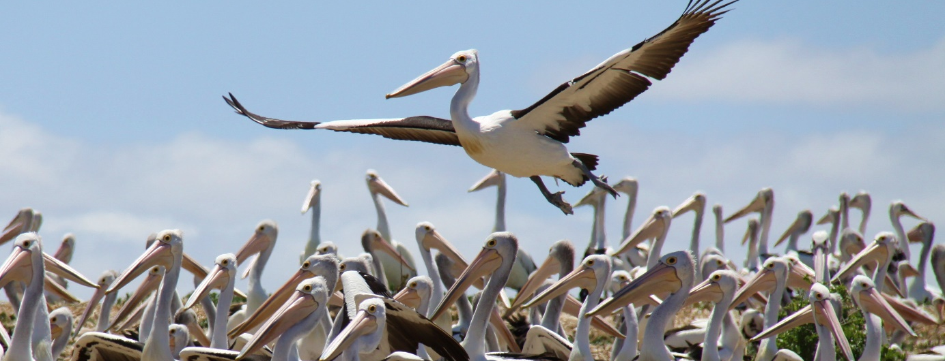
Coorong Environmental Trust

Is your organisation committed to improving the Coorong?
The Government of South Australia is seeking nominations for a Trust constituted of members representing organisations with a professional, financial, physical or legal commitment to the ecological wellbeing of the Coorong. The Trust is established by the Coorong Environmental Trust Act 2021 and the initial members of the Trust will be appointed by the Minister for Climate, Environment and Water. Thereafter the Trust manages itself.

Functions of the Trust
The functions of the Trust are:
(a) to create and maintain a repository for all environmental data and research outcomes relating to the Coorong;
(b) to prepare an annual 'State of Our Estuary' report, along with presenting an opportunity for community, policy writers, and researchers to discuss outcomes;
(c) to prepare, adopt and maintain a set of rules relating to the membership, management and operations of the Trust;
(d) to provide independent, impartial scientific advice on the state of the Coorong to all stakeholders;
(e) to provide guidance for future environmental research within the Coorong;
(f) to clearly monitor and document environmental flow outcomes;
(g) to coordinate and if necessary implement a comprehensive water quality monitoring program;
(h) to independently assess proposed solutions to ecological challenges faced by the Coorong;
(i) to raise money so that it can carry out its functions with financial independence;
(j) to perform any function assigned to the Trust by regulation.

Get involved – how to nominate
Membership to the Coorong Environmental Trust is only open to representatives of organisations with a professional, financial, physical or legal commitment to the ecological wellbeing of the Coorong. Organisations that meet this criterion should nominate representatives for membership of the Trust using the attached form and submit it to email address dewcet@sa.gov.au by Tuesday 31 October 2023.

Coorong Environmental Trust FAQs

How is the Trust established?
The Trust was established under the Coorong Environmental Trust Act 2021. The Trust is a body corporate and has a perpetual succession and a common seal and is capable of suing and being sued in its corporate name.

Is the Trust independent of the Government of South Australia?
The Trust is established under an Act of the South Australian Parliament and as such is part of government. The Trust and the Board of management for the Trust are required to comply with the Coorong Environmental Trust Act 2021 and any legal and financial requirements imposed on public authorities under other South Australian legislation such as the Public Finance and Audit Act 1987 and Legislation Interpretation Act 2021.
The Trust is required to raise money so that it can carry out its functions with financial independence.
The Auditor-General must audit the accounts of the Trust each financial year.
The Minister for Climate, Environment and Water has no role in the Trust other than to appoint the initial members of the Trust, to appoint two members to the Board of management and to cause copies of the annual report of the Trust to be laid before both Houses of Parliament within six sitting days of receiving the report.

How does an organisation become a member of the Trust?
The initial members of the Trust will be appointed by the Minister for Climate, Environment and Water. Organisations can nominate to be an initial member by filling out and submitting the nomination form (including declaration) in this document. The names of the initial members and the organisations they represent will be published in a Notice in the South Australian Government Gazette. After the initial appointment of members, the Trust manages itself and new members may be admitted as members of the Trust by resolution of the Trust or as provided by the rules of the Trust.

Why is an organisation required to nominate both a man and a woman representative?
Section 42 of the Legislation Interpretation Act 2021 requires that if an Act provides for a member of a body to be appointed by a Minister on the nomination of a non-government entity, then the non-government entity must nominate a panel of persons, and that the panel must include at least one woman and one man from which the Minister is to select a person for appointment.
Woman includes a person who identifies herself as a woman regardless of the person’s designated sex at birth.
Man includes a person who identifies himself as a man regardless of the person’s designated sex at birth.
A non-government entity means a person or body other than an officer, agency or instrumentality (including a Minister) of the Crown in right of the State or the Commonwealth or another State or a Territory of the Commonwealth.

Can an organisation nominate a person other than a man and a woman?
Yes every person is entitled to participate fully in all aspects of life, free from discrimination and prejudice, no matter their sexual orientation or how they define their gender. Please use the section of the form that does not refer to a man or a woman and nominate their pronouns.

Is there a limit to the number of organisations that can be members of the Trust?
There is no limit to the number of organisations that can be members of the Trust.

How is the Trust managed?
A board of management of the Trust consisting of seven directors will carry out the day-to-day operations of the Trust and manage its general affairs. Five directors will be elected members of the Trust and two directors will be appointed by the Minister for Climate, Environment and Water.

How much does membership cost?
The Trust must prepare, adopt and maintain a set of rules relating to the membership, management and operations of the Trust. The cost of membership, if any, will be determined through the development of the Trust rules.

How will the Trust be funded?
The Trust is required to raise money so that it can carry out its functions with financial independence.

How will the initial members be appointed?
The Minister for Climate, Environment and Water will appoint the initial members of the Trust from the nominations in this open call that are assessed as being representatives of organisations with a professional, financial, physical or legal commitment to the ecological wellbeing of the Coorong as initial members of the Trust.

How will the initial members be notified?
The initial members of the Trust will be notified via email and their names and the organisations that they represent will be published in a Notice in the South Australian Government Gazette.

How long is the process for the appointment of the initial members of the Trust expected to take?
The Department for Environment and Water expects the initial members of the Trust to be appointed within four months of the closing date for nominations.

Can an individual nominate to join the Trust?
No, the Act defines the members of the Trust as members representing organisations with a professional, financial, physical or legal commitment to the ecological wellbeing of the Coorong.

How can an individual become involved in supporting the Coorong?
An individual will be able to participate in Trust activities open to the public. Community advocacy and ongoing involvement in the long-term management of the Coorong is fundamental to its future health and sustainability. The South Australian Government works closely with the Coorong Partnership, Coorong and Lower Lakes Community Advisory Panel and the Murraylands and Riverland Landscape Board’s Water Advisory Committee to gain community input and share information about projects in the region, as well as providing opportunities for local groups and the broader community to get involved - Landscape South Australia - Murraylands and Riverland | Get involved and SA Directory of Community Services | SAcommunity - Connecting Up Australia. There are also a number of local groups so talk to your local council and your neighbours.

Have any functions been assigned to the Trust by regulation?
No, the Government is not currently considering assigning any additional functions to the Trust by regulation.

Nomination for membership of the Coorong Environmental Trust

Name of organisation

Postal Address

Email

Brief description of your organisation’s commitment to the ecological wellbeing of the Coorong

Supporting documentation that demonstrates your organisation’s commitment to the ecological wellbeing of the Coorong (maximum of 20 A4 pages)
Please list the attachments attached to this nomination.

Nominated woman representative’s name

Nominated woman representative’s email

Nominated woman representative’s phone number

I declare that the above organisation has a professional, financial, physical or legal commitment to the ecological wellbeing of the Coorong.
Signature of nominated woman representative Date

Nominated man representative’s name

Nominated man representative’s email

Nominated man representative’s phone number

I declare that the above organisation has a professional, financial, physical or legal commitment to the ecological wellbeing of the Coorong.
Signature of nominated man representative Date

Nominated representative’s name

Nominated representative’s email

Nominated representative’s phone number

Nominated representative’s pronouns

I declare that the above organisation has a professional, financial, physical or legal commitment to the ecological wellbeing of the Coorong.
Signature of nominated representative Date

I declare that the above organisation has formally agreed to the above nominations.
Signature Date

Position of signatory Contact phone number

