Restrictive Practices System

Guide – Nominating Authorised Program Officers

Contents
1 Introduction 3
1.1 About this guide 3
1.2 Introduction to the Restrictive Practices System 3
1.3 Icons used in this guide 3
1.4 Glossary of Terms 4
2 Nominating an Authorised Program Officer 5
2.1 Why do I need an Authorised Program Officer? 5
2.2 What are the qualifications and skills of Authorised Program Officers 5
2.3 What else should I consider in nominating an Authorised Program Officer 5
2.3.1 Other skills and knowledge 5
2.3.2 Alignment with other official duties 6
2.3.3 Administrative considerations 6
3 Accessing the Restrictive Practices System 7
3.1 Log in 7
4 Creating Authorised Program Officer Nominations 9
4.1 Create new nomination 9
4.2 Add APO Information 11
4.3 Add Qualifications 12
4.4 Add Experiences 13
4.5 Add Screening Checks 15
4.6 Add Additional Considerations 16
4.7 Add Endorsements 17
4.8 Review Summary screen 18
4.9 Confirmation 19
5 Resubmitting an APO Nomination 20
6 Nominating additional Authorised Program Officers 23
7 Editing Authorised Program Officer Details 24
8 Logging Out 25
8.1 Logging out of the Restrictive Practices System 25

Introduction

About this guide
This guide helps registered NDIS providers to nominate appropriate people within their organisation to be an Authorised Program Officer in the South Australian Restrictive Practices authorisation scheme.

Introduction to the Restrictive Practices System
The Restrictive Practices System (RPS) is the online system for managing the application, authorisation, and reporting of restrictive practices by NDIS service providers for NDIS participants in South Australia.
This guide provides information about:
- The role of Authorised Program Officers
- The skills and qualifications of Authorised Program Officers
- Additional criteria that should be considered by registered NDIS in nominating Authorised Program Officers
- How to nominate an Authorised Program Officer online using the Restrictive Practices System.
Note: Instructions for registering a provider account are excluded from this training guide. Refer to the <Guide – Provider Registration> for further information.

Icons used in this guide
Throughout this guide you will find icons representing various kinds of information to help you follow the guide effectively.

Icon | Description
 | Information – provides context for the following process steps
 | Note – contains important information to be aware of
 | Stop – before proceeding with the next step, there may be information you need to have available, or there may be something you need to do or check

Glossary of Terms

Term | Definition
Restrictive Practices System (RPS) | The online system for managing the application, authorisation and reporting of restrictive practices by NDIS providers providing NDIS supports to NDIS participants in SA.
CEO or equivalent | This is the Senior Executive / Manager responsible for the operations of the NDIS service provider in South Australia. For some providers, this will be a Chief Executive. For other (especially national organisations with a South Australian presence), this may be the SA state manager.
Account Owner | The Account Owner is the systems administrator for NDIS service provider who can nominate the Authorised Program Officers for their provider.
Authorised Program Officers (APO) | This is a key role in the South Australian Restrictive Practices authorisation scheme. APOs can authorise Level 1 restrictive practices by their registered NDIS provider for NDIS participants and may endorse the use of Level 2 restrictive practices for the Senior Authorising Officer’s authorisation.
Senior Authorising Officer (SAO) | The Senior Authorising Officer has statutory responsibilities to:  - Approve appropriate persons to be Authorised Program Officers  - Approve restrictive practices, including Level 2 practices  - Provide education, training and support to reduce and eliminate the use of restrictive practices where possible
Restrictive Practices Team | Also known as the Restrictive Practices Unit and the Restrictive Practices Authorisation Team. The team supports the SAO to undertake their statutory functions and provides support to NDIS providers using the Restrictive Practices System. The team can be contacted at:  DHSRestrictivePracticesUnit@sa.gov.au

Nominating an Authorised Program Officer

Why do I need an Authorised Program Officer?
Authorised Program Officers play a key role in the South Australian Restrictive Practices authorisation scheme. Authorised Program Officers have the power to authorise Level 1 restrictive practices by their registered NDIS provider for NDIS participants and may endorse the use of Level 2 restrictive practices for the Senior Authorising Officer’s authorisation.
Registered NDIS providers will generally need at least one Authorised Program Officer to be able to implement authorised restrictive practices.
In limited circumstances, registered NDIS providers that have less than five employees may not be able to sustain an Authorised Program Officer within their organisation. At times, the Authorised Program Officer may need to recuse themselves in matter where they may have been directly involved in the behaviour support planning process for the NDIS participant. In these situations, registered NDIS providers may negotiate to refer their matters directly to the Senior Authorising Officer. Approval of this arrangement is at the discretion of the Senior Authorising Officer.

What are the qualifications and skills of Authorised Program Officers
Under the Disability Inclusion (Restrictive Practices – NDIS) Amendment Act 2021 (section 23L), a registered NDIS provider must nominate a person with requisite skill, knowledge and experience to be an Authorised Program Officer.
Authorised Program Officers must have:
- tertiary qualifications relevant to the functions of an Authorised Program Officer under the Act (such as allied health, nursing, education, or a disability-specific or behaviour-specific discipline)
- extensive experience and knowledge in the planning, development, implementation, evaluation, and monitoring of behaviour interventions and supports.

What else should I consider in nominating an Authorised Program Officer

Other skills and knowledge
Authorised Program Officers should also be familiar with the following:
- Trauma-informed practices
- Positive behaviour support
- Client-centred approaches
- The impact of colonisation and systemic racism for Aboriginal people
- Child development and developmental trauma.

Authorised Program Officers should also have strong professional networks and be able to seek cultural, religious, gender and issue-based expertise to guide their Level 1 authorisation decisions.

Alignment with other official duties
Authorised Program Officers will have to access data reports about their organisation’s authorisations and use of restrictive practices the Restrictive Practices ICT System (RPS).
This RPS data is designed to support registered NDIS providers to analyse the trends and patterns of restrictive practices in their organisation and target:
- Preventative and alternative supports for people with disability
- Staff professional development and training
- Policy and program review and development.
NDIS service providers should ensure that Authorised Program Officers can contribute to organisational planning and development, either directly or indirectly through the provision of reports and information.
NDIS service providers should also ensure that Authorised Program Officers are able to maintain their professional knowledge, skills and understanding about national and state restrictive practices requirements through participation in staff training, networking, and communities of practice.

Administrative considerations
Registered NDIS providers may nominate a sufficient number of persons to be Authorised Program Officers to ensure that they are able to meet their authorisation requirements based on participant numbers, staff leave and movements, and recusals.

Accessing the Restrictive Practices System

Log in

Step | Action
 | To log in to the Restrictive Practices System you will need your Username (sent in the welcome email) and password. You will also need to verify your identity using the authenticator application used when you first accessed the Restrictive Practices System.
1 | Go to https://www.rps.sa.gov.au/login
2 | Enter your Username and password.  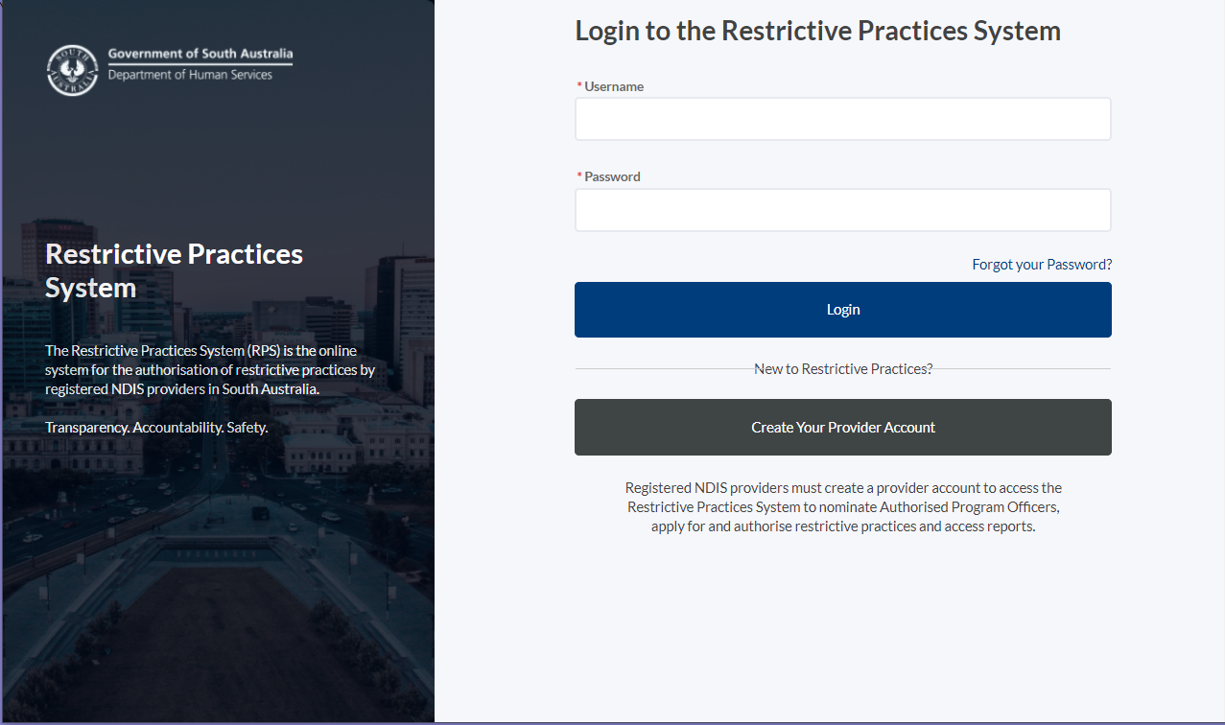
 | The Verify Your Identity screen will be displayed.
3 | Enter the Verification Code from your authenticator application and click Verify.  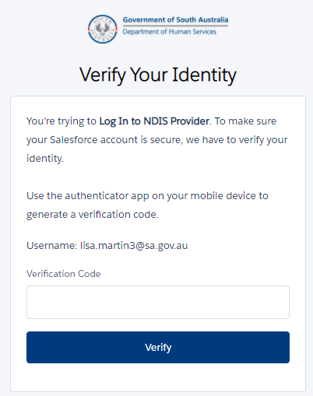
 | You will be logged into the Restrictive Practices System.

Creating Authorised Program Officer Nominations

Create new nomination

Step | Action
The Restricted Practices System will guide you through the Authorised Program Officer Nomination process via the following screens:
- APO Information
- Qualifications
- Experiences
- Screening Checks
- Additional Considerations
- Endorsements
- Summary
- Confirmation
The nomination process enables you to complete each screen sequentially.

Only the Account Owner can nominate Authorised Program Officers.
Before you get started, please ensure you have the information required to complete the APO nomination screens. You will need:
- The individual’s knowledge and consent to be nominated as an APO.
- Contact information for the prospective APO, i.e. first name, last name, email address, phone number, mobile number.
- Qualification details including the Qualification Type and Sub-type (e.g. Degree, Diploma, Graduate Certificate, Certificates), the Discipline. This information is mandatory. You must upload documentation to support this information. This may include a copy of the person’s CV, academic transcripts, certificates, or accreditation by a professional / regulatory body (e.g. AASW).
- Experiences. This includes information about different professional roles, training, and accreditation. This information is mandatory. You must upload documentation to support this information. This may include a copy of the person’s CV, training certificates, CPD history from a professional or regulatory body.
- Screening checks, including screening check type, expiry date, reference number and the screening check / clearance documentation for uploading. This information is mandatory.
- Additional considerations. This field allows providers to document any other issues that should be considered by the Senior Authorising Officer in their assessment of the nomination. It may include specific NDIS participants for whom the APO can not authorise restrictive practices for personal or professional reasons. It may include any preferences identified by the provider (e.g. that the APO only authorises restrictive practices for adult NDIS participants).
- Endorsements. This field documents the Chief Executive’s (or equivalent) knowledge and endorsement of the person to be an Authorised Program Officer for the provider. The CE (or equivalent) will be notified of the nomination.
1 | Click APO Nominations.  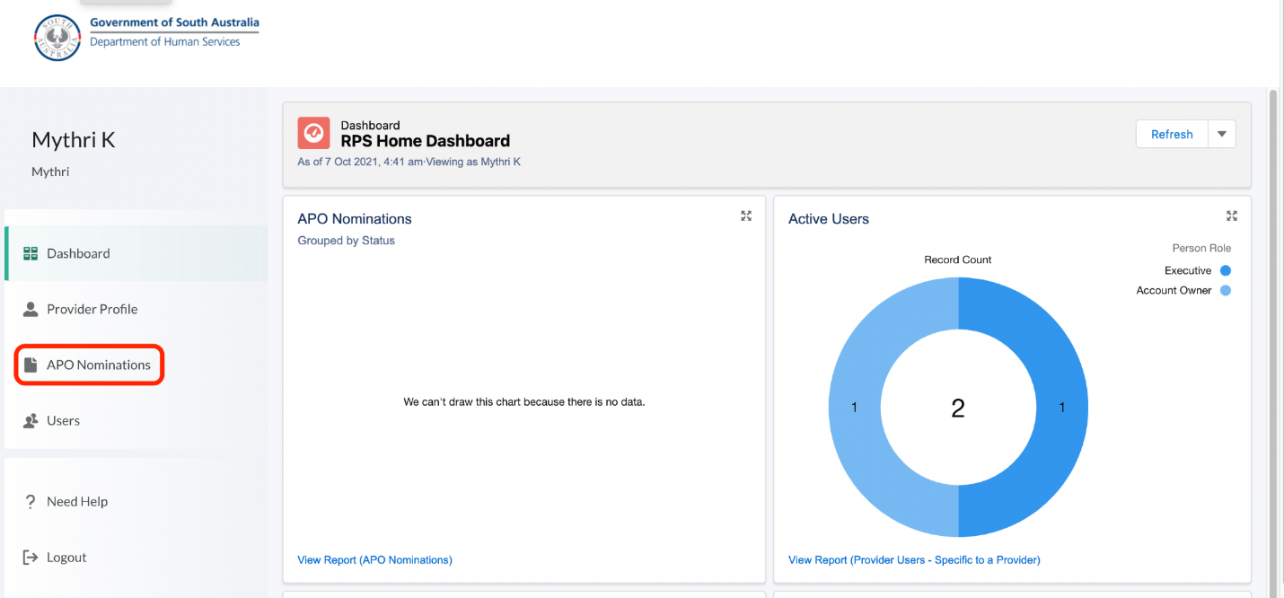
2 | Click New Nomination.  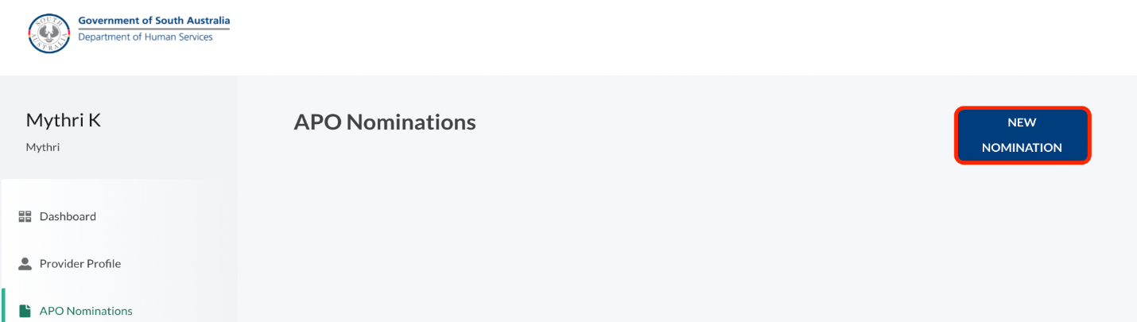
 | The APO User Nomination screen will be launched.

Add APO Information

Step | Action
 | In this screen you will add the APO nominees contact details.
1 | Fill in the Contact Information.  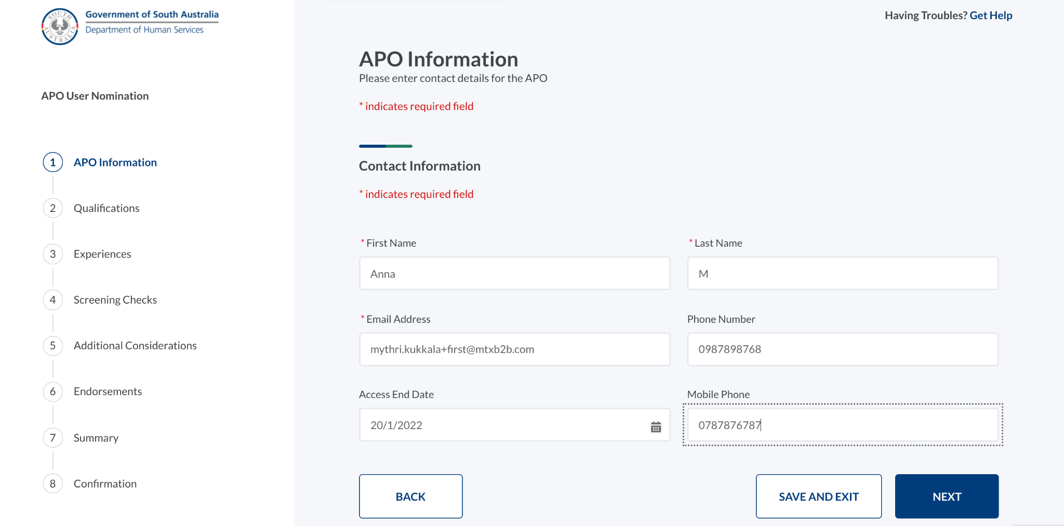
2 | Click Next.
 | The Qualifications screen will be displayed.

Add Qualifications

Step | Action
 | In this screen you will add the APO nominee’s Qualifications.
1 | Click Add New.  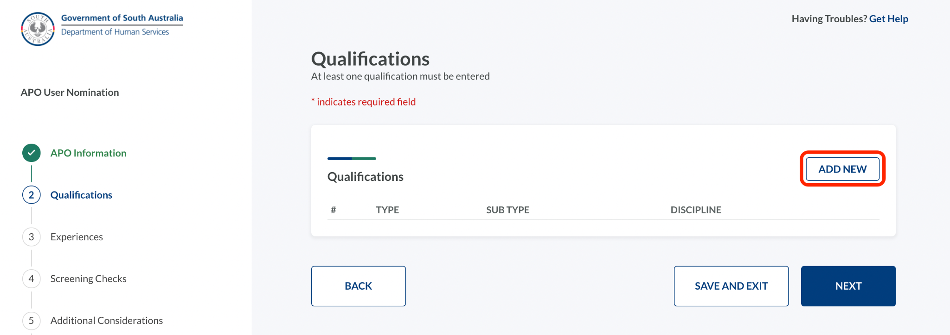
2 | Select the qualification information, click Upload Files to upload the necessary files, and click Save.  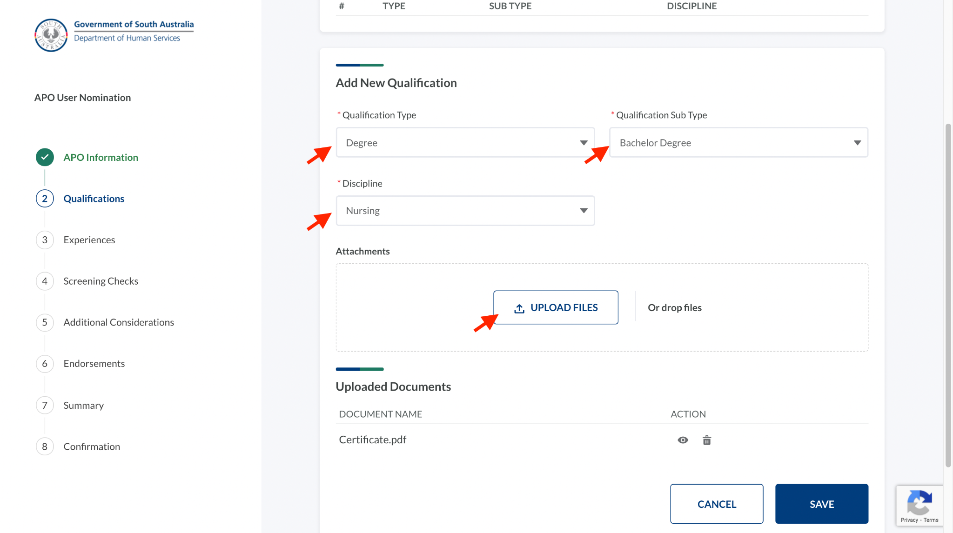
 | Repeat the process to add more qualifications.
3 | Click Next.
 | The Experiences screen will be displayed.
 | From this step onwards, you can click Save & Exit at any point to fill the form later.

Add Experiences

Step | Action
 | In this screen you will add the APO nominee’s Experiences.
1 | Click Add New.  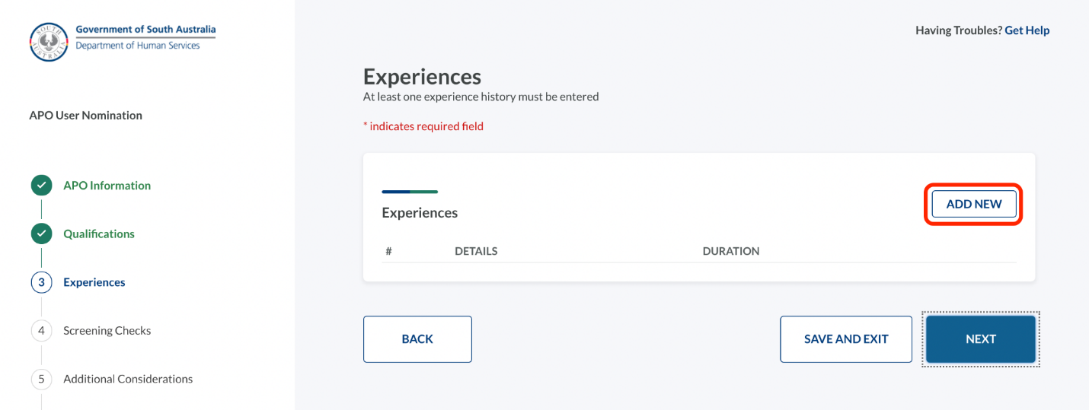
2 | Enter the experience details, click Upload Files to upload relevant files, and click Save.  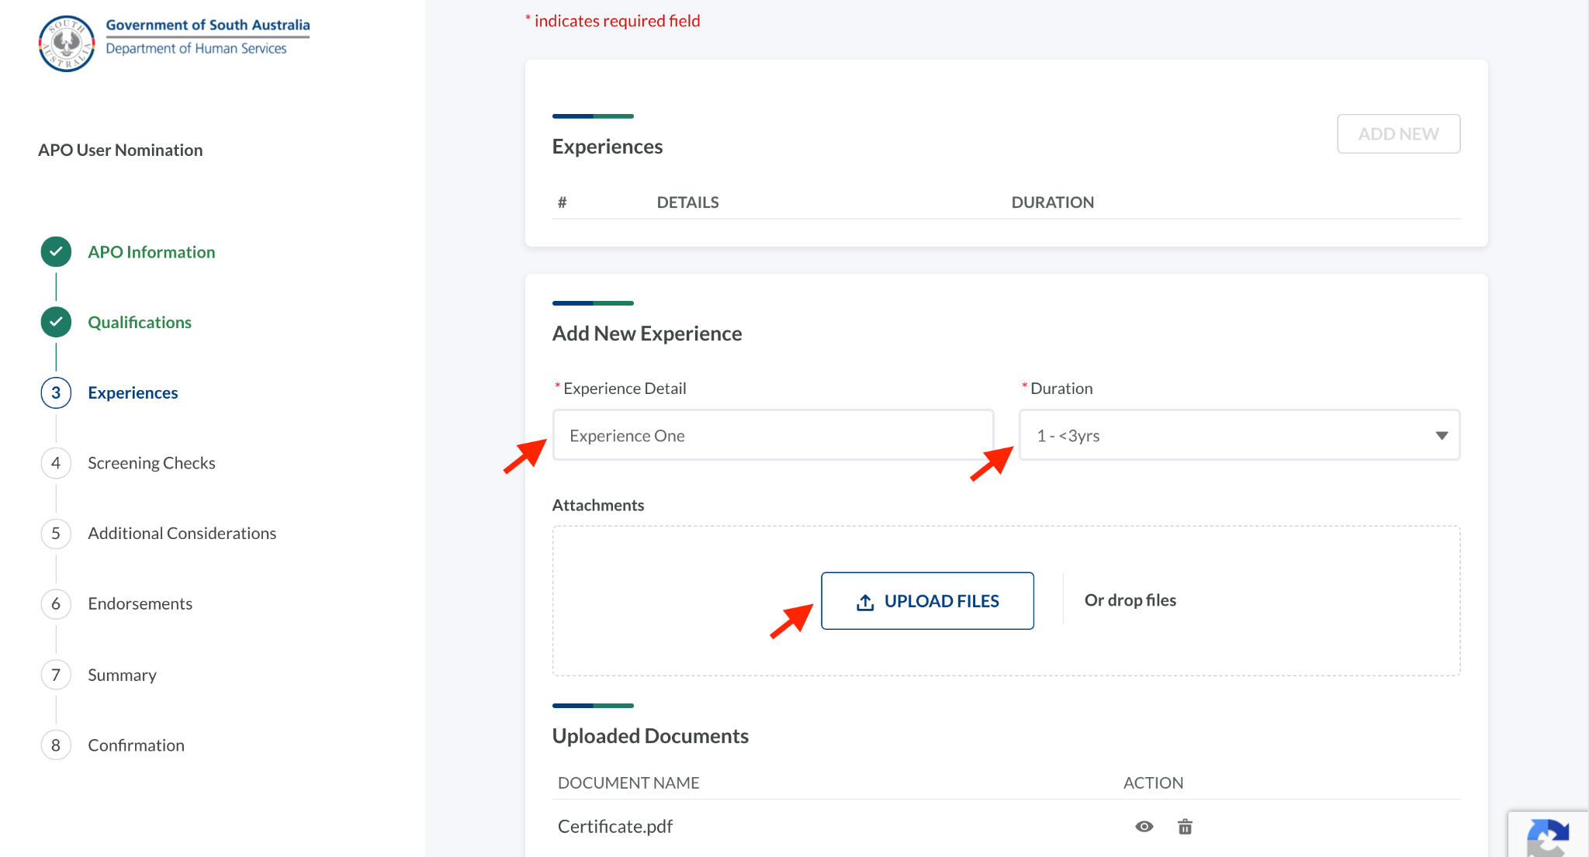
 | Repeat the process to add more details.
3 | Click Next.
 | The Screening Checks screen will be displayed.

Add Screening Checks

Step | Action
 | In this screen you will add the APO nominee’s Screening Checks.
1 | Click Add New.  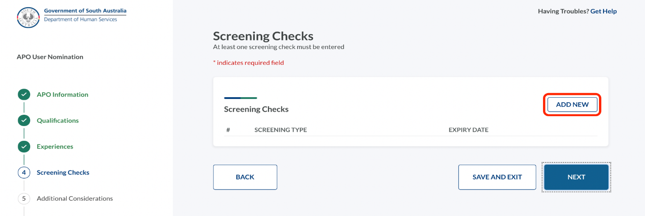
2 | Enter the details, click Upload Files to upload the relevant certificate(s), and click Save.  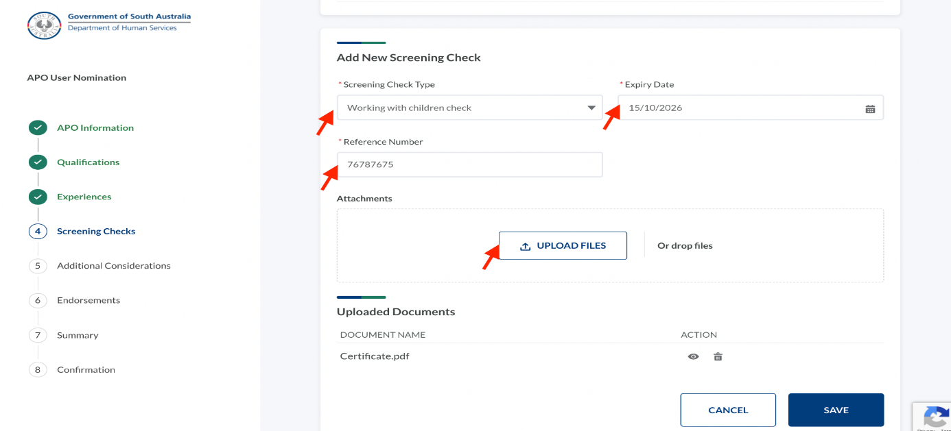
3 | Repeat steps 1 and 2 to add more screening checks.
4 | Click Next.
 | The Additional Considerations screen will be displayed.

Add Additional Considerations

Step | Action
 | In this screen you will note any additional considerations.
1 | Enter the information that must be considered additionally.  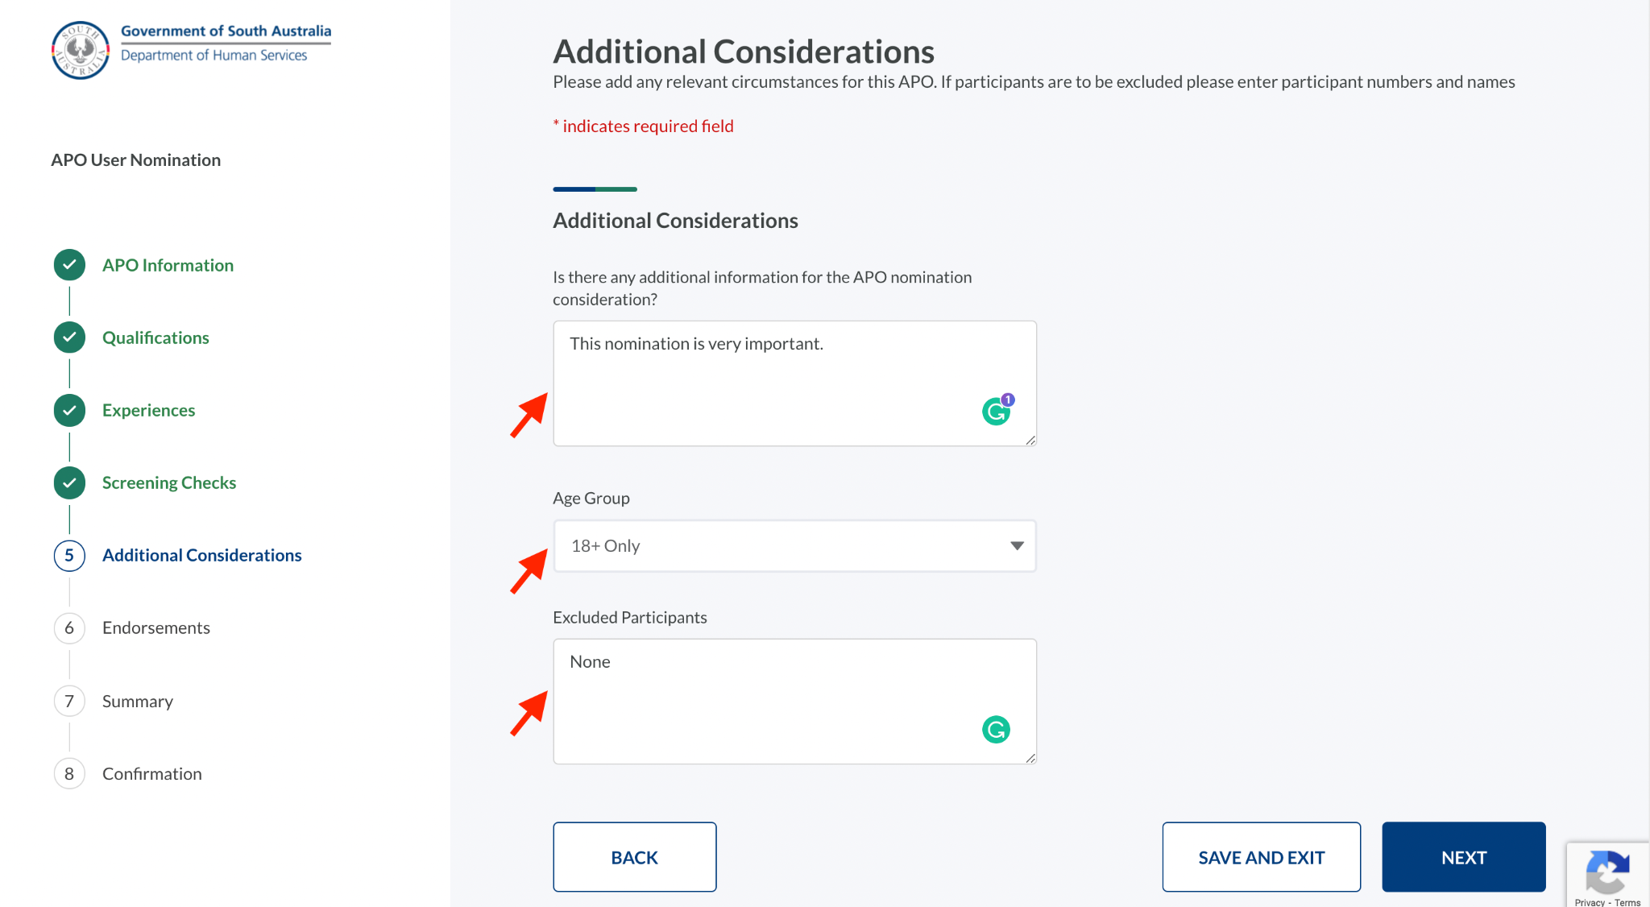
2 | Click Next.
 | The Endorsements screen will be displayed.

Add Endorsements

Step | Action
 | In this screen you will document who has endorsed the APO nomination.
1 | The CEO information is auto populated. However, you can edit if required.  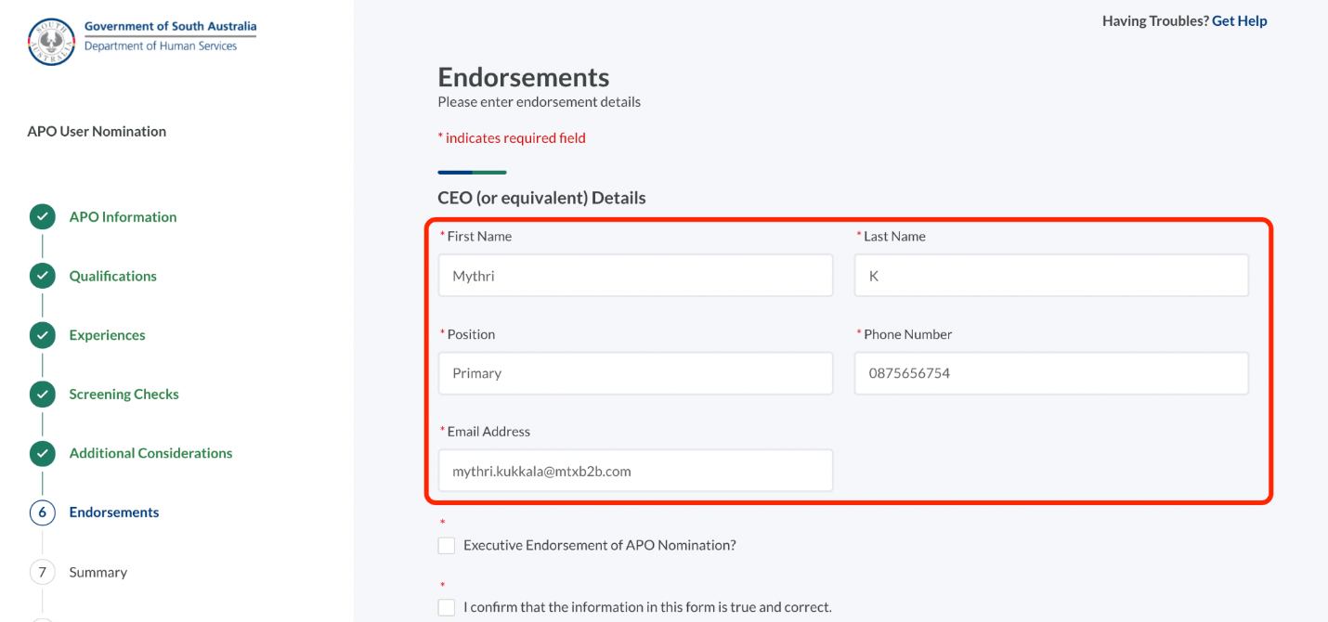
2 | Select the check boxes.  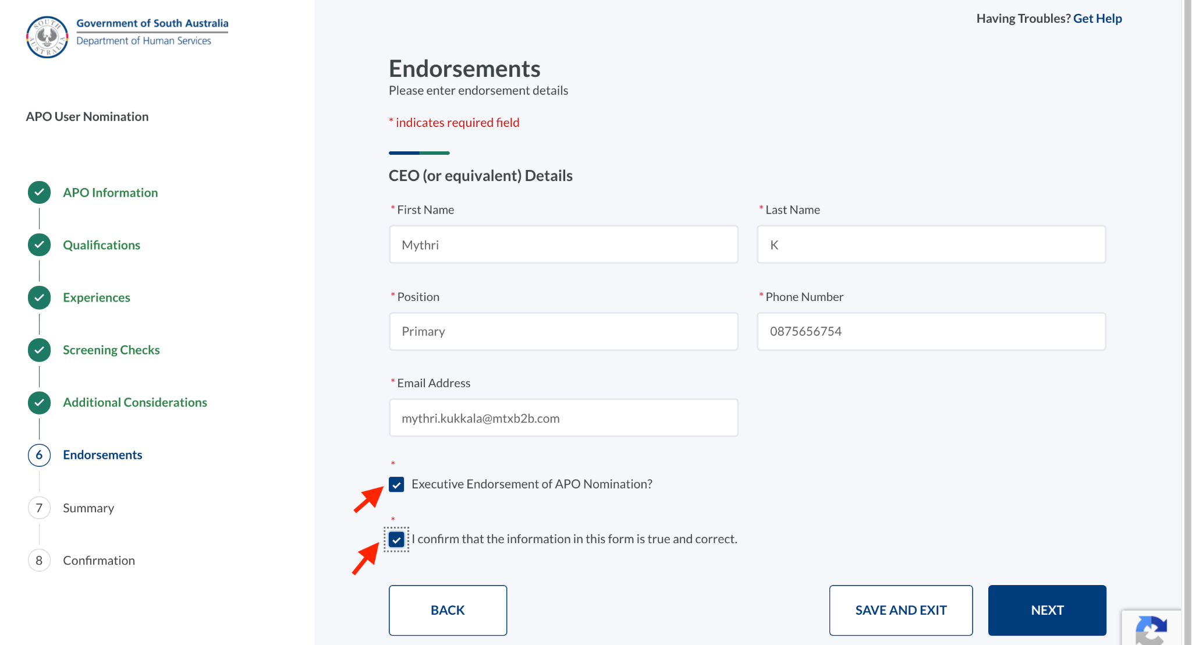
3 | Click Next.
 | The Summary screen will be displayed.

Review Summary screen

Step | Action
 | The Summary screen enables a review of the APO nomination details prior to submission. Information entered can be edited from this screen if required.
1 | Review the information.  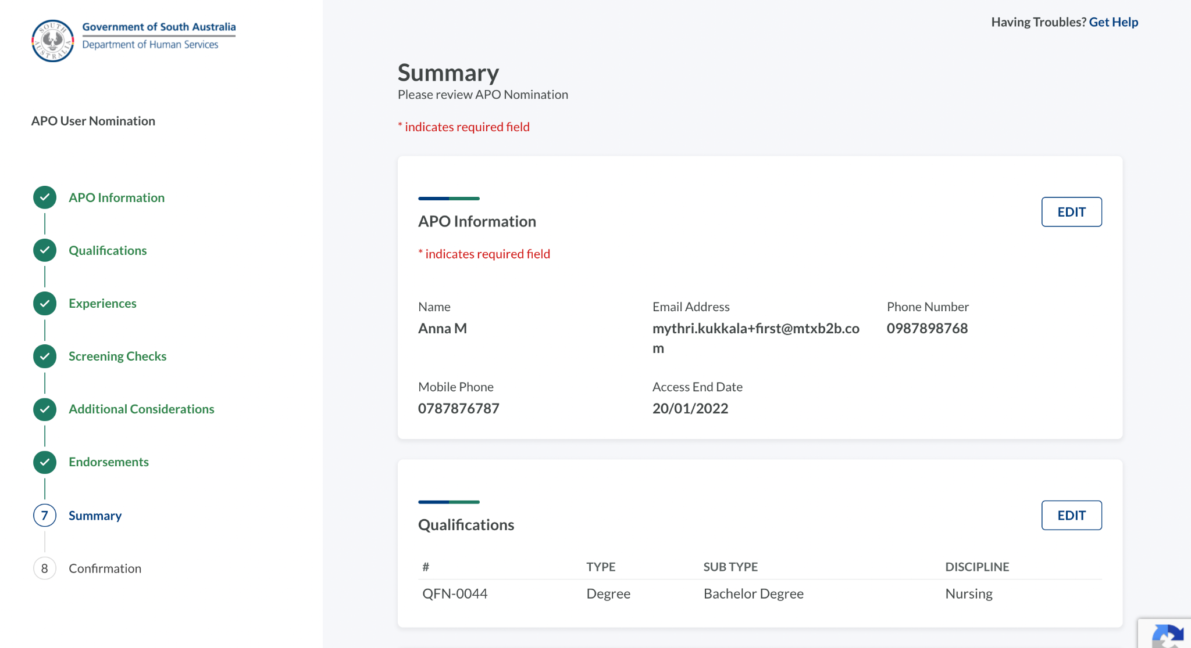
2 | Click Edit to edit any information. You will be navigated back to the step to update the details and navigate to the Summary page.
3 | After reviewing the information, click Submit.
4 | At the prompt, click Yes.  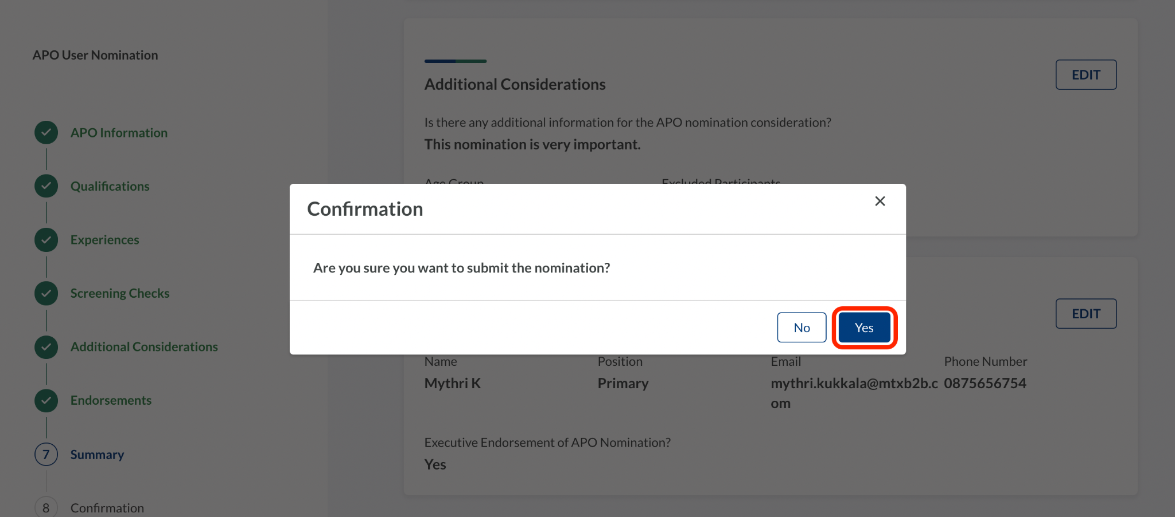
 | The Confirmation screen will be displayed.

Confirmation

Step | Action
 | The Confirmation screen confirms the nominations has been submitted.
1 | Review the Confirmation details, then click Back to Home.  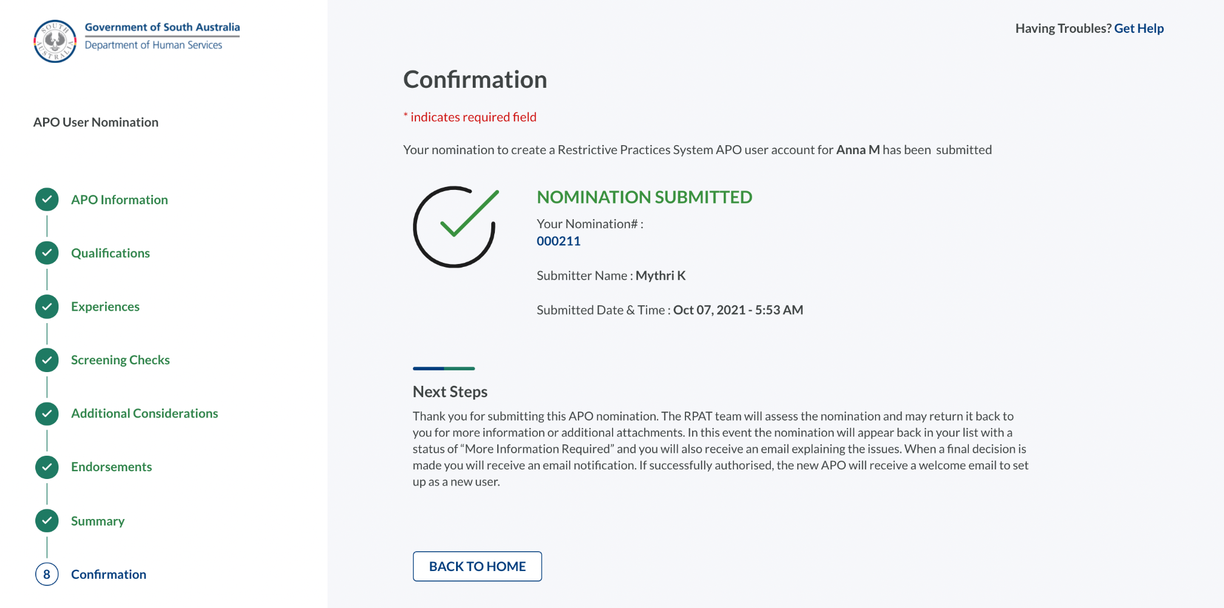

Resubmitting an APO Nomination

Step | Action
 | The Restrictive Practices Authorisation Team may return an APO nomination to the Account Owner, seeking further information. The Account Owner will receive an email identifying the additional information required.
1 | Log in to the application (if not logged in) and click APO Nominations.  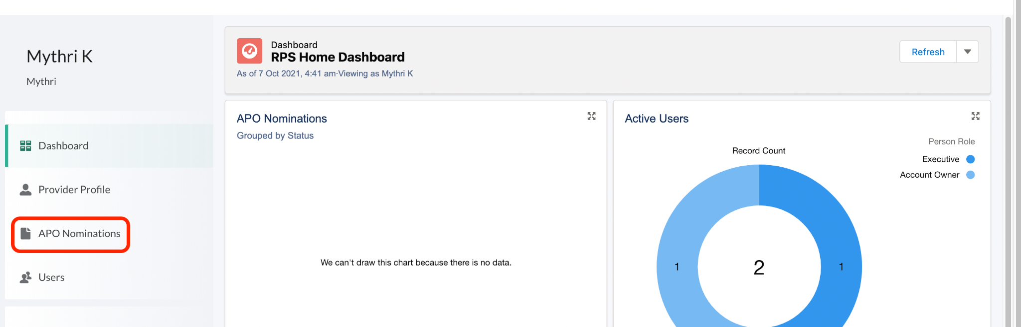
2 | Click Edit for the nomination that has the status More Information Required.  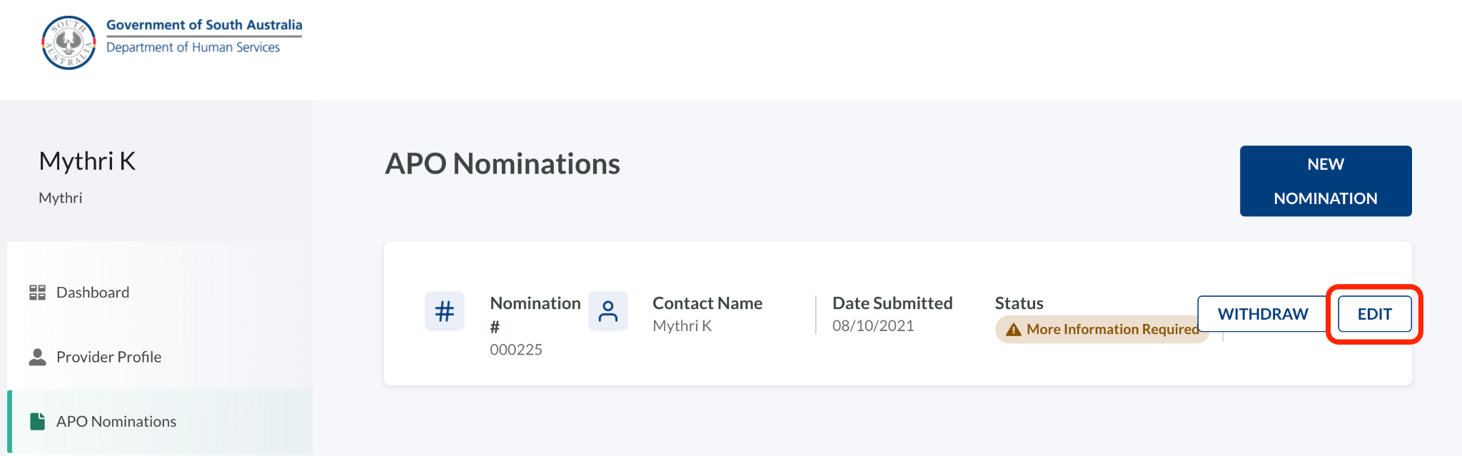
3 | Read the feedback available in the APO Information step and act accordingly. In the following screenshot, the feedback is to add another experience. This may be because the original application did not demonstrate the extent of experience that is required to be an APO.  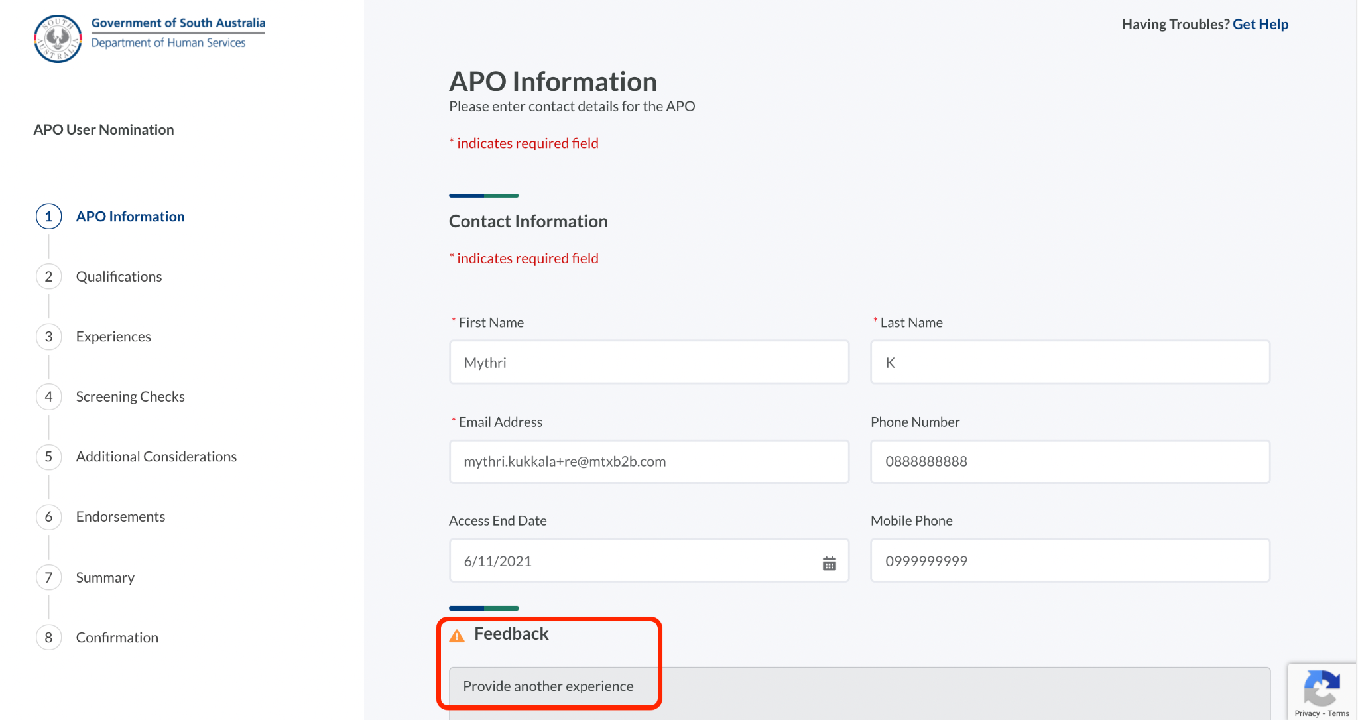
4 | Once the requested information is added, navigate to the Endorsements step and describe the updates in the Please describe your changes field.  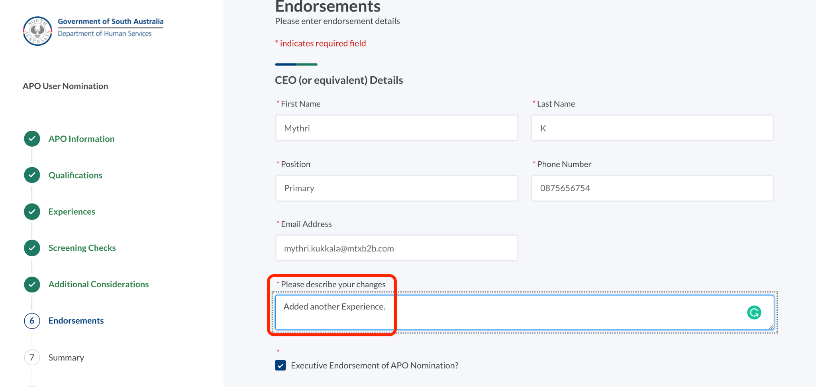
5 | Navigate to the Summary step and click Resubmit.  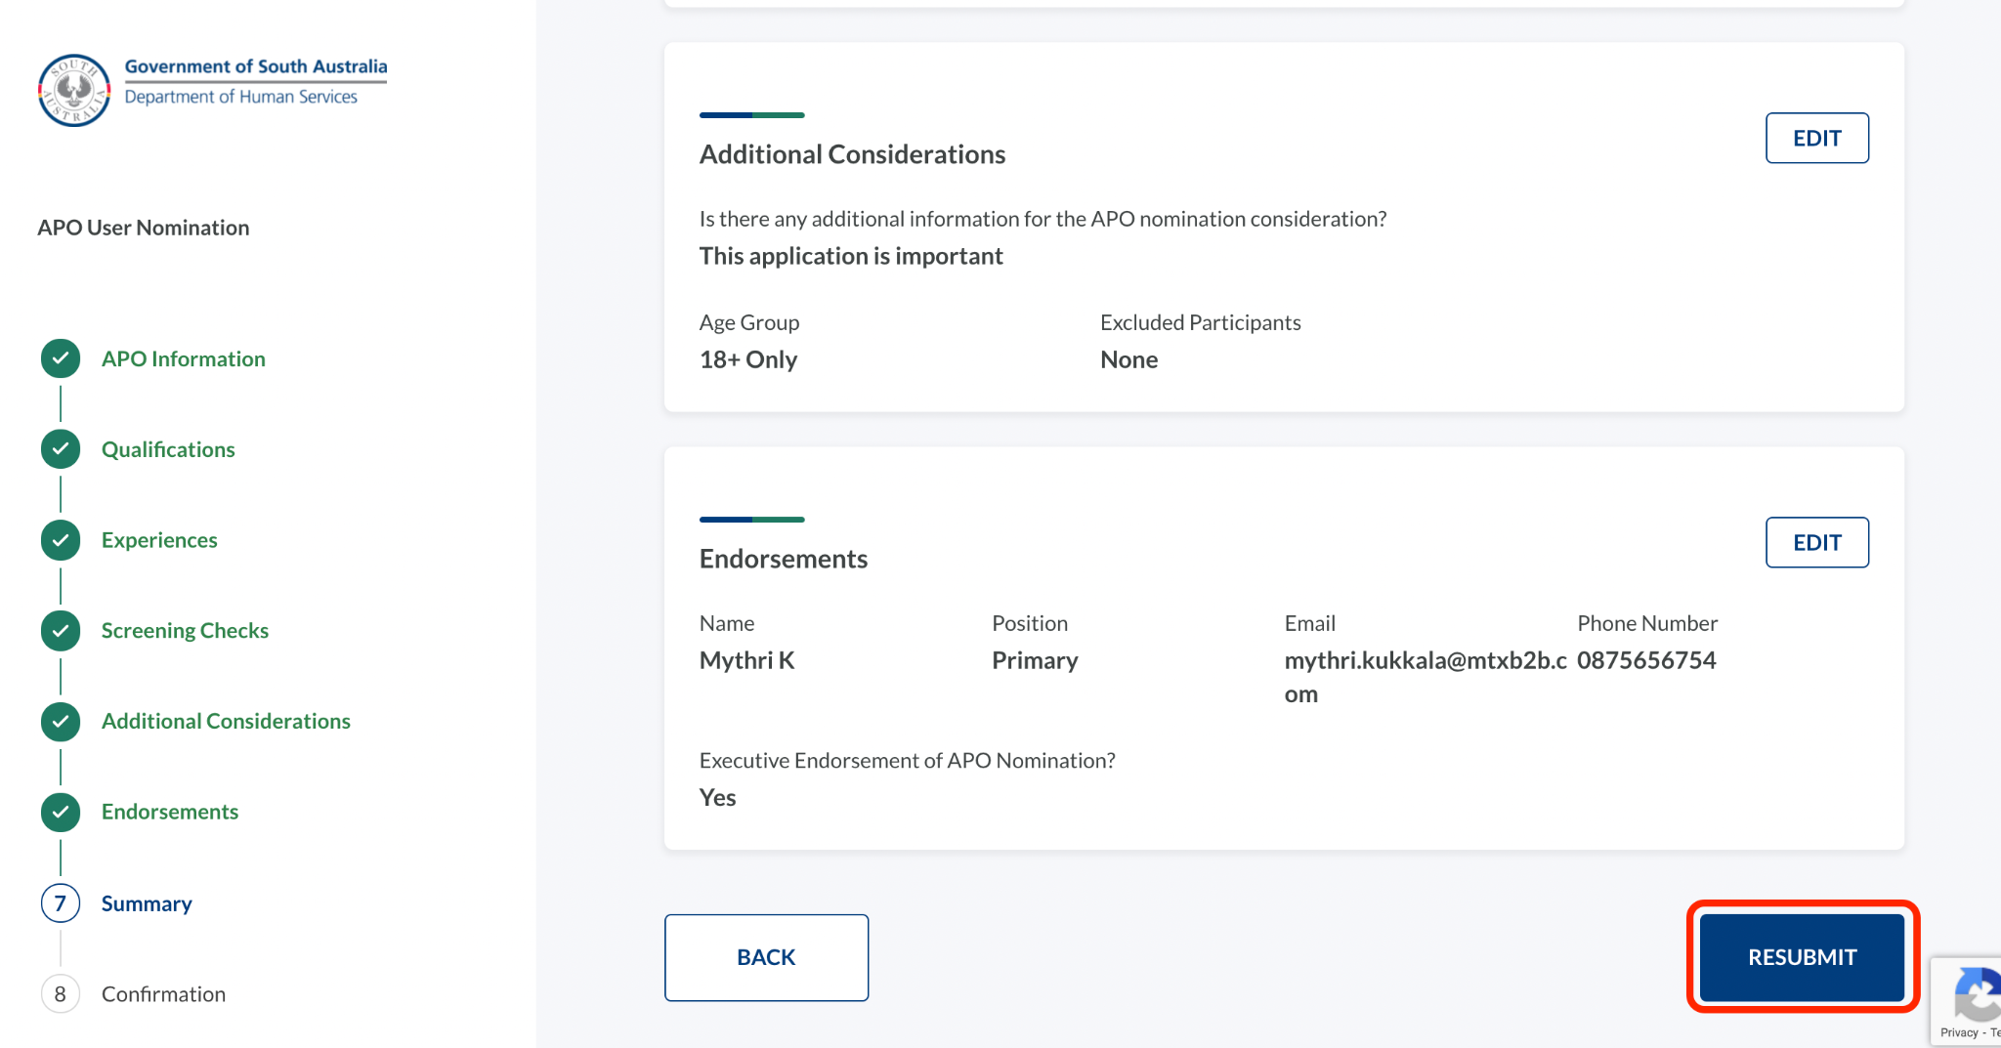
A confirmation will be shown that the application has been resubmitted.
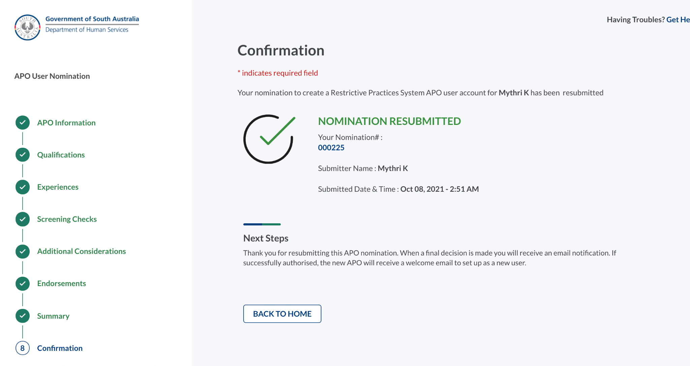

Nominating additional Authorised Program Officers

Step | Action
 | Additional Authorised Program Officers can be nominated.
1 | Navigate to APO Nominations on the left side of the application.  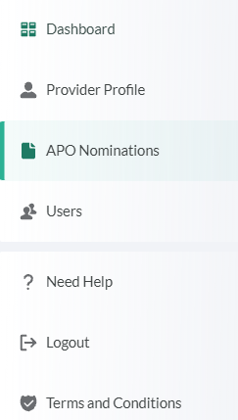
2 | Click Add New.
 | The APO User Nomination screen will be launched.
3 | Repeat the Authorised Program Officer Nomination process described in Section 4 of this guide.

Editing Authorised Program Officer Details

Step | Action
Details for Authorised Program Officers can be updated, including:
- Contact Information
- Access End Date
- Qualifications
- Experience
- Screening
1 | Click APO Nominations.
2 | Click Edit for the APO details that require updating, then Save.

Logging Out

Logging out of the Restrictive Practices System

Step | Action
 | The Restrictive Practices Team recommends you logout of the Restrictive Practices System when not in use. This is especially important if you share computers within your office as it prevents unauthorised use of the system.
1 | Navigate to the Logout option on the left side of the application.  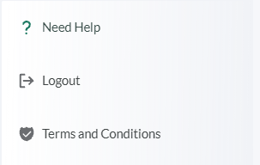
2 | Click Logout.
 | You are now logged out of the Restrictive Practices System.

