Keeping Safe: Child Protection Curriculum Review

Teacher Consultation
Draft activities paper #1.5 – Years 7 to 8
Items covered in this paper

- Overview and framework
- Proposed content progression
- Proposed activities for Focus Area 1 – The right to be safe
- Any other comments

Overview and framework

Overview
The Keeping Safe: Child Protection Curriculum (KS:CPC) Review will ensure the curriculum remains contemporary, world leading and evidence-based.
This paper provides the draft version 3 Rationale and Aims that were updated to highlight the shared responsibility for the protection of children and young people. It also provides the new framework graphic and the proposed content progression for Focus Area 1. We seek your feedback on a selection of activities that have been updated or added.

KS:CPC Rationale
All children have the fundamental right to be safe – to learn, play, grow, live safely, be supported and valued, in accordance with the United Nations Convention on the Rights of the Child.

Keeping all children safe is a global challenge with millions of children subjected to abuse, neglect, violence and other rights violations each year. Child abuse reaches all parts of society across economic and social circumstances, culture, religion or ethnicity and has both immediate and long-term consequences.

Research indicates that most child abuse and neglect is perpetrated by someone known to the child or their family. Furthermore, survivors of abuse often say they didn’t know what abuse was, that the behaviour was wrong, what to do about it, and that people didn’t listen. Education is paramount.

Promoting the safety and wellbeing of all children and young people is a shared societal responsibility. Families, communities, governments, business, and services all play a role in protecting children and young people. While safeguarding policies and practices support organisations to respond to harmful or unsafe situations; child protection education empowers children.

Education must support children’s self-efficacy and agency to advocate for their right to be safe. Children need the knowledge, skills and understanding to develop respectful relationships, recognise and report abuse, and apply strategies to support their safety and wellbeing. This is at the core of the Keeping Safe: Child Protection Curriculum.

KS:CPC Aims
All children and young people in developmentally appropriate ways can:
1. Understand they have the right to be safe
2. Recognise abuse and unsafe situations
3. Apply knowledge, skills and understanding to be safe
4. Seek support for themselves or others

Framework
A new visual representation of the curriculum’s framework will demonstrate:  - the core reason why we use the KS:CPC  The KS:CPC is premised on the core belief that all children have the right to be safe, in accordance with the United Nations Convention on the Rights of the Child.  - the essential knowledge, skills and understanding that children need to learn  To support their rights, children must learn how to:  - Recognise abuse and unsafe situations  - Develop and apply strategies to be safe  - Seek support and report  - how the curriculum is organised and implemented  The curriculum is organised into four Focus Areas that build on a child’s understanding in a holistic, sequential, and developmentally appropriate way.  The Focus Areas contain learning activities for teachers to use with children and young people, to build knowledge, skills and understanding across a variety of contexts.  - Focus Area 1: The right to be safe  - Focus Area 2: Relationships  - Focus Area 3: Recognising and reporting abuse  - Focus Area 4: Protective strategies | 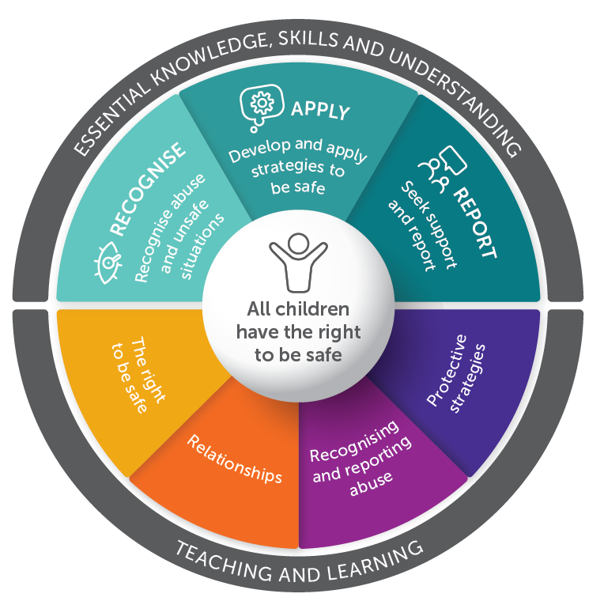

Your comments on the Rationale, Aims and Framework
Click or tap here to enter text.

Proposed content progression

Note: The focus areas have not changed. Most activities have been updated and some have been moved to a different focus area since the previous edition (previous location in brackets). The ‘Content’ column is to assist with the consultation process and will not appear in the curriculum documents. Activities in italics are still under development and not currently available for consultation.

Focus Area | Topic name | Content (at an age and developmentally appropriate level) | Activities – Years 3 to 4
FA1 – The right to be safe | Keeping safe | - Setting group norms for safe learning  - Establishing networks  - Trusted people | - 1.1 Group norms, networks and themes (NEW)
FA1 – The right to be safe | Rights and responsibilities | - Understanding rights and responsibilities  - UN Convention on the Rights of the Child  - Human Rights  - Personal space and boundaries  - Identity  - Gender stereotypes | - 2.1 Rights for everyone (FA2-1.1)  - 2.2 Personal space / boundaries (NEW)  - 2.3 Privacy (FA3-1.2)  - 2.4 Identity (FA2-2.1)  - 2.5 Gender stereotypes (FA2-2.3)
FA1 – The right to be safe | Safe and unsafe | - Feelings  - Recognising feelings as warning signs  - Safe and unsafe situations  - Defining and assessing risks and risk-taking  - Online risks, image sharing, online safety and laws  - Risk mitigation, what makes something safer | - 3.1 Feelings and emotions (NEW)  - 3.2 Emotions: thoughts, behaviours, strategies (NEW)  - 3.3 Warning signs (FA1-1.2)  - 3.4 Warning signs online (NEW)  - 3.5 Exploring Theme 1: ‘We all have the right to be safe’ (FA1-1.1)  - 3.6 Safe and Unsafe (FA1-2.6 ASM)  - 3.7 Online risks and safety (NEW)  - 3.8 Risk-taking (NEW)  - 3.9 Online risks, safety and the law (FA3-3.6)

Proposed activities for Focus Area 1 – The right to be safe
Note: the following are a selection of activities that have been modified or added since the KS:CPC Revised Second Edition, the sequence and content of these activities may change further prior to publishing.

Topic 1 – Keeping safe
  - Group norms, networks and themes (NEW)

Under development

Topic 2 – Rights and responsibilities
2.1 Rights for everyone  - Use one or more of the following resources to review rights of children and determine students’ prior knowledge:  - Realizing the Rights of Every Child, UNICEF Pacific  - What are children’s rights?, Australian Human Rights Commission  - What are Child Rights?, BBC What’s New  - Discuss with the class that all people have rights as described within the Declaration of Human Rights. Children have additional rights described within the Convention on the Rights of the Child. There are additional treaties/documents to support the rights of people, including:  - UN Declaration on the Rights of Indigenous Peoples | OHCHR  - Convention on the Rights of Persons with Disabilities | OHCHR  - Declaration on the Elimination of Violence against Women  - Convention on Consent to Marriage, Minimum Age for Marriage and Registration of Marriages  - Ask students ‘why are additional treaties/documents required to address the rights of all people (eg children, people with disability, indigenous peoples)?’  - In small groups, students use a variety of presentation modes (eg a poster, presentation, short movie or infographic) to present information about one of the key documents identified above.  - Reinforce that all people have rights and there are additional treaties/documents to support all people’s rights. If anyone feels that their rights are not being respected or protected, then they must talk to a trusted adult or contact a support service, such as Kids Helpline (Australia). | From: Focus Area 2 – 1.1 (Middle Years)  https://youtu.be/dTXhfQS9R80  https://youtu.be/HHNfaPuoZHM  https://youtu.be/ZtKPr1tpsQ0  https://www.ohchr.org/en/indigenous-peoples/un-declaration-rights-indigenous-peoples  https://www.ohchr.org/en/instruments-mechanisms/instruments/convention-rights-persons-disabilities  https://www.ohchr.org/en/instruments-mechanisms/instruments/declaration-elimination-violence-against-women  https://www.ohchr.org/en/instruments-mechanisms/instruments/convention-consent-marriage-minimum-age-marriage-and
Your comments
Click or tap here to enter text.

2.2 Personal space / boundaries  Under development | New activity
2.3 Privacy  - Students individually write three sentences or short descriptions of things they consider private (eg ‘I like to spend time in my room alone when I feel angry or just want to think’). Students are not expected to share what they have written or reveal specific private things.  - Discuss privacy, rights and responsibilities by asking students:  - What are our rights in regards to privacy?  - What are our responsibilities to others in regards to privacy?  - Ask: ‘What are some examples of someone’s privacy being invaded?’ (Responses could include: a person going into someone’s bedroom unannounced; reading someone’s diary without their permission; logging on to someone else’s social media account; taking a photo of someone without their permission; touching someone without their consent).  - In small groups, students brainstorm how someone might feel if their privacy was invaded. (Responses could include: embarrassed; upset; angry; exposed)  - In small groups, students brainstorm a list of appropriate responses to the situations below:  - Someone leaves their mobile phone unattended and their friends look through their messages.  - A Year 7 student comes home to find that their younger sibling has been looking through their belongings.  - A Year 8 student’s family members walk into the bathroom when they are having a shower in the morning before school.  - Ask: ‘What could someone do if someone invades their privacy?’ (Responses could include: talk to a a trusted adult or someone on their trusted network; tell the person they do not have the right to invade their privacy; tell the person to stop; leave the situation; avoid that person or situation until there has been a resolution.) | From: Focus Area 3 – 1.2 (Middle Years)
Your comments
Click or tap here to enter text.

2.4 Identity  - Watch the video Identity Tapestry and visit the Identity Tapestry website for further examples.  - As a class, create an identity tapestry. Display the identity tapestry within the school or community and invite other students and community members to take part.  - Ask: ‘How can we celebrate and acknowledge diversity in our school and community?’ (Responses could include: Be respectful to everyone; find out more about other people at school and in the community; be welcoming to new people; acknowledge and celebrate important days or events.)  - Use local, national and international events to celebrate and acknowledge diversity, such as:  - Harmony Week (Australia)  - National Reconciliation Week (Australia)  - NAIDOC Week (Australia)  - Wear it Purple Day (Australia)  - International Day of People with Disability.  - As a class, brainstorm the words that could be used in an advertising or social media campaign to promote diversity and inclusion. Examples may include respect, rights (the right to identity), responsibility, support, freedom, celebration.  - In small groups, students select a national or international event to create an advertising or social media campaign for. This could be presented in a variety of formats, such as a a short video, billboard, poster or comic strip.  - If someone is treated unfairly because of their identity, this is called discrimination. Ask students: ‘If someone is discriminated against or made to feel unsafe because of their identity, who could they speak to?’ (Responses should include: a trusted adult or someone on their trusted network) | From: Aboriginal materials FA2 – 2.1  https://vimeo.com/169927836  http://www.marymarch.com/identity-tapestry-gallery.php  https://www.harmony.gov.au/  https://www.reconciliation.org.au/our-work/national-reconciliation-week/  https://www.naidoc.org.au/  https://www.wearitpurple.org/  https://www.idpwd.com.au/
Your comments
Click or tap here to enter text.

2.5 Gender stereotypes  - Brainstorm (RLS 10) attributes of someone’s identity that society may generalise or stereotype as being either female or male. For example:  - clothing (eg shorts, skirts, tights, singlets)  - sports (eg netball, football, motor racing, gymnastics)  - jobs/occupations (eg nurse, doctor, cleaner, babysitter, plumber)  - behaviour (eg rough, caring, active, passive)  - interests (eg yoga, cars, video games, fashion).  - Examples that are not based on someone’s biological attributes could be examples of gender stereotypes. Highlight that many of these examples may vary according to history, culture and/or geographic location. Use examples to highlight this such as traditional dress around the world and in different times throughout history.  - Brainstorm gender stereotypes that young people may have seen or heard. (Responses may include: “like a girl” (i.e. “run like a girl”); “be a man”; “real men don’t cry”; “women are emotional”)  - In small groups, students discuss: ‘How do gender stereotypes impact how people relate to each other in different contexts, such as families, relationships, leisure and work?’  - Identify examples of positive role models or media examples that challenge traditional gender roles and stereotypes, such as the video Always #LikeAGirl.  - Ask students: ‘What is the potential positive impact of challenging gender stereotypes?”  - Brainstorm safe ways of challenging stereotypes or discrimination. Examples may include not participating or laughing in jokes or statements; challenge someone’s use of harmful language; talking to a trusted adult.  - Reinforce the need and importance of valuing and respecting the identity of all individuals. | From: Focus Area 2 – 2.3 (Middle Years)  http://tiny.cc/AlwaysLikeAGirl
Your comments
Click or tap here to enter text.

Topic 3 – Safe and unsafe
- Feelings and emotions  - Watch the excerpt from the movie Inside Out when the character Sadness supports Riley to process the big emotions and seek support from their parents.  - If experiencing sadness can lead people to seeking support, how can other emotions support people to seek support or stay safe?  Consider emotions such as fear, anger and disgust:  - Fear: When someone feels fear, it can signal that they are in danger or that something bad might happen. This can help people to be more cautious and take steps to protect themselves.  - Anger: When someone feels anger, it can signal that their boundaries have been crossed, and they need to take action to protect themselves. For example, if someone is being treated unfairly, feeling angry can motivate them to stand up for themselves and assert their rights.  - Disgust: When someone feels disgust, it can signal that something is unclean or potentially harmful. This can help someone to avoid situations or objects that might be dangerous or harmful to their health.  - Explain to students that emotions should not be labelled as ‘good’ or ‘bad’ or ‘positive’ and ‘negative’ -all emotions are normal.  - In small groups, students brainstorm different emotions and consider them in a range of contexts. Students then identify how these emotions can be used to identify safe or unsafe situations; and how they can support them to seek help. (Activity resource 13: Feelings vocabulary can be used to support students with a variety of emotions)  - Remind students that it’s okay to have different feelings, and it’s important to talk to someone they trust if they feel overwhelmed or confused by their emotions. Talking to a trusted adult can help someone to understand their feelings better and to help keep them safe. | New activity  https://www.youtube.com/watch?v=y2CJ46XkwxA&t=1s  octor, P., & Del Carmen, R. (2015). Inside Out. Walt Disney Studios Motion Pictures.  - Emotions should not be labelled as ‘good’ or ‘bad’. Emotions are sometimes categorised as ‘good’ and ‘bad’ or ‘positive’ and ‘negative’ according to how comfortable or uncomfortable they may feel in our bodies and minds; but they aren’t, all emotions are important as stated by Marcia Reynolds, PsyD., in a Psychology Today piece about “bad” emotions. “I would like you to consider a different view of emotions. All emotions are a part of your human experience. You can’t experience joy without sorrow, peace without anger, and courage without fear. Life is richer when we allow ourselves to move through the dark as well as the light.”  http://kscpc.2.vu/R-2_Act01
Your comments
Click or tap here to enter text.

3.2 Emotions: thoughts, behaviours, strategies  Under development | New activity
3.3 Warning signs  - Explain to students that there are physical indicators, external indicators and emotional indicators that help people to recognise a situation that may be risky or harmful. These are called warning signs.  - In small groups, students brainstorm examples of each type of warning sign. The chart below provides some examples.  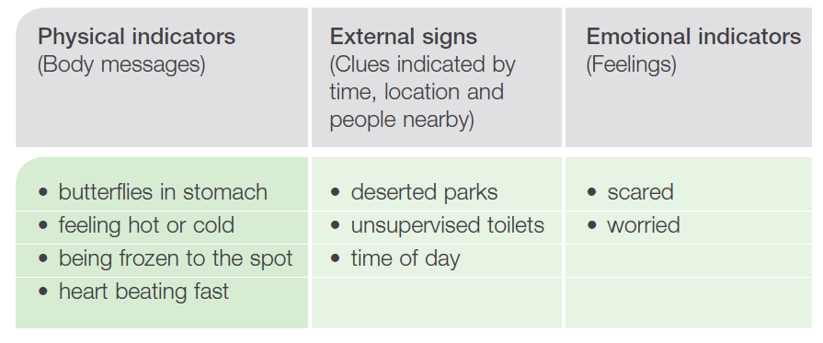  - As a class, brainstorm potentially unsafe situations where someone may experience warning signs, eg: attempting tricks at the skate park, being near a fight that has broken out during a sporting event, being scammed online, being asked to watch inappropriate content online, a friend experiencing a medical emergency.  - Individually, students select 2 to 3 examples from the brainstormed list of unsafe situations and record in a table someone’s potential warning signs if they were in that situation. Students then suggest strategies the person could use to increase their safety and seek support.  - In small groups, s students then share and work together to value add to each other’s suggestions.  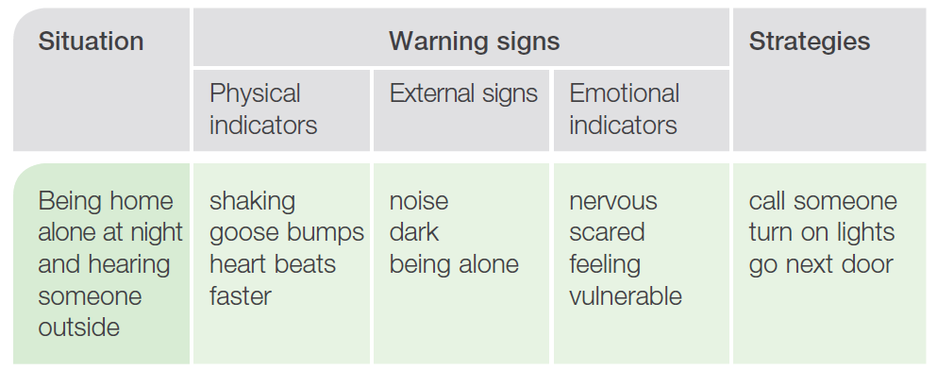  - Explain to students that if someone feels unsafe or has warning signs, that they must talk to a trusted adult or someone on their trusted network. | From: MY Focus Area 1 – 1.2  3.3 Students may confuse feelings with physical responses of the body. Persist in supporting students to understand the difference. Be aware of one step removed technique when brainstorming unsafe situations.
Your comments
Click or tap here to enter text.

3.4 Warning signs

Under development

3.5 Exploring Theme 1: 'We all have the right to be safe’  - Tell students that the KS:CPC has two main themes:  - Theme 1: ‘We all have the right to be safe.’  - Theme 2: ‘We can help ourselves be safe by talking to people we trust.’  - Explore Theme 1: ‘We all have the right to be safe’ by considering what it means to be safe.  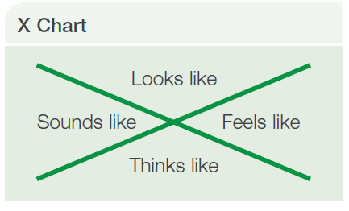  - Individually or in small groups, use Activity resource 4: X chart template (RLS 4) to brainstorm words and phrases for the following questions:  - What does ‘safe’ look like?  - What does ‘safe’ feel like?  - What does ‘safe’ sound like?  - What does safe think like? (How do I have to think to be safe?)  - Discuss responses for each question and potential differences between individuals and/or groups, for example:  - safe may sound quiet for some people but noisy for others  - safe may look like being alone in a room for some people but in an open space for others  - In small groups, students select a setting or context (eg at school, in the park, online, at the swimming pool, at the mall, at a sleepover, on a school camp) and brainstorm ideas of what safe may look, sound, feel and think like.  - Students use the responses from the X Chart to create an acrostic poem, short story, or comic strip incorporating ideas from X Chart. Check students are following group norms and focused on the concept of being safe.  - Reinforce that all people have the right to feel and be safe, and the importance of speaking to trusted adults or people on their network if someone does not feel safe. | From: MY FA 1 – 1.1
Your comments
Click or tap here to enter text.

3.6 Safe and Unsafe  - Distribute sets of cards from Activity resource 15: Safe and unsafe strategies to small groups of students and ask them to discuss each strategy, including when they may be appropriate.  - Read the scenarios in Activity resource 16: Safe and unsafe scenarios and identify appropriate strategies/responses to each scenario using suggestions from Activity resource 15. Encourage students to create alternative strategies if necessary.  - 3 Discuss each scenario using questions such as:  - Is the situation safe or unsafe?  - What are the characters doing that is safe or unsafe?  - How might their future be affected?  - What could be done to make the situation safer?  - As a class, discuss various strategies that young people could use when in unsafe situations. Ensure contacting local community agencies and speaking to people they trust are included within the discussion. | From: Aboriginal materials FA 1 – 2.6  http://tiny.cc/AbSM_Act08  http://tiny.cc/AbSM_Act09
Your comments
Click or tap here to enter text.

3.7 Online risks and safety  Under development | New activity
3.8 Risk-taking  Under development | New activity
3.9 Online risks, safety and the law  - Ask students to list electronic devices and services that young people use. Examples include:  - internet  - smart phones  - tablets/iPads  - apps  - websites  - emails  - taking photographs using mobile phones/tablets  - instant messaging  - social networking  - video games.  - Discuss how using digital technology may make someone vulnerable to image-based abuse.  - Share the following definition of image-based abuse from Youth Law Australia:  ‘image-based abuse is where someone films, shares or shows, or threatens to share or show, an invasive moving or still image of someone without their consent. This applies both in person and online and includes showing or sending the image to another person or posting the image online.’  - The Youth Law Australia provides additional information, including further definitions of ‘invasive images’ and ‘indecent filming’. Explore these as a class if necessary. Select relevant resources to guide discussion about online safety and the law, such as:  - Legal Services Commission of South Australia: Young people and the law factsheets  - Youth Law Australia: Internet, phones and technology  - eSafety Commissioner (Australia): Young people.  - Using a modified jigsaw activity (RLS 7), students work in groups to research and report on how various technologies might be open to abuse and what the implications or outcomes are for children and young people as victims or perpetrators.  - Reinforce that young people should talk to a trusted adult and report if they feel unsafe online or are victim to online abuse such as image-based abuse. Discuss how students can report online harm or abuse, for example:  - eSafety Commissioner (Australia): Report online harm | From: Focus Area 3 – 3.6 (Middle Years)  3.9 Refer to relevant legalisation to support discussion.  South Australia: Criminal Law Consolidation Act 1935 covers criminal defamation and child pornography in parts 63, 63A, 63B and 257) http://tiny.cc/CLC-Act-1935  https://yla.org.au/sa/topics/internet-phones-and-technology/image-based-abuse/  https://lsc.sa.gov.au/cb_pages/youth_publications.php  https://yla.org.au/sa/topics/internet-phones-and-technology/  https://www.esafety.gov.au/report
Your comments
Click or tap here to enter text.

Any other comments

Click or tap here to enter text.

