Keeping Safe: Child Protection Curriculum Review

Teacher Consultation
Draft activities paper #1.2 – Foundation to Year 2
Items covered in this paper

- Overview and framework
- Proposed content progression
- Proposed activities for Focus Area 1 – The right to be safe
- Any other comments

Overview and framework

Overview
The Keeping Safe: Child Protection Curriculum (KS:CPC) Review will ensure the curriculum remains contemporary, world leading and evidence-based.
This paper provides the draft version 3 Rationale and Aims that were updated to highlight the shared responsibility for the protection of children and young people. It also provides the new framework graphic and the proposed content progression for Focus Area 1. We seek your feedback on a selection of activities that have been updated or added.

KS:CPC Rationale
All children have the fundamental right to be safe – to learn, play, grow, live safely, be supported and valued, in accordance with the United Nations Convention on the Rights of the Child.

Keeping all children safe is a global challenge with millions of children subjected to abuse, neglect, violence and other rights violations each year. Child abuse reaches all parts of society across economic and social circumstances, culture, religion or ethnicity and has both immediate and long-term consequences.

Research indicates that most child abuse and neglect is perpetrated by someone known to the child or their family. Furthermore, survivors of abuse often say they didn’t know what abuse was, that the behaviour was wrong, what to do about it, and that people didn’t listen. Education is paramount.

Promoting the safety and wellbeing of all children and young people is a shared societal responsibility. Families, communities, governments, business, and services all play a role in protecting children and young people. While safeguarding policies and practices support organisations to respond to harmful or unsafe situations; child protection education empowers children.

Education must support children’s self-efficacy and agency to advocate for their right to be safe. Children need the knowledge, skills and understanding to develop respectful relationships, recognise and report abuse, and apply strategies to support their safety and wellbeing. This is at the core of the Keeping Safe: Child Protection Curriculum.

KS:CPC Aims
All children and young people in developmentally appropriate ways can:
1. Understand they have the right to be safe
2. Recognise abuse and unsafe situations
3. Apply knowledge, skills and understanding to be safe
4. Seek support for themselves or others

Framework
A new visual representation of the curriculum’s framework will demonstrate:  - the core reason why we use the KS:CPC  The KS:CPC is premised on the core belief that all children have the right to be safe, in accordance with the United Nations Convention on the Rights of the Child.  - the essential knowledge, skills and understanding that children need to learn  To support their rights, children must learn how to:  - Recognise abuse and unsafe situations  - Develop and apply strategies to be safe  - Seek support and report  - how the curriculum is organised and implemented  The curriculum is organised into four Focus Areas that build on a child’s understanding in a holistic, sequential, and developmentally appropriate way.  The Focus Areas contain learning activities for teachers to use with children and young people, to build knowledge, skills and understanding across a variety of contexts.  - Focus Area 1: The right to be safe  - Focus Area 2: Relationships  - Focus Area 3: Recognising and reporting abuse  - Focus Area 4: Protective strategies | 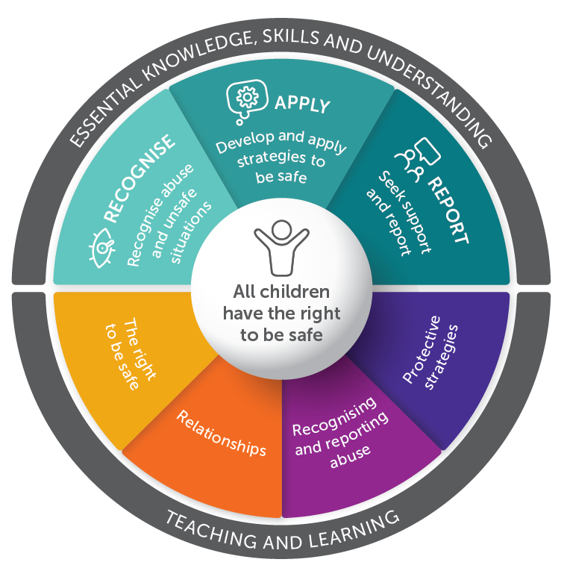

Your comments on the Rationale, Aims and Framework
Click or tap here to enter text.

Proposed content progression

Note: The focus areas have not changed. Most activities have been updated and some have been moved to a different focus area since the previous edition (previous location in brackets). The ‘Content’ column is to assist with the consultation process and will not appear in the curriculum documents. Activities in italics are still under development and not currently available for consultation.

Focus Area | Topic name | Content (at an age and developmentally appropriate level) | Activities – Foundation to Year 2
FA1 – The right to be safe | Keeping safe | - Setting group norms for safe learning  - Establishing networks  - Trusted people | - 1.1 Group norms, networks and themes (NEW)
FA1 – The right to be safe | Rights and responsibilities | - Understanding rights and responsibilities  - UN Convention on the Rights of the Child  - Human Rights  - Personal space and boundaries  - Identity  - Gender stereotypes | - 2.1 Needs and wants (FA2-1.1)  - 2.2 Children's rights (FA2-1.2)  - 2.3 Behaviour code and children’s rights (FA2-1.3)  - 2.4 Body awareness (FA3-1.1)  - 2.5 Personal space (FA3-1.2)  - 2.6 Meaning of private (FA3-1.4)  - 2.7 Exploring identity (FA2-2.1)  - 2.8 Stereotypes (NEW)
FA1 – The right to be safe | Safe and unsafe | - Feelings  - Recognising feelings as warning signs  - Safe and unsafe situations  - Defining and assessing risks and risk-taking  - Online risks, image sharing, online safety and laws  - Risk mitigation, what makes something safer | - 3.1 Characters’ feelings (FA1-1.1)  - 3.2 Different feelings (FA1-1.2)  - 3.3 Miming feelings (FA1-1.4)  - 3.4 Signs (FA1-3.2)  - 3.5 Introducing warning signs (FA1-3.1)  - 3.6 Warning signs (FA1-3.3)  - 3.7 Identifying warning signs in others (NEW)  - 3.8 How do we make it safer? (FA1-2.1)  - 3.9 Exploring online safety (NEW)  - 3.10 Identifying safe places (FA1-2.3)  - 3.11 Choosing strategies to keep safe (FA4-1.9)  - 3.12 Defining unsafe and risk-taking (FA1-4.1)  - 3.13 Exploring risks and unsafe situations (FA1-4.2)  - 3.14 Looking for clues about risks (FA1-4.3)

Proposed activities for Focus Area 1 – The right to be safe
Note: the following are a selection of activities that have been modified or added since the KS:CPC Revised Second Edition, the sequence and content of these activities may change further prior to publishing.

Topic 1 – Keeping safe
1.1 Group norms, networks and themes  Under development | New activity

Topic 2 – Rights and responsibilities
2.1 Needs and wants  - Brainstorm (RLS 10) ‘needs’ and ‘wants’ using examples such as:  - food and water is a need; ice-cream and lemonade is a want  - shelter and warmth is a need; a big house with a swimming pool is a want.  - Develop a definition of needs and wants, for example:  - A need is something everyone must have to survive  - A want is something someone would like to have.  - Students choose a pet and make a list of the pet’s needs and wants. If they do not have their own pet, refer to a class pet within the school, an imaginary pet, or use a book such as Sebastian lives in a hat, My dog’s a scaredy cat or Just a little brown dog. Use a table such as the one below, ask for examples and record information:  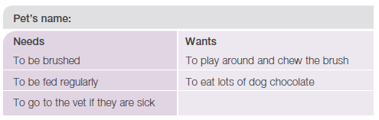  - Create a new list of needs, this time focussing on the needs of children? Examples could include love, care, food, medicine, education, play and safety.’  - For each need identified for pets or animals above, students identify who is responsible to make sure those needs are met.  - Further discuss the term ‘responsibility’ using additional examples such as:  - Whose responsibility is it to look after children in the class? (Response: the teacher and all children in the class.)  - Whose responsibility is it to make sure children arrive at school on time? (Response: parent/carer; children.)  - Whose responsibility is it to be respectful and follow the rules in class? (Response: everyone.)  - Summarise by reinforcing that all children have rights, and it is an adult responsibility to make sure their rights are considered. Children also have the responsibility to support the rights of themselves and others. If children are concerned about their rights (or the rights of others) they should talk to a trusted adult. | From: EY R-2 Focus Area 2 – 1.1  Continual reference to, and evaluation of, actions taken by students, helps them to understand and internalise the concept of their own and others’ needs and wants. Support them to understand the difference between a need: something they must have to survive (food, clothing, shelter, to be cared for) and a want: something they would like to have (a new toy, a certain type of snack food, to be first in line). In this way, students learn to take responsibility for their behaviour and are able to interact with others in a positive way, show mutual respect, and use positive conflict resolution.  Ball, D (2000) My dog’s a scaredy cat, Harper Collins Publishers Pty Ltd, Sydney, NSW  Catterwell, T (1985) Sebastian lives in a hat, Omnibus Books an imprint of Scholastic Australia, Gosford, Australia  Morgan, S (1997) Just a little brown dog, Fremantle Arts Centre Press, WA
Your comments
Click or tap here to enter text.

2.2 Children's rights  - Explain what is meant by the term ‘children’s rights’.  - Using a mind map (RLS 5), brainstorm rights that children have, or things that children need to be healthy and safe, for example:  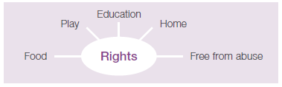  - Watch the video We all have rights from UNICEF to explore the rights of children and the Convention on the Rights of the Child. Consider watching the video over several sessions or selecting a small section of the video to show, such as the introduction.  - Ask ‘who is responsible for ensuring that children’s rights are protected and that children are safe? (Response: parents/carers; adults; government).  - Reinforce that it is an adult responsibility to keep children safe, however, children also have responsibilities. They have a responsibility to help to keep themselves and other children safe.  - On the ‘Children’s rights mind map’ add who is responsible for each right that has been listed.  - Create a series of posters or other forms of visual media that show examples of children having their rights respected.  - Ask students: ‘If a child feels as though their rights, or the rights of other children, are not being respected, who could they talk to?’ (Responses could include: parent/carer; teacher; trusted adult; support services) | From: EY R-2 Focus Area 2 – 1.2  We all have rights I UNICEF - YouTube  Additional resources  - The Convention on the Rights of the Child: The children’s version  - Australian Human Rights Commission poster showing 12 key rights  - UN Convention on the Rights of the Child In Child Friendly Language
Your comments
Click or tap here to enter text.

2.3 Behaviour code and children’s rights  - Revise the rights of children by asking students what they remember from previous activities or what rights do all children have?  - Discuss the first KS:CPC theme: We all have the right to be safe and ask students what it means to them?  - Ask students: ‘How does everyone help to keep each other safe at school?’ (Responses could include: following the rules; helping each other; telling the teacher if there is a problem)  - Ask students what they know about the class and school behaviour codes or rules.  - Use the class and school behaviour code or rules to discuss how children’s rights are supported by asking the following questions:  - Why does the school behaviour code or rules exist?  - What are the needs or rights of the children at school?  - How does the school behaviour code or rules support the rights of children?  - What changes could be made to any of the rules to better support the rights of children?  - Who is responsible for following the behaviour code or rules?  - What happens if the behaviour code or rules are not followed?  - Make a list of the student responsibilities in the classroom that will support the rights of all children in the class.  - Ask students: ‘If someone feels unsafe at school, who could they speak to?’ (Responses could include: teacher; principal; parent/carer; other trusted adult/source). | From: EY R-2 Focus Area 2 – 1.3
Your comments
Click or tap here to enter text.

2.4 Body awareness  Under development | From: EY R-2 Focus Area 1 page 48
2.5 Personal space  - Give each student a hoop and ask them to stand inside it.  - Instruct students to lift their hoop above their heads and gently bring it down to the ground. The area inside their hoop is their personal space and during this activity no-one may enter their personal space.  - Students hold their hoop carefully at waist height and walk around the room, without touching anyone else’s hoop. This demonstrates respecting everyone’s personal space.  - Ask students to place their hoop on the ground so that it is not touching anyone else’s hoop, and to sit inside their hoop.  - Ask questions such as:  - How might someone know that there is someone else in their personal space? (Responses could include: uncomfortable feelings; feeling crowded; someone touching your body.)  - What might someone do if they felt a person was in their personal space? (Responses could include: ask the person to move away; move away; tell a trusted adult..)  - Tell students that no-one may enter someone else’s personal space without being invited. If a child felt uncomfortable or unsafe about someone not respecting their personal space, they must talk to a trusted adult. | From: EY R-2 Focus Area 3 – 1.2
Your comments
Click or tap here to enter text.

2.6 Meaning of private  - Ask students to gather items that belong to them, eg sun hat, school bag, lunch container, school jumper, and a special personal item from home.  - Explain to students: ‘These things belong to you. They may have your name on it, so everyone knows it belongs to you. They are your private belongings’.  - Ask: ‘What does private mean?’ (Responses could include: something belonging to me, for example, my favourite toy, my bed or my name.)  - Brainstorm (RLS 10a) ‘What else might be private?’ The list may include:  - personal belongings, eg named drink bottle  - personal information, eg address  - personal medication, eg asthma puffer  - our bodies – our whole body is private.  - Ask: ‘Why are these things considered private?’  - If someone’s privacy is not being respected, who could they speak to for support? (Responses could include: a trusted adult or someone on their trusted network.) | From: EY R-2 Focus Area 3 – 1.4
Your comments
Click or tap here to enter text.

2.7 Exploring identity  - Draw or paint hand and footprints for each student individually. When dry, students cut around their hand and footprints.  - Combine the hand and footprints of all students to form a shape or object such as a tree or shape of a person.  - Ask students to comment on the hand and footprints. Consider questions such as:  - Are everyone’s prints the same?  - How/why are they similar?  - How/why are they different?  - Summarise by explaining that everyone’s prints are different, as is everyone’s identity. However, there are lots of similarities too.  - Encourage students to celebrate and appreciate difference and discuss why this is important.  - Ask students to draw inside the hand/footprint shape, their favourite things, places or activities (eg playing in their cubby house; their favourite toys, colour or games; what they like doing most at school; favourite place at home or at school). Alternatively, students can cut images out of magazines or from an online source.  - Discuss as a class the wide variety of things and activities that people like. Explain that there are many things that people share in common and many things that make people different and that diversity should be celebrated.  - Discuss with students that if someone treats them unfairly because of their identity, such as things or activities that they like, that they should talk to a trusted adult, or someone on their trusted network. | From: EY R-2 Focus Area 2 – 2.1 (and 2.1 Aboriginal SM)  Aboriginal resources  - Dreise, G (2015) Kookoo Kookaburra, Magabala Books  - Hardy, D (2014) Alfie’s Big Wish, Magabala Books  - Leffler, D (2011) Once there was a boy, Magabala Books  - Little, L & Lyndon, J (2012) The Mark of the Wagarl, Magabala Books  - Milroy, G & Milroy, J (2012) Dingo’s Tree, Magabala Books  - Prewett, M (2012) Two Mates, Magabala Books  - Seden, P (2016) Crabbing with Dad, Magabala Books
Your comments
Click or tap here to enter text.

2.8 Stereotypes  Under development | NEW

Topic 3 – Safe and unsafe
3.1 Characters’ feelings  - Read Possum Magic or watch ABC Kids – Play School Story Time, or Little J & Big Cuz episode 11 .  - Discuss the different sorts of feelings that the characters experience in different situations. Refer to Activity resource 13: Feelings vocabulary for a wide range of feelings.  - Use the following questions to facilitate discussion about the characters’ feelings in Possum Magic:  - How do you think Hush felt about:  - being able to slide down kangaroos?  - being near a snake?  - How did Grandma Poss feel when she couldn’t find the right magic? (Response: miserable) What are some other words that mean the same or similar? (Responses could include: unhappy; sad; distraught; blue; downhearted; sullen.)  - Hush said “I don’t mind” when Grandma Poss couldn’t find the right magic. How do you think she was really feeling? (Responses could include: sad; unhappy; gloomy; glum; down). How do you know? (Responses could include: body language; hunched; eyes cast down; no smile, ears look flat.)  - If a child felt sad or down like Hush, who could they talk to? (Reinforce they must talk to a trusted adult eg parent or carer, family member, teachers or educators at school, support service (eg Kids Helpline Australia).)  - The next morning Grandma Poss recalled that it was something to do with people food. How do you think the two possums might feel now? (Responses could include: hopeful, curious, excited.)  - How did they feel as they discovered each type of food that revealed a new body part? (Responses could include: elated, excited, overjoyed, wonderful, zany, free, delighted, joyful, marvellous.)  - Ask students to mime the feelings of the characters in the stories.  - Record the mimes using a digital camera and display the images. Alternatively, record the activity using a story map with thinking bubbles for characters’ thoughts. | From: Focus Area 1 – 1.1 & Aboriginal materials p39  Possum Magic read by Benita Collings | Play School Story Time | ABC Kids - YouTube  http://tiny.cc/LittleJBigCuz  http://kscpc.2.vu/R-2_Act01  Fox, Mem. 1991, Possum Magic, Harcourt Brace & Co  Awareness of and willingness to acknowledge feelings will vary between children. Consider the full range of emotion words rather than simply discussing opposites; for example, happy – sad.  Aboriginal resources  Boyle, J & Martins, F (2012) Bubbay: A Christmas Adventure, Magabala Books  Boyle, J & Martins, F (2014) The Spotty Dotty Lady, Magabala Books  Corpus, T & Prewett, M (2016) The Grumpy Lighthouse Keeper, Magabala Books  Dreise, G (2015) Kookoo Kookaburra, Magabala Books  Hardy, D (2014) Alfie’s Big Wish, Magabala Books  Leffler, D (2011) Once there was a boy, Magabala Books  Little J & Big Cuz teacher resources  Next to #5  Photographs  When photographing students, follow the procedures relevant to your jurisdiction. Good practice includes informing parents/carers about the context, who will be taking the photos, how they will be used and what will happen to them after the activity.  (Department for Education SA - Consent to publish images and creative work of students and the community).
Your comments
Click or tap here to enter text.

3.2 Different feelings  - Brainstorm and record feelings onto individual flash cards. Alternatively, make ‘feeling faces’ using Activity resource 14: Feeling faces.  - In small groups, students sort the feelings into comfortable and uncomfortable feelings.  - Discuss each feeling as a whole class. A third group of feelings may arise for feelings that can be either comfortable or uncomfortable, depending on the situation.  - Ask students ‘What should someone do if they feel any of these uncomfortable feelings?’ (Response should include: Talk to a trusted adult – because we all have the right to be safe and we can help ourselves to be safe by talking to people we trust.)  - Use these lists as a reference and add to them as students’ understanding increases. | From: EY R-2 Focus Area 1 – 1.2  http://kscpc.2.vu/R-2_Act02  3.2 Children need an awareness of a range of feelings and be able to discuss their own feelings.. If this needs further development, refer to the KS:CPC Early Years: Ages B–5.  It is appropriate to feel ‘OK’ rather than either ‘happy’ or ‘sad’ and feelings may change. Consider the stage of development of children when exploring this concept. Boardmaker is a useful resource for creating visual resources..
Your comments
Click or tap here to enter text.

3.3 Miming feelings  - Ask students to improvise a movement that depicts the following scenarios, using a freeze frame role-play (RLS 3a):  - a proud person  - a bad-tempered tennis player  - an excited sports fan  - a crazy pop star  - a frustrated toddler  - a person who has just had a nice meal.  - a worried parent/carer  - a silly six year old  - a toddler who is scared of the dark  - an athlete who has just won a medal  - At the end of the activity, discuss the ways the feelings were demonstrated. Discuss the importance of posture, movement, facial expression, and general body awareness to depict the scenario successfully.  - Discuss the effects on someone who is watching the feeling being expressed (eg what might it feel like to watch someone being angry, or upset, or funny?) | From: EY R-2 Focus Area 1 – 1.4
Your comments
Click or tap here to enter text.

3.4 Signs  - Explore the concept of signs by going for a walk around the school or local area and sketching or taking photos of the signs that students find. Signs might include:  - school crossing signs  - no smoking signs  - stop signs  - speed limit signs  - street signs.  - Next to each sketch or photo, students record the messages that the signs convey.  - Discuss using the following questions:  - Why do we have these signs in the school/community?  - What is their purpose?  - What would happen if these signs didn’t exist?  - Why is it important that people follow the instructions of the signs?  - Students identify a place in the school where they can alert people of potential risk or to follow the rules (eg no running).  - Students create a sign and share why they believe people need to be warned about potential risks or dangers. | From: EY R-2 Focus Area 1 – 3.2
Your comments
Click or tap here to enter text.

3.5 Introducing warning signs  - Play the activity ‘Dragon’s treasure’. You will need ‘treasure’ for the dragon. The aim of the activity is for the class to steal the treasure from the dragon.  How to play:  - Choose one child to be the dragon.  - The dragon stands with its back to the class and its treasure directly behind it.  - Class members start sneaking up on the dragon from the farthest point in the classroom.  - The dragon turns around at intervals in order to catch the class moving.  - The dragon ‘names’ anyone it catches moving.  - The named class member goes back to the farthest point before trying again.  - The class member who manages to steal the treasure takes a turn to be the dragon.  - After the activity, ask questions to explore physical and emotional warning signs, for example:  - How might someone feel at the beginning of the activity?  - How might someone feel at the end of the activity?  - How might someone feel changes in their body?  - What body messages might have been felt? (Responses could include: butterflies in stomach; breathing more easily.)  - Where in the body might these messages be felt?  - Explain that these body messages and associated feelings are called warning signs and that it is a good idea to talk to someone they trust about them if they experience any. | From: EY R-2 Focus Area 1 – 3.1
Your comments
Click or tap here to enter text.

3.6 Warning signs  - Draw an outline of a human figure on a large sheet of paper (Refer to Activity resource 15: Body outline).  - Students identify and record body messages (physical indicators) they might have that could be warning signs. Students show exactly where the messages are experienced on the body. Examples of body messages could include:  - squirmy tummy  - cold shivery body  - racing heart  - shaky knees.  - This information is then displayed in the classroom for future reference and can be added to with new learning and understanding. Alternatively, a large class teddy bear could be used. You could record physical indicators onto stick-on notes and children can place them onto the teddy. | From: EY R-2 Focus Area 1 – 3.3  http://kscpc.2.vu/R-2_Act03  3.6 Warning sign suggestions can be found in Activity resource 16: Warning signs.
Your comments
Click or tap here to enter text.

3.7 Identifying warning signs in others  - Read the story Hattie and the fox. Focus on how the illustrations show warning signs.  - Discuss Hattie’s warning signs: her body messages, her feelings, and the clues around her. Note that the other animals didn’t have warning signs to begin with and told Hattie not to worry, but she persisted until she was safe.  Questions to discuss:  - What was ‘unsafe’ in this story? (Responses could include: Hattie saw a fox in the bush who might want to eat her; Hattie tried telling her friends but they didn’t believe her or didn’t care; the other animals were unsafe because they ignored a warning from their friend.)  - What warning signs do you think Hattie experienced? (draw on observations from the illustrations (Responses could include: emotional signs: curious, scared, worried, nervous; physical signs: gasping, having wide eyes, flapping, raising her voice, flying away; external signs: seeing something unsafe like a fox.)  - Do you think the other animals experienced or noticed any warning signs? (Responses could include: not until the fox jumped out and the danger was clear. Then the other animals show - physical signs: wide eyes, gaping mouths, shrieking or yelling, fleeing, jumping or moving away; emotional signs: scared, shocked, frightened; external signs: finally saw the fox jumping out of the bushes.)  - The other animals ignored Hattie and told her not to worry. What do you think the other animals should have done? (Responses could include: listening to and believing Hattie; investigating with her; scaring the fox away; telling someone else such as a trusted adult.)  - What can this story teach us about warning signs and being safe?  - Conclude the discussion by reinforcing that if anyone experiences any warning signs or sees something unsafe, they must tell a trusted adult and keep telling until they are safe.  - Other useful stories include Franklin and the babysitter, Franklin is lost, Franklin in the dark, The pig in the pond, Bear and Chook, Felix and Alexander and Jellylegs. | NEW  Bourgeois, P (1993) Franklin in the dark, Scholastic Paperbacks, Sydney, Australia  Bourgeois, P (2001) Franklin and the babysitter, Scholastic, Sydney  Bourgeois, P & Clark, B (1993) Franklin is lost, Scholastic Paperbacks, Reprint edition, USA  Denton, T (1986) Felix and Alexander, Oxford University Press Children’s Books  Fox, M (1996) Hattie and the Fox, Scholastic Australia, Gosford, NSW  Shanahan, L & Quay, E (2002) Bear and Chook, Hodder Headline Australia, Sydney  Varney, C (1995) Jellylegs, Jellylegs Publishing, Australia  Waddell, M (1992) The pig in the pond, Walker Books, London
Your comments
Click or tap here to enter text.

3.8 How do we make it safer?  - Discuss the first KS:CPC Theme: ‘We all have the right to be safe’.  - Devise a short obstacle course or ‘follow the leader’ activity over some play equipment.  - After playing the activity, discuss what happened using the following focus questions:  - How do we make the activity safe? (Responses could include: rules; everyone being sensible.)  - How do we know if the equipment is safe? (Responses could include: there are safety rules for building play equipment; the grounds person checks equipment; students and educators report maintenance problems.)  - How do we make sure children are safe? (Responses could include: adult’s job is to keep children safe; children’s job is to behave safely.)  - Use a Y chart (RLS 4) to identify what safe sounds like, feels like and looks like. This X chart will be referred to in Topic 4.  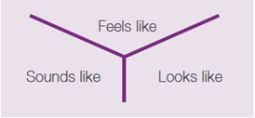  - Students identify feelings that they associate with safety and reflect upon and discuss places where they are safe, people they are safe with, things they do when they are feeling safe. | From: EY R-2 Focus Area 1 – 2.1
Your comments
Click or tap here to enter text.

3.9 Exploring online safety

Under development

3.10 Identifying safe places  - Watch the video What makes children feel safe? (NSPCC). or Feeling Happy, Feeling Safe - Feeling Safe (Kidscape).  - Ask students 'when someone may need to go to a safe place?’ (Responses could include: if someone has warning signs such as feeling unsafe or uncomfortable; hearing an alarm.)  - Students discuss a range of possible safe places in a range of contexts, for example:  - at home  - while shopping  - at school  - while playing.  3. Ask students to identify feelings that may occur when someone is in a safe place. 5. Share with students the possible safe places they could go to in the classroom and at school if they feel unsafe or uncomfortable. When going to a safe place, it is important that adults know where students are so that they are can help to keep them safe.  5. Remind students that a safe place needs to include the option of being able to talk with a trusted adult. | From: EY R-2 Focus Area 1 – 2.3  NSPCC – What makes children feel safe? - YouTube  Feeling Happy, Feeling Safe - Feeling Safe - YouTube
Your comments
Click or tap here to enter text.

3.11 Choosing strategies to keep safe  - Brainstorm with students a list of strategies that they could use to help keep themselves safe. Choose between the following activities:  - Poster  - Make a large poster that can be added to as more strategies are identified (see the example below).  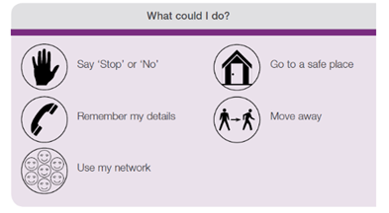  - Encourage students to use the poster to help them choose strategies when exploring problems.  - Safe tree  - Introduce the concept of a ‘safe tree’ by discussing how trees have often been used to create safe places, eg by hollowing them out for a safe and warm shelter.  - Make ‘safe tree’ a class display by painting or drawing a large tree on a big piece of paper or large outside space.  - Using Activity resource 17: Safety leaf students make leaves to add to the safe tree. Students write the different things that people within the class need to keep safe and be strong when at school. Provide examples such as respect, no teasing, helping and trust. As a class discuss how to make the class and school a safe place.  - Discuss how to make the class and school a safe place. There are many strategies children may use to help keep themselves safe. However, it is an adult responsibility to keep children safe.  - Reinforce that if anyone feels unsafe they must speak to a trusted adult or someone on their trusted network. | From: EY R-2 Focus Area 4 – 1.9 & Aboriginal materials p43  Next to 1b  Aboriginal resource  Making connections with land and culture.  http://tiny.cc/AbSM_Act06
Your comments
Click or tap here to enter text.

3.12 Defining unsafe and risk-taking  - Refer to the Y chart (RLS 4) from the activity 3.8 How do we make it safer? Remind students about the words used to describe what safe sounds like, feels like and looks like.  - Use a new Y chart to identify what unsafe sounds like, feels like and looks like.  - Display both Y charts for children to refer to and compare.  - Brainstorm the meaning of risk-taking.  Risk-taking can involve courageously trying new things and making choices that have unknown outcomes, while prioritising both wellbeing and safety. It can be about exploring within safe boundaries whilst following safety rules and guidelines for self and others, and recognising that taking calculated risks can lead to valuable learning experiences and personal growth.  - As a class, brainstorm (RLS 10) everyday situations that could be considered risk-taking. For example:  - going on the monkey bars for the first time  - using scissors without adult supervision  - running on the footpath  - trying something new for the first time  - speaking to new people  - presenting in front of the class  - playing with matches/fire  - running across a road without looking  - climbing high in a tree  - riding a bike without a helmet  - walking into a spider web  - seeing a snake  - patting unfamiliar dogs  - climbing/standing on or jumping off a roof  - swimming without adult supervision  - being lost in a shopping centre.  - Ask students to work in small groups to brainstorm potential positive and negative outcomes for some of the examples above.  - Ask each group to identify strategies to minimise risk in one or more of the examples to make it safer.  - Remind students to talk to trusted adults if they are concerned or unsure about risk-taking or unsafe behaviours, including at school and at home. | From: EY R-2 Focus Area 1 – 4.1
Your comments
Click or tap here to enter text.

3.13 Exploring risks and unsafe situations  - Read the picture book (RLS 14) Bear & Chook about Bear who likes adventures and Chook who prefers the quiet life.  - Explore the adventures and risks by asking:  - Why does Chook think the situation is unsafe? (Response could include: because of her experiences with and knowledge about Bear and other understandings she may have.)  - How does she know? (Response should include: warning signs.)  - Is Bear able to recognise unsafe situations? (Responses could include: sometimes he uses protective equipment; he has his friend nearby.)  - What other strategies might help Bear work out the risks? (Responses could include: plan more carefully; consult with someone he trusts, like Chook.)  - What actions might Chook take when she feels the activity is risky? (Responses could include: warn Bear; not join in; wear protective gear.)  - Discuss risk-taking using the following questions:  - How might someone know that a situation is risky? (Response could include: warning signs; feeling unsafe.)  - How might someone decide to have a go, even if it is risky? (Responses could include: personal experience; being aware of the dangers; getting help.)  - What might help someone decide not to do something? (Responses could include: personal experience; being warned about the dangers; warning signs.)  - What if someone decides to take the risk and the situation becomes dangerous? (Responses could include: tell someone as soon as possible; get out of the situation if possible.)  - What if a friend wanted a person to do something risky or unsafe, what might the person do? (Responses could include: say ‘no’; suggest another, safer idea; talk to someone else to get another opinion.)  - Remind students to talk to trusted adults if they are concerned or unsure about risk-taking or unsafe behaviours, including at school and at home. | From: EY R-2 Focus Area 1 – 4.2
Your comments
Click or tap here to enter text.

3.14 Looking for clues about risks  - Use a grid, such as the one below, to support students to identify clues to help decide if a situation is risky or not, and how safe or unsafe the risk may be.  - Clues are the external signs component of warning signs. Use examples such as someone:  - asking to come and see a new puppy  - watching a scary movie  - staying with a friend (or relative)  - playing in the yard after school  - riding a farm motor bike or using a piece of farm equipment  - cooking instant noodles  - making a new friend  - offering a ride home after school.  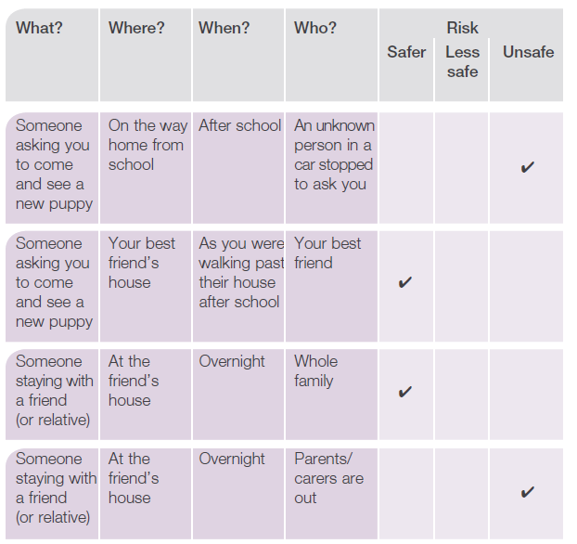  - Ask students the following questions:  - What are the things which make the risk less safe or unsafe?  - What are the things which make the risk safer?  - Why is it important to stop and think when we feel scared or unsafe? (Response could include: so that we can check our clues.)  - Why is it important to take notice of clues? (Response could include: they can sometimes give a more definite message about whether a situation is safe or unsafe.)  - What are some actions that could be taken in unsafe risk situations? (Responses could include: tell an adult as soon as possible; treat it like a personal emergency.)  - An alternative to a grid is a values continuum (RLS 8). Draw an imaginary line across the room indicating safe risk at one end and unsafe risk at the other. Ask students to stand along the continuum according to their beliefs about the level of risk.  - Close the session by reviewing who children could talk to if they feel unsafe, or are concerned or unsure about risk-taking behaviours. | From: EY R-2 Focus Area 1 – 4.3  3.14 Use the one step removed strategy (NNA 3).  The concept of being scared and thinking at the same time can be difficult for young children. Children need opportunities to discuss and practise the concept of looking for clues to identify the level of risk, and that the concepts are further reinforced by parent/carer involvement (NNA 1).
Your comments
Click or tap here to enter text.

Any other comments

Click or tap here to enter text.

