Accessible Signage,
Wayfinding & Multimedia
Devices for People Who Are
Deaf and/or Blind
Inclusive SA: State Disability Inclusion Plan 2019-2023
Priority 9.
Access to services
Action 25.
Develop and promote a toolkit for signage, wayfinding and multimedia devices for State authorities to support deaf, hard of hearing, blind, vision or hearing-impaired persons.

Welcome
This toolkit provides practical information to assist South Australian government agencies and local councils to develop and promote communication tools to assist people who are deaf, hard of hearing, blind or have low vision to be able to participate fully in our community.

Acknowledgment of Country
The South Australian Government acknowledges and respects Aboriginal peoples as the State’s first people and recognises their traditional relationship with Country.
We acknowledge that the spiritual, social, cultural and economic practices of Aboriginal peoples come from their traditional lands and waters, and that the cultural and heritage beliefs, languages and laws are still of importance today.

Contents
Accessible Signage, Wayfinding & Multimedia Devices for People Who Are Deaf and/or Blind 1
Welcome 2
Acknowledgment of Country 2
Contents 3
Disclaimer 5
Introduction 5
Background to the toolkit 6
The impacts of living with disability 6
Disability discrimination 7
What is wayfinding and signage? 8
Dealing with unconscious bias 9
Legislation and frameworks 9
Guidelines 10
Guideline - Universal design 10
Principle 1: Equitable use 10
Principle 2: Flexibility in use 10
Principle 3: Simple and intuitive use 11
Principle 4: Perceptible information 11
Principle 5: Tolerance for error 11
Principle 6: Low physical effort 12
Principle 7: Size and space for approach and use 12
Signage 13
Walkways 15
Tips for outdoor walkways 15
Tips for indoor walkways 17
Use of contrast 18
Use of sound 19
Use of lighting 19
Use of barriers 20
Using stairways 21
Using elevators (lifts) 21
Doorways and windows 22
Toilets 22
Design don’ts for shared spaces 23
Design don’ts for indoor spaces 23
Extra considerations for people using assistance dogs or assistance canes 24
Special considerations for people who are colour blind, have reduced depth perception or have reduced peripheral field 25
Wayfinding using multimedia devices 27
Resources and further information 30
Practice Review – City of Brisbane 32

Disclaimer
This toolkit has been prepared by the Department of Human services, drawing on information provided by people with lived experience of disability, the wider disability sector and community, and open-source disability information.
It is for reference only, is not a complete guide and may be added to or expanded over time.
References or links in this toolkit may change over time.
References to third parties are provided for your assistance only and not as an endorsement by the South Australian Government.
Please consider your own requirements and circumstances when using this toolkit.

Introduction
The State’s first Disability Inclusion Plan, Inclusive SA, was released in late 2019 and is a whole-of-government approach based on fairness and respect to improve access and inclusion for people with disability. The Plan includes 12 priorities with associated actions and aims to increase the involvement of people with disability in the community.
A key element of Inclusive SA is social inclusion, a priority for people living with disability as it affects all aspects of their lives. It is our aim that the contributions and rights of people living with disability are valued and understood by all South Australians and that their rights are promoted, upheld and protected.
It is important for social wellbeing that all South Australians are able to make independent decisions on how to engage with and contribute to the community. It benefits the whole community when all South Australians can attend and participate in community events such as cultural celebrations, festivals and forums that have been designed to be accessible and inclusive and where everyone belongs.

Background to the toolkit
This toolkit provides practical information to assist South Australian government agencies and local councils to use signage, wayfinding tools and technological aids to assist people living with disability.
The toolkit has been developed by drawing on feedback from government agencies and the community.
The toolkit is developed in response to Action 25 of Inclusive SA.

The impacts of living with disability
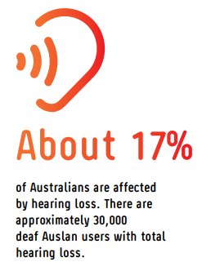
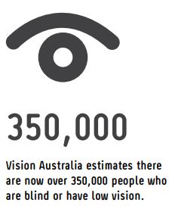

Disability discrimination
This toolkit will assist government agencies and councils to hold accessible and inclusive events and thereby prevent discrimination based on disability.
Direct discrimination happens when a person, or a group of people, is treated less favourably than another because of their background or certain personal characteristics.
Examples:
- Refusing a person access to an event because they are accompanied by an assistance dog.
- Failing to provide suitable physical access to an event for a person with a disability.
- Providing transport options to an event that does not cater for people with physical disability.

Indirect discrimination also occurs when a rule or policy applies to everyone but has the effect of disadvantaging some people because of a personal characteristic they share.
Examples:
- Failing to provide a suitable place for a person using a wheelchair to watch a show.
- Failing to provide adequate toilet facilities for people with physical disability.
- Providing event information in a form that does not cater for neurodiversity or people with communication difficulties.

What is wayfinding and signage?
Signage and other visual, tactile, sound, colour and light cues can either assist or hinder how people get around or find their way from one point to another. When a space or pathway is well-considered and well-signed, it can help everyone feel more confident and safer, and can be essential for people with disability.
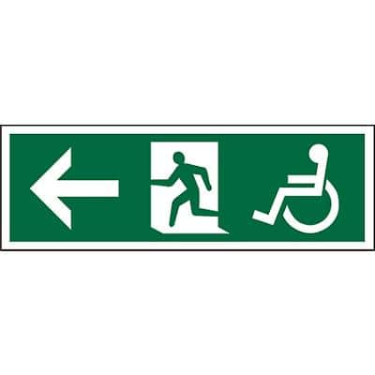
Signage and wayfinding design features should be consistent within and across different environments. Consistent features assist people to understand information and learn the patterns in a space, for instance, always using the same green signs for exits.

Other universal signs, such as road traffic signs are used globally. Through repeated use, they are understood without words and assist people to travel safely on roads, for example:

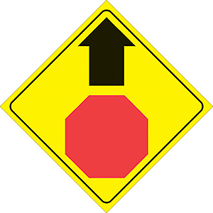
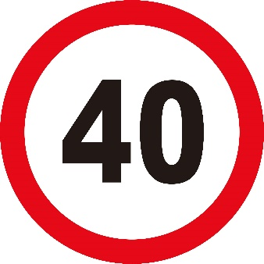


Wayfinding is the process of how people orientate themselves and navigate in a space or along a pathway. It is a combination of graphic design, architectural design and landscape design. Signage can help wayfinding.
Wayfinding is about knowing where you are, where you’re headed, how to get there, how to recognise when you’re there, and when needed, how to find your way out of a place.
Wayfinding enables problem solving and moving around spaces by using consistent environmental clues. Design features that enable wayfinding include lines on the ground to indicate a way out, and symbols and colours to indicate male/female toilets, accessible toilets, lifts and exits.
Good wayfinding design can minimise the need for detailed signage.

Dealing with unconscious bias
Unconscious biases are social stereotypes about other groups of people that individuals form that they are not aware of. We all have biases but by becoming aware of unconscious biases, challenging them and actively working to reduce them, we can enable better engagement and communication. Check yourself, use inclusive language and ensure you are being truly inclusive.

Legislation and frameworks
(Combined information to be provided on the Inclusive SA website)
This toolkit is informed by the Disability Discrimination Act 1992 (Cth) and the Equal Opportunity Act 1984 (SA), which promote equality of opportunity and the prevention of discrimination based on sex, race, disability and age.
The toolkit is also informed by the principles set out in the Disability Inclusion Act 2018 (SA), which reflect the principles in the United Nations Convention on the Rights of Persons with Disabilities (CRPD).
Disability (Access to Premises – Buildings) Standards 2010 are also relevant to ensure that dignified, equitable, cost-effective and reasonably achievable access to buildings, and facilities and services within buildings, is provided for people with disability.
The toolkit is informed by Inclusive Design (also known as Universal Design) principles, which ensure that all aspects of an event support human-centred design. These principles consider the full range of human diversity, including disability, language, culture, gender, and age, and should be reflected in the event planning process.
They also include identifying barriers that may exist in the built environment, facilities, services and communication, and promote solutions to allow everyone in the community to fully participate.

Guidelines
This toolkit contains guidelines about signage and wayfinding. The guidelines provide information on each of the topics identified and may contain pictures and graphics to support the content.

Guideline - Universal design
Universal design is a process of designing something to be functional as possible for as many people as possible.
Universal design is also an outcome of a design process where something is as functional as possible for as many people as possible.
The 7 Principles of Universal Design were developed in 1997 by a working group of architects, product designers, engineers and environmental design researchers at the North Carolina State University.

Principle 1: Equitable use
The design is useful and marketable to people with diverse abilities.
Guidelines:
- Provide the same means of use for all users: identical whenever possible; equivalent when not.
- Avoid segregating or stigmatising any users.
- Provisions for privacy, security and safety should be equally available to all users.
- Make the design appealing to all users.

Principle 2: Flexibility in use
The design accommodates a wide range of individual preferences and abilities.
Guidelines:
- Provide choice in methods of use.
- Accommodate right- or left-handed access and use.
- Facilitate the user's accuracy and precision.
- Provide adaptability to the user's pace.

Principle 3: Simple and intuitive use
Use of the design is easy to understand, regardless of the user's experience, knowledge, language skills or current concentration level.
Guidelines:
- Eliminate unnecessary complexity.
- Be consistent with user expectations and intuition.
- Accommodate a wide range of literacy and language skills.
- Arrange information consistent with its importance.
- Provide effective prompting and feedback during and after task completion.

Principle 4: Perceptible information
The design communicates necessary information effectively to the user, regardless of ambient conditions or the user's sensory abilities.
Guidelines:
- Use different modes (pictorial, verbal, tactile) for redundant presentation of essential information.
- Provide adequate contrast between essential information and its surroundings.
- Maximise "legibility" of essential information.
- Differentiate elements in ways that can be described (i.e. make it easy to give instructions or directions).
- Provide compatibility with a variety of techniques or devices used by people with sensory limitations.

Principle 5: Tolerance for error
The design minimises hazards and the adverse consequences of accidental or unintended actions.
Guidelines:
- Arrange elements to minimise hazards and errors: most used elements, most accessible; hazardous elements eliminated, isolated or shielded.
- Provide warnings of hazards and errors.
- Provide fail safe features.
- Discourage unconscious action in tasks that require vigilance.

Principle 6: Low physical effort
The design can be used efficiently and comfortably and with a minimum of fatigue.
Guidelines:
- Allow user to maintain a neutral body position.
- Use reasonable operating forces.
- Minimise repetitive actions.
- Minimise sustained physical effort.

Principle 7: Size and space for approach and use
Appropriate size and space is provided for approach, reach, manipulation and use regardless of user's body size, posture or mobility.
Guidelines:
- Provide a clear line of sight to important elements for any seated or standing user.
- Make reach to all components comfortable for any seated or standing user.
- Accommodate variations in hand and grip size.
- Provide adequate space for the use of assistive devices or personal assistance.

Signage
Remember signage is about helping wayfinding. Accessible signage is to the point, easy to read and easy to understand. It should be at least 18-point font and use internationally recognised symbols.
Keep signage large and contrasting
People with low vision rely on contrasting colours to see. Large signs with clearly contrasting characters and images are easier to read than small signage with low contrast.
Use high-contrast lighting to illuminate signs
Brighter illumination on signage can improve the ability to see contrasts and discern characters for people with low vision.
Know where you must add signage throughout your facility/location
Fire escapes and other signage may be required. Find out what you need to include and ensure it complies with requirements.
Include additional signage to help wayfinding
People who are deaf, blind, hard of hearing or who have low vision will benefit from symbols such as the international symbol for access or the international symbol of deafness and hearing loss.
Add tactile signage and tactile maps
Including Braille and raised or indented signs at an appropriate height for people to touch can help people who are blind or have low vision to work out where they are.

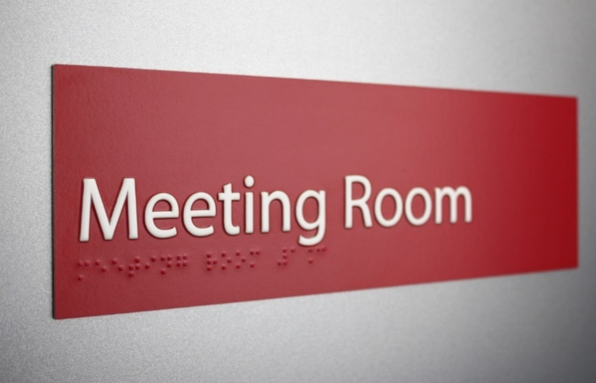

Large and accessible font
To provide accessible communication for people who have low vision, signs should be printed in a sans serif font, 18 point or larger, and displayed prominently.
Sans serif fonts are distinguished by their clear definitions and wider spacing between letters, as opposed to the decorative elements that are a feature of many other fonts or typefaces which can make the content harder to read.
- √ Sans serif fonts include
Arial
- Calibri
- Century Gothic
- Helvetica
- Verdana
Styling
Avoid using italics, bolding, all capital letters or underlining on signs as this can make content more difficult to read. Of these, bold is the most accessible format but should not be used excessively.
- × italics, bold, CAPITAL LETTERS, underlining
Colour contrast
To be accessible for people who have low vision or colour blindness, clear definition is required when developing signs. Providing a contrast in colour between the text and the background of signs is important. The darkest colour should be used for the text with the lighter colour for the background. Bold pictorial formats and graphics can also be used to support signage text.

- 

Braille
Braille is a reading and writing system for people who are blind or have low vision, and for people who are deafblind it is often their only means of communication. Braille is increasingly used in public spaces, for example on the front of buildings, on signage for parklands and nature trails, directional signs, maps and accessible toilets.

- 
Further information: Vision Australia - Braille
Information
This universal symbol indicates the location of accessible information about an event or environment.

- 

Walkways
Navigating walkways is a primary concern for people with low vision. People who are blind or who have low vision rely on other ways to navigate walkways and better design can make this easier.

Tips for outdoor walkways
Outdoor walkways can be hazardous for people who are blind or who have low vision. Here are some tips to make outdoor walkways easier to navigate.
Use tactile ground surface indicators (TGSIs)
Tactile ground surface indicators (TGSIs) are patterns of bumps on the ground that can be felt with your feet or a mobility cane. These can highlight changes in direction or provide warning indicators for hazards, for example at the bottom of stairs, at landings and at ramps, they can also be used as guides to entrances or key locations such as bus stops.

To make access easier for everyone, the indicators need to be at least 30% brighter than the ground around them. Some kinds of indicators need to be 45% or 60% brighter.
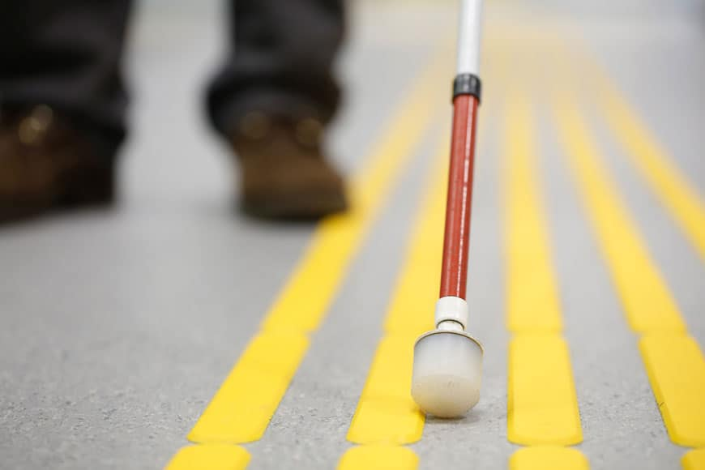
Add railings to mark walking paths
People who are blind or have low vision can run their hands along a railing and use it as a guide to avoid stepping off the walkway. This can be particularly helpful when they are navigating walkways near busy streets or bike paths.
Avoid features that could mislead someone with low vision
People with low vision expect tactile ground surface indicators at crosswalks or contrasting colors to indicate walkways. Avoid adding these features where they are not helpful as this may create confusion.
Logical pathways help people find their way around a space
It is important to be able to see a connection from where you are to where you are going. Level, covered outdoor walkways should have predicable paths or loops that return to the starting point. This can help people find their way.
Avoid skewed crosswalks
People who are blind or have low vision are taught to enter a crosswalk and walk straight ahead. A crosswalk that is skewed - sloped in different directions and do not point straight toward the curb - can confuse and potentially harm a person who is blind or who has low vision.
Keep trees and plants out of pathways
People who are blind or who have low vision may not see hanging branches. Keep trees and bushes along walkways trimmed and where necessary make sure they’re marked well, using contrasting coloured path edging, fencing or differing textures to help people avoid them.

Use natural guidance lines
Drainage channels, contrasting pavement, tactile contrasts, grass edging and curbs can all help people with vision concerns know where the edge of the walkway is. The key to making these work well is ensuring that they’re continuous, clearly marked and free of obstruction.
Add curb cuts near intersections
Curb cuts are dips in the sidewalk that eliminate a curb ledge at intersections, making it easier for wheeled vehicles and people with disabilities to mount the curb. When combined with the textured surfaces that indicate a crosswalk, these can make navigating the crosswalk much easier for someone who is blind or has low vision.

Tips for indoor walkways
Here are some tips to make indoor walkways easier to navigate for people who are blind or who have low vision.
Change flooring texture to indicate doorways or openings to seating areas
If a walkway is made of one surface and you have a seating area off the walkway, consider changing the floor surface of the seating area. This will allow someone using an assistance cane to find a seat. If different flooring types are not possible, then consider adding a different pattern or boundary markers.
Use colour contrast on the flooring
Using contrasting tiles or carpet to highlight direction can help wayfinding.
Keep route guidance as straight as possible
Straight-line pathways and clear, sharp corners can help people navigate the route inside more easily.
Avoid checkerboard patterns of dark and light floor tiles
To someone with low vision, a “checkerboard” or similar pattern can look like changes in the height of the floor, which is difficult to navigate. Use contrasting colors only for wayfinding.

Use of contrast
People with low vision often rely on increased contrast to help them see where roadways and hazards are. Here are some areas where you can add contrast to improve wayfinding in an outdoor space.
Use colour contrasts to indicate a difference in function
For example, if you want to differentiate between a sidewalk and a curb, add a bright white or yellow line to the edge of the curb, which will differentiate it from the dark pavement.
Add colour contrast to the edge of steps
Someone with a visual impairment might struggle to discern the difference in depth at a stairway or step. Add a visual, high-contrast colour to the edge of the steps.
Use illumination or lighting contrasts to help people see areas where their safety may be at risk
Ensure sufficient illumination at crosswalks and similar areas for people who struggle to see well. Care should be taken to minimise glare while maximising contrast.
Add illumination to the ground for contrast after dark
Lighting added to areas where contrasting colours are located will help people with low vision see the contrast in low natural light.
Use contrasting textures, like bubble pavement, to indicate changes
In some areas, like crosswalks, texture changes may be needed (consider using tactile ground surface indicators – see earlier). In other areas, texture changes are simply a helpful signifier of terrain or traffic-feature changes.

Use of sound
People who are blind or have low vision will use sounds to assist getting around. For example, they may know they are approaching a street junction by listening for the sounds of oncoming traffic or feeling a change in the wind direction due to the lack of buildings blocking the wind. There are different ways of enhancing the use of sounds to assist navigation.
Create spaces to minimise echo
The sound distortion created by echoes can be difficult for people who are blind or have low vision to manage. Echoes can confuse the information being relied on to navigate surroundings.
Use auditory (sound) cues at important places
Adding an audible sound or audible countdown at an intersection can alert a person who is blind or has low vision to when it is safe to cross.
Consider different sounds given off by different textures when making textured surfaces
For example, when someone is using an assistance cane near an intersection, rubber tiles will give off a different sound than the pavement signaling a change in surface.

Use of lighting
Ensure spaces are well lit
While dim lighting may create an ambiance, it also makes it nearly impossible to navigate a space for people who are blind or have low vision. Bright light that minimises glare while allowing ample contrast is ideal. Choose lighting as close to natural sunlight as possible.
Install floor or other area lighting
Lighting directed onto traditionally darkened areas that illuminates barriers, walkways and stairs, or brightens workspaces, can be helpful to people who are blind or have low vision.
Consider the problem of glare
Glare makes it difficult for people who are blind or have low vision to navigate. Choose glare-free lighting options to help eliminate this problem. Watch for places where lighting reflects off different surfaces or there is glare from other sources such as external windows.

Use of barriers
In outdoor spaces, barriers are important to help people who are blind or have low vision to discern where they are.
Use fencing or other markers to indicate the boundary of shared spaces
Adding a fence or other boundary markers can assist a person who is blind or who has low vision to identify the boundary between one space and another, for example, between a playground, garden or walkway.
Add contrasting colours to boundaries to make them more visible
Add colours on the fence or boundary markers that contrast with surrounding areas to make them more visible.
Keep boundaries low enough that a user can trail the boundary by hand
This means boundaries should be about waist high for the average adult. Too low and a boundary creates a tripping hazard, and too high imposes an obstacle.

Using stairways
Use tactile and visual signals around stairways
Use signage, contrasting colours or textures and prominent boundaries to make stairways more obvious to a person who is blind or has low vision.
Use stripes at the top and bottom of the staircase
Raised, coloured stripes indicate a tripping hazard is ahead. The stripes should run parallel to the step to help orientate someone approaching or walking in the space.
Add tape to the edge of each step
Using coloured textured tape can help a person going up or down stairs to know when they have reached the edge of each step.
Add railings to stairways
Railings are required on most stairs for buildings; make sure they’re readily accessible to people who are blind or have low vision. Where possible, place them at a natural height and on both sides of the stairs.

Using elevators (lifts)
Install alarms or audible sounds in lifts
Using sounds assists people who are blind or have low vision to know what floor they’re passing and when they arrive. Chimes, voice and other signals are all useful.
Use contrasting textures and colours at the opening to an lift
Using contrasting colours or textures leading up to and inside the lift will assist people who are blind or have low vision to locate the entrance and to know when they have completely entered the elevator.
Include textured or Braille markings on lift buttons
Using textures or Braille can assist people who are blind or have low vision to select the floor they need by reading the markings on the bank of buttons.
Substitute a keypad for Braille
Though Braille is effective, it can be time-consuming for users. Many people who are blind or have low vision have learned to use traditional keypads, which can be more effective to select a floor.

Doorways and windows
Add stickers or glazing to glass windows and doors to improve visibility
Clear glass can be particularly difficult for people with low vision to see and they may not realise there’s a barrier in the way. Using decals with dots or stripes to create a visual mark on the glass can help.
Create significant colour contrast on the flooring near doorways
This can assist people who are blind or have low vision to detect the approach to a doorway.
Add colour contrast around the frame of a door
This can assist people who are blind or have low vision to detect and enter the doorway safely.
Consider installing automatic doorways
Doors that open automatically are easier to use for people who are blind, have low vision or who are using wheelchairs or other mobility aids. Where possible, have the doors open into the flow of traffic, rather than toward people approaching the door. If possible, opt for sliding doors that move completely out of the way.

Toilets
Make toilet signage tactile so people know which toilet to use
People who are blind or have low vision do not want to be embarrassed by walking into the wrong washroom — and not everybody wants to ask a passerby which one they should enter.
Use contrasting colors to make toilet, sink and paper towel locations clear
White toilets with light-coloured walls are hard to see. Contrast the white against a darker wall colour to help. Consider dark-coloured toilet seats as an additional opportunity to add contrast.

Design don’ts for shared spaces
When designing outdoor spaces to accommodate the needs of blind individuals, keep these don’ts in mind:
Don’t use textures in areas where they do not make sense
People who are blind or have low vision expect certain textures. If they feel tactile markers but do not find a crossing, the textured pavement is not helpful. Don’t create confusion by inserting textures where they’re not needed.
Don’t make the walkways too curved
Curves simply for the sake of aesthetics can be confusing or frustrating for people who are blind or have low vision. Try to keep walkways as straight as possible.
Don’t add boundaries that could be more hazardous than helpful
Poles, rails and fences can help people who are blind or have low vision navigate a space - but not if they’re hard to see or feel, or if they’re situated in an unexpected place that makes them dangerous.

Design don’ts for indoor spaces
Don’t make everything the same colour shadeColour contrasts are critical for helping people with low vision to distinguish between surfaces, levels and features.
Don’t use textures on the floor that could be mistaken for wayfinding cues
Learn the standard wayfinding cues that people with low vision will look for, then avoid using them on the floors around your space unless you’re using them correctly.
Don’t keep the space too open with many glass barriers
Glass barriers are hard to navigate for people who are blind or have low vision. Only use them if you add stickers, glazing, etching or other visual indicators of the barrier.

Extra considerations for people using assistance dogs or assistance canes
When designing spaces for people who are blind or have low vision, make sure you also consider the needs of people who walk using an assistance dog or an assistance cane. These tips can help.
Understand the challenges faced by those using assistance dogs or canes in shared spaces
Sharing a space with pedestrians, bikes and cars can make using mobility aids more difficult. For example, because many visually impaired pedestrians cannot make eye contact with someone, they may not be able to read subtle clues that a cyclist intends to proceed first, which could lead to an accident.
Install dedicated pedestrian-only walkways
Creating spaces solely for the use of pedestrians and separate spaces for the use of cyclists, can help eliminate crashes.
Place street furniture off the walking path
A park bench in the middle of a walking path can be a hazard for someone using a cane to navigate the space. Move the furniture, rubbish bins and other obstacles to the side of the path.
Remove obstacles that could allow a cane to get stuck
Canes can be narrow and divots or cracks in the walkway, or even the seam between two footpath panels, can allow them to get stuck. Remove these hazards from public paths.
Remove obstacles that complicate the workload for assistance dogs
Though guide dogs are well trained to ignore and avoid most distractions, their job should not be made harder by the design of spaces they travel through. Make an environment less complex to help them guide their handler properly. For example, avoiding stationary and moving obstacles at the same time can be too much for some guide dogs to handle. Also, cyclists and motorists that travel close to the walking path can increase the risk of spooking an assistance dog, presenting a danger for the dog and the person it is guiding.
Understand that assistance dogs do not react to colour or texture contrasts
Assistance dogs are trained to react to obstacles like curbs and barriers, and building and outdoor space design should be adjusted accordingly.

Special considerations for people who are colour blind, have reduced depth perception or have reduced peripheral field
Colour blindness, reduced depth perception and reduced peripheral field vision each create their own specific challenges for people navigating public spaces. , Each can be assisted by different design elements.
Colour blindness involves an inability to see colours or contrasts properly
Colour blindness affects around 4.5% of the population. People who are colour blind can see clearly but cannot differentiate between certain colors. Keep these things in mind when designing spaces.
Understand the different types of colour blindness
The most common type of colour blindness is red/green colour blindness, which involves the inability to differentiate between different hues of red and green. Some people suffer from blue/yellow colour blindness, which makes blues and yellows indistinguishable, while a small number of people with colour blindness will be unable to distinguish colours at all.
Keep signage universal in shape and orientation to eliminate confusion
Because many signs use red and green associated with “stop” and “go” signals, people with colour blindness sometimes struggle. To avoid confusion, keep the orientation of the signage universal. For example, the red “stop” signal should always be at the top of a traffic signal, with the green “go” at the bottom.
Avoid using red and green or blue and yellow together if a sign or signal requires colour differentiation
You can use these colors as desired for aesthetics, but if the people need to be able to distinguish the colour differences, avoid using those colours together.
Use prominent contrasts
Contrast, once again, is important when designing for people with colour blindness. The greater the visual contrast between two items, the better someone with colour blindness will be able to see them, even if the colours appear similar to the individual.
Never use colour alone to indicate the meaning of a sign
Also use text or symbols to ensure someone with colour blindness can understand the meaning.
Use patterns in addition to colours to create greater contrast
This can make it easier for people who are colour blind to differentiate between different parts of a sign, markings on the floor, and other important designations in your space, even if they cannot distinguish the colours well.
Because they find it difficult to judge distances, people with compromised depth perception have trouble perceiving where surfaces change levels, whether on walkway floors or at countertop levels. This condition happens most frequently when one eye is damaged or lost. The brain can adjust to improve depth perception through one eye, but people with compromised depth perception may still find level changes challenging to negotiate.
Clearly indicate areas where walking or counter surfaces change levels
Help people see these spots by implementing brighter illumination and designated markings in prominently contrasting colours.
A reduced visual field means that a person has trouble seeing at the periphery, or outer edges, of their field of vision. It can also mean that the person’s two eyes don’t function together, sending conflicting images to the brain and resulting in blurry, overlapping or indistinct images. This can make it difficult for someone with reduced peripheral vision to anticipate obstacles or moving hazards.
Expand bottlenecks, mark and light pathways, and duplicate signagePeople with reduced peripheral vision may have trouble navigating narrow doorways and walkways. Expand any doorways where it’s possible to ease the traffic flow, avoiding potential bottlenecks. Make sure pathways and interchanges are adequately lit, glare is controlled and large-lettered signage is duplicated in several prominent spots to accommodate these needs. Designated wayfinding pathways also help people with a reduced peripheral field find their destinations.
Sources:
https://www.bigrentz.com/blog/ultimate-guide-designing-navigating-spaces-people-vision-impairment
https://segd.org/wayfinding-visually-impaired

Wayfinding using multimedia devices
The rapid development of technology and the high uptake of personal electronic devices provide new options for people who are blind or who have a visual impairment.
Assistive technology
One recently developed technology enables access to a computer or device using eye tracking. This technology makes it possible for a person who is unable to speak and use their hands to communicate and use apps though use of their eyes. Information on this technology is available at www.tobii.com .
Hearing aids
Hearing aids have been around for a long time, but improvements have been made, particularly relating to new hearing aid technology. Some later models can connect to smart devices and enable third party engagement.
Hearing loops
A hearing loop provides a magnetic, wireless signal that is picked up by a hearing aid set to ‘T’ (Telecoil).
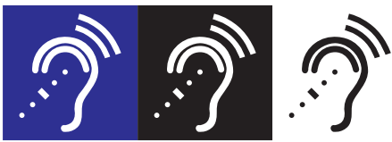
Talking tactile maps
The talking tactile map combines a physical map with voice information to describe a building using hearing and touch. The shape of the map is a simplified version of the footprint of the actual space.
When a user touches the map, they hear a spoken description of the location or function located at that point. The longer the person’s finger stays on the spot, the more information they receive. This approach allows the visitor to quickly scan through the building to find what they are looking for.
A map can also be connected to a video screen that displays the information in written form as it is spoken to assist people who are hard of hearing or who have low vision.

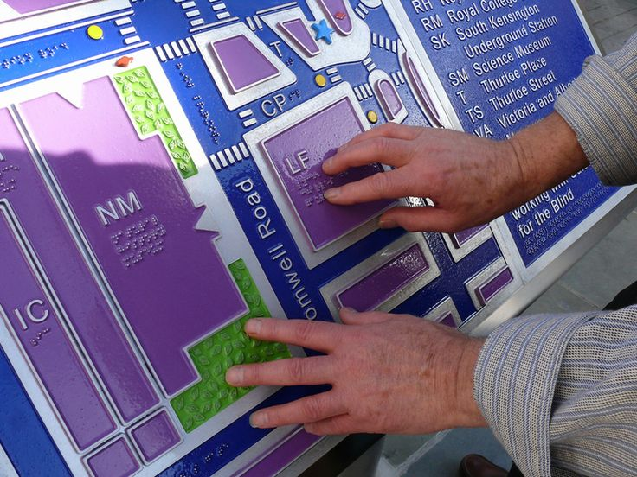
RFID and other mobile navigation devices
Tactile maps are static and stationery and therefore facilitate only orientation and route. Therefore consideration should also be given to mobile navigation devices.

An RFID tag can be placed at information points as geographic markers. Each tag triggers a device carried by a user with the device speaking and/or displaying the information describing that location. When the user lowers the device and walks away, the description stops. In some instances, an app on a personal device may be substituted for the separate device.
QR codes
Quick response (QR) codes instantly decode information using a mobile phone or other device. Each QR code contains a URL address, which retrieves the information stored there. The information is stored digitally and can be communicated in a variety of different ways—visually, aurally or by touch.
Apps
There are many apps designed to assist people with disability.
Listed below are examples of some of these; their usability or usefulness has not been tested and they are not endorsed.
Apps for people who are blind or who have low vision
- Describes objects around people using artificial intelligence (Aipoly Vision)
- Describes the environment and streets (Blind Square)
- Provides specific wayfinding information from a talking map (Ariadne GPS)
- Provides virtual online assistance from a sighted person (Be My Eyes)
- Identifies colours of objects (Colour ID)
- Translates written words into speech or Braille (KNFB Reader)
- Transforms any natural or artificial light source it encounters into sound. (Light Detector)
- Translates texts on mobile phones to Braille and Braille to text (Smart Braille)
- Navigates public spaces and search for accessible features (Ability)
Apps for people who are deaf or who have hearing loss
- Translates text-to-sign (ASL Translator)
- Uses flashcards (BuzzCard)
- Translates live speech (Live Transcribe)
- Transcribes live speech (Ava)
- Makes live transcription and phone call making (RogerVoice)
- Enhances sound and voice (Sound Amplifier)

Resources and further information
Inclusive Play Guidelines
https://inclusive.sa.gov.au/__data/assets/pdf_file/0007/95461/Inclusive-Play-GuidelinesV2.pdf

Australian Network on Disability – Accessible content
Vision Australia – Inclusive design and legibility
National Disability Practitioners – Accessible Communication
Australian Network on Disability – Disability Statistics
Vision Australia - Braille
Smashing Magazine – Nailing Accessibility in Design
  - Brailliant Touch Australia – Wayfinding Systems
Government Resources
https://sport.vic.gov.au/publications-and-resources/design-everyone-guide/index-elements/signage-and-wayfinding.

Sport and Recreation Victoria has produced a Design for Everyone Guide, which has a section dedicated to signage and wayfinding. It states the “key requirements” for wayfinding design are architectural cues, graphic communication, audible communication and tactile communication. The four main categories of graphic wayfinding elements include identification, reinforcement, orientation and destination. The Design for Everyone Guide provides advice on general access requirements for:
- All signage
- Static signage
- Screen and scrolling signage
- Maps
- Tactile signs and maps
- Display and exhibition signage
- Tactile ground surface indicators

Tasmania - Clarence City Council, Access and Inclusion Assessment Toolkit ‘The Human Factor’
https://www.ccc.tas.gov.au/the-human-factor-access-and-inclusion-assessment-toolkit/
The signage and wayfinding section of the toolkit explains important points to consider for signage, particularly its significance to not only people living with vision impairment but also for people living with intellectual, cognitive and other sensory disabilities.
Further background information about wayfinding cues is provided on:
- architectural features, such as using contrasting colours to identify pathways
- graphical features, like symbols identifying key features
- audible communication, such as audio information in lifts
- tactile features, including the use of directional tactile indicators.

Practice Review – City of Brisbane
The City of Brisbane in Queensland spent $200 million implementing its Access and Inclusion Plan 2012-2017. During that five-year period a number of improvements were made the accessibility of the city, including:

- audio-tactile signals at pedestrian crossings to communicate information in a non-visual format about when it was safe to cross
- longer walking times at certain signalised pedestrian crossings to allow people more time to cross safely.
- a 1.6km Braille trail network in the city to assist people living with vision impairment to move more independently
- even, firm and consistent pathways to prevent tripping hazards
- tactile street signs at traffic lights.

Descriptions of discrimination are taken from the SA Equal Opportunity Commission website.
The 7 Principles | Centre for Excellence in Universal Design

