Heritage Standard
Moonta Mines State Heritage Area

(1862-1923)

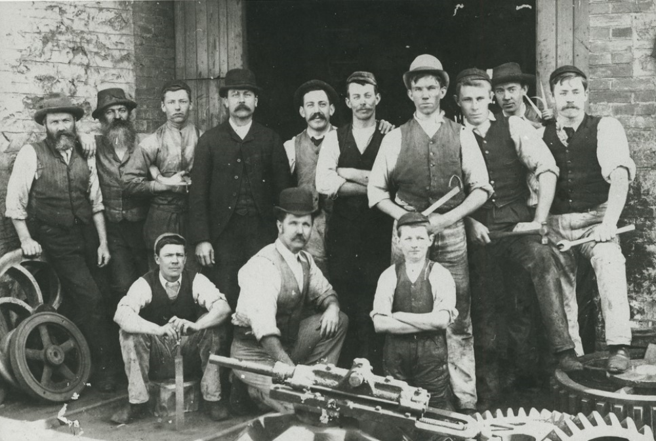
(SLSA B-26970) 1890, Miners

Contents

1. Background 3
1.1. Moonta Mines State Heritage Area 3
1.2. Purpose of Heritage Standards 3
1.3. History – Moonta Mines 3
2. Heritage Value 8
2.1. Statement of Significance Moonta Mines State Heritage Area 8
2.2. What is of heritage significance? 8
3. Heritage Standards for Development (Moonta Mines State Heritage Area) 18
3.1. Purpose of Heritage Standards for Development 18
3.2. Land use 20
3.3. New buildings 21
3.4. Alterations and additions 24
3.5. Ancillary development 28
3.6. Land division 32
3.7. Landscape context and streetscape amenity 33
3.8. Demolition 35
3.9. Conservation works 36

Version 1 – 13 June 2023
Heritage South Australia
Department for Environment and Water

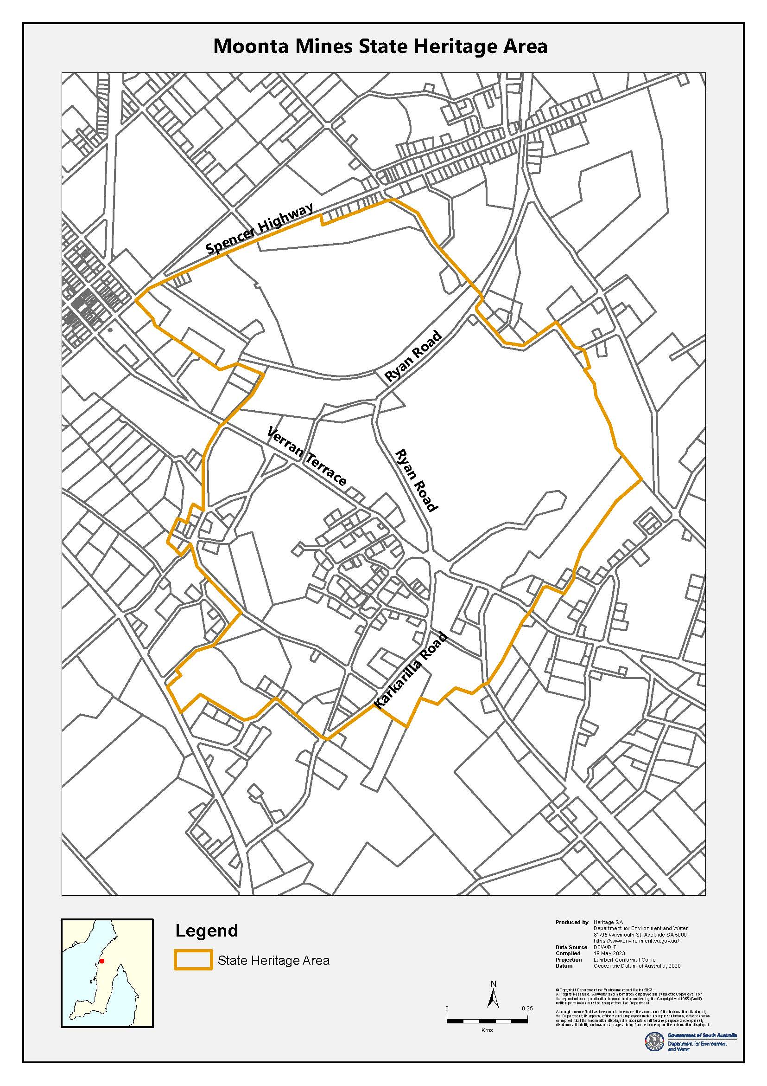

Background

Moonta Mines State Heritage Area
South Australia’s State Heritage Areas represent significant aspects of the State’s rich natural and cultural heritage. Moonta Mines was designated as a State Heritage Area under the Heritage Places Act 1993 in 1984. The designation ensures that future development of properties and open spaces within Moonta Mines State Heritage Area is managed in a way that maintains the Area’s heritage value.

Purpose of Heritage Standards
The Heritage Standard is published in accordance with the Planning, Development and Infrastructure Act 2016 and the Planning and Design Code (Code). It is a supplementary tool of the Code and is referenced in the State Heritage Area Overlay.
Any proposals to undertake development within a State Heritage Area will be referred to the Minister responsible for administering the Heritage Places Act 1993, for heritage advice. Heritage South Australia (Heritage SA) in the Department for Environment and Water is the Minister’s delegate for decisions on referred development applications. Heritage SA also has the ability to direct conditions, should the development be approved, or to direct refusal if heritage values are compromised. The Heritage Standard forms a key part of Heritage SA’s assessment of development proposals.
The Heritage Standard is presented in three parts:
- Background - the historical development of Moonta Mines and principles that underpin the State Heritage Area listing
- Statement of Significance –the South Australian Heritage Register listing and the context and description of the heritage values
- Heritage Standards for Development - Principles and Acceptable Standards for development

History – Moonta Mines
Nharangga ownership and dispossession
The Nharangga (also spelt) Narungga people are the traditional owners of the Yorke Peninsula. Prior to and for some time after the arrival of Europeans, the Nharangga people modified their environment, burning selected areas to create lightly forested expanses, suitable for hunting, within a broader landscape of thick mallee scrub.
Yorke Peninsula’s dense vegetation and apparent lack of water delayed the arrival of pastoralism until 1846. While the best hunting country and water sources were ‘rapidly occupied,’ the vegetation and geography of the Peninsula, including access to the resources of the sea, allowed the Nharangga people to ‘live relatively autonomous lives.’ Nharangga people also worked in exchange for food and goods in the above-ground mine workings at Moonta and Kadina, in the townships and on pastoral stations.
In 1868, some European settlers and Nharangga people cooperated to bring about the creation of the Point Pearce Mission south of Moonta, which Nharangga people visited ‘if and when it suited them.’ Nharangga agency in the creation and operation of the Mission differentiates the Nharangga experience from that of other Aboriginal people.
Environmental destruction and government regulation in the early twentieth century made it increasingly difficult for Nharangga people to live independently of the Mission, and those who identify as Nharangga today have close associations with Point Pearce. The Narungga Nation Native Title claim was lodged in 2013 and covers the whole of the Yorke Peninsula and offshore waters and islands. On 14 March 2023 the Federal Court of Australia handed down the determination of Native Title for the Narungga People.
Copper mining in Cornwall
Cornwall in South West England once possessed rich mineral resources including tin and copper. From the Bronze Age tin mining was Cornwall’s dominant industry. The exhaustion of surface deposits catalysed the development of deep mining technology in the sixteenth and seventeenth centuries. Copper mining supplanted tin in the eighteenth century and led to the rapid emergence of an industrialised mining landscape characterised by ‘deep underground mines, engine houses, foundries, new towns, smallholdings, ports and harbours, and their ancillary industries.’
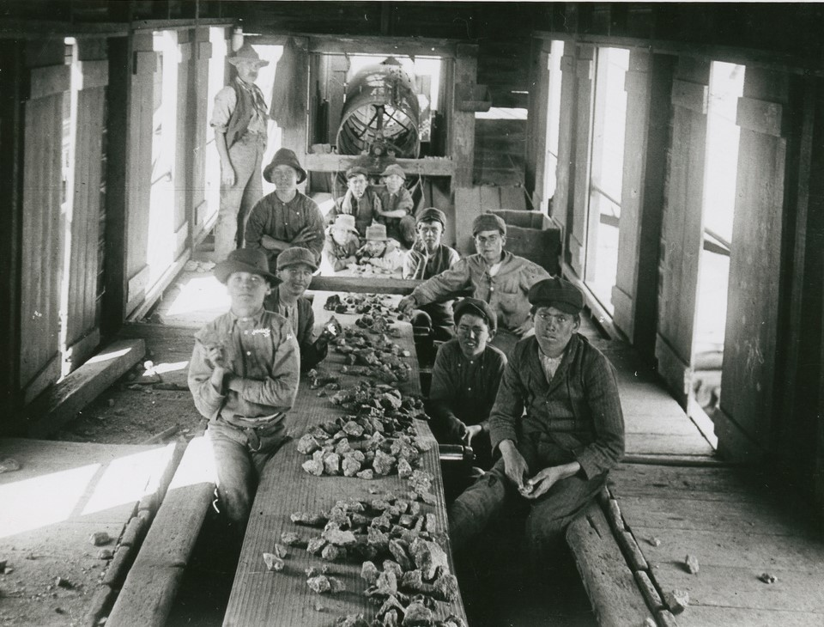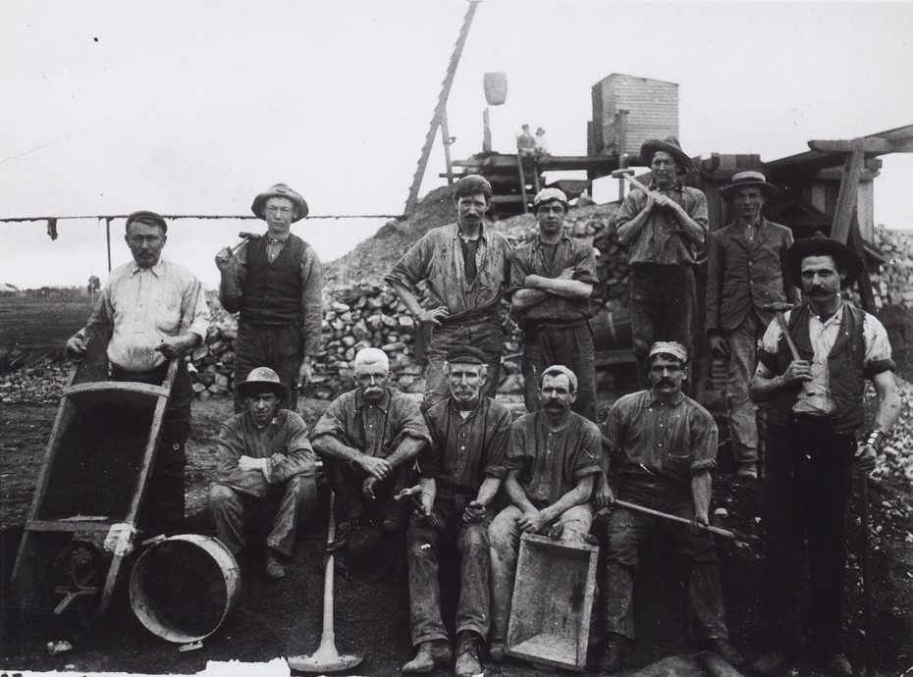Mining was accomplished under the ‘traditional leadership’ of the Cornish mine ‘Captain’ (superintendent) and employed the Cornish system of ‘tribute’ and ‘tutwork’. Miners engaged in tutwork sunk shafts, excavated levels and were paid a low but reliable rate per fathom, while teams of tribute workers bid for the right to mine lodes made accessible by tutwork and were paid according to the value of ore mined. This system promised flexibility and independence for miners with little risk to investors, and played an important role in the success of Cornish mining and its diffusion worldwide.
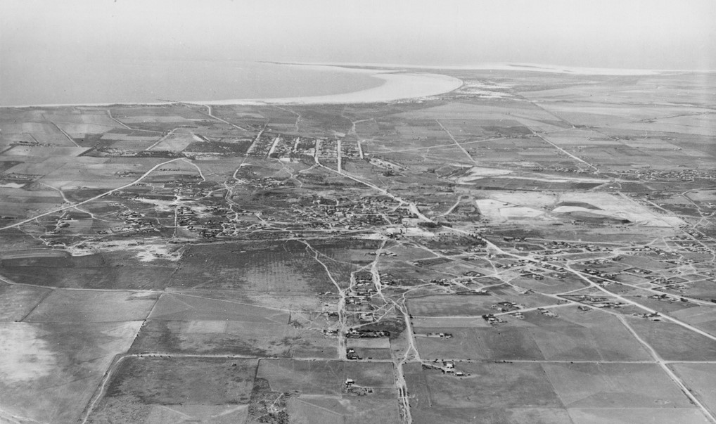The development of the steam engine occurred in Cornwall and was driven by the mining industry’s need to efficiently dewater deep mines, allowing work to occur below groundwater level. The first practical steam engine, with motion transmitted from steam cylinder to water pump through a pivoting beam or bob, was devised by Thomas Newcomen in 1712. Improvements by James Watt, commercialised by 1776, were protected by patents, and with their expiry in 1800 the steam engine developed rapidly. The high-pressure ‘Cornish’ engine and boiler, developed by Cornishman Richard Trevithick from James Watt’s engine, reached its zenith c.1850, revolutionising the mining industry at a time when the first wave of intensive copper mining was occurring in South Australia.
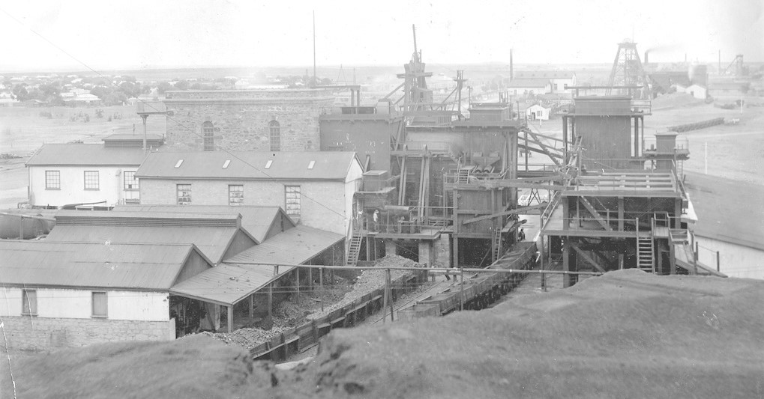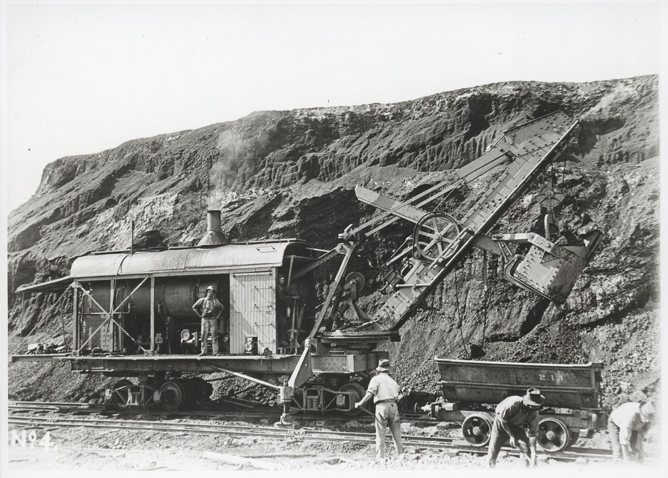Cornish engineers developed two main varieties of the Cornish engine, namely the beam pumping engine, in which the reciprocating see-saw motion of the bob powered subterranean pumping apparatus known as pitwork, and the beam rotative engine, which translated the motion of the bob into rotary motion, allowing the engine to drive machinery including crusher rolls, dressing machinery and winches. Tall masonry engine houses and the tapered cylindrical chimneys of their associated boiler houses were defining characteristics of the Cornish mining landscape that were transposed into South Australia.

(SLSA B-28600)1910, Steam Shovel and Miners (SLSA PRG-280-1-19-282) 1910, Mining Operations
Economic depression and famine in the 1840s and the decline of copper mining in Cornwall in the 1850s coincided with the discovery and exploitation of copper in places such as South Australia, Chile and the United States, and provided impetus for Cornish miners and their families to emigrate in large numbers. They took with them hard-rock mining expertise as well as their vernacular building traditions, social and cultural customs, religious beliefs and identity.
Establishment of Moonta Mines
Copper was discovered at Kapunda in 1842 and Burra in 1845. The Burra Burra Mine rapidly emerged as the largest mine in Australia, a title it held for a decade from 1845, and reputedly saved the colony from bankruptcy. The value of exported copper surpassed that of wool and wheat combined, and large numbers of experienced Cornish copper miners and their families were deliberately recruited to South Australia through agents in Cornwall.
In 1854, pastoralist and retired sea captain Walter Watson Hughes leased the Wallaroo pastoral station on northern Yorke Peninsula with his brother-in-law John Duncan. An amateur minerologist, Hughes noticed that mallee roots on Wallaroo burned with a green flame, and instructed his shepherds how to recognise the colours of copper ore.
On 17 December 1859, shepherd James Boor discovered copper ore on Hughes’ property west of present-day Kadina. In January the following year, Hughes secured an 80-acre mineral lease under the Waste Lands Act 1857 and established the Wallaroo Mining Company (WMC). Subsequently on 13 May 1861, shepherd Patrick Ryan discovered copper ore near a wombat burrow on Hughes’ property in an area known as Tiparra (near present-day Moonta). After defeating rival claimants, Hughes established the Tipara [sic] Mining Company, later the Moonta Mining Company (MMC), separate from WMC and in partnership with Edward Stirling, John Taylor, Robert Barr Smith and Thomas Elder. MMC commenced mining at Moonta in 1861.
Immediately profitable, Moonta Mines soon became ‘a phenomenal success.’ MMC was the first Australian mining company to pay £1 million in dividends, and Moonta Mines cemented Australia’s international reputation as a major exporter of copper. The Wallaroo Smelting Works also opened in 1861 and most Moonta ore was smelted there prior to export. The region encompassing Moonta Mines, the Wallaroo Mine west of Kadina and the Wallaroo Smelter emerged as the largest industrial area in the colony of South Australia and is often referred to as the ‘Copper Triangle.’
The opening of Moonta Mines triggered a ‘rush’ of Cornish miners from Burra and Wallaroo. Like Burra, mining at Moonta initially followed traditional Cornish practice with little adaptation, and all positions of responsibility were held by Cornishmen. MMC also imported two new Cornish engines and acquired a further two second-hand. The engines were unloaded at Port Wallaroo and then installed in large stone enginehouses built to standardised Cornish designs. Successful mining in South Australia would not have been possible without Cornish engines and their introduction and subsequent use marked the beginning of the industrialisation of South Australia.
Management, innovation and reform
Henry Richard Hancock was appointed Mine Captain at Moonta Mines in 1864. A strict yet benevolent manager, Hancock played an influential role in the development of the mine and is especially remembered for his technical innovations and welfare reforms.
An ‘enthusiast’ for technology, Hancock replaced horses with steam power and barrows with tramways. He introduced wire cables instead of rope, steel skips, mechanical drills powered by compressed air and built a railway to carry ore to the Wallaroo Smelting Works. Under Hancock’s regime, Moonta reputedly possessed ‘the best-equipped engineering shops’ in South Australia. Hancock also claimed personal responsibility for developing the Hancock Jig, a mechanical sieve which improved ore processing efficiency. The Jig was patented under Hancock’s name in 1895 and was subsequently used in mines across the world.

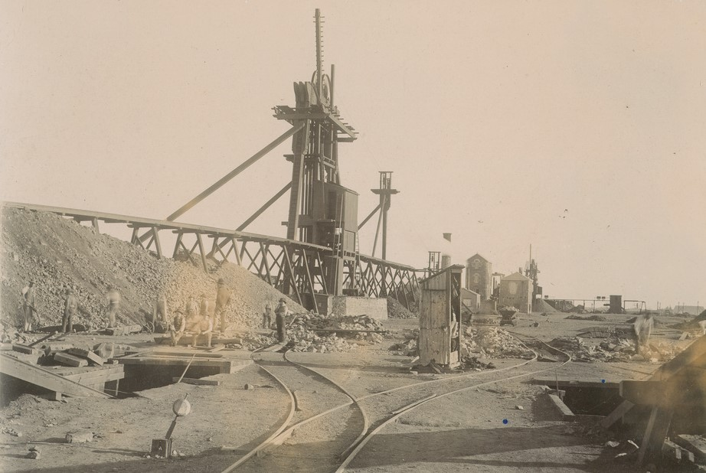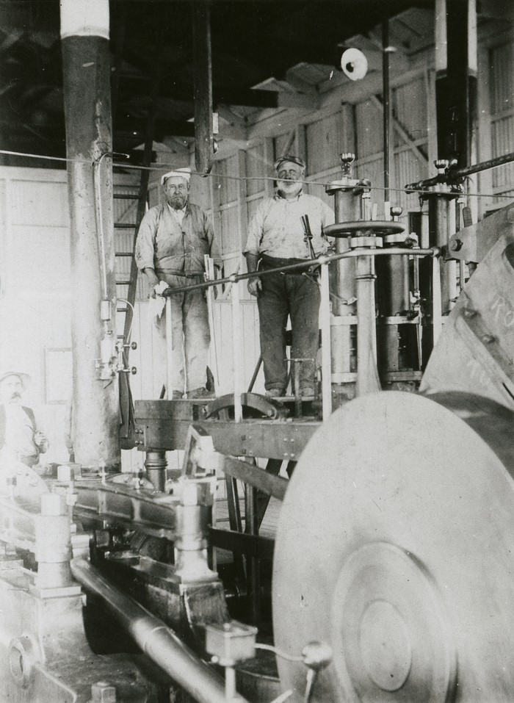
(SLSA B-19611) 1908, Taylor’s Winding Engine (SLSA B-12596) 1898 Prankerd’s winding engine, Boiler Houses, Crusher House
A prominent community leader, Hancock took a sincere interest in the welfare of his workers, informed by his Wesleyan Methodist religious convictions. Hancock intr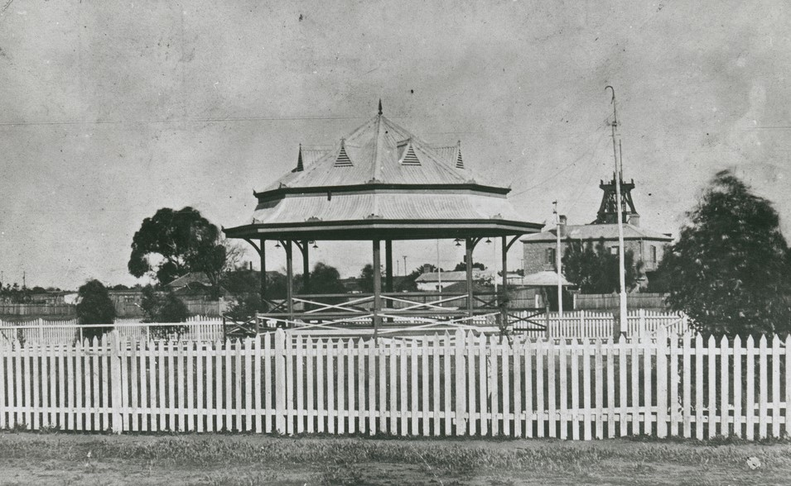oduced a minimum weekly wage against opposition from the company directors, required all employees to join the medical club at a low weekly rate, encouraged the establishment of sport and social clubs, introduced compulsory night school for boys, served on numerous boards and helped to found organisations including a school of mines, a library and the Point Pearce Mission.
(SLSA B-19607) 1908 Rotunda
Through Hancock’s leadership, Moonta Mines survived the ‘great copper crash’ of 1866 which proved devastating for the copper industry in Cornwall. In 1883, Hancock also instituted a ‘massive’ drive to recruit miners and their families from Cornwall. His initiative resulted in ‘the last collective, large-scale movement of population from Cornwall to South Australia’ and led to the Copper Triangle becoming home to the greatest concentration of Cornish miners in Australia. The region has since become known as ‘Australia’s Little Cornwall.’
Despite Hancock’s popularity, tensions between management and labour were not unknown. For example, in April 1874 MMC directors resolved to cut wages without consultation, leading the mining workforce to strike. While Hancock petitioned the mine director, up to one hundred women brandishing brooms and switches of tea-tree successfully dispersed strike-breakers at Moonta Mines, helping to bring about a successful resolution to the strike in the miners’ favour.
Following the ‘Great Strike’ of 1874, local trade unionists began calling for the abolition of the Cornish system of tribute and tutwork, believing that the Cornish system had become a ‘mechanism’ through which mine management kept wages ‘artificially low.’ Discontent led to numerous reforms in the late nineteenth century and culminated in the complete abolition of the tribute and tutwork system at Moonta Mines by 1910.
Moonta Mines Settlement
By 1875 the greater Moonta district, with a population of 12,000, was the largest urban area outside Adelaide. The settlement of Moonta Mines was characterised by an informal village pattern sprawling haphazardly around several local Methodist churches, reflecting the ‘scale and form of cottage life.’ Unlike Burra, at Moonta Mines mining families were allowed to build houses on the mining leases in and amongst the mine workings.
Meanwhile the government town of Moonta, surveyed in March 1863 to the west of Moonta Mines, was laid out following Surveyor General George Woodroffe Goyder’s ‘ideal town plan,’ which in turn was based on Light’s Adelaide Plan (1837). While not included in the Moonta State Heritage Area, the adjacent government town shares an ‘inseparable history’ with Moonta Mines. The government town emerged as a focus for commercial development and middle-class settlement while Cornish miners at Moonta Mines ‘remained a poor labouring class’ without access to sewerage or running water, and epidemics of diphtheria, typhoid, cholera were commonplace.
(SLSA B-9075) 19838 Aerial Photo
Decline and closure of Moonta Mines
Low copper prices in the 1870s caused widespread unemployment and MMC experienced its first losses, leading to the amalgamation of WMC and MMC in 1889. The resulting Wallaroo and Moonta Mining and Smelting Company Limited (WMMSC) emerged as the largest mining company in Australia. Moonta Mines produced ore worth £5.4 million prior to amalgamation and a further £5.3 million afterwards.
In the twentieth century the Wallaroo Mines surpassed Moonta in ore production while Moonta Mines entered a phase of gradual decline and the focus of mining enterprise moved from underground workings to above ground processing of waste product tailings and slimes.
The First World War temporarily increased demand for copper, however, a fall in world copper prices after the war led WMMSC to enter into voluntary liquidation in 1923. While the town of Moonta was able to ‘flourish’ as an agricultural and commercial service centre, agricultural development encroached on the Moonta Mines township leading to the demolition of many structures. In the 1930s, the State and Commonwealth governments subsidised mining at Moonta Mines providing local employment during the Depression, and waste product leaching continued until 1943. No ore of economic grade is known to remain at Moonta Mines.
Rising car ownership and road improvements after the Second World War brought more visitors to country South Australia and tourism contributed to an emerging awareness of the cultural heritage significance of Moonta Mines. The Moonta Branch of the National Trust of South Australia was established in 1964 and played an important role in preservation by stabilising ruins and acquiring leases over mining sites. Moonta Mines was designated a State Heritage Area on 10 May 1984 and with Burra, was entered in the National Heritage List on 9 May 2017. Moonta continues to be an agricultural and commercial centre, with a focus on cereal farming and cultural heritage and seaside tourism.

Heritage Value

Statement of Significance Moonta Mines State Heritage Area
Moonta Mines State Heritage Area is of heritage value for the following reasons:
The Moonta Mines State Heritage Area encompasses the site of one of the largest commercial mining enterprises in colonial South Australia which generated vast wealth and wages from the sale of copper ore. The opening of the copper mines at Moonta led to a rapid influx of skilled miners and other artisans from Cornwall and the area became known as ‘Australia’s Little Cornwall.’ For a time exports of copper surpassed those of wheat, and the town of Moonta and the mines area contained the largest urban population outside Adelaide. Considerable remnants of the mining venture remain, illustrating many aspects of copper mining and processing.
Heritage SA Heritage Places Database; Statement of Significance

What is of heritage significance?
Moonta Mines (1862-1923) survives as a collection of residences, community buildings and industrial remains set within regenerated scrub, a small representative example of the 19th Century Cornish mining system adopted here at a much larger scale. Improvements made to mining and ore processing technology, and to labour organisation and relations, resulted in the system being dispersed further throughout Australia. The impact of a generation of Cornish miners, engineers and tradespeople on the development of Australia's mining industry is mirrored in the country’s wealth production and nation building – evidence of Australia’s emerging international position in an increasingly industrialised global economy. Welsh smelter technology and labour skills also contributed to the mining system's profitability and success.
Future development should seek to protect the form of the area, characterised as a disparate collection of individual elements in a Historic Park setting.

Features within the State Heritage Area which contribute to the heritage value of the State Heritage Area:

- Remnant surface and underground mining structures demonstrating Cornish mining practice and technology. Part of SAHR 13975, including the Hughes enginehouse and stack, the Hughes engine pool, the ruins of Elders enginehouse, Richmans enginehouse and nearby tailings dumps, Hancocks tailings dump (including the tailings and the form and shape of the heap, nearby former mining shafts, remnant ore floors and the foundations of Hancocks enginehouse and crusher house), Ryans tailings heap, Ryans shaft, Taylors shaft, Treuers shaft, ruins of precipitation works, site of the mine workshops, site of mine offices, site of General Manager's residence, site of the assayers residence, the ruins of the powder magazine, the remnant water reservoir (Ryan Road), site and remnant structures of the Hamley mine, the remnant route of the Hamley tramline and the Moonta Railway Station (including disused railway line within the Moonta Mines State Heritage Area).

- Ruins of former mining structures, constructed topographic forms and remains of industrial infrastructure. Ruins along Elder’s Main Lode have the greatest integrity. | 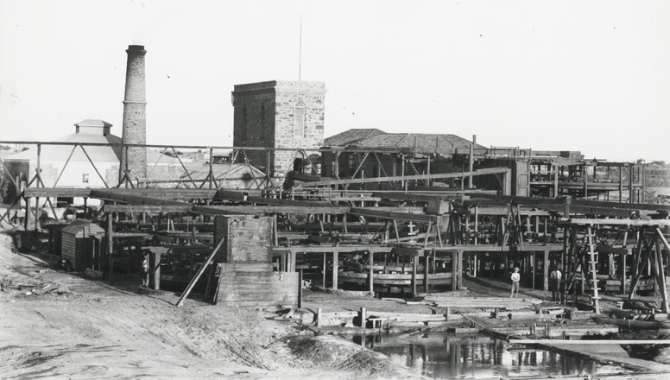  (SLSA B-34840) 1900 Richman’s ore concentration plant erected in 1869, marks the northern end of the Elders main line of lode, (now ruins), sawmill, buddles and slime pits.
- Network of original shafts, including exploratory, focussed along main lode lines, demonstrating the development of a system of vertical shafts and horizontal levels organised in the efficient exploitation of the ore body. | 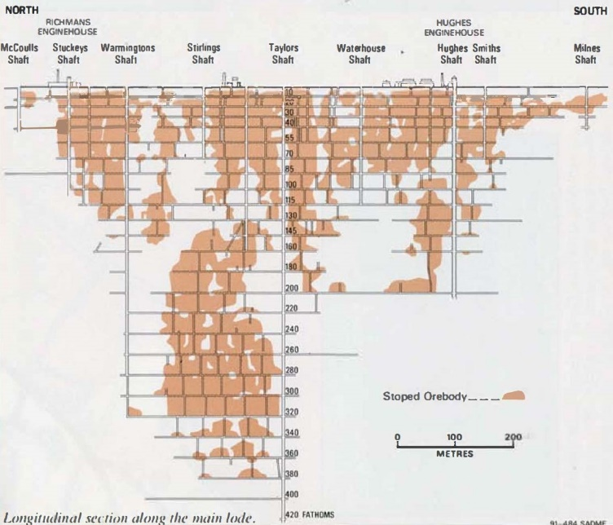  Longitudinal section through Elders Main Lode.
- Remnant arrangement and pattern of surface mining infrastructure, organised along the north-south aligned mineral lodes, with the tailings heaps at lode ends, marking locations of former treatment plants. | 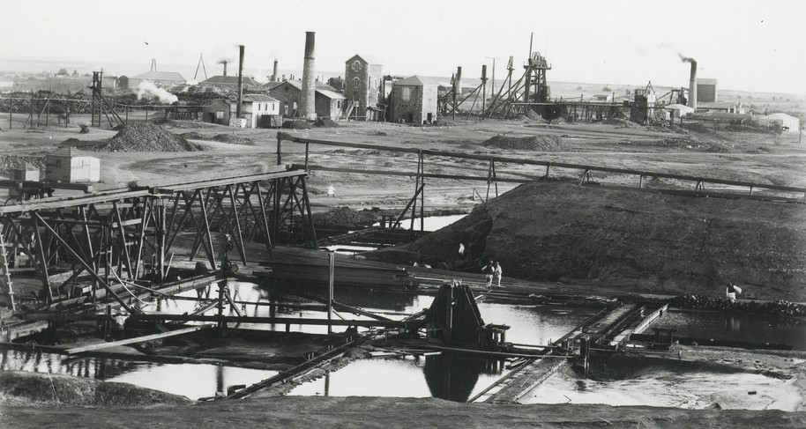  Prominent is Elders main line of lode, marked by Hughes and Richmans Enginehouses. (SLSA B-34843) 1898 Elders line of lode looking south.
- Tailings heaps, slime ponds, ore floors and other industrial landforms… | 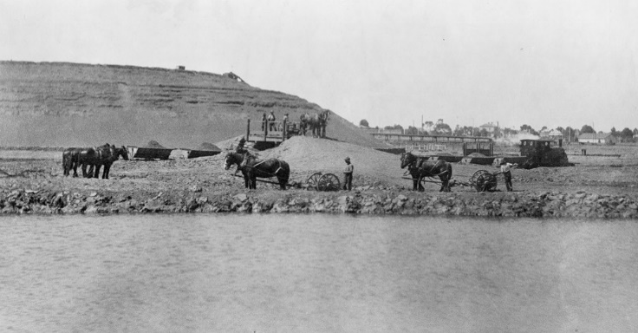  (SLSA B-5700) 1917 Loading slimes with scoops for treatment at leaching plant with tailings heaps behind.
- …including ruins of Precipitating / Leaching / Cementation Works. Established in 1901 to extract copper from tailings and slimes, operating until 1944. Remaining evidence of structures, topographic features, channels and piping across site, concentrated north of Ryans tailings heap where copper recovery and conversion processes were located. | 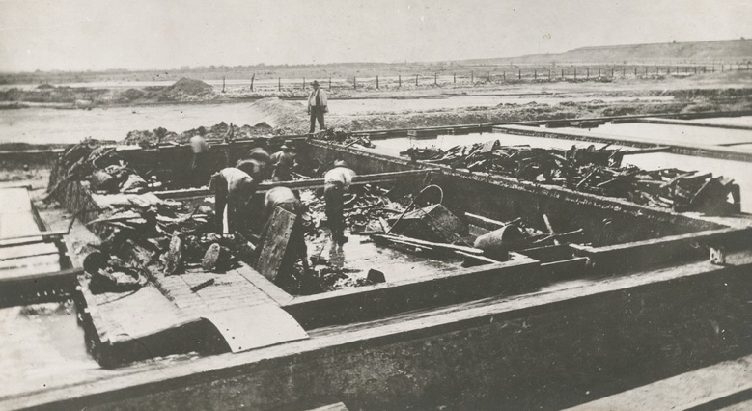  (SLSA B-12762) 1910 Cementation Works, copper being removed from Precipitating Tanks
- Subsurface archaeological remains.

- Hughes Pumping Engine House, constructed 1864 on the Elders line of lode. The only beam pumping engine erected at Moonta, sufficient to dewater most of the mine, also the longest serving Cornish beam engine in Australia. (SAHR 10113) Hughes Pump House and flue, adjacent ruins, shaft and paving. | 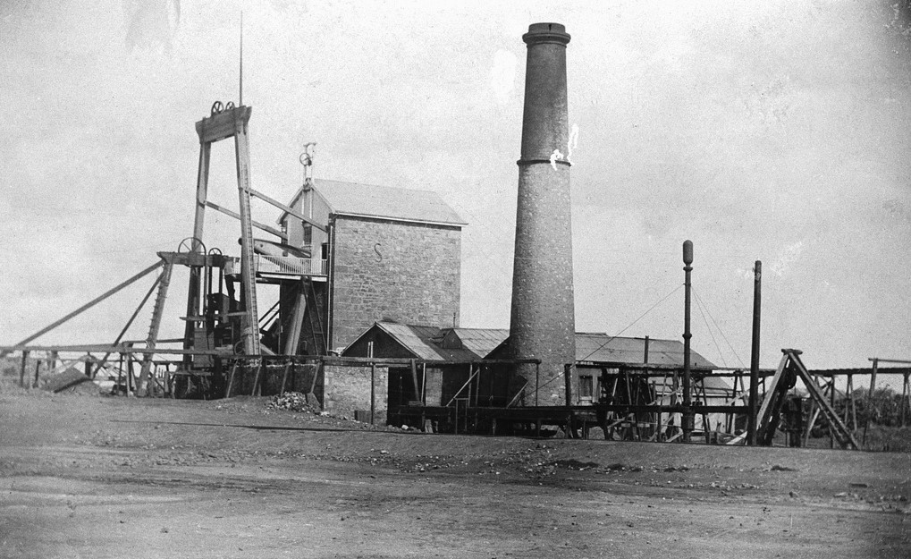  (SLSA B-9207) 1916 Hughes Pumping Plant
- The c.1908 Federation Arts and Crafts style Moonta Railway Station replaced an earlier timber station, closed in 1979. Now Tourist Office. (SAHR 10187) includes toilet block, c1878 goods shed, rail lines. | 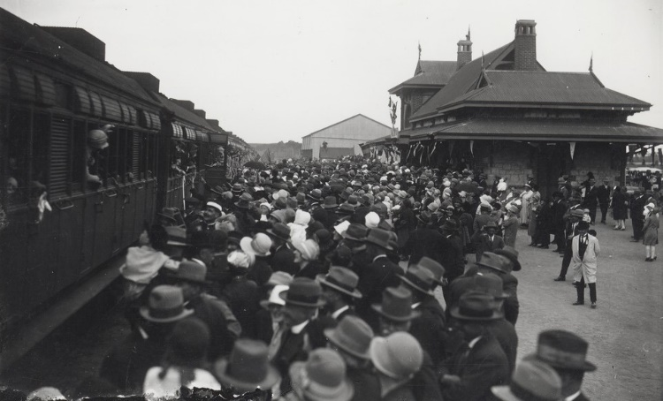 (SLSA B-3487) 1927 Back to Moonta Celebrations
- Area’s low topographic relief. Regenerated mallee scrub, now obscuring most low-lying mining fabric, significant in its representation of the area’s 20th Century history of closure, demolition and abandonment. | 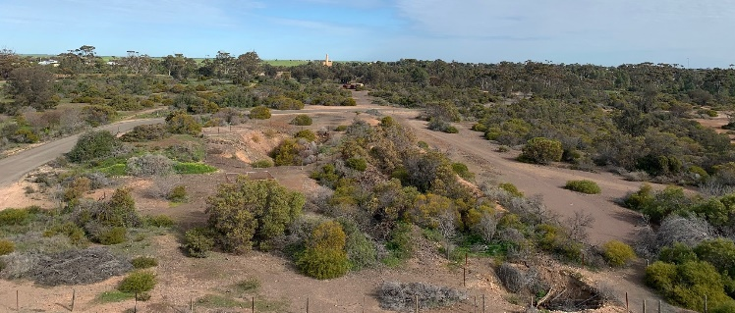  2022 View south from Richmans towards Hughes Engine House
- Surrounding rural setting, exposing the area to views from key approaches, evidencing the encroachment of agricultural development following the closure of the mines (most of East Moonta’s structural heritage was ploughed over by farmers in the 1940s-50s). | 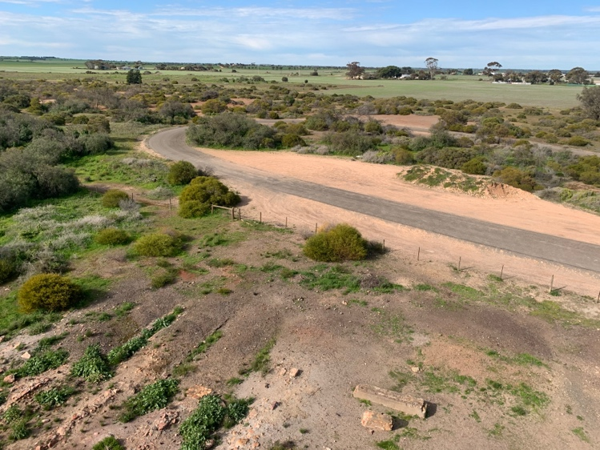  2022 View south towards agricultural holdings from Richmans Engine House.
- Views and vistas incl. to and from Tailings Heaps and along Elders lode.

- Remnant Cornish settlements, characterised by informal village pattern of makeshift cottages, established on mining leases along lode lines, clustered around several local Methodist churches.

- Unplanned road layout, in contrast to the surveyed street grid of the adjacent Moonta government township, demonstrates the 19thC Cornish mining village settlement pattern and historic arrangement of transport routes incl. horse tramways and railway alignments. | 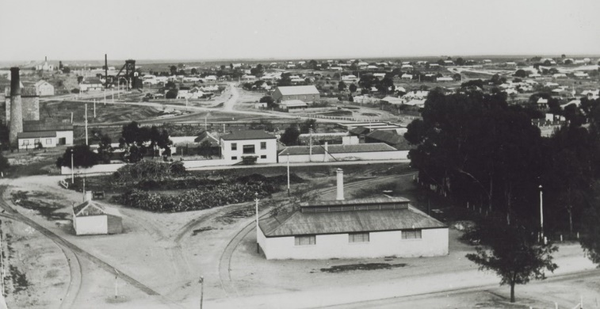  (SLSA B-27805) 1910 Looking south from Taylor’s Shaft
- Early two-roomed miners cottages, expanded incrementally over the period of mining operations with numerous modest additions. | 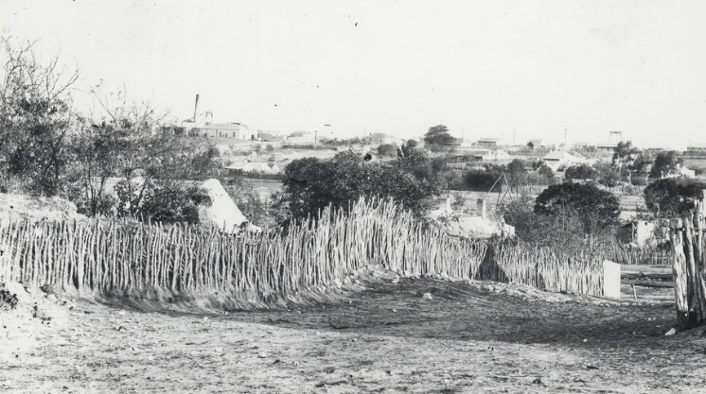  (SLSA B-34851) 1900 Miner’s House & Hamley Mine (background)
- Miners’ cottages typically constructed of local materials including stone (loose paddock calcrete) and clay; whitewashed wattle-and-daub; rammed earth or ‘German brick’; some with brick quoins and door/window surrounds; mallee saplings for roof framing; timber or iron (flattened nail cans) shingle roof cladding, later covered-over with corrugated iron; massive buttressed chimneys. | 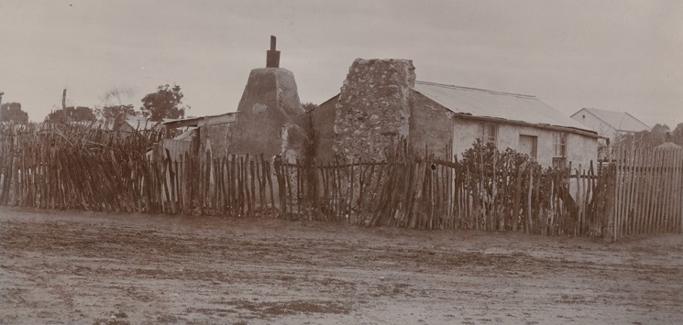  (SLSA B-12612) 1900 Miner’s Cottage & Garden, Verco Street, now National Trust Museum, demonstrates a typical Cornish vernacular housing type. (SAHR 10135)
- More substantial community & company buildings typically constructed from limestone. | 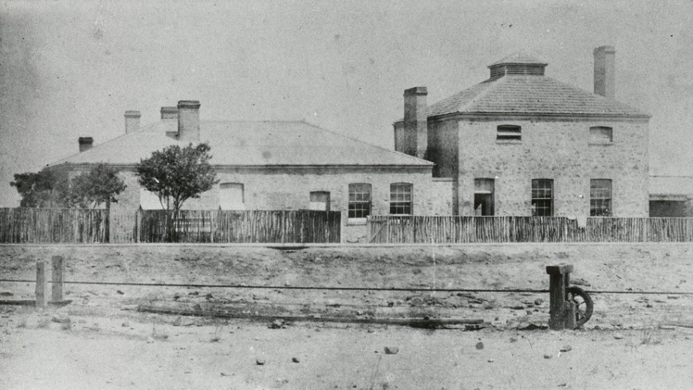  (SLSA B-21313_1) 1900 Assay Office & Residence
- Numerous religious buildings: prominent landmarks around which the Cornish community was focussed, including former Bible Christian Chapel; Moonta Mines Methodist Church (former Wesleyan Chapel (listed, refer below); site of Methodist Sunday School - former Primitive Methodist Chapel (listed, refer below); Moonta Mines Model Sunday School (listed, refer below). | 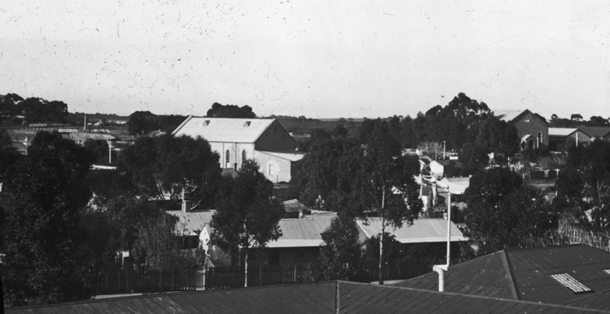  (SLSA B-72434) 1910 Church & houses
- Neo-gothic inspired Moonta Mines Methodist Church (now Uniting Church), constructed by the Wesleyans in 1865. (SAHR 10114) including Church Hall and attached Sunday School building, front fence and outbuildings. | 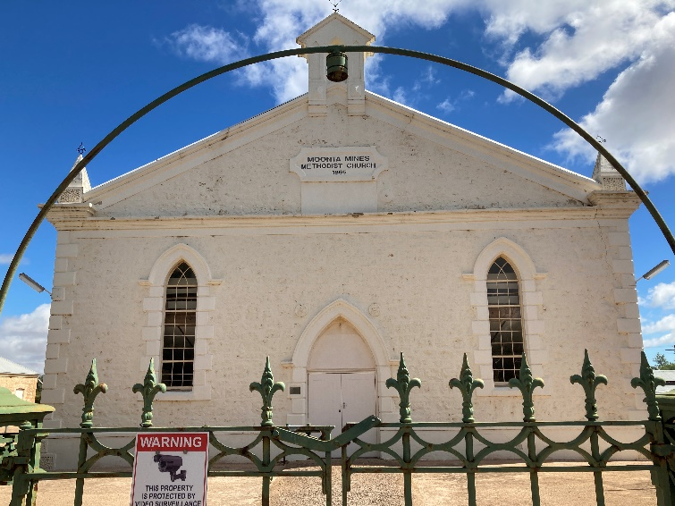
- Moonta Mines Model Sunday School ruin site (former Primitive Methodist Chapel), constructed in 1865, converted to Methodist Sunday School in 1900, demolished in 1939.; (SAHR 13110). | 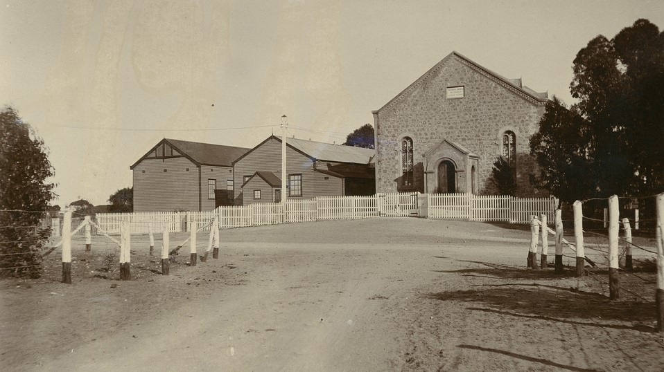  (SLSA PRG-1185-7-1) 1900 Methodist Sunday School
- Moonta Mines Model School, opened on the mining leases in 1878, following the introduction of compulsory education under Education Act 1875 . Closed in 1968. Now National Trust Museum (SAHR 11732). | 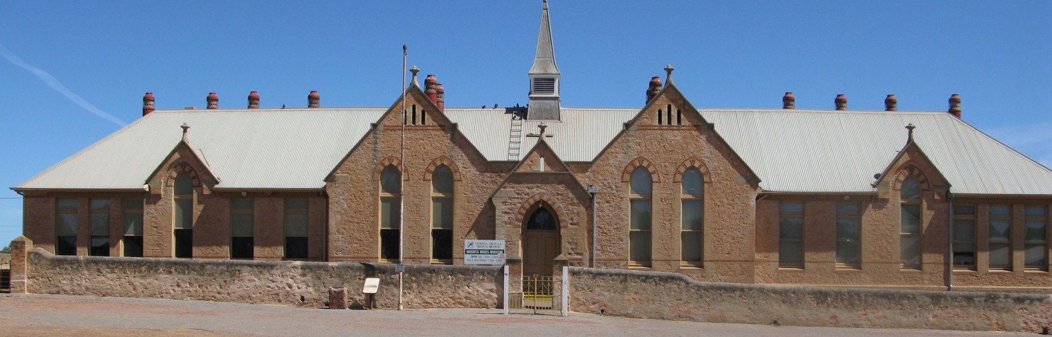
- Few of the once hundreds of cottages remain, now sparsely scattered around the State Heritage Area. The low density of residential development retains a sense of abandonment, evidence of the decline of the copper mining industry in Moonta. | 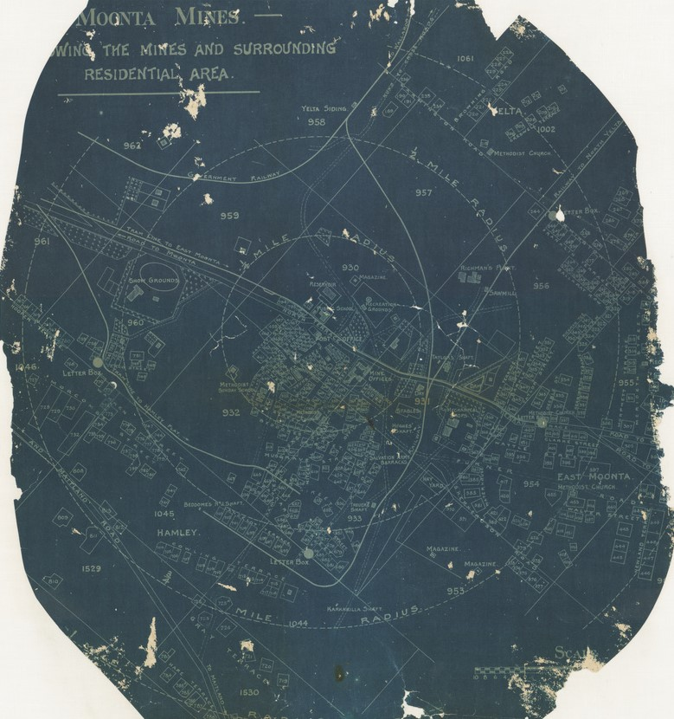  (SLSA C-445) 1918, Moonta Mines Map of Residential Area
- Unsealed roads and absence of modern street amenities such as parking bays, kerbs, guttering, street signs and repetitive lighting, reinforce the industrial past. | 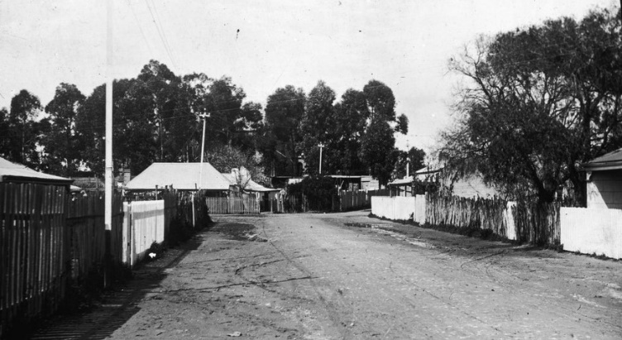  (SLSA B-72434-2 (1)) 1920, Miners’ Cottages
- Architectural features of heritage value include:  - Importation of the Cornish building construction traditions. Miners used local materials to build replicas of cottages and chapels from their home country. The informal arrangement of allotments centred around religious buildings also reflects settlement patterns of Cornish mining villages. | 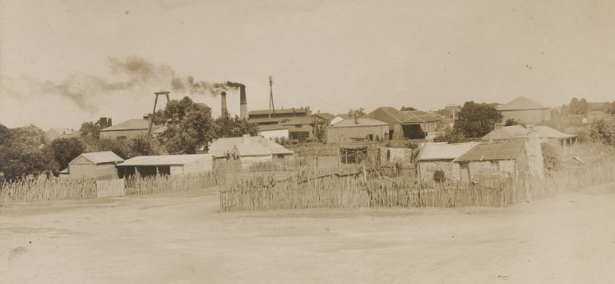  (SLSA B-48281) 1900, Miners’ homes
- Low, two-roomed, symmetrical cottages, vernacular in nature, modest in scale and consistent in proportion. Community and company ‘landmark’ buildings with higher ceilings and steeper roofs punctuate the low-lying terrain. | 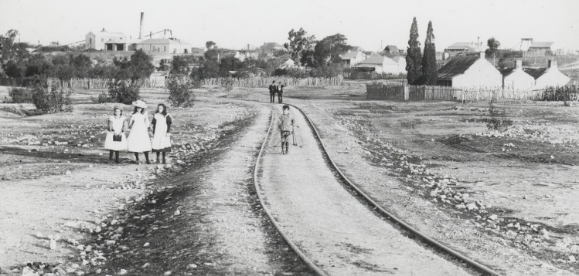  SLSA B-34846) 1895 Hamley Flat
- Double gable or double hipped roofs (35-45° pitch). Originally clad in wooden planks or shingles, later covered over with corrugated steel sheet. | 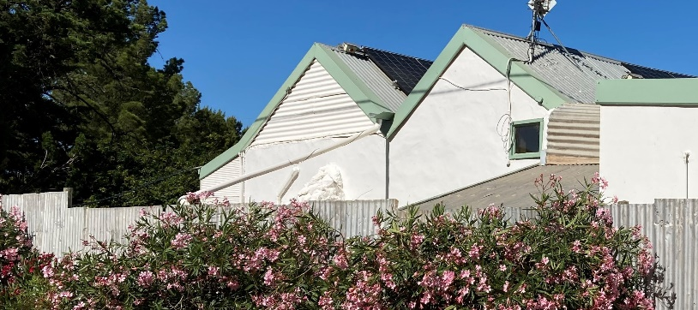
- Traditional, corrugated steel sheet, lean-to additions to rear sections of dwellings. Small, circular corrugated steel rainwater tanks. | 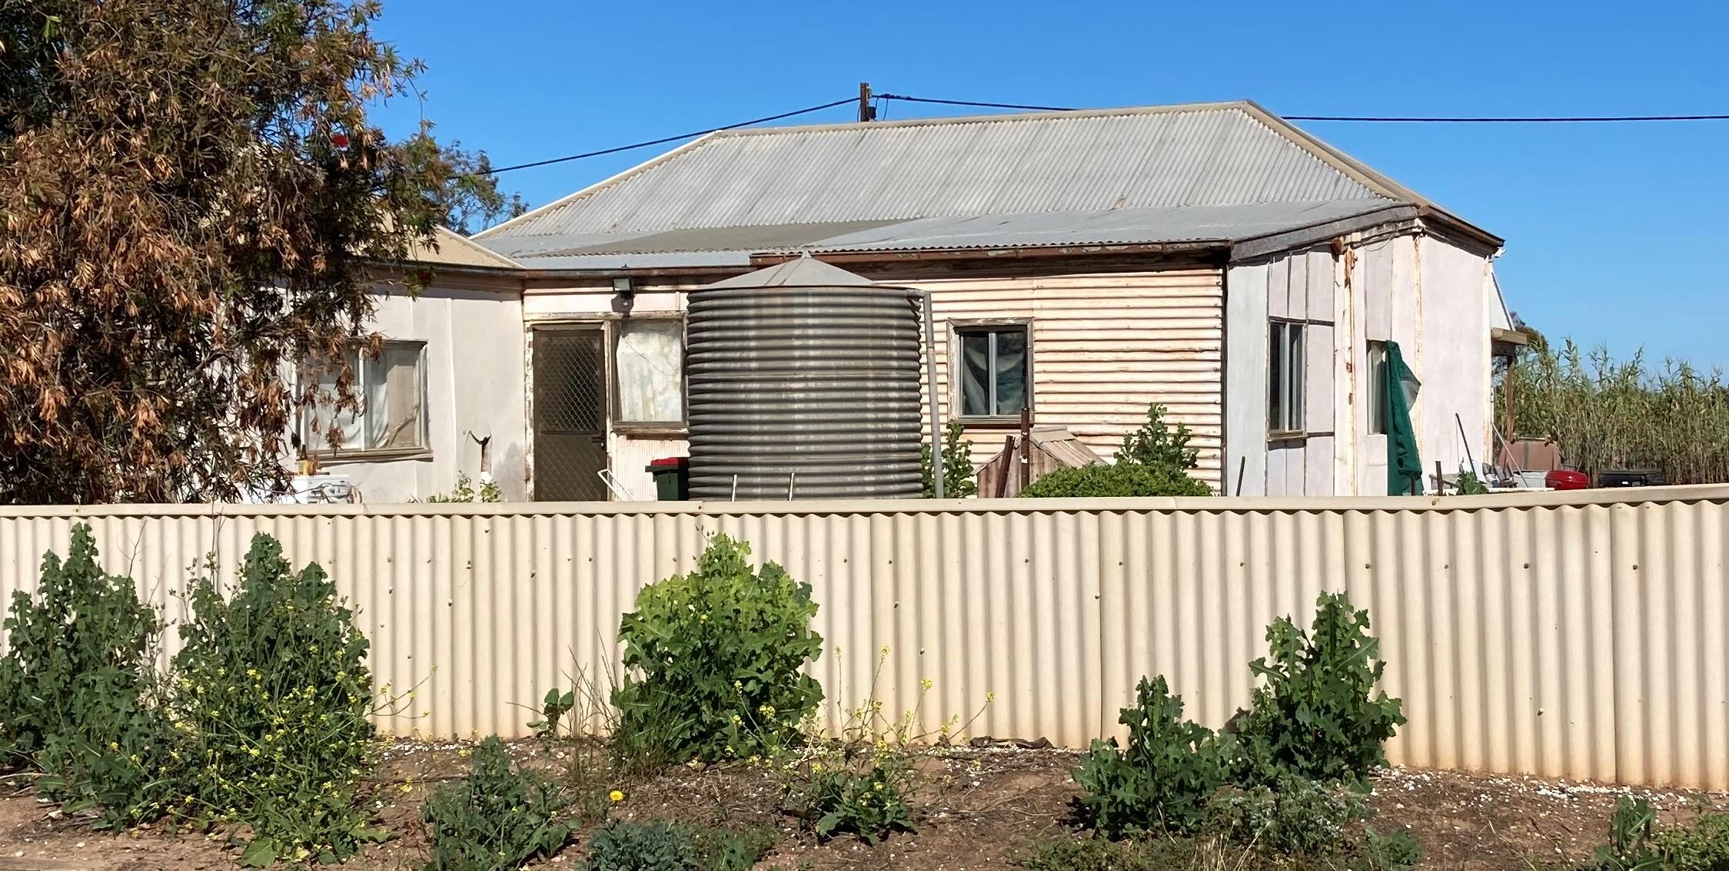
- Verandahs dominate. Concave or straight pitch, often integral with the roof slope, supported on plain timber posts with some use of timber or iron brackets. | 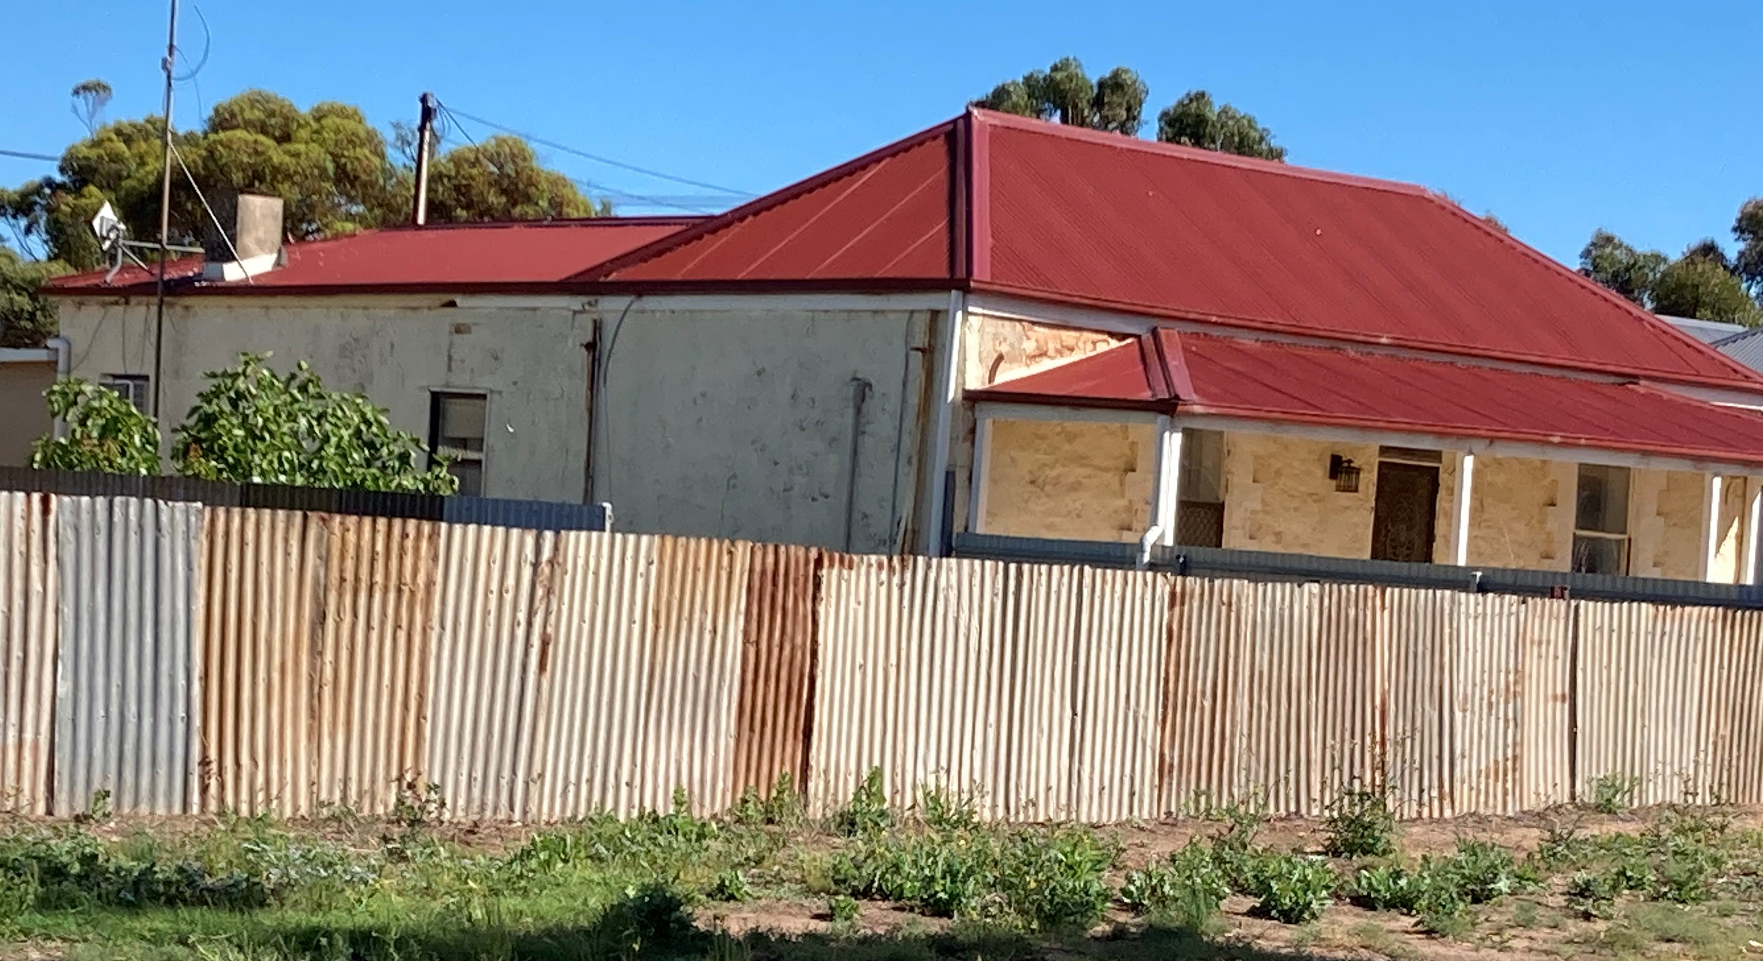
- Vertically proportioned openings. Timber double sash / casement windows of traditional 1:2 proportion. | 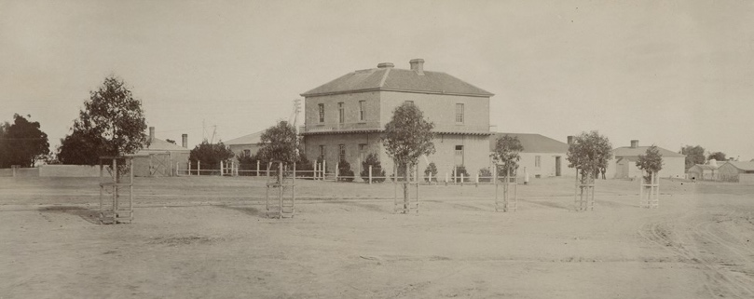  (SLSA B-12587_1) Mine Office, small opening-to-façade proportions, symmetrical arrangement.
- Town allotments were large enough to accommodate numerous outbuildings in rear yards. Freestanding sheds of smaller scale but traditional in form: gable or single pitched roofs, clad in corrugated steel sheet or timber boarding. | 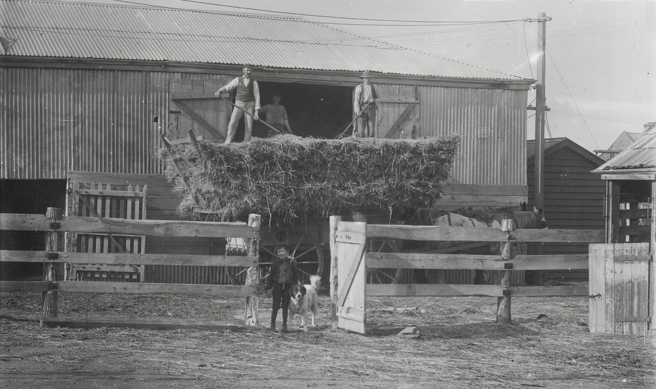  (SLSA B-34861_1) 1898, Moonta Mines Stables
- Open, low fencing styles, maintaining views through allotments, reinforcing the sense of a dispersed remnant community living in the centre of an abandoned industrial landscape. | 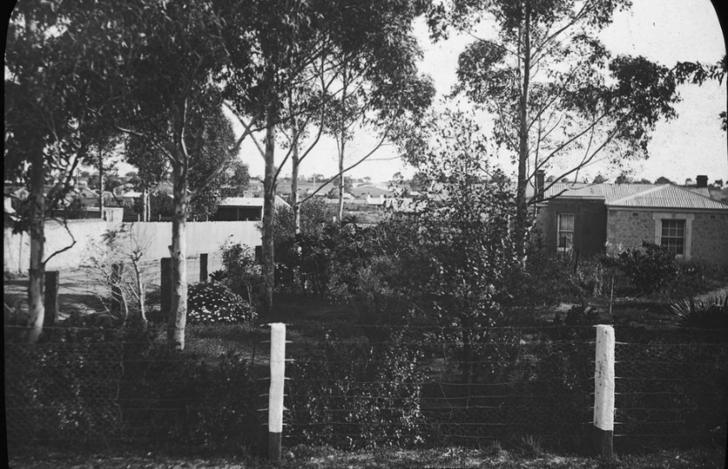  (SLSA B-72434-7) 1910, picket (background) and post & wire fencing to residential yards.
- Minimal advertising, way-finding and interpretation signage maintains the early authenticity of the site. | 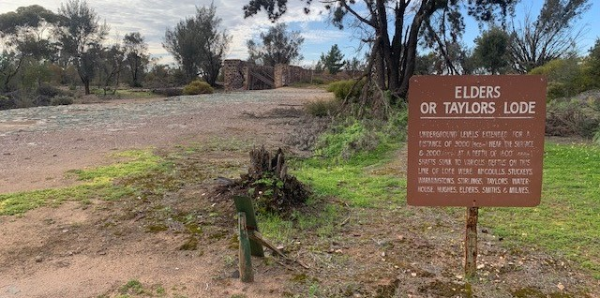
- Informal landscaping: minimal street planting, open gardens, unpaved footpaths and roads. | 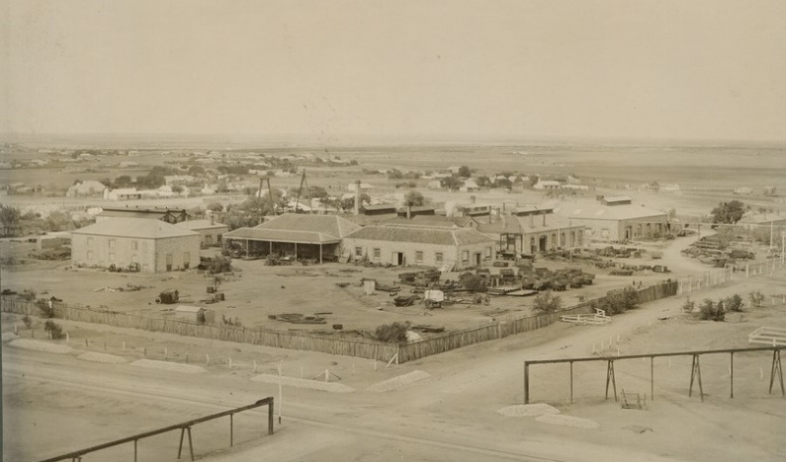  (SLSA B-12603_1) Maintenance Shops and yards

Heritage Standards for Development (Moonta Mines State Heritage Area)

Purpose of Heritage Standards for Development
Any proposals to undertake development within a State Heritage Area will be referred to the Minister responsible for administering the Heritage Places Act 1993, for heritage advice. Heritage South Australia (Heritage SA) in the Department for Environment and Water is the Minister’s delegate for decisions on referred development applications. Heritage SA also has the ability to direct conditions, should the development be approved, or to direct refusal if heritage values are compromised. The Heritage Standard forms a key part of Heritage SA’s assessment of development proposals.
Heritage Standards:
- provide a basis for assessment regarding management of heritage impact of development by Heritage SA Heritage Officers.
- include heritage principles and location specific detail on how development can be undertaken to ensure heritage values are protected
- propose a minimum acceptable standard for development related solutions within the State Heritage Area.
A State Heritage Area includes both private and public spaces (including streets) and the Heritage Standard is applicable to development across the entire State Heritage Area.
Development associated with a State Heritage Place and also within a State Heritage Area is defined in the Planning, Development and Infrastructure Act 2016 Part 1, 3 (1). Additional definition specific to a State Heritage Place or Area includes:
“ (e) …….—the demolition, removal, conversion, alteration or painting of, or addition to, the place, or any other work that could materially affect the heritage value of the place”.
The State Heritage Area Overlay ‘Procedural Matters (PM) Referrals’ – identifies the types of development to be referred to the Minister responsible for the Heritage Places Act 1993 - Heritage SA, for assessment and direction.
Exemptions to the definition of Development within a State Heritage Area are scheduled in the Planning, Development and Infrastructure (General) Regulations 2017 – Schedule 5
Development of a State Heritage Place, located within in a State Heritage Area, is governed by the State Heritage Place (SAPPA) Overlay. This Overlay requires approval for development of the interior and exterior of a State Heritage Place.
Moonta Mines State Heritage Area is to be conserved and interpreted as a place of historic and archaeological significance, demonstrating Cornish mining history in South Australia. Conservation and development is to be undertaken in order to preserve the character of the place and uphold its heritage values through:
- Retention of the original land subdivision pattern.
- Reinforcement of the mining village character with minimal infrastructure.
- Retention of significant views across the historic mining site and out towards to agricultural land.
- Retention and conservation of the buildings, structures and ruins of heritage value.
- Adaptation of existing buildings and structures to ensure their long-term conservation and viability.
- Unity of built form, with new buildings compatible in design and form to existing buildings of heritage value.
- Retention of the town’s landscape character.
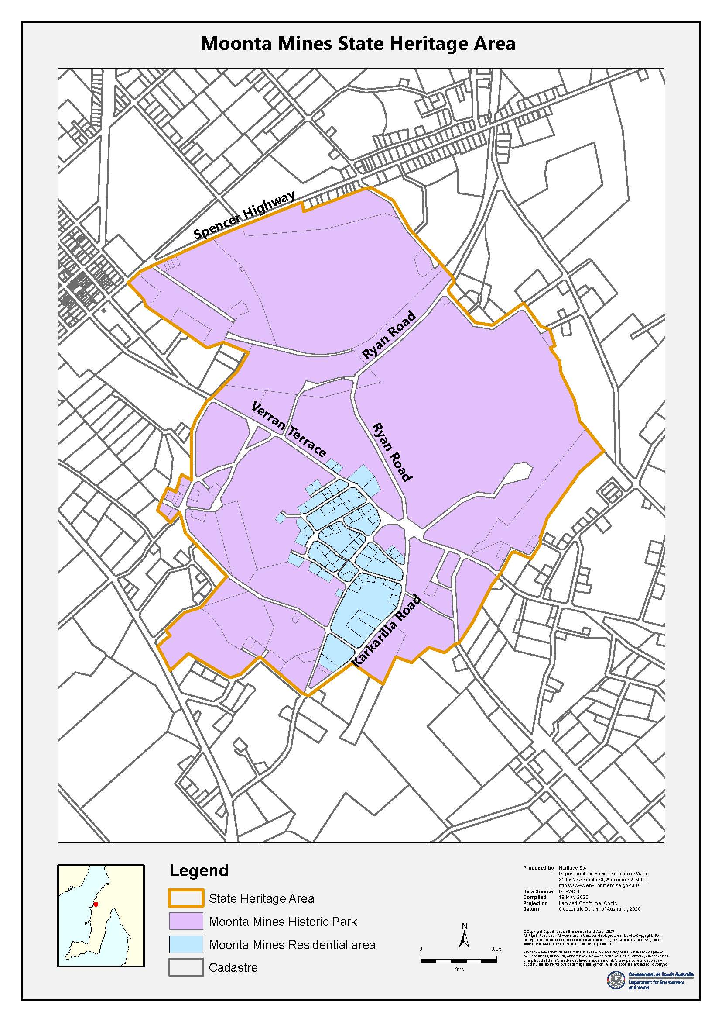

Land use
(refer: State Heritage Area Overlay – Alterations and Additions PO 2.2)
Following the closure of the principal mining operations in 1923, the town of Moonta survived and flourished as an agricultural commercial centre. Moonta Mines, instead, entered a period of decline. Development focussed on areas closer to the coast, west of Moonta, largely sparing Moonta Mines to the east. As a result, Moonta Mines retains evidence of its previous land use and a small community resides at the centre of an abandoned decaying industrial landscape, reclaimed by mallee scrubland.
Ownership of the Moonta historic mining sites is shared between Copper Coast Council and the Crown. Land management is delegated under annual license or lease agreements to the National Trust and individual land holders. Most surviving cottages have been converted to freehold and are now privately owned.
Commercial development is unacceptable unless it directly supports the management and operation of visitor services connected with the interpretation of the Moonta Mines State Heritage Area. Development of accommodation, visitor attractions and other facilities promoting accessibility to the area’s heritage is only acceptable if it does not adversely affect the significance of the area.

Principles | Acceptable Standard

3.2.1. Land Use
Land use in Moonta reflects its development history, with the Cornish model of settlement around mines and churches. Current land use illustrates the decline of the mining industry, and its subsequent replacement with the agricultural and tourism industries.
To help inform future land management, the character of specific ‘conservation areas’ has been defined in detail, based on former function or use. (see Moonta Mines State Heritage Area map outlining the Moonta Historic Park & Residential Area).
Development is to have regard to the following:
- Land use planning  The land use plan intent associated with the State Heritage Area is important in the understanding of Cornish mining and settlement history. | Development within the Historic Park area is restricted to conservation, interpretation and the sensitive adaptation of existing buildings and structures supporting tourism use.  The Residential area is retained as a private residential community with supporting, small-scale, commercial development.

New buildings
(refer: State Heritage Area Overlay - Built Form PO1.1 to 1.5)
The Moonta Mines State Heritage Area is to be conserved and developed as a Historic Park to enable the preservation, study and interpretation of its cultural significance. New development is to support this objective and is acceptable only where existing historic building stock is unable to appropriately accommodate a proposed use. Master Planning will identify acceptable locations for interpretation facilities ahead of need.
The Residential area contains a number of miners cottages which still retain their original character, in addition to some of the commercial and public buildings associated with the former mining community. The open nature of the built form character of the residential area is homogenous in scale, form and use of materials, demonstrating 19th Century Cornish building techniques and culture.
Adaptive re-use of historic buildings is encouraged.
New development is to be sited to maintain important views and vistas, safeguarding the visual dominance of the former mining site.
Existing development exhibiting undesirable variations to the desired built form character in a locality will not be used to justify additional change from the desired character of the locality.

Principles | Acceptable Standard

3.3.1. Siting of new buildings
Moonta Mines is open in spatial character, with most residential buildings set well within their site boundaries and aligned square to street frontages. New buildings to follow this pattern, adopting typical setbacks and alignments, protecting key views/vistas and retaining visual dominance of existing historic buildings in the locality.
Residential development, including garages, carports and verandahs, is to repeat the common site coverage of development on existing allotments.
New buildings are to have regard to the following:
- Street and side boundary setbacks  The continuity of streetscapes is largely undefined. Houses follow a random street pattern with variable setbacks, retaining open space between buildings.  Future development is to maintain the historic allotment layout characteristic of the Moonta Mines area, referencing existing adjacent development. | Dwellings: Front and side setbacks are to repeat existing setbacks on the allotment or in the surrounding area. No new construction should take place between the street boundary and front or side facades of existing buildings of heritage value.  Non-residential buildings: Development is to adopt site setbacks common to existing surrounding buildings of heritage value.

3.3.2. Form and design of new buildings
New development should complement the existing built aesthetic, maintaining consistency in form, scale and architectural features characteristic of the Moonta Mines area. A clear visual distinction between new development and existing buildings to be maintained.
New buildings are to have regard to the following:
- Scale  The prevailing scale of the historic cottages, some of which are partly set into the ground, is single storey, low, and modestly sized (30-60msq). Community and company buildings are larger in scale, with higher ceilings and steeper roofs, reflecting their landmark importance.  New development should be of a similar size and proportion to established built form. The scale and bulk of new work should not dominate the old. | Dwellings: Residential development is to be low and vernacular, adopting small, rectangular floorplans. For larger building footprints, a grouped arrangement of small building elements reduces bulk by maintaining the short roof spans characteristic of the area.  Single or double gable/hipped roofs with verandahs and lean-to extensions are characteristic of the Moonta Mines Residential area.  Wall, eaves and ridge heights are to match those in the locality, with modestly-scaled facades (10-12metres length). Where possible, the natural slope of the ground can be used to gain additional ceiling height.  Non-residential buildings: The scale and bulk of new buildings should not visually dominate existing structures of heritage value.
- Roof form and pitch  Roofs in Moonta Mines are typically steeply-pitched (35-45⁰), simple or parapet gable-ended, or slightly lower-pitched, simple hipped, without eaves. Verandah and lean-to / skillion roof additions are a gentler pitch, often integral with the main roof.  Outbuildings are smaller versions of these basic forms, or have simple, low, mono-pitched roofs. | Dwellings: Roof forms and eaves profiles are to match traditional styles characteristic of the Moonta Mines area. New roofs to reflect the incremental extension of historic houses - adopting a grouping of smaller, steeply-pitched gables or hipped roofs to reduce building mass, and incorporating simple verandahs to front facades and lean-tos to rear.  Non-residential buildings: New development should reflect roof form and pitch in the area, maintaining a subservient scale to existing buildings of heritage value.
- Façade proportions  Design of buildings is consistent and vernacular in style, with double-fronted and side facades punctuated by small, vertical openings and massive buttressed chimneys. | New buildings are to complement the traditional proportions and architectural features of existing buildings. Street-facing door and window openings are to be vertically proportioned and modestly sized so as not to dominate the façade.
- Verandahs and Lean-tos  Verandahs typical of Moonta Mines are straight-sloped or concave, at a shallower pitch, often integral with the main roof. Supported on plain timber posts, with some use of timber or iron brackets. Lean-to extensions are smaller in scale to the main building structure. | Verandahs and lean-tos are modest in scale and simple in design. Where removed or altered, verandahs are to be reinstated to original, or otherwise appropriate, form and detailing.
3.3.3. Materials, finishes and colours  The architectural features of 1862-1923 Moonta Mines are of heritage value, illustrating the success and subsequent decline of the copper mining industry, and the transfer of Cornish mining technology, construction techniques and culture.  Early dwellings in Moonta Mines are constructed of wattle and pug, or pug and limestone (loose paddock calcrete), often limewashed, with some brick detailing to quoins and openings. Original roofs, clad in wooden planks or shingle palings, are covered-over in corrugated, galvanised steel. More substantial community & company buildings are constructed from cream-coloured fossiliferous limestone. | New development is to have regard to Accepted Materials, Finishes and Colours as scheduled in: (Alterations and Additions) 3.4.3 Materials, finishes and colours, incorporating those common to the era of heritage value of the State Heritage Area.

Alterations and additions
(refer: State Heritage Area Overlay - PO 2.1-2.2)
Additions and alterations are acceptable, provided they do not visually dominate existing buildings or the surrounding landscape of heritage value. Any addition or alteration should complement the established building, without attempting to imitate architectural features, maintaining a clearly legible pattern of development.

Principles | Acceptable Standard

3.4.1. Site and location of additions
Development should maintain the open, unplanned nature of the 1862-1923 Moonta Mines State Heritage Area. Key views/vistas are to be protected.
Development is to have regard to the following:
- Street and side boundary setbacks  Development is to repeat site setbacks common to existing surrounding development. Additions and alterations to retain a sense of space between buildings, maintaining historic allotment layouts characteristic of the 1862-1923 Moonta Mines area. | Dwellings: Additions to be located to rear of existing dwellings matching building width, or to one side of existing dwellings (unless on a secondary street boundary).  Additions to the side of existing dwellings are only acceptable where the shape and space available on an irregular allotment precludes rear additions. In these cases, additions to the side are to be set back from the existing front façade by at least 4 metres, and set back a minimum of 1.5 metres from any point along a side boundary. If the existing building is located less than 1.5 metres off the side boundary, additions can match this alignment, subject to approval.  Non Residential buildings: Development is to repeat the site setbacks common to existing surrounding development.

3.4.2. Design of additions
The consistency in form, scale and architectural features of existing buildings in Moonta Mines is of heritage value, demonstrating Cornish building techniques and culture. Additions are to complement existing building form, maintaining a clear distinction between old and new.
Development is to have regard to the following:
- Scale  The Moonta Mines Residential area is consistently single storey in scale. Community buildings, such as schools and churches, are larger, reflecting their landmark importance.  The proportion of additions is to complement existing built form. The scale and bulk of new work should not dominate the old. | Dwellings: Additions should not have a floor area greater than the existing building. Additions are to be designed so that the scale of the original dwelling is still obvious. A break in the roof line between dwelling and addition is required.  Additions to be single storey in height, matching the eaves height of the original dwelling.  To complement existing built form and composition, larger additions can be designed as a group of smaller units, referencing the historic, incremental expansion of the original, modestly-scaled cottages. Where possible, the natural slope of the ground can be used to add ceiling height.  Non-residential buildings: The scale of additions is to respect existing mass and height without dominating the old.
- Roof form and pitch  Established dwellings maintain an overall consistency in roof form (typically a grouping of gable or hipped roofs, reflecting incremental expansion of the original two-roomed cottages), are steeply pitched (35-45 degrees), without eaves.  Lean-to additions and verandahs are a gentler pitch, often integral with the main roof, responding to lower ceiling heights. Roofs, other than attached skillion, are generally 1:3 and 1:4 in rise to the horizontal distance.  Barge and fascia boards are fixed against walls. Overhanging or extended eaves (at gable ends) are inappropriate. | Roof form, pitch, span, ridge height, eaves detail and cladding of additions to match/complement existing building of heritage value. Additions are to maintain legibility of original roof form. A break in the roofline between established building and addition is required.  Verandahs to be simple-sloped structures supported by timber posts.  New chimneys to be massive, partially or wholly external, and attached to the gable or hipped roof. Chimneys to existing roofs are to remain and not be removed when roof cladding is updated.
- Façade proportions  Small, vertically proportioned doors and windows to symmetrical facades of two-roomed cottages are typical of 1862-1923 Moonta Mines. Building proportions are consistently 2/3 wall to 1/3 roof. Early extensions, doubling the original footprint, were added to the rear of buildings presenting as double hip or gable. | Additions to buildings are to complement the built form proportions of existing buildings of heritage value. New window and door openings visible from the public realm should not visually dominate and be similar in proportion and extent. Plate glass walls and ‘patio’ doors are not acceptable where visible from the public realm.
- Alterations to original building features  The overall consistency in architectural features to buildings associated with the 1862-1923 period buildings in Moonta Mines are of heritage value. Where inappropriate alterations have been undertaken in the past, reconstruction of the original known form is appropriate. | Refer [3.10 Conservation Works] for further details.  Exposed masonry walls are to be retained and not painted or render-finished. Painted external walls to be maintained using traditional paint systems.  Façade features and detailing, including windows and doors, verandahs and lean-tos, to be retained in the original configuration and material. Front verandahs to remain unenclosed.  Where original façade features have been removed or altered and evidence is unclear, reinstatement is to match detailing of similar, nearby buildings of heritage value.

3.4.3. Materials, finishes and colours
Buildings constructed before the closure of the mines are generally consistent in design, typically including limestone or stone & pug with brick detailing; wattle & pug; galvanised, corrugated steel sheet or wooden planks for walls and roofs; timber doors and double-hung sash windows with substantial frame profiles.
New development to be undertaken using materials which complement those used in adjacent buildings of heritage value.
External walls of houses were often lime/whitewashed. Use of raw timber for verandah structures was also common. Where painting is appropriate, colours should follow muted earth tones of the mid-Victorian palette.

The design of alterations and additions is to have regard to the following: | Acceptable | Not supported (where visible from street/public space)
- Roofing and rainwater goods (new)  Where evidence of an original gutter profile exists this should be reinstated. | - deep profile, corrugated, galvanised steel sheet  - Galvanised ‘ogee’, & ‘half round’ profile gutters; round metal downpipes.  - scribed roof cappings  - ‘colonial’ rainwater heads unless originals remain | - metal sheeting profiles other than traditional corrugated  - zincalume / Colorbond finish;  - PVC, zinclaume / Colorbond gutters & downpipes.  - square profile gutters & downpipes.  - roof tiles.
- Exterior walls (new)  Note: existing face stone/ brick external walls to original dwellings to not be rendered or painted. | - Stone with stone or brick quoins to match existing  - deep profile corrugated (short lengths on listed buildings), galvanised steel sheet; Colorbond metal sheet in stone/mid grey tones.  - natural/limewashed (white or stone colour) render; limewashed stone.  - painted timber weatherboard, (19mm min. thickness, profile to match traditional). | - square profile steel sheeting  - zincalume or Colorbond metal sheet in colours/tones inappropriate to historic examples, incl. very light or very dark tones  - brick walling  - concrete blocks  - fibre cement sheeting  - cement render  - stone veneer facing.  - stone construction not in keeping with traditional style or materials.  - painting of unpainted masonry  - unpainted/exposed timber  - vertical weatherboard
- Proposed external doors and windows in view of the street | - simple, timber-framed doors (vertical boards, ledged & braced or recessed four panel style).  - Timber (woven) flywire screen doors.  - timber framed windows, vertically proportioned (double-hung sash or casement), multi-paned to match original.  - timber shutters to match original detailing of heritage value. | - sliding doors/windows  - decorative aluminium screen/security doors.  - aluminium-framed doors and windows.  - horizontally proportioned and/or large windows.
- Exterior painting  Colour schemes should be appropriate to the historic period of construction.  Stripping of historically painted timber and painting of unpainted external surfaces to existing buildings is not appropriate. | - Painting of additions is not deemed development, but compatible colours are encouraged.
- Verandahs | - Simple, dressed, timber posts (110-120mm square); native pine if available.  - simple timber or iron brackets where evidence of existing original.  - flagstone, timber board, natural ground verandah floors. | - finials and cast iron lace work.  - decorative timber posts.  - steel or concrete posts.  - post shoes.  - tiled verandah floors.
- fencing | - refer 3.5.2 Fences and Gates
- Ancillary development | - Refer 3.5 Ancillary development

Ancillary development
(refer: State Heritage Area Overlay - PO3.1-3.4) – garages, carports, sheds, verandahs, solar panels, signage, fences
Ancillary development in Moonta Mines includes: carports, garages and sheds; studios, offices and dependent accommodation; fences and gates; signage; solar panels, rainwater tanks and other ancillary services. While such development is of a secondary nature, it may still have an adverse impact on the heritage value of the State Heritage Area if not managed appropriately.

Principles | Acceptable Standard
    - Outbuildings (carports, garages and sheds, studios, offices and dependent accommodation).
Outbuildings contribute to the built form heritage values of Moonta Mines.
Existing outbuildings in Moonta Mines are typically smaller, freestanding versions of the 1862-1923 buildings: rectilinear in plan, with short-span, steeply pitched, gabled, hipped or low-pitch skillion (mono-pitch) roof forms.
Development is to have regard to the following:
- Outbuildings: carports, garages & garden sheds; studios, offices and dependent accommodation.  New outbuildings complement the architectural language of existing buildings of heritage value. The scale and bulk of these structures do not dominate existing buildings.  Outbuildings are located to avoid adverse visual impact on the setting of buildings of heritage value. Outbuildings are free-standing and located to the rear of existing buildings, well set back from the street, to maintain the visually open nature of allotments and streetscapes in Moonta Mines. Key views and vistas are to be protected - refer 3.7.1.(d) | Outbuildings are to be freestanding and sited behind existing buildings.  Outbuildings to be rectilinear in floor plan and constructed of stone, stone-coloured render, weatherboard or corrugated steel sheeting in galvanised finish.  Roofs to be steeply pitched (35-40 degrees), gabled or hipped, of modest ridge-to-eaves length (max. 2m), without overhanging eaves, similar to associated dwellings. Small-scale skillion roofs are acceptable where not in view from the street. The scale of any proposed larger building footprint is to be broken down into a number of connected roof elements.  Double car-width roll-up doors are acceptable only where not visible from the public realm.
- Pergolas and garden structures  Garden structures to be located to the rear of properties, away from street view. | Freestanding or attached pergolas are sited to the rear of the building, and in a location to not visually dominate views of the heritage streetscape from the public realm.
- Fences and gates  Early fencing styles contribute to the heritage character of Moonta Mines. Low, open, minimal fencing reinforces the rural nature of the area.  Original fences include simple timber stick & post (2.5cm diam. tea tree stakes woven between wire), timber-framed picket, timber post & rail or post & wire fencing. Timber paling, corrugated steel sheet and stone wall fencing is less typical. Solid fencing styles are inconsistent with the heritage values of Moonta Mines. | New fencing to reflect palette of materials evidenced in historic photographs, without compromising the open character of Moonta Mines.  Fencing to property boundaries to follow informality of post & wire, post & rail and open timber picket fencing, reinforcing the heritage character of the area.  Although some corrugated steel sheet fencing exists, it is inappropriate to the historic character of Moonta Mines.  Reconstruction of damaged or demolished stone walls using traditional materials and methods is appropriate.
- Fences and gates (replacement or new) | Location | Accepted
 | - Dwellings
Open fencing styles, including timber pickets and gates on timber frames, timber post & wire or timber post & rail. | - Boundary A shown below | Simple timber stick/stake or picket fence & gate, not higher than 1.2m; post & rail / post & wire fence; Reconstructed stone walls based on historic evidence.
 | - Boundary B shown below | Simple timber stick or picket, post & rail / post & wire fence, not higher than 1.2m; timber paling or deep profile corrugated galvanised steel sheet (vertical orientation) on timber frame - taper height to Boundary A fence.
 | - Boundary C as shown below, and other adjoining property boundaries | Simple post & rail; post & wire fence, timber picket fence, not higher than 1.2m;  Timber paling or corrugated galvanised steel sheet (vertical orientation) on timber frame, no higher than 1.5m.
 | 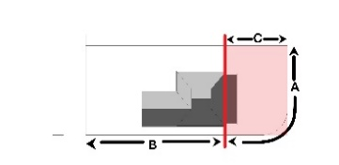
 | - Public Buildings | Unfenced, or reinstatement of historic fencing, based on evidence.
 | - Former Mine Sites | Unfenced, or security / safety fencing (e.g. around mine shafts) to be open in style and consistent across site, ideally designed as part of the overall site re-presentation.
- Signage  A distinguishing feature of Moonta Mines is an absence of signage, including street signs. Signage to be minimal, small and of a low profile within the landscape.  Signage to be designed and sited to avoid negatively impacting on views, vistas and visual amenity of the place. | All signs in the Moonta State Heritage Area require development approval.
- Advertising signage  New signs should be compatible with the setting, scale and character of the immediate area. | Signage to not conceal or obstruct historic detailing, project beyond the building silhouette or skyline, or otherwise form the dominant visual element of a place.  Signs are to not be more than one square metre in area; contain internal illumination or neon lighting. Permanent LED screen type signs are not acceptable. Sign design to be based on a heritage range of external colours appropriate to the era. Corporate colour signage is not acceptable.  Commercial (office / retail) signage is to be restricted to traditional signage panel locations below roof level, such as parapet walls above verandahs, verandah fascias and infill end panels, hung from below verandah fascias and painted on shop windows.  Community Buildings: Signs for public, school and religious buildings to be small and free-standing, sited so as not to intrude on the landscape setting of the place.
- Directional & Interpretive signage – within the Moonta Mines Historic Park area  Interpretative and directional signage to be informed by a site-wide signage strategy, facilitating design consistency and dual-purpose functionality. | Interpretive signage to be located inside or fixed onto structures to avoid cluttering the landscape. External, free-standing signs are acceptable where visual impact on setting and views is minimal, or when signage references the landscape (e.g. historic photographic angles).
    - Services
- Solar Panels  Solar panels provide environmental benefits. Adverse visual impact is negated if panels are placed out of view of public streets/areas. Key views/vistas are also a consideration. | Solar panels are to be:  - Located on roof planes not visible from the public realm and sited below the ridge.  - Located on sheds, carports, garages, rear verandahs provided they are not visible from the public realm.  If no other mounting location is possible, roof mounted solar panels on the side of a roof must be:  - located at least 4 metres behind the front of the roof (but not on a corner site)  - located as far as practical on the lower part of the roof,  - arranged in a symmetrical group (not staggered) with a margin of visible roof edge around the group.  - Black framed solar panels  Sundry cabling, conduits, batteries and inverters should not visible from the public realm.
- Skylights | New or replacement skylights are to be low profile and located out of view of the public realm. Skylights on street facades are not acceptable.
- Rainwater tanks  Traditionally, rainwater tanks in Moonta were circular in plan, small in size and fabricated from corrugated galvanised iron.  Rainwater tanks were an original feature common throughout Moonta. | Rainwater tanks are to be located underground or to the rear of properties to avoid adverse visual impact on the public realm.  Above-ground tanks to be corrugated, circular, metal tanks of modest size in galvanised or Colorbond finish (mid grey tones). Where required, clusters of small tanks to be used rather than a single large tank.  Large, galvanised, corrugated steel tanks are acceptable where capacity is required for firefighting purposes.
- Plant and ancillary equipment | Hot water units, water pumps and effluent systems are to be located to the rear of properties, underground or otherwise concealed by vegetation or small sheds.  Air conditioners are not to be located on street façades and external air handing units are screened from view of the public realm. Roof-mounted evaporative units are located on rear roof planes and coloured to match roof sheeting.  Use of through-wall or window-mounted units on historic properties is not appropriate. Service runs to be concealed internally or run externally in circular, painted metal conduits along the most efficient route. Chasing of walls is to be avoided.
- Antennae, satellite dishes, windmills | Antennae and satellite equipment to be located out of view of the public realm.  Windmills / wind generators to be simply designed, of timber or steel construction.

Land division
(refer: State Heritage Area Overlay - PO4.1)
Land division refers to boundary adjustments and sub-division of allotments within the State Heritage Area. The division of land is to reinstate or maintain the original subdivision layout of Moonta Mines.
Cornish miners and their families initially settled on mining leases in residential clusters around the workings. In the mid.1860’s the Moonta Mining Company surveyed ‘occupation blocks’, designating rectilinear residential areas, but these were largely ignored in favour of established community settlement patterns which gave cottages a substantial curtilage for stables and outbuildings. Settlements, focussed around religious and other public buildings, were quickly surrounded by the industrial infrastructure of expanding mining activities.
The remnant land division pattern at Moonta Mines provides a record of the Cornish settlement and mining layout. Existing land boundaries are to be retained, unless subdivision or amalgamation of titles is of advantage to the conservation of an historic site. Land division to facilitate new housing development is only acceptable where it restores a historic subdivision pattern.
Principles | Acceptable Standard
    - Land division characteristics
The Moonta Mines residential area illustrates the Cornish village settlement pattern of cottages sprawled unplanned along mineral lodes, forming bands through the site, punctuated by the landmark buildings of mining industry and Cornish community.
Development is to have regard to the following:
- Land division  The established pattern of allotment size and orientation is to be maintained. | Any division of land or adjustment of boundaries should only reinstate or maintain the historic land division layouts of the 1862-1923 Moonta Mines area.  Subdivision and amalgamation of land is inappropriate unless it supports the conservation of historic sites and structures.  Subdivision of existing allotments to create additional allotments is not acceptable unless it can be established that the boundary alignment previously existed.  Boundary adjustments to remedy boundary anomalies are acceptable where they are of a minor nature.

Landscape context and streetscape amenity
(refer: State Heritage Area Overlay - PO5.1)
The landscape character of Moonta Mines is a key part of its heritage value.
Low site topography maintains visibility of above-ground relics, dominated by the tailings heaps and pumphouse ruins, set within a landscape of regenerated scrubland. Low-lying ruins and cottages are now almost completely obscured by vegetation and the loss of key visual connections between mining activities makes interpretation difficult. New roads have further compromised legibility of historic movement patterns, and poorly defined vehicular routes negatively impact on the physical integrity and setting of the place.

Principles | Acceptable Standard
- Landscape character  The landscape character of Moonta Mines illustrates the historic development of mining activities along north/south-oriented mineral lodes. Surviving is an informal road network linking remnant dwellings and community buildings, surrounded by the ruins of an industrial landscape, visually dominated by tailings heaps.  Although revegetation of the mallee scrubland contributes to the area’s abandoned character, it is not characteristic of the historic mining landscape, obscuring low-lying ruins and visual connections between historic mining activities.  The public realm is distinguished by the absence of street amenities such as parking bays, kerbs and guttering. Maintaining minimal infrastructure on public land reinforces the character of a historic rural settlement.  Development is to have regard to the following: | Actions involving the replacement or upgrade of public realm features by a local council are typically not defined as development. These actions are, nevertheless, not exempt from the definition of development in a State Heritage Area. Early discussion between Heritage South Australia and the Copper Coast Council is required to confirm if works materially affect heritage values. Where they are likely to affect heritage values, development approval is required.  Other non-statutory documentation such as Conservation Management Plans may provide guidance as part of Heritage South Australia advice.
- Visual Setting | Visual setting of Moonta Mines to be protected: Remnant village of low-profile cottages and larger community buildings, set within the ruins of an industrial, revegetated landscape, surrounded by agricultural land.
- Historic Routes | Historic routes through the area are to be protected. Conservation of existing and restoration of lost historic routes is appropriate.  Future walking/cycling/rail routes to be developed following historic movement patterns to avoid traversing fragile fabric. Introduction of new routes is to be avoided except where required for safety, conservation or interpretation of historic boundaries. Closing existing routes which compromise the legibility of historic road patterns, or the conservation of significant fabric, is appropriate.
- Views and Vistas | Views and Vistas along Elders Main Lode, to and from the tailings heaps, and towards Moonta Mines Uniting Church at the centre of the site, to be maintained and enhanced. Views along the northern approach towards Moonta Railway Station to be protected and restored where possible. New development to be sited to avoid compromising legibility of visual connections associated with historic mining activity. Use of fencing and vegetation to screen existing intrusive development is appropriate.
- Street Typology | Unstructured street typology is to be retained, illustrating a haphazard pattern of roadways originating from the unplanned village layout. Straightening historically winding streets or formalising with concrete kerbing is inappropriate.  Unsealed road surfaces and footpaths are to be retained in preference to paving and hard (bitumen) surfacing.
- Services and infrastructure | Services, pathways, visitor facilities and infrastructure (roads & carparks) to be designed and sited to facilitate legibility of historically significant visual connections, without compromising the setting of individual places or disturbing archaeological remains / underground features. Stormwater to be diverted away from significant fabric, including sites of potential archaeological importance.
- Roads and Footpaths | Informal, unsealed public paths, private driveways and garden paths are appropriate.
- Vegetation | Non-indigenous plantings are not appropriate. Selective clearance of vegetation where it compromises public safety, preservation of surviving mining infrastructure, views or legibility of historic site connections is appropriate. Stands of Sugar Gums, planted on the northern road reserve, contribute to the heritage value and sense of arrival - to be preserved and enhanced.
- Interpretation | Interpretation is currently structured around vehicular movement across the site. Future development is to be sited to support walking/cycling/rail trails along historic routes.

Demolition
(refer: State Heritage Area Overlay - PO6.1)
Demolition of features of identified heritage value - buildings, structures, public realm elements, is not acceptable.

Principles | Acceptable Standard
    - Demolition
The form, scale and architectural features of existing buildings, structures and landscape features within Moonta Mines are of heritage value.
Considerable remnants of the mining venture remain. Surviving fabric provides tangible evidence of aspects of copper mining and processing.
Development is to have regard to the following:
- Demolition of complete buildings / structures | Demolition of buildings or structures erected before 1923 is not acceptable. Demolition of later structures is subject to PDI Act State Heritage Area Overlay Performance Outcome 6.1.
- Demolition of outbuildings, dwelling additions and limited building fabric as part of development proposals | Demolition of post 1923 building fabric, is acceptable, subject to confirmation that removal does not adversely impact on the heritage values of the State Heritage Area - PDI Act State Heritage Area Overlay Performance Outcome 6.1.
- Demolition of Public realm infrastructure | Demolition and replacement of public realm infrastructure is acceptable where heritage values are not compromised.
- Demolition of mining remains | Demolition of ruins / remains of mining activities is not acceptable and is subject to PDI Act State Heritage Area Overlay Performance Outcome 6.1.

Conservation works
(refer: State Heritage Area Overlay - PO7.1)
Built fabric of heritage value at Moonta Mines survives in various states of repair or ruination, ranging from sites with little remaining above-ground evidence, to relatively intact engine houses.
Conservation work to repair and maintain building fabric of heritage value is a development matter and getting the right advice is important, to save time, cost and to ensure the ongoing and appropriate management of buildings and sites.

Principles | Acceptable Standard
    - Conservation approach
Significant building fabric of existing buildings and structures of heritage value within the Moonta Mines Heritage Area is to be conserved and maintained.
Correct repair methods ensure the ongoing preservation of built fabric. The aim is to only repair as much as needed, avoiding conjectural reinstatement. Conservation works are to respect the historic layering of individual buildings, structures, and ruins.
The ruins contained within the Moonta Mines State Heritage Area are to be retained and conserved. New structures designed to protect ruins are not to adversely impact on the heritage values. Reconstruction of ruinous structures is not supported as it compromises the authenticity of the place.
The following conservation works are deemed ‘development’:
- Roof, guttering and verandah repairs  - Chimney repairs – stabilisation, repointing  - Structural stabilisation  - External wall repairs and repointing/ rendering  - External timber repair  - Rising / falling damp repair  - Removal of paint finishes from external masonry surfaces and original timber/metal surfaces.  - Repairs to historic fences.  - Repair/stabilisation of ruins | Seek the advice of a Heritage South Australia heritage officer before undertaking conservation repairs to dilapidated building fabric.  Works that could materially affect the heritage values of a place within a State Heritage Area require Development Approval (PDI Act). Works exempt from approval are listed as exclusions in PDI Regulations, Schedule 5.  The Relevant Authority (Copper Coast Council), in conjunction with Heritage SA, can provide advice confirming if works require Development Approval.

Different spellings have been adopted by the Narungga Nation Native Title Claim and the Nharangga Aboriginal Progress Association Inc (NAPA). The NAPA website (https://www.napainc.com.au/) explains that the spelling Nharangga was adopted during community language recovery workshops to best replicate the sound spoken traditionally. NAPA always uses the traditional spelling when referring to people, language, culture or Country.
Skye Krichauff, “Yorke Peninsula: Rethinking Narungga responses to Europeans and colonialism” in Peggy Brock and Tom Gara, Colonialism and its Aftermath: a history of Aboriginal South Australia (2017) Mile End SA: Wakefield Press p. 177
Skye Krichauff, “Yorke Peninsula” p. 177
Skye Krichauff, “Yorke Peninsula” p. 177
Skye Krichauff, “Yorke Peninsula” p. 189
Swanbury Penglase, Australian Cornish Mining Sites: Moonta Conservation Management Plan (May 2020 ref 19127) p. 19
Skye Krichauff, “Yorke Peninsula” p. 184
Skye Krichauff, “Yorke Peninsula” pp. 184-186
Skye Krichauff, “Yorke Peninsula” pp.186
Skye Krichauff, “Yorke Peninsula” p. 185
Skye Krichauff, “Yorke Peninsula” p. 190
Skye Krichauff, “Yorke Peninsula” p. 188
Swanbury Penglase, Australian Cornish Mining Sites: Moonta p. 21
Swanbury Penglase, Australian Cornish Mining Sites: Moonta p. 15
Swanbury Penglase, Australian Cornish Mining Sites: Burra Conservation Management Plan (March 2021 ref 18188) p. 16
Swanbury Penglase, Australian Cornish Mining Sites: Burra p. 16
Swanbury Penglase, Australian Cornish Mining Sites: Moonta p. 21
Masao Yamanaka, “Tribute System and Cost Book Principle: South Australian Copper Mining Business in Mid-Nineteenth Century” in Otemon Economic Studies 19 (1985) pp. 8-9
Masao Yamanaka, “Tribute System and Cost Book Principle”
G. J. Drew and J. E. Connell, Cornish Beam Engines in South Australian mines (Special Publication No. 9) (1993) Adelaide SA: Department of Mines and Energy of South Australia pp. 13-15
G. J. Drew and J. E. Connell, Cornish Beam Engines pp. 21-27, 37-51
Sean M. Gohman, Cornish-Periphery Analysis: Contextualising invention, innovation and the diffusion of technological practice in the mid-nineteenth century copper mining districts of South Australia and Michigan (2012) p. 7
Swanbury Penglase, Australian Cornish Mining Sites: Moonta p. 16
Jim Faull, “The Cornish miner in South Australia” in Jonathan Shelby (ed) South Australia’s Mining Heritage (Special Publication No. 7) (1987) Adelaide SA: Department of Mines and Energy South Australia/Australian Institute of Mining and Metallurgy p. 139
Sean M. Gohman, Cornish-Periphery Analysis p. 7
Swanbury Penglase, Australian Cornish Mining Sites: Burra p. 45
Swanbury Penglase, Australian Cornish Mining Sites: Burra p. 21
Swanbury Penglase, Australian Cornish Mining Sites: Burra p. 45
Peter Bell, “Copper Industry” in Adelaidia https://adelaidia.history.sa.gov.au/subjects/copper-industry accessed 19 May 2022
Jim Faull, “The Cornish Miner in South Australia” p. 141
Weidenhofer Architects, Yorke Peninsula Heritage Survey (1997) pp. 10-12
Swanbury Penglase, Australian Cornish Mining Sites: Moonta p. 18
Moonta Mines State Heritage Area Draft Management Plan (1985) p. 3
Oswald Pryor, Australia’s Little Cornwall (1973) Adelaide SA: Rigby p. 26
Ian Auhl, The Story of the ‘Monster Mine’: The Burra Burra Mine and its Townships 1845-1877 (1986) Burra SA: District Council of Burra Burra p. 31
Swanbury Penglase, Australian Cornish Mining Sites: Moonta p. 18
Drew, Greg J., Discovering Historic Moonta: South Australia, (Adelaide: District Council of the Copper Coast, 2019), p4. cited in Swanbury Penglase, Australian Cornish Mining Sites: Moonta p. 19
While the locality was known as Tiparra the mineral leases were named the Tipara Mineral Leases.
Oswald Pryor, Australia’s Little Cornwall pp. 25-31
Draft Management Plan 1985 p. 3
Swanbury Penglase, Australian Cornish Mining Sites: Moonta p. 19
Swanbury Penglase, Australian Cornish Mining Sites: Moonta p. 19
Swanbury Penglase, Australian Cornish Mining Sites: Moonta p. 13
Swanbury Penglase, Australian Cornish Mining Sites: Moonta p. 21
Swanbury Penglase, Australian Cornish Mining Sites: Moonta p. 13
D. A. Cumming and G. J. Drew, “Copper smelting in South Australia: the first fifty years” in Jonathan Shelby (ed), South Australia’s Mining Heritage (Special Publication No. 7) (1987) Adelaide SA: Department of Mines and Energy South Australia/Australian Institute of Mining and Metallurgy p. 134
J. F. Drexel, Mining in South Australia: A Pictorial History (Special Publication No. 3) Adelaide SA: Department of Mines and Energy of South Australia (1982) p. 52
Australian Heritage Database Record - Moonta https://www.environment.gov.au/cgi-bin/ahdb/search.pl?mode=place_detail;place_id=106096
Drew, G.J., Discovering Historic Moonta: South Australia (2019) Adelaide SA: District Council of the Copper Coast p4 cited in Swanbury Penglase, Australian Cornish Mining Sites: Moonta p. 19
Swanbury Penglase, Australian Cornish Mining Sites: Burra p. 45
G. J. Drew and J. E. Connell, Cornish Beam Engines p. 75
G. J. Drew and J. E. Connell, Cornish Beam Engines pp. 139-153
Swanbury Penglase, Australian Cornish Mining Sites: Burra p. 26
G. J. Drew and J. E. Connell, Cornish Beam Engines pp. 9-10
Swanbury Penglase, Australian Cornish Mining Sites: Burra p. 46
Swanbury Penglase, Australian Cornish Mining Sites: Moonta p. 19
Oswald Pryor, Hancock, Henry Richard (1836-1919) in Australian Dictionary of Biography https://adb.anu.edu.au/biography/hancock-henry-richard-3706
Swanbury Penglase, Australian Cornish Mining Sites: Moonta p. 21
Swanbury Penglase, Australian Cornish Mining Sites: Moonta p. 22
G. J. Drew and J. E. Connell, Cornish Beam Engines p. 137
Swanbury Penglase, Australian Cornish Mining Sites: Moonta p. 22
Oswald Pryor, Australia’s Little Cornwall p. 72
Swanbury Penglase, Australian Cornish Mining Sites: Moonta p. 13
https://sahistoryhub.history.sa.gov.au/people/captain-henry-richard-hancock
Swanbury Penglase, Australian Cornish Mining Sites: Moonta p. 22
Swanbury Penglase, Australian Cornish Mining Sites: Moonta p. 22
Swanbury Penglase, Australian Cornish Mining Sites: Moonta p. 22
Swanbury Penglase, Australian Cornish Mining Sites: Moonta p. 23
https://web.archive.org/web/20170518180012/http://www.historic-cornwall.org.uk:80/flyingpast/age.html
Philip Payton, Making Moonta: The Invention of Australia’s Little Cornwall (2007) Exeter: University of Exeter Press, cited in in Swanbury Penglase, Australian Cornish Mining Sites: Moonta p. 23
Philip Payton, Pictorial History of Australia’s Little Cornwall (2020) Mile End SA: Wakefield Press p. 16
Philip Payton, Pictorial History p. 18
Swanbury Penglase, Australian Cornish Mining Sites: Moonta p. 13
Philip Payton, “Making Moonta: The Invention of ‘Australia’s Little Cornwall’” in Journal of Australasian Mining History Vol. 4 September 2006 p. 60
On This Day: 2 April 1874 Strike at Moonta Mines, Professional Historians Australia (South Australia) http://www.sahistorians.org.au/175/chronology/april/2-april-1874-strike-at-moonta-mines.shtml accessed 23 May 2022
Oswald Pryor, “Hancock, Henry Richard (1836-1919)” in Australian Dictionary of Biography https://adb.anu.edu.au/biography/hancock-henry-richard-3706 accessed 25 May 2022
Roslyn Paterson, “The Cornish Heritage on Northern Yorke Peninsula: The Cousin Jenny Contribution” in Journal of the Historical Society of South Australia Number 21, 1993 pp. 142-143
Swanbury Penglase, Australian Cornish Mining Sites: Moonta p. 24
Swanbury Penglase, Australian Cornish Mining Sites: Moonta p. 33
Swanbury Penglase, Australian Cornish Mining Sites: Moonta p. 42; see map https://collections.slsa.sa.gov.au/resource/C+445 accessed 16 May 2022
Moonta Mines State Heritage Area Draft Management Plan p. 4
Swanbury Penglase, Australian Cornish Mining Sites: Moonta p. 31
Swanbury Penglase, Australian Cornish Mining Sites: Moonta p. 31
Moonta Mines State Heritage Area Draft Management Plan p. 4
Williams “The Parkland Towns of Australia and New Zealand” in J. M. Powell (ed) The Making of Rural Australia (1974) Melbourne VIC: Sorrell Publishing p. 63
Williams “The Parkland Towns of Australia and New Zealand” p. 63
Swanbury Penglase, Australian Cornish Mining Sites: Moonta p. 42
Moonta Mines State Heritage Area Draft Management Plan p. 4
Swanbury Penglase, Australian Cornish Mining Sites: Moonta p. 131
G. J. Drew and J. E. Connell, Cornish Beam Engines p. 137
Philip Payton, Pictorial History of Australia’s Little Cornwall p. 18
G. J. Drew and J. E. Connell, Cornish Beam Engines p. 137
Flightpath Architects, “Conservation Management Plan for Moonta Mines Hughes’ Pump House Precinct”, June 2012, p. 27 cited in Swanbury Penglase, Australian Cornish Mining Sites: Moonta p. 37
G. J. Drew and J. E. Connell, Cornish Beam Engines p. 137
G. J. Drew and J. E. Connell, Cornish Beam Engines p. 137
Drew, G.J., Discovering Historic Moonta p. 268 cited in Swanbury Penglase, Australian Cornish Mining Sites: Moonta p. 37
Moonta Mines State Heritage Area Draft Management Plan p. 4
Tailings and slimes were coarse and fine waste products respectively – Swanbury Penglase, Australian Cornish Mining Sites: Moonta p. 37
Swanbury Penglase, Australian Cornish Mining Sites: Moonta p. 37
Moonta Mines State Heritage Area Draft Management Plan p. 5
Swanbury Penglase, Australian Cornish Mining Sites: Moonta p. 37 p. 38
Swanbury Penglase, Australian Cornish Mining Sites: Moonta p. 38
J. F. Drexel, Mining in South Australia p. 53
Swanbury Penglase, Australian Cornish Mining Sites: Burra p. 47
Swanbury Penglase, Australian Cornish Mining Sites: Moonta p. 42

