South Australia’s
Youth Action Plan 2023–2026

Consultation Paper
A new plan for
young South Australians
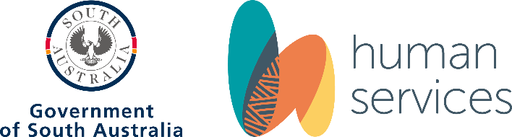

Contents
Introduction 3
Reflection on the previous Youth Action Plan 2020–2022 3
South Australia’s Youth Action Plan 2023–2026 5
Seeking your input 8
Key overarching areas for action 9
Action Area 1: Physical Health, and Social and Emotional Wellbeing and Mental Health 10
Action Area 2: Safety and Justice 14
Action Area 3: Education and Employment 17
Action Area 4: Connections and Access to Resources 21
Action Area 5: Citizenship and Participation 23
Appendix 1 – Plain text description 24

Introduction
Welcome to the conversation about South Australia’s next Youth Action Plan.
Young people hold the key to creating a better future. They have told us that they want to be taken seriously, listened to and included in important conversations. The South Australian Government is keen to ensure that the voices of young South Australians are heard.
The South Australian Government is developing a new Youth Action Plan to enhance fair and equitable access to opportunities, resources and supports for young people.
The aim of this paper is to support young people and stakeholder organisations to provide direct input to South Australia’s new Youth Action Plan. This input may include:
- Considering the potential actions presented in this paper.
- Proposing other actions not included in this paper.
- Raising any other issues you think are important for young people aged 12–25 who live in South Australia.
South Australia’s Youth Action Plan 2023–2026 is an important opportunity for deeper collaboration across government, Aboriginal-led organisations, the youth sector and the broader community. In developing this new Youth Action Plan for SA, we acknowledge the Aboriginal peoples of South Australia, their ongoing strength, resilience and culture. We are committed to Closing the Gap and ensuring that Aboriginal peoples have a genuine say in the design and delivery of policies, programs and services that affect them. Through the development of this Plan, we will work closely with Aboriginal peoples and their communities to improve life outcomes for young people, in line with Closing the Gap.

Reflection on the previous Youth Action Plan 2020–2022
South Australia’s previous Youth Action Plan, Strong Futures, ended in December 2022. A reflection on Strong Futures was undertaken in early 2023 with key State Government and youth sector stakeholders. This highlighted that the vision for Strong Futures — creating a safe, inclusive and sustainable State for all young people — remains important. We also heard that the priorities identified in Strong Futures, in consultation with young people, are still relevant. These were:
- Preparing young people for work and life.
- Including young people and supporting them to reach their potential.
- Ensuring young people are safe, healthy and resilient.
- Ensuring young people are engaged and have influence in the issues and decisions that affect them.
However, the reflection process raised some important considerations for the development and implementation of the next Youth Action Plan, including:
- Raising awareness of the plan.
- Funding to support actions.
- Cooperation and collaboration across Government and community.
- More involvement of, and support for, the youth sector.
- Better monitoring of, and reporting on, outcomes.

Infographic: South Australia’s Young People
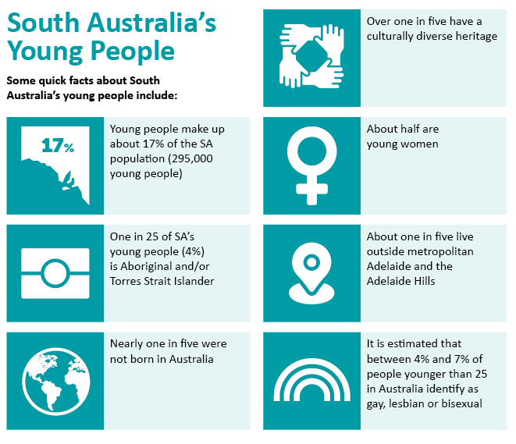
Infographic plain text description

South Australia’s Youth Action Plan
2023–2026
South Australia’s new Youth Action Plan is being developed by the Department of Human Services (DHS), which has a lead role in policy development and implementation with, and for, young people aged 12–25 who live in South Australia.
The new SA Youth Action Plan aims to ensure the South Australian Government better meets the needs of young people, by delivering fairer and more equitable access to opportunities, resources and supports.

Meeting the needs of diverse young people
There are almost 300,000 young people in SA and they are diverse, but share many interests, strengths and challenges. They are passionate about equity, fairness, social justice, physical and mental health, the environment, diversity in all its forms, social connections, learning about each other and much more.
We all experience successes and challenges, and everyone may encounter barriers in unique ways and at different stages. However, some young people experience particular disadvantage, marginalisation and discrimination. To promote equity and social justice, it is important that we take action to meet the needs of these young people, including:
- Aboriginal young people
- Young people experiencing socio-economic disadvantage
- LGBTIQA+ young people
- Young people who have caring responsibilities
- Young people who live with disability and/or who are neurodivergent
- Culturally and linguistically diverse young people
- Young people who live regionally or remotely
- Young women
- Young people in contact with the youth justice and child protection system.
Around 4% of SA’s young people identify as Aboriginal and/or Torres Strait Islander. SA’s Youth Action Plan is an important opportunity for the State Government to work with Aboriginal peoples and their communities to achieve life outcomes equal to all SA’s young people.

The Plan will provide key actions that will contribute to Closing the Gap:
- Outcome 5: Aboriginal students achieve their full learning potential
- Outcome 6: Aboriginal students reach their full potential through further education pathways
- Outcome 7: Aboriginal young people are engaged in employment or education
- Outcome 11: Aboriginal young people are not overrepresented in the criminal justice system
- Outcome 12 Aboriginal children are not overrepresented in the child protection system
- Outcome 13: Aboriginal children are safe
- Outcome 14: Aboriginal young people enjoy high levels of social and emotional wellbeing

Current policies relevant to young people
South Australia’s Youth Action Plan will complement and, where appropriate, help shape a range of other SA Government policies that support young people to participate socially, economically and in other areas of community life. These policies include:
- Digital Strategy 2022–2025 (Department for Education)
- Aboriginal Education Strategy 2019–2029 (Department for Education)
- Country Education Strategy 2021–2028 (Department for Education)
- Child and Youth Engagement Strategy 2021–2023 (Department for Child Protection)
- Youth Justice State Plan 2020–2023 (Department of Human Services)
- SA Health and Wellbeing Strategy 2020–2025 (SA Health)
- Physical Activity in Nature Action Plan 2021–2024 (SA Health)
- Our Housing Future Strategy 2020–2030 (Housing SA)
- Volunteering Strategy for SA 2021–2027 (Department of Human Services)
- State Disability Inclusion Plan 2019–2023 (Department of Human Services)
- Arts and Culture Plan 2019–2024 (Department of the Premier and Cabinet)
- Office for Recreation, Sports and Racing’s Strategic Plan 2021–2025 (ORSR)

South Australian Government policy snapshot
Snapshot of common themes of existing South Australian Government policies with a focus on young people.
The most prominent themes are:
- Aboriginal people
- Engagement and Inclusion
- Students and Education.
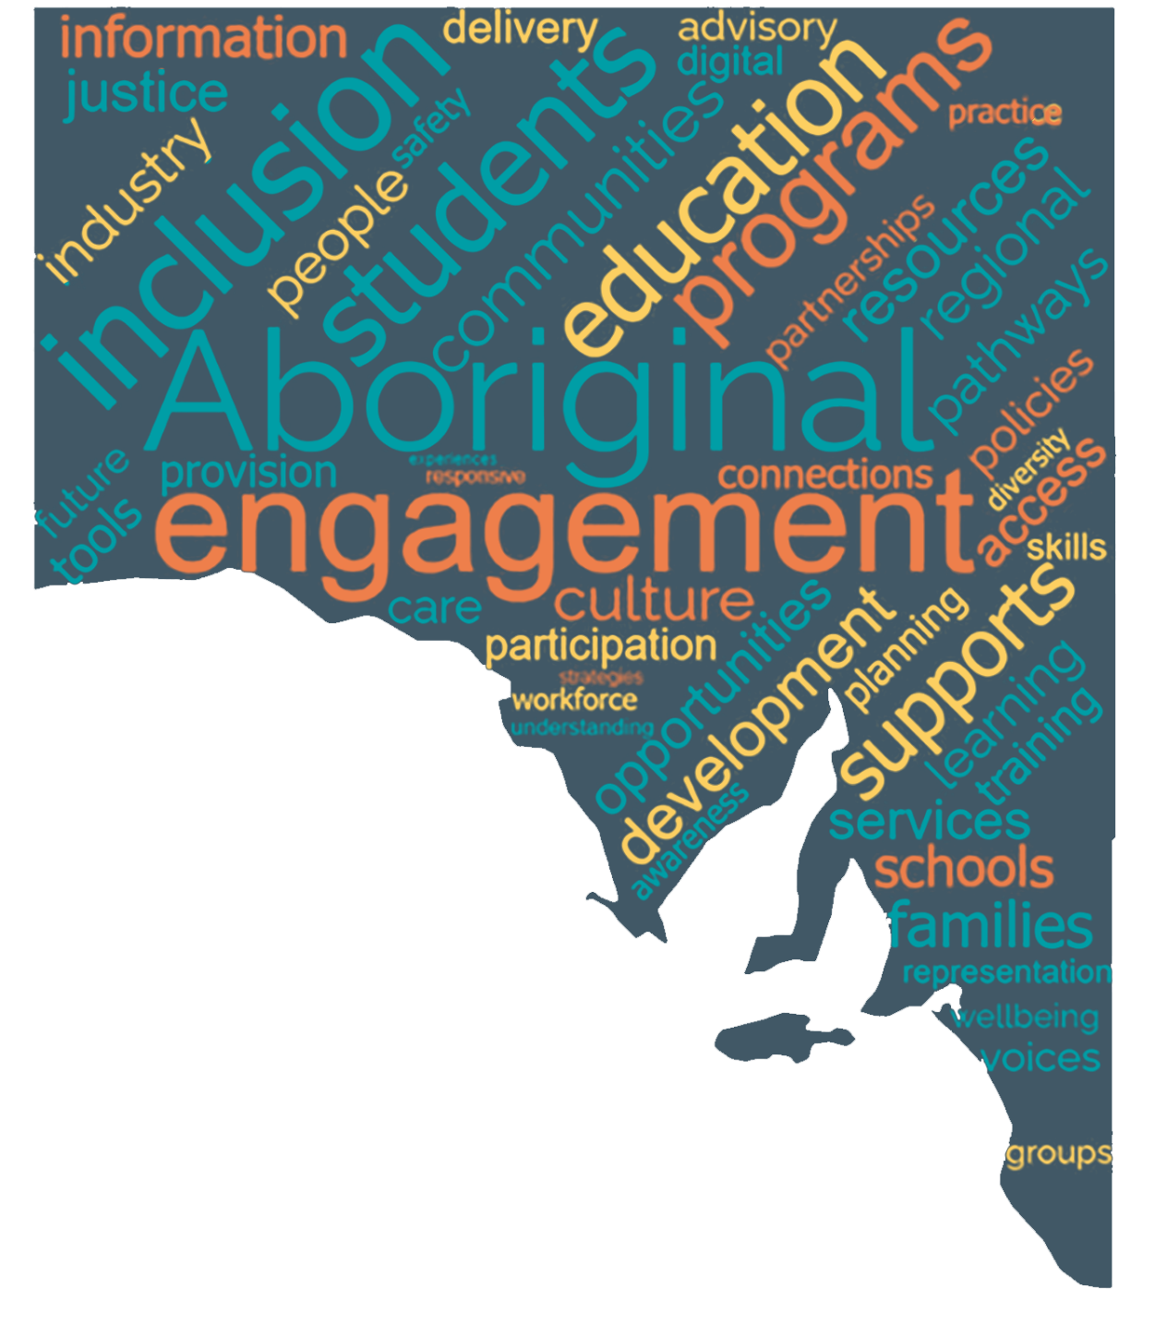

Seeking your input
You can have your say on SA’s Youth Action Plan by:
- Responding to the online survey based on the questions below via the YourSAy website (yoursay.sa.gov.au/yoursay-sa-gov-au-youth-action-plan-2023-2026)
- Providing feedback online via alternative engagement tools available on the YourSAy website (yoursay.sa.gov.au/yoursay-sa-gov-au-youth-action-plan-2023-2026)
- Writing a submission using the questions below as a guide and sending it to youthactionplan@sa.gov.au or to SA Youth Action Plan, GPO Box 292, Adelaide SA 5001
- Emailing feedback to youthactionplan@sa.gov.au, or sending it to SA Youth Action Plan, GPO Box 292, Adelaide SA 5001
- Participating in a public consultation event – details will be available at yoursay.sa.gov.au/yoursay-sa-gov-au-youth-action-plan-2023-2026
Further details about the public engagement process for SA’s Youth Action Plan and how you can have your say can be found on the YourSAy website at (yoursay.sa.gov.au/yoursay-sa-gov-au-youth-action-plan-2023-2026).
You can also contact us at youthactionplan@sa.gov.au for any information.

Key overarching areas for action
Young people demonstrate many strengths — including creativity, resilience, empathy, independence, collaboration and innovation. However, there are also areas where we need to take action to ensure that all young people can flourish. In line with South Australia’s Outcomes Framework for Children and Young People, we are proposing that SA’s Youth Action Plan has five key areas for action:
- Physical Health, and Social and Emotional Wellbeing and Mental Health: Young South Australians are physically, socially, emotionally and mentally healthy
- Safety and Justice: Young South Australians are safe and nurtured
- Education and Employment: Young South Australians are successfully learning and\or working
- Connections and Access to Resources: Young South Australians are connected to community and needed resources
- Citizenship and Participation: Young South Australians participate actively in society
Q1: Are there any other overarching areas for action that should be included in SA’s Youth Action Plan?
Young people have already told us a lot about the issues and opportunities that are important to them. We have included below some potential actions for the new Youth Action Plan. These have been informed by a review of recent reports from a range of key youth organisations, which reflect consultation with over 10,000 young people in South Australia and nationally. These organisations include, but are not limited to:
- the Commissioner for Children and Young People
- the Commissioner for Aboriginal Children and Young People
- the Youth Affairs Council of SA (YACSA)
- YMCA SA
- Multicultural Youth SA
- the Child Development Council
- the SA Youth Forum
- Mission Australia
- UNICEF Australia
The potential actions presented below are intended to prompt your thinking and we encourage you to tell us more about how the South Australian Government can meet the needs of young people.

Action Area 1: Physical Health, and Social and Emotional Wellbeing and Mental Health
Young South Australians are physically, social, emotionally and mentally healthy

Physical Health

Fewer than 1 in 10 exercising
The SA Government’s “Game On” Report found that fewer than 1 in 10 young people aged 13–17 in SA do at least 60 minutes of daily physical activity, which is what they need for a healthy lifestyle. We need to get more young people moving.

2 in 3 vaping
Vaping is posing health risks for young people across the State. In her Vaping Survey, the Commissioner for Children and Young People found that 2 in 3 young people have tried vaping, with almost a quarter vaping regularly.

More than 1 in 4 living with illness
28% of young people in SA live with a long-term health condition, including a mental health condition (2021 Census). There is currently minimal research into the impact of chronic illness on South Australian children and young people. We need a beter understanding of this issue so that we can develop informed responses.
The Commissioner for Children and Young People’s Menstruation Matters Report found that we need to do much better to address the impacts of menstruation on wellbeing, participation and school attendance for young people who menstruate.
Q2: How can the South Australian Government improve the physical health of young people?
(You can suggest actions and/or refer to the potential actions following)
Some potential actions may include:
- Co-design opportunities for young people to participate in physically active ‘play’ in local communities.
- Better understand and respond to the experiences of children and young people living with chronic illness.
- Develop a state-wide menstrual wellbeing policy.
- Co-design resources to educate young people about the health risks of vaping and how to navigate social pressures.

Social and Emotional Wellbeing and Mental Health
Mental health is a critical issue for young people in SA, with COVID-19 increasing the challenges in this area for many.

More than 1 in 10 living with mental illness
The 2021 South Australian Population Health Survey found that more than one in 10 young people in SA experience depression, anxiety and/or other mental health conditions, with this percentage increasing to 35% among young people aged 16–17. Some young people, for example those identifying as LGBTIQA+, are at higher risk of experiencing mental health issues.
Through Mission Australia’s Youth Survey 2022, a third of SA’s 15–19 year olds told us that mental health is their biggest personal challenge, with over half needing support with mental health at some point in their lives. Young people have also told us that coping with stress and body image are critical issues of personal concern. The 2021 Census indicates that nearly one in six Aboriginal young people have a mental health condition, including depression and/or anxiety.
It is important to acknowledge that for Aboriginal and Torres Strait Islander peoples, social and emotional wellbeing is the foundation for mental health, as well as physical health. While it differs across cultural groups and individuals, social and emotional wellbeing is an holistic concept that reflects the importance of relationships between individuals, family, kin and community, as well as connection to land, culture, spirituality and ancestry. We know that connection to family, country, culture and language is critically important to the social and emotional wellbeing of young Aboriginal people.
Young people have made it clear that we need to make it easier for them to access local social and emotional wellbeing supports earlier and that responses should be co-designed with young people. We need to help schools and the broader community support young people who are struggling. It is also important that we take targeted action to remove barriers to services, for example for young people living regionally.
Q3: How can the South Australian Government improve the social and emotional wellbeing and mental health of young people?
(You can suggest actions and/or refer to the potential actions below)
Some potential actions may include:
- Improve opportunities for young people to provide direct advice to the Minister for Health and Wellbeing on mental health.
- Co-design a model for informal, non-clinical, community-based supports for young people to improve social and emotional wellbeing and mental health.
- Increase and improve opportunities for Aboriginal young people to connect with country, culture and language.
- Remove barriers to safely accessing mental health information and services, particularly for LGBTQIA+ young people and for young people living outside metropolitan areas.
- Introduce mental health first aid training in secondary schools.
- Co-design mental health peer-to-peer resources and supports for young people.
- Increase access to high quality school and community-based mental health assessment and support, including culturally sensitive and trauma-informed services.

Young People with Disability
Living with disability is something that many young people experience.

1 in 9 living with disability
Australian Bureau of Statistics data indicate that one in nine young people in SA, aged 15–24, live with disability. Approximately one third of young people in SA need assistance with core activities (2021 Census).
We know from national evidence on social inclusion that people with disability experience discrimination and infringements on their rights. In the 2022 Child Rights Progress Report, the Commissioner for Children and Young People highlighted that the sterilisation of children with disability is a serious issue that needs attention.
Some groups of young people are more likely to live with disability. A recent report from the Commissioner for Aboriginal Children and Young People estimates that Aboriginal young people are up to twice as likely to live with disability than non-Aboriginal young people. The Writing Themselves In 4 Report from La Trobe University found that over one in three South Australian LGBTQA+ young people aged 14 to 21 live with disability or a long-term health condition.
Q4: How can the South Australian Government improve the inclusion and wellbeing of young people who live with disability?
(You can suggest actions and/or refer to the potential actions below)
Some potential actions may include:
- Increase the focus on participation, inclusion and independence of young people with disability within Disability Access and Inclusion Plans.
- Improve inclusion and safeguarding of young people with complex disability needs who are unable to live in the family home.
- Address discrimination towards young people with disability.
- Support young people with disability to access complaint mechanisms and raise issues of concern, ensuring their issues are appropriately addressed.

Health Services
To be physically, mentally and emotionally healthy, young people need access to appropriate and effective health services. However, some young people face barriers in accessing the services they need. For example, a recent report from the Commissioner for Children and Young People highlighted that sexual health information and services are not equally accessible for all young people, including LGBTIQA+ young people and those in regional areas. Given that nearly one in three Aboriginal young people live with a long-term health condition (2021 Census), access to culturally appropriate health services for Aboriginal young people and their families is vital.
We also know that better understanding and responding to young people’s experiences of violence and abuse, and supporting young parents, will improve outcomes for young people now and for future generations.
Q5: How can the South Australian Government improve the availability and accessibility of health services to young people?
(You can suggest actions and/or refer to the potential actions below)
Some potential actions may include:
- Support Aboriginal Controlled Community Organisations (ACCOs) to ensure culturally appropriate, holistic and trauma-responsive supports and health services are available to Aboriginal young people.
- Make sexual health services and information more accessible, particularly for LGBTIQA+ young people and those in regional areas.
- Conduct research to better understand young people’s experiences of sexual assault to improve responses.
- Co-design therapeutic interventions to better respond to young people’s experience of violence.
- Support young parents to build their parenting skills and capacity, including more programs targeted to young fathers.

Action Area 2: Safety and Justice
Young South Australians are safe and nurtured

Child Protection
In SA, the proportion of young people who live in out-of-home care is higher than in the rest of Australia. Young people living in out-of-home care, particularly in residential care, face a much higher risk than others of becoming involved with the youth justice system. Aboriginal young people are significantly over-represented in the child protection system. Children and young people with disability are also over-represented in this system. We need to strengthen our efforts to address what is causing this over-representation.
Q6: How can the South Australian Government assist young people who are involved with, or are at risk of becoming involved with, the child protection system?
(You can suggest actions and/or refer to the potential actions below)
Some potential actions may include:
- Better understand and respond to the factors that determine the over-representation of Aboriginal young people in the child protection system, including disability, mental health needs, homelessness and intergenerational trauma.
- Better understand and respond to the factors that determine the over-representation of young people with disability in the child protection system.
- Develop innovative measures that refer children in out-of-home care away from the justice system as a first resort.

Youth Justice
Aboriginal young people and children and young people with disability are also over-represented in the youth justice system. Young Aboriginal people in SA are up to 10 times more likely to be under community supervision or in youth detention than non-Aboriginal young people. DHS’ Disability Screening Assessment Project found a very high prevalence of complex disability-related needs among young people in Kurlana Tapa Youth Justice Centre. It is important to better understand and to address the reasons of this over-representation, as well as to divert and support young people away from the justice system.
Q7: How can the South Australian Government assist young people who are involved with, or are at risk of becoming involved with, the youth justice system?
(You can suggest actions and/or refer to the potential actions below)
Some potential actions may include:
- Better understand and respond to the factors that determine the over-representation of Aboriginal young people in the youth justice system, including racism, trauma, disability, mental health needs and homelessness.
- Better understand and respond to the factors that determine the over-representation of young people with disability in the youth justice system.
- Co-design community-based alternatives and interventions that divert young people from the justice system, including in remote areas.
- Invest in safe and appropriate accommodation options for young people on bail and develop a targeted response to support young people leaving detention.

Housing and Homelessness
Access to appropriate and safe housing is incredibly important for young people and can have lifelong impacts on education, employment and health outcomes.

More than 1 in 10 without safe housing
Mission Australia’s Youth Survey 2022 found that more than one in ten young people in SA aged 15–19 are worried about having a safe place to stay.
Reports from the Australian Housing and Urban Research Institute and the Australian Institute for Health and Welfare indicate that cost of living, housing supply and family and domestic violence are some of the main reasons young people may become homeless. Young people also face serious discrimination in the private rental market and, while young people still aspire to home ownership, some groups are particularly pessimistic about their ability to ever own their home, including non-binary, gender diverse and agender young people.
Q8: How can the South Australian Government assist young people to access safe and appropriate housing?
(You can suggest actions and/or refer to the potential actions below)
Some potential actions may include:
- Develop a coordinated multi-agency response to young people who are at risk of homelessness (and entering the youth justice system and/or out of home care).
- Increase investment in accommodation and supports for young people at risk.
- Educate property owners and young people on their rights and responsibilities in the private rental market.
- Work within the parameters of the Planning, Development, and Infrastructure Act 2016 to increase the availability of affordable housing options.
- Understand better and respond to the experiences in the housing market of non-binary, gender diverse and agender young people.

Respectful Relationships and Sex and Sexual Health Education
Violence and abuse, including sexual violence, is experienced by a significant proportion of young people around Australia.

1 in 5 women experienced sexual violence
Data from the Australian Institute for Health and Welfare tell us that one in five Australian women and one in 20 Australian men have experienced sexual violence of some kind from the age of 15.
Some young people are more likely than others to experience exploitation and abuse, including Aboriginal young people, young people with disability and those in out-of-home care. The Royal Commission into Institutional Responses to Child Sexual Abuse found that problematic or harmful sexual behaviour perpetrated against young people by young people is also a critical issue and is more prevalent than previously thought.
Educating young people is critical to promote safe, respectful and healthy relationships, including sexual relationships. However, young people have told us that such education in South Australian schools should be more consistent and inclusive of gender and sexual diversity.
Q9: How can the South Australian Government better promote safe, respectful and healthy relationships, including sexual relationships, among young people?
(You can suggest actions and/or refer to the potential actions below)
Some potential actions may include:
- Ensure all young people have access to age-appropriate, evidence-based, safe and inclusive respectful relationships (including consent), sex and sexual health education in school, inclusive of LGBTQIA+ young people.
- Develop targeted actions to improve access for young people to respectful relationships, sex and sexual health information, including resources for young people in residential care, flexible learning options, disability school leaver support programs, regional community health centres, or who are in the youth justice system.
- Improve prevention, intervention, therapy and case management for young people with problematic or harmful sexual behaviours.

Action Area 3: Education and Employment
Young South Australians are successfully learning and\or working
Study and Post-School Pathways

118 thousand students
According to the 2021 Census, nearly 118,000 young people in SA are students, either in secondary school (50%), university (40%) or in vocational tertiary education (10%). Of the young people in SA who study, 88% study full-time and 12% study part-time.
Through the Mission Australia Youth Survey 2022, young South Australians aged 15 to 19 told us that school or study problems are among the most important issues of personal concern.
It is important that we improve gender equality and cultural safety in schools and undertake targeted actions to promote successful post-school pathways for young people experiencing particular barriers, including Aboriginal young people, refugee and migrant young people, young people with disability, young people leaving out of home care and young people leaving Kurlana Tapa Youth Justice Centre.
Q10: How can the South Australian Government improve school and study experiences and outcomes, and post-school pathways?
(You can suggest actions and/or refer to the potential actions below)
Some potential actions may include:
- Strengthen the focus in schools on Aboriginal histories, countries, cultures and languages, led by Aboriginal people.
- Develop ‘pathway to employment’ initiatives and supports targeted to those young people experiencing particular barriers.
- Invest in volunteering opportunities for young people experiencing barriers to participation and employment, to build skills and capacity.
- Ensure that all students, regardless of gender, have access to information about possible careers across all industries and sectors, and are supported in their aspirations.
- Better understand how racism impacts the experience of belonging in school of Aboriginal young people and culturally and linguistically diverse young people.

School Attendance and Engagement
School exclusion, expulsion and suspension are used to respond to student behavioural issues in Australian schools. However, there is evidence, for example from the Australian Institute of Criminology, that shows a clear relationship between exclusion from school and young people engaging in behaviours that are detrimental to their health and social and emotional wellbeing. Evidence also shows that excluded and marginalised young people are at higher risk of exposure to and involvement with the youth justice system.

3 times more likely to be suspended
The recent Inquiry into Suspensions, Exclusions and Expulsion Processes in SA Government Schools found that Aboriginal children are three times more likely to be suspended than non-Aboriginal children.
Q11: How can the South Australian Government improve school attendance and engagement for young people at risk of marginalisation?
(You can suggest actions and/or refer to the potential actions below)
Some potential actions may include:
- Co-design with community targeted strategies to increase school attendance and engagement, particularly for Aboriginal students and students with disability.
- Review, in collaboration with the Aboriginal Controlled Community Organisations (ACCO) sector, the Aboriginal Education strategy to increase school engagement of Aboriginal young people.
- Introduce an independent appeals mechanism for young people who have been excluded from school to mitigate systemic barriers.

Young Carers

1 in 20 young people are carers
Approximately one in twenty young people in SA provide unpaid care to an older person, a person with disability, someone with a health condition, or someone else’s child. It is estimated that the proportion of Aboriginal young people who provide unpaid care for others is double this (2021 Census).
Through the Commissioner for Children and Young People’s Take Care Report, young people with caring responsibilities told us that caring impacts their friendships, educational outcomes and community involvement.
Q12: How can the South Australian Government better meet the needs of young people with caring responsibilities?
(You can suggest actions and/or refer to the potential actions below)
Some potential actions may include:
- Co-design innovative school-based supports for young people with significant caring roles to improve their educational, social and community inclusion.
- Improve opportunities for young carers to access sport, recreational and social activities.
- Improve access for young carers to training, further education and employment opportunities that fit with their caring role.

Employment
Access to adequate and safe employment opportunities is critical to assist young people in meeting some of the pressing demands they are faced with, including the rising cost of living.

1 in 3 students are working
Nearly one in three full-time students in SA also work, either part-time or full-time.
Young people experience unemployment at higher rates than other South Australians and the impacts of COVID-19 on employment were disproportionately experienced by young people.

More than 1 in 10 unemployed
About 11% of young people in SA are unemployed and looking for work, compared with around 5% of all South Australians.

Nearly 1 in 4 Aboriginal youth unemployed
While around three quarters of Aboriginal young people aged 15–24 are employed, nearly one in four is unemployed (2021 Census).

Unemployment higher if living with disability
In the People with Disability in Australia Report, the Australian Institute of Health and Welfare points out that people with disability are twice as likely to be unemployed than those without disability and that young people with disability are more than twice as likely to be unemployed than adults.
In her Advocacy Agenda, the Commissioner for Children and Young People highlights that workplace bullying and harassment, including sexual harassment, is a serious health and safety issue for young employees.
Q13: How can the South Australian Government improve employment outcomes for young people?
(You can suggest actions and/or refer to the potential actions below)
Some potential actions may include:
- Create effective linkages between youth services and training and education providers, including a focus on groups of young people experiencing poorer employment outcomes.
- Develop youth traineeships and employment opportunities for young people, including graduates, across a broader range of industries and sectors – including a focus on groups of young people experiencing particular barriers to employment.
- Increase opportunities for young people to develop life skills and work readiness through meaningful and innovative volunteering roles.
- Reduce workplace bullying and harassment, including sexual harassment, perpetrated and experienced by young people.

Action Area 4: Connections and Access to Resources
Young South Australians are connected to community and needed resources

Socio-Economic Disadvantage and Cost of Living
Young people in SA are particularly vulnerable to socio-economic disadvantage and the detrimental impacts of the rising cost of living.

Over 1 in 2 living in disadvantage
The Child Development Council of South Australia’s 2022 Report Card identified that over half of people under the age of 20 in SA live in disadvantaged socioeconomic circumstances, compared to 38% nationally.

Over 1 in 10 below the poverty line
The 2021 Census revealed that over one in 10 young people in SA live in households where the total income is below the poverty threshold for a family.
The 2021 Census revealed also that 38% of Aboriginal families earn an income below the poverty line, and about one in three people aged 20–24 earn an income below the poverty threshold, with a further 8% earning no income. This impacts on young people’s wellbeing and life opportunities in a range of ways.
Q14: How can the South Australian Government improve outcomes for young people facing socio-economic disadvantage?
(You can suggest actions and/or refer to the potential actions below)
Some potential actions may include:
- Ensure that South Australia’s concessions schemes responds to the needs of young people.
- Develop targeted actions to address issues of food insecurity for young people experiencing significant financial struggles.
- Improve access to sporting and recreational opportunities for young people who are socio-economically disadvantaged, in partnership with the Office for Recreation, Sport and Racing.

Connections and Access to Resources
Establishing connections is important for young people’s wellbeing and to enable access to needed supports and resources.

Over 1 in 2 worried about the future
Mission Australia’s Youth Survey 2022 found that over half of young people aged 15–19 in SA do not think their communities offer them what they need to have a positive and thriving future.
Mission Australia’s Youth Survey 2022 reported also that around a third of young people in SA say that nothing more could help, or they are unsure what could help with their challenges.
For some young people in SA, having limited or no digital access creates significant barriers to education, career and citizenship opportunities. Existing information and reporting gaps make it hard to understand how connected young people feel to community and supports.
Q15: How can the South Australian Government promote connections and access to resources for young people?
(You can suggest actions and/or refer to the potential actions below)
Some potential actions may include:
- Build on the Child Development Council of South Australia’s Outcomes Framework for Children and Young People to address data gaps, create new opportunities for ongoing engagement with young people and better monitor outcomes for young people (including those aged 18–25).
- Invest in local community-led solutions to promote connection and wellbeing for young people.
- Expand free public Wi-Fi services to include all public buildings, public transport and community infrastructure, such as libraries and school grounds, in South Australia.
- Improve young people’s awareness of current supports and resources available to them.

Action Area 5: Citizenship and Participation
Young South Australians participate actively in society
YOUTH PARTICIPATION
Young people have made it clear they want to be listened to, taken seriously and have a voice in decision-making about issues that affect them, such as the environment and climate change.

1 in 2 prioritise the environment
Through Mission Australia’s Youth Survey 2022, half of the young South Australians aged 15–19 surveyed told us that the environment is the most important issue in Australia today.
It is also important that the voices of young people in child protection and youth justice contexts are heard in decisions that impact them.
Q16: How can the South Australian Government promote young people’s active participation in their communities?
(You can suggest actions and/or refer to the potential actions below)
Some potential actions may include:
- Introduce direct mechanisms for young people to influence environment and climate change policy and provide advice to the Minister for Climate, Environment and Water.
- Review and/or create best practice mechanisms for young people to participate in decision-making in the child protection and youth justice systems to strengthen service delivery outcomes.
- Implement youth participation and engagement training for State Government agencies and develop accountability measures for reporting meaningful youth participation in policy, program and service development.
- Identify and invest in youth-led advocacy initiatives, including in regional and remote SA.
Q17: Do you have any other comments about SA’s Youth Action Plan?

Appendix 1 – Plain text description

Infographic plain text description
Some quick facts about SA's young people include:
- young people make up about 17% of the essay population (295, 000 young people)
- one in 25 of SA's young people (4%) is Aboriginal and/or Torres Strait Islander
- one in five young people has a culturally diverse heritage.
- About half our young women
- About one in five lives outside metropolitan Adelaide and the Adelaide Hills
- Nearly one in five was not born in Australia
- It is estimated that between 4 and 7% of people younger than 25 in Australia identify as gay, lesbian or bisexual.
Return to infographic

