Keeping Safe: Child Protection Curriculum Review

Teacher Consultation
Draft activities paper #1.4 – Years 5 to 6
Items covered in this paper

- Overview and framework
- Proposed content progression
- Proposed activities for Focus Area 1 – The right to be safe
- Any other comments

Overview and framework

Overview
The Keeping Safe: Child Protection Curriculum (KS:CPC) Review will ensure the curriculum remains contemporary, world leading and evidence-based.
This paper provides the draft version 3 Rationale and Aims that were updated to highlight the shared responsibility for the protection of children and young people. It also provides the new framework graphic and the proposed content progression for Focus Area 1. We seek your feedback on a selection of activities that have been updated or added.

KS:CPC Rationale
All children have the fundamental right to be safe – to learn, play, grow, live safely, be supported and valued, in accordance with the United Nations Convention on the Rights of the Child.

Keeping all children safe is a global challenge with millions of children subjected to abuse, neglect, violence and other rights violations each year. Child abuse reaches all parts of society across economic and social circumstances, culture, religion or ethnicity and has both immediate and long-term consequences.

Research indicates that most child abuse and neglect is perpetrated by someone known to the child or their family. Furthermore, survivors of abuse often say they didn’t know what abuse was, that the behaviour was wrong, what to do about it, and that people didn’t listen. Education is paramount.

Promoting the safety and wellbeing of all children and young people is a shared societal responsibility. Families, communities, governments, business, and services all play a role in protecting children and young people. While safeguarding policies and practices support organisations to respond to harmful or unsafe situations; child protection education empowers children.

Education must support children’s self-efficacy and agency to advocate for their right to be safe. Children need the knowledge, skills and understanding to develop respectful relationships, recognise and report abuse, and apply strategies to support their safety and wellbeing. This is at the core of the Keeping Safe: Child Protection Curriculum.

KS:CPC Aims
All children and young people in developmentally appropriate ways can:
1. Understand they have the right to be safe
2. Recognise abuse and unsafe situations
3. Apply knowledge, skills and understanding to be safe
4. Seek support for themselves or others

Framework
A new visual representation of the curriculum’s framework will demonstrate:  - the core reason why we use the KS:CPC  The KS:CPC is premised on the core belief that all children have the right to be safe, in accordance with the United Nations Convention on the Rights of the Child.  - the essential knowledge, skills and understanding that children need to learn  To support their rights, children must learn how to:  - Recognise abuse and unsafe situations  - Develop and apply strategies to be safe  - Seek support and report  - how the curriculum is organised and implemented  The curriculum is organised into four Focus Areas that build on a child’s understanding in a holistic, sequential, and developmentally appropriate way.  The Focus Areas contain learning activities for teachers to use with children and young people, to build knowledge, skills and understanding across a variety of contexts.  - Focus Area 1: The right to be safe  - Focus Area 2: Relationships  - Focus Area 3: Recognising and reporting abuse  - Focus Area 4: Protective strategies | 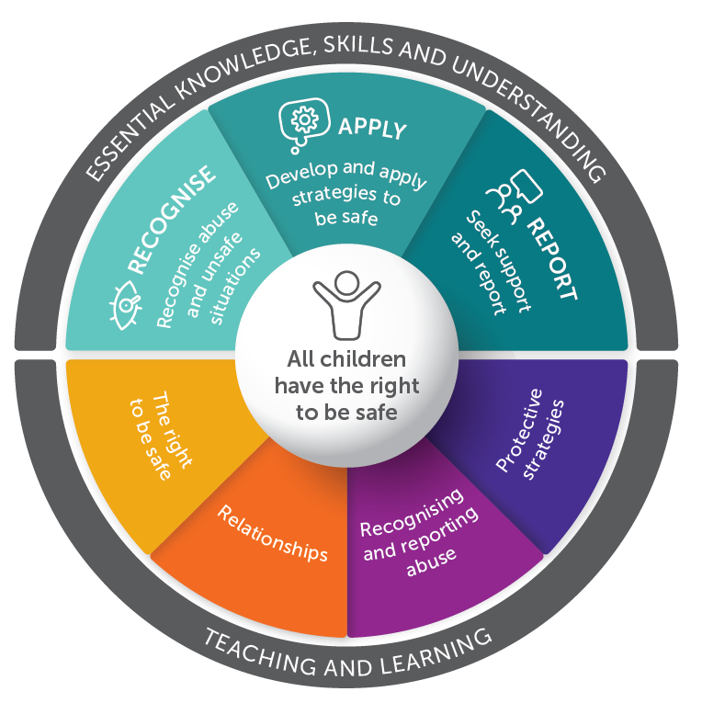

Your comments on the Rationale, Aims and Framework
Click or tap here to enter text.

Proposed content progression

Note: The focus areas have not changed. Most activities have been updated and some have been moved to a different focus area since the previous edition (previous location in brackets). The ‘Content’ column is to assist with the consultation process and will not appear in the curriculum documents. Activities in italics are still under development and not currently available for consultation.

Focus Area | Topic name | Content (at an age and developmentally appropriate level) | Activities – Years 3 to 4
FA1 – The right to be safe | Keeping safe | - Setting group norms for safe learning  - Establishing networks  - Trusted people | - 1.1 Group norms, networks and themes (NEW)
FA1 – The right to be safe | Rights and responsibilities | - Understanding rights and responsibilities  - UN Convention on the Rights of the Child  - Human Rights  - Personal space and boundaries  - Identity  - Gender stereotypes | - 2.1 United Nations Convention on the Rights of the Child (FA2-1.2)  - 2.2 Rights and responsibilities (FA2-1.1)  - 2.3 Personal space (NEW)  - 2.4 Defining public and private (FA3)  - 2.5 Character strengths (NEW)  - 2.6 Gender stereotypes – media analysis (NEW)
FA1 – The right to be safe | Safe and unsafe | - Feelings  - Recognising feelings as warning signs  - Safe and unsafe situations  - Defining and assessing risks and risk-taking  - Online risks, image sharing, online safety and laws  - Risk mitigation, what makes something safer | - 3.1 Feelings wheel (NEW)  - 3.2 Identifying characters warning signs (NEW)  - 3.3 Feeling unsafe (FA1-2.4)  - 3.4 Warning signs: placemat (NEW)  - 3.5 Definition of safety (FA1)  - 3.6 Ideas about being safe and unsafe (FA1)  - 3.7 Adults caring for children (FA1)  - 3.8 Chatting safely online (NEW)  - 3.9 Assessing risks (NEW)  - 3.10 Exploring online risk and safety (NEW)

Proposed activities for Focus Area 1 – The right to be safe
Note: the following are a selection of activities that have been modified or added since the KS:CPC Revised Second Edition, the sequence and content of these activities may change further prior to publishing.

Topic 1 – Keeping safe
1.1 Group norms, networks and themes  Under development | New activity

Topic 2 – Rights and responsibilities
2.1 United Nations Convention on the Rights of the Child  - Select an appropriate video to explore the United Nations Convention on the Rights of the Child (UNCRC):  - What are child rights? UNICEF Australia  - Convention on the Rights of the Child Explainer, UNICEF Canada  - Rights of the Child Segment 1 - What are Children’s Rights, Global Teacher Prize  - Ask ‘Why does the Convention on the Rights of the Child exist?’ (Response could include: the UNCRC is in place to protect children.)  - Display or provide students with a version of the UNCRC. Choose the most suitable version for your students:  - The United Nations Convention on the Rights of the child – the children’s version, UNICEF  - 12 key rights poster, Australian Human Rights Commission  - A simplified version of the United Nations Convention on the Rights of the Child, UNICEF  - Students use Activity resource 4: X chart (RLS 4) to brainstorm what it looks, feels, sounds, and thinks like when a child has their rights respected.  - Students individually select one or more rights/articles to represent in a format of their choice. Emphasis should be on children having their rights respected and not having their rights violated. Students could present their right/article using:  - a short story  - visual arts  - a poem  - song lyrics  - a short film.  - Provide opportunities for students to share their work with the class and/or the wider school community.  - Remind students to talk to a trusted adult or someone on their trusted network if they feel uncertain or unsafe. | From: Focus Area 2 Activity 1.2  https://youtu.be/V1BFLitBkco  https://youtu.be/WO_yAe1RqXk  https://youtu.be/COjVj9czgrY  AHRC.2030.The Big Banter A3 poster - web version.pdf (humanrights.gov.au)  https://www.unicef.org/media/56661/file  http://tiny.cc/AHRC-12KeyRights  http://tiny.cc/UNCRC-Simplified  The concepts and language of the Convention on the Rights of the Child are quite challenging for primary students. However, by unpacking the sentences with your input, the statements can be re-written for clear meaning.  Next to #5  Additional resources  - Illustrated version of the Convention on the Rights of the Child, Save the Children  - Your rights in pictures, Children and Young People’s Commissioner Scotland
Your comments
Click or tap here to enter text.

2.2 Rights and responsibilities  - Students individually complete Activity resource 13: My rights and responsibilities. Use this as an opportunity to determine students’ level of understanding about rights and responsibilities. Consider narrowing the focus such as ‘Rights and responsibilities of students at school’.  - Reinforce that it is an adult’s responsibility to keep children safe, however all children can help to keep themselves and others safe.  - Brainstorm (RLS 10) rules or laws that are in place to keep children and young people safe. Consider the following contexts:  - school  - community  - family  - state or country laws  - Use resources such as school policies and guidelines to explore the rules or laws brainstormed above. Students could explore local laws, eg Youth Law Australia.  Ask questions such as:  - Why do these rules or laws exist?  - Whose responsibility is it to ensure children and young people are kept safe?  - What happens if people do not follow the rules or laws? What is the impact on themselves and on other people?  - Use Activity resource 14: Rights and responsibilities to explore a range of rights and the responsibilities that children, adults and the community/government have in protecting children.  - Provide opportunities for students to discuss what they would do if their rights were compromised or they felt unsafe. Remind students about talking to a trusted adult, someone on their network or a support service. | From: Focus Area 2 Activity 1.1  Disability and additional needs p118  http://kscpc.2.vu/Y3-5_Act05  https://yla.org.au/  http://tiny.cc/DAN_Act13
Your comments
Click or tap here to enter text.

2.3 Personal space  - Students participate in an activity that emphasises personal space, for example:  - Clumps—Students move around the room. Call out a number and students form groups of that number. Those who are left out are out of the activity.  - Birthday line—Students line up shoulder to shoulder across the room in order of birthdays, January to December, without talking or touching.  - Ask the following questions:  - How did it feel when people moved close together?  - How did people show that their personal space was invaded?  - How might people feel about their personal space in the following situations:  - a crowded train?  - a party?  - a rock concert?  - How might someone know that another person is uncomfortable about their personal space being invaded? (Responses could include: body language; the person moves away.)  - What messages can we learn from looking at other people’s body language? (Responses could include: how other people feel; what they might be about to do: sometimes body language communicates more than a person’s verbal responses.)  - In the case of the ‘Birthday line activity’, ask students how they worked out where they needed to stand and discuss responses to different kinds of body language. | New activity
Your comments
Click or tap here to enter text.

2.4 Defining public and private  - Ask students to brainstorm (RLS 10) the word ‘public’. Ask:  - Where and when is this word used? (Responses could include: public toilet; open to the public.)  - What other words may be associated with it? (Responses could include: open; free; unrestricted.)  - Brainstorm the word ‘private’. Ask:  - Where and when is the word used? (Responses could include: private property; private hospital.)  - What sorts of things can be considered private? (Responses could include: ideas; thoughts; possessions; our bodies; places we go.)  - Draw the following table and ask students to give examples under each category. Alternatively, place the categories on large sheets of paper displayed around the room. Students move around the displays, writing examples in each category.  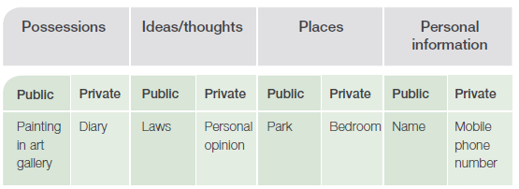  - Discuss the words in each category, asking questions such as:  - What makes the word public or private?  - Who controls whether something is public or private?  - Can some words be both public and private? If so, why/how?  - Clarify that for something to be private, the person who it belongs to must be able to control who can access it. For example, a bedroom or bathroom is only private if the person can control who can enter and/or see in.  - Ask what might influence a person’s view of what is public and what is private. (Responses could include: culture; family upbringing; the situation a person is in, for example being examined by a doctor; relationship to another person.)  - Remind students that their whole body is private and if someone feels their privacy is not being respected or they feel unsafe, they should talk to a trusted adult or someone on their trusted network. | From Focus Area 3  2.4 Activities about parts of the body are covered in Focus Area 3.
Your comments
Click or tap here to enter text.

2.5 Character strengths  - Students use stories to select strengths of characters or animals they feel best describes them. Use books that students are familiar with or currently being read in class.  - Examples of strengths include creativity, honesty, fairness, humour, kindness and more. … (examples for VIA)  - Students copy or draw images on a poster labelled ‘My strengths’. If they can’t find images for some things, they can write a description. This can be done individually or as a combined student piece of work to display in the class, school, or community.  - For each strength, students describe why it is important to them and how it can be used to help themselves and others stay safe.  - Students identify 2-3 traits/strengths that they want to focus on to improve, and which will help them to keep themselves safe. Note that these should not be described as ‘weaknesses’.  - Conclude the activity by discussing that everyone has character strengths, and that they may help someone to keep themselves safe, such as by communicating with a trusted adult. Use this opportunity to review adults at school that a student could talk to if they felt unsafe. | From Aboriginal materials p56  Next to #2  Refer to Values In Action for more suggested character strengths.  Aboriginal resource  Use character strength cards from the KS:CPC Anangu resources.
Your comments
Click or tap here to enter text.

2.6 Gender stereotypes - media analysis  - Use appropriate children’s movies, TV shows, traditional stories or fairy tales and ask students to analyse a range of characters.  - Ask questions such as:  - What do they look like?  - What are they wearing?  - What activities do they do?  - What role do they have (eg main character; hero; villain).  - Compare examples of characters of different genders in different examples of media.  - Is there a pattern of how characters of certain genders are represented?  - Why do you think this is the case?  - Would it be OK if these gendered roles did not exist or were reversed?  - Show a piece of media that challenges traditional gender roles and stereotypes, such as … provide examples.  - Explain that gender stereotypes are when certain behaviours, roles, activities, careers, appearance, etc are assumed or expected because of a person’s gender. Gender stereotypes within society and/or culture can be harmful and may limit a person’s potential or stop them from doing something that they want to do.  - As a class, brainstorm (RLS 10) stereotypes that exist in society based on someone’s gender. Examples could come from a range of categories, such as clothing, sports, careers/jobs (including paid and unpaid work) and behaviours.  - Show the video Inspiring the Future – Redraw the balance. Brainstorm the potential impact that stereotypes, such as gender stereotypes, may have on a child or young person.  - Discuss with students that if someone treats them unfairly because of their identity, they should talk to a trusted adult l or someone on their trusted network. | New activity  2.6 Refer to the Educator tips on gender for more information about gender and gender stereotypes.  https://youtu.be/qv8VZVP5csA
Your comments
Click or tap here to enter text.

Topic 3 – Safe and unsafe
3.1 Feelings wheel  Under development | New activity
3.2 Identifying character’s warning signs  - Select scenes from popular movies, TV shows or books to explore different types of warning signs. For example:  - Shrek - where Donkey escapes from the guards.  - The Curse of Mr Bean – where Mr Bean is afraid to jump off the diving board into the swimming pool.  - Harry Potter and the Philosopher's Stone - where Harry, Hermione, Nevil and Draco venture into the Forbidden Forest and face many dangers.  - The Hobbit – where Bilbo and his companions must outsmart the trolls to save themselves.  - Ask students to focus on a range of characters and then ask questions such as:  - What might the character’s warning signs be? Record responses in 3 categories: physical indicators, emotional indicators, and external indicators.  - How do you know this? (Responses could include: body language; facial expression; external signs)  - Would everybody have the same warning signs? (Response: warning signs may be different for everyone.)  - Reinforce that if they or someone they know feel unsafe and experience warning signs, they must talk to a trusted adult or someone on their trusted network. | New activity  Adamson, A & Jenson, V (2003) Shrek, DVD, Universal pictures, PG Rating  Davies, J (1990) 38The Curse of Mr Bean, DVD, Tiger Television  Jackson, P (2012) The Hobbit, DVD, Warner Bros Pictures  Rowling, JK (1997) Harry Potter and the Philosopher’s Stone, DVD, Bloomsbury UK
Your comments
Click or tap here to enter text.

3.3.Feeling unsafe  - In groups, students discuss the question ‘How do we know when we are not safe?’  - Students record their responses on Activity resource 4: X chart. For example:  - feels like—sick in stomach, frozen to the spot  - looks like—shaking fist, scared face  - sounds like—people yelling, teasing, threatening  - thinks like—I need to get away.  - Continue the discussion as a whole class focussing on body messages and how important it is to recognise them and take action.  - Pose the question: What about online? If someone is unsafe online, how might they know?  - Students return to their X chart and add further indicators relating to being unsafe online, for example”  - Feels like - worried, scared, tricked, fooled, hesitant,  - Looks like - chatting to an unknown person or people, giving personal details, cyberbullying behaviour or harassment, viewing or sharing inappropriate content, falling for scams, sarcastic comments.  - Sounds like - inappropriate content or language, violent video, people yelling,  - Thinks like - having the right to be safe, others have the right to be safe, reporting to the platform or site, taking a screen shot, showing a trusted adult.  - Ask: How might someone seek support if they or someone they know felt unsafe? (Response should include: talk to a trusted adult or someone of their trusted network or a support service, Eg Kids Helpline (Australia). | From PY FA1 2.4 Feeling unsafe p 44
Your comments
Click or tap here to enter text.

3.4 Warning signs: placemat  Under development | New activity
3.5 Definition of safety  - Display ‘Theme 1: We all have the right to be safe’.  - Use a mind map (RLS 5) to establish what students already know about safety. Add to the map throughout the topic and use it as a tool to assess student learning.  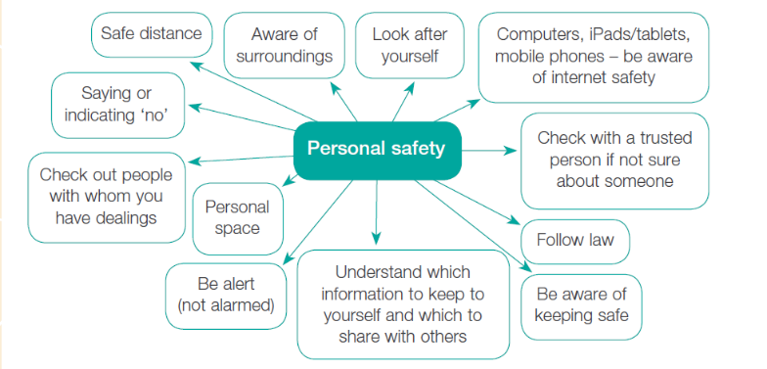  - Begin the discussion about safety with the question ‘How might someone keep safe?’  - Use a ‘safety web’ to ensure maximum participation: Sitting in a circle, students pass a ball of brightly coloured wool or streamers to each other, holding onto the wool or streamers as they pass and offer their ideas in sentences beginning with ‘Safety means …’  - Ask students:  - based on what you learned about your right to be safe and personal safety, how has it changed your thinking?  - How might it influence what choices children and young people may make?  - What could someone do if they were feeling unsafe? (Responses should include: talk to a trusted adult or someone on their trusted network.) | From PY FA1 page 40
Your comments
Click or tap here to enter text.

3.6 Ideas about being safe and unsafe  - Use a mind map (RLS 5) or Activity resource 5: Mind map template to explore examples of the following:  - scary but fun (eg riding a roller coaster)  - scary, not fun but safe (eg having an injection to be immunised)  - scary, not fun, not safe (eg being lost)  - fun, not safe (eg arranging to meet someone you don’t know via an online conversation).  - Use any of the following strategies to explore ideas of safe and unsafe situations.  - Complete Activity resource 3: What is safe? using the Knee-to-knee activity (RLS 2).  - Use Activity resource 4: Feelings scenarios to guide freeze-frame role-plays (RLS 3a). Group members make guesses about the activity/situation being acted out and offer suggestions why one person finds the activity/situation scary or unsafe, while someone else thinks it is OK. Discuss the feelings different people in the scenarios may experience.  - Record ideas on a grid, with columns headed: ‘Scary but fun’, ‘Scary, not fun but safe’, ‘Scary, not fun, not safe’, ‘Fun, not safe’. Some students may add to the grid or move suggestions from one column to another. This promotes the idea that we can have mixed feelings and can change our ideas.  - Reinforce talking to trusted adults or someone on their trusted network, if they or others feel unsafe. | From PY FA 1 page 45  Students need to understand about their own safety by encouraging them to see that people have different opinions about what might be scary, fun or unsafe. Challenge opinions about dominant gender practices, such as ideas about play based on gender (eg boys play with cars and girls play with dolls).  Challenge gender stereotypes such as boys being tough and girls being afraid. Some students may be inclined to show bravado about a particular activity being scary but fun.  Don’t voice your own opinion immediately but encourage students to state their views. There are some things that can’t be done safely and students should come to that understanding.
Your comments
Click or tap here to enter text.

3.7 Adults caring for children  - Brainstorm (RLS 10) a range of adult responsibilities when caring for children.  - Ask students to record different situations about how adults support children. Use Activity resource 5: Mind map template (RLS 5), under headings such as:  - Food  - Clothing  - Health  - Medical  - Education  - Safety  - As a class discuss some of the ideas that students suggested and expand on those that are most pertinent. Local laws could also be discussed about child protection and adult responsibilities. For example, in Australia, refer to Youth Law Australia.  - Ask students: ‘What could a child they felt their safety and wellbeing was was at risk? (Responses could include: Talk to trusted adult, talk to someone on their trusted network, contact a support service , eg Kids Helpline (Australia). | From PY FA 1 page 41  https://yla.org.au/
Your comments
Click or tap here to enter text.

3.8 Chatting safely online  Under development | New activity
3.9 Assessing risks  - Ask students:  - What does risk-taking mean?  - Are there good risks and bad risks?  - How can you tell?  - In small groups and using a Positive Minus and Interesting (PMI) table, students discuss and record their response to the question: Why do people take risks?  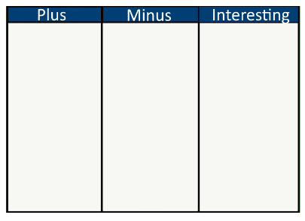  - Students share their discussions with the class. Reinforce that risk-taking is part of life and that risks should be assessed to determine if they are safe or unsafe.  - Further exploration of risk-taking can include using Activity resource 11: POOCH problem-solving model to explore different risk scenarios such as:  - Speaking in front of a large group of people  - Walking home in the dark  - Riding a bike without a helmet  - Going to party with a new friend  - Entering an online competition  - Remind students about talking to a trusted adult or someone on their trusted network if they are unsure about a risky situation and need some advice or support. | New activity  To children, risk typically refers to the possibility of harm or danger occurring in a particular situation or activity. Children may encounter various types of risks as they explore and navigate their environment, such as physical risks (e.g. falling off a playground structure), social risks (e.g. speaking up in class), emotional risks (e.g. sharing personal feelings with a friend), and cognitive risks (e.g. trying a challenging puzzle or problem).  http://kscpc.2.vu/Y3-5_Act19
Your comments
Click or tap here to enter text.

3.10 Exploring online risk and safety  Under development | New activity

Any other comments

Click or tap here to enter text.

